Comparative efficacy of exercise modes on cardiometabolic health in women with polycystic ovary syndrome: a systematic review with pairwise and network meta-analyses

Running title: exercise training and polycystic ovary syndrome

Mousa Khalafi^{1*}, Saeid Fatolahi², Ghodsieh Rahmatpanah¹, Michael E Symonds³, Sara K Rosenkranz⁴, Farnaz Dinizadeh⁵, Alexios Batrakoulis^{6,7*}
¹Department of Sport Sciences, Faculty of Humanities, University of Kashan, Kashan, Iran
²Department of Physical Education and Sport Sciences, Faculty of Humanities, Tarbiat Modares University, Tehran, Iran
³Centre for Perinatal Research, Academic Unit of Population and Lifespan Sciences, School of Medicine, University of Nottingham, Nottingham, UK
⁴Department of Kinesiology and Nutrition Sciences, University of Nevada Las Vegas, Las Vegas, NV, USA
⁵Department of Sport Sciences, Tabriz branch, Azad University, Tabriz, Iran
⁶Department of Physical Education and Sport Science, Democritus University of Thrace, Komotini, Greece
⁷Department of Physical Education and Sport Science, University of Thessaly, Trikala, Greece
*Corresponding authors
Mousa Khalafi, Department of Sport Sciences, Faculty of Humanities, University of Kashan, Kashan, Iran; Email: Mousa.Khalafi@kashanu.ac.ir
Alexios Batrakoulis, Department of Physical Education and Sport Science, University of Thessaly, Trikala, Greece; Email: abatrakoulis@uth.gr

Supplementary table 1. Risk of bias assessment
 | Eligibility criteria specified | Subjects randomly allocated | Allocation method concealed | Groups similar at baseline | All subjects blinded | Therapists administering blinded | Blinding of Assessors | Outcomes obtained from >85% | Intention-to-Treat Analysis | Between-group results reported | Variability measures provided | Score | Score  (Qualitative)
Almenning et al. 2015 |  |  |  |  |  |  |  |  |  |  |  | 7 | Good
Benham et al. 2021 a |  |  |  |  |  |  |  |  |  |  |  | 7 | Good
Bruner et al. 2006 |  |  |  |  |  |  |  |  |  |  |  | 5 | Fair
Costa et al. 2018 |  |  |  |  |  |  |  |  |  |  |  | 5 | Fair
Elbandrawy et al. 2022 |  |  |  |  |  |  |  |  |  |  |  | 5 | Fair
Kiel et al. 2022 b |  |  |  |  |  |  |  |  |  |  |  | 7 | Good
Kirthika et al. 2019 |  |  |  |  |  |  |  |  |  |  |  | 6 | Good
Konopka et al. 2015 |  |  |  |  |  |  |  |  |  |  |  | 4 | Fair
Li et al. 2022 |  |  |  |  |  |  |  |  |  |  |  | 5 | Fair
Lionett et al, 2021 |  |  |  |  |  |  |  |  |  |  |  | 4 | Fair
Lopes et al. 2018 |  |  |  |  |  |  |  |  |  |  |  | 5 | Fair
Mohammadi et al. 2023 |  |  |  |  |  |  |  |  |  |  |  | 6 | Good
Nybacka et al. 2013 |  |  |  |  |  |  |  |  |  |  |  | 5 | Fair
Orio et al. 2016 |  |  |  |  |  |  |  |  |  |  |  | 8 | Good
Patel et al. 2020 |  |  |  |  |  |  |  |  |  |  |  | 5 | Fair
Patten et al. 2022 |  |  |  |  |  |  |  |  |  |  |  | 5 | Fair
Philbois et al. 2022 |  |  |  |  |  |  |  |  |  |  |  | 5 | Fair
Ribeiro et al. 2020 |  |  |  |  |  |  |  |  |  |  |  | 4 | Fair
Stener-Victorin et al.2009 |  |  |  |  |  |  |  |  |  |  |  | 6 | Good
Thomson et al. 2008 |  |  |  |  |  |  |  |  |  |  |  | 4 | Fair
Turan et al. 2015 |  |  |  |  |  |  |  |  |  |  |  | 5 | Fair
Vigorito et al. 2007 |  |  |  |  |  |  |  |  |  |  |  | 6 | Good
Vizza et al. 2016 |  |  |  |  |  |  |  |  |  |  |  | 7 | Good
Wang et al. 2024 |  |  |  |  |  |  |  |  |  |  |  | 5 | Fair
Woodward et al. 2022 |  |  |  |  |  |  |  |  |  |  |  | 7 | Good

(1) Eligibility Criteria specified, (2) Random allocation of participants, (3) Allocation concealed, (4) Groups similar at baseline, (5) Subjects blinded, (6) Therapists blinded, (7) Assessors blinded, (8) Outcome measures assessed in 85% of participants, (9) Intention to treat analysis, (10) Reporting of between group statistical comparison, (11) Point measures and measures of variability reported for main effects. low (✓), high (x) and unclear (?)

Supplementary table 2. Node-splitting method in comparison between direct and indirect evidence of different specific intervention for fasting glucose
comparison | k | prop | nma | direct | indir | Diff | z | p-value
AT:CON | 10 | 0.84 | -0.675 | 0.102 | -4.621 | 4.723 | 2.16 | 0.031
AT:CT | 1 | 0.35 | -0.546 | -1.8 | 0.126 | -1.926 | -0.48 | 0.631
AT:HIIT | 5 | 0.52 | -0.62 | -1.042 | -0.165 | -0.876 | -0.44 | 0.6591
AT:Yoga/Tai Chi | 1 | 0.22 | 4.874 | 1.62 | 5.794 | -4.174 | -1.01 | 0.3112
CT:CON | 3 | 0.9 | -0.129 | 0.14 | -2.638 | 2.778 | 0.45 | 0.6499
HIIT:CON | 7 | 0.9 | -0.055 | -0.11 | 0.425 | -0.535 | -0.21 | 0.8347
RT:CON | 2 | 0.92 | -0.053 | -1.098 | 11.418 | -12.516 | -1.46 | 0.1451
Yoga/Tai Chi:CON | 1 | 0.82 | -5.549 | -6.3 | -2.126 | -4.174 | -1.01 | 0.3112
HIIT:RT | 1 | 0.65 | -0.001 | -1.8 | 3.29 | -5.09 | -1 | 0.3154
Notes: p>0.05 indicates that indirect comparisons were consistent with direct comparisons.

Supplementary table 3. Node-splitting method in comparison between direct and indirect evidence of different specific intervention for fasting insulin
comparison | k | prop | nma | direct | indir | Diff | z | p-value
AT:CON | 10 | 0.88 | -0.259 | -0.197 | -0.699 | 0.502 | 1.05 | 0.2952
AT:CT | 1 | 0.33 | 0.021 | 0.178 | -0.057 | 0.234 | 0.35 | 0.7249
AT:HIIT | 5 | 0.65 | 0.123 | 0.012 | 0.33 | -0.318 | -0.77 | 0.4426
CT:CON | 4 | 0.93 | -0.28 | -0.232 | -0.895 | 0.664 | 0.6 | 0.5465
HIIT:CON | 7 | 0.81 | -0.382 | -0.4 | -0.307 | -0.093 | -0.2 | 0.8403
RT:CON | 2 | 0.86 | -0.316 | -0.509 | 0.915 | -1.424 | -1.13 | 0.2568
HIIT:RT | 1 | 0.47 | -0.066 | -0.405 | 0.236 | -0.64 | -0.72 | 0.4735
Notes: p>0.05 indicates that indirect comparisons were consistent with direct comparisons.

Supplementary table 4. Node-splitting method in comparison between direct and indirect evidence of different specific intervention for HOMA-IR
comparison | k | prop | nma | direct | indir | Diff | z | p-value
AT:CON | 8 | 0.88 | -0.575 | -0.463 | -1.389 | 0.927 | 1.14 | 0.2534
AT:CT | 1 | 0.38 | -0.085 | 0.189 | -0.254 | 0.443 | 0.44 | 0.6595
AT:HIIT | 3 | 0.57 | -0.011 | -0.162 | 0.188 | -0.351 | -0.51 | 0.6105
CT:CON | 3 | 0.92 | -0.49 | -0.381 | -1.673 | 1.293 | 0.81 | 0.4172
HIIT:CON | 6 | 0.85 | -0.564 | -0.56 | -0.583 | 0.023 | 0.03 | 0.9784
RT:CON | 1 | 0.77 | -0.506 | -0.894 | 0.822 | -1.716 | -0.94 | 0.3465
HIIT:RT | 1 | 0.77 | -0.057 | -0.447 | 1.265 | -1.712 | -0.94 | 0.3465
Notes: p>0.05 indicates that indirect comparisons were consistent with direct comparisons.

Supplementary table 5. Node-splitting method in comparison between direct and indirect evidence of different specific intervention for TG
comparison | k | prop | nma | direct | indir. | Diff | z | p-value
AT:CON | 6 | 0.92 | 0.5 | 0.176 | 4.485 | -4.308 | -0.29 | 0.7682
AT:CT | 1 | 0.02 | 4.113 | 15.06 | 3.836 | 11.224 | 0.43 | 0.6677
AT:HIIT | 3 | 0.17 | 1.845 | 7.543 | 0.673 | 6.87 | 0.62 | 0.5326
CT:CON | 2 | 1 | -3.613 | -3.593 | -31.582 | 27.989 | 0.58 | 0.5612
HIIT:CON | 5 | 0.99 | -1.345 | -1.194 | -14.672 | 13.479 | 0.83 | 0.4069
RT:CON | 1 | 1 | -4.106 | -4.42 | 71.715 | -76.135 | -0.35 | 0.7254
HIIT:RT | 1 | 0.54 | 2.761 | -1.78 | 8.079 | -9.859 | -0.35 | 0.7254
Notes: p>0.05 indicates that indirect comparisons were consistent with direct comparisons.

Supplementary table 6. Node-splitting method in comparison between direct and indirect evidence of different specific intervention for TC
comparison | k | prop | nma | direct | indir. | Diff | z | p-value
AT:CON | 8 | 0.89 | -2.69 | -2.81 | -1.696 | -1.114 | -0.09 | 0.9253
AT:CT | 1 | 0.27 | 1.865 | 2.32 | 1.7 | 0.62 | 0.04 | 0.9653
AT:HIIT | 3 | 0.52 | 0.772 | 3.322 | -2.011 | 5.333 | 0.58 | 0.5616
CT:CON | 2 | 0.95 | -4.555 | -4.861 | 0.912 | -5.773 | -0.24 | 0.8124
HIIT:CON | 5 | 0.91 | -3.463 | -2.427 | -14.356 | 11.928 | 0.91 | 0.3613
RT:CON | 1 | 0.76 | -2.089 | 3.87 | -20.545 | 24.415 | 1.05 | 0.2937
HIIT:RT | 1 | 0.82 | -1.373 | 3.49 | -23.678 | 27.168 | 1.05 | 0.2937
Notes: p>0.05 indicates that indirect comparisons were consistent with direct comparisons.

Supplementary table 7. Node-splitting method in comparison between direct and indirect evidence of different specific intervention for LDL
comparison | k | prop | nma | direct | indir. | Diff | z | p-value
AT:CON | 8 | 0.93 | -1.143 | -1.116 | -1.484 | 0.368 | 0.04 | 0.9701
AT:CT | 1 | 0.22 | 7.262 | -0.39 | 9.434 | -9.824 | -0.98 | 0.3267
AT:HIIT | 3 | 0.44 | 5.316 | 7.297 | 3.789 | 3.507 | 0.52 | 0.6007
HIIT:CON | 5 | 0.93 | -6.459 | -5.947 | -13.216 | 7.269 | 0.71 | 0.4756
RT:CON | 1 | 0.89 | -18.708 | -15.48 | -44.286 | 28.806 | 0.65 | 0.5167
HIIT:RT | 1 | 0.89 | 12.248 | 15.48 | -13.3 | 28.78 | 0.65 | 0.5167
Notes: p>0.05 indicates that indirect comparisons were consistent with direct comparisons.

Supplementary table 8. Node-splitting method in comparison between direct and indirect evidence of different specific intervention for HDL
comparison | k | prop | nma | direct | indir. | Diff | z | p-value
AT:CON | 8 | 0.88 | 3.036 | 3.366 | 0.632 | 2.734 | 0.55 | 0.5835
AT:CT | 1 | 0.42 | 2.047 | 0 | 3.544 | -3.544 | -0.67 | 0.5025
AT:HIIT | 3 | 0.58 | 0.845 | -0.853 | 3.148 | -4.001 | -0.96 | 0.3368
CT:CON | 2 | 0.91 | 0.989 | 0.377 | 7.145 | -6.768 | -0.84 | 0.3999
HIIT:CON | 5 | 0.89 | 2.191 | 1.715 | 5.882 | -4.166 | -0.75 | 0.4503
RT:CON | 1 | 0.85 | -2.732 | -1.43 | -10.209 | 8.779 | 0.67 | 0.5017
HIIT:RT | 1 | 0.58 | 4.922 | 7.63 | 1.148 | 6.482 | 0.67 | 0.5017
Notes: p>0.05 indicates that indirect comparisons were consistent with direct comparisons.

Supplementary table 9. Node-splitting method in comparison between direct and indirect evidence of different specific intervention for CRP
comparison | k | prop | nma | direct | indir. | Diff | z | p-value
HIIT:CON | 2 | 0.95 | -0.292 | -0.264 | -0.816 | 0.552 | 0.31 | 0.757
RT:CON | 2 | 0.93 | 0.007 | -0.048 | 0.712 | -0.76 | -0.47 | 0.6387
HIIT:RT | 1 | 0.63 | -0.299 | -0.486 | 0.023 | -0.509 | -0.5 | 0.6189
Notes: p>0.05 indicates that indirect comparisons were consistent with direct comparisons.

Supplementary Figure 1. Forest plot of the effects of exercise training on fasting glucose. Data are reported as WMD (95% confidence limits). WMD: weighted mean difference.
Supplementary Figure 2. Forest plot of the effects of exercise training on fasting insulin. Data are reported as SMD (95% confidence limits). WMD: standardized mean difference.
Supplementary Figure 3. Forest plot of the effects of exercise training on insulin resistance. Data are reported as SMD (95% confidence limits). SMD: standardized mean difference.
Supplementary Figure 4. Forest plot of the effects of exercise training on TG. Data are reported as WMD (95% confidence limits). WMD: weighted mean difference.
Supplementary Figure 5. Forest plot of the effects of exercise training on TC. Data are reported as WMD (95% confidence limits). WMD: weighted mean difference.
Supplementary Figure 6. Forest plot of the effects of exercise training on LDL. Data are reported as WMD (95% confidence limits). WMD: weighted mean difference.
Supplementary Figure 7. Forest plot of the effects of exercise training on HDL. Data are reported as WMD (95% confidence limits). WMD: weighted mean difference.
Supplementary Figure 8. Forest plot of the effects of exercise training on CRP. Data are reported as SMD (95% confidence limits). SMD: standardized mean difference.
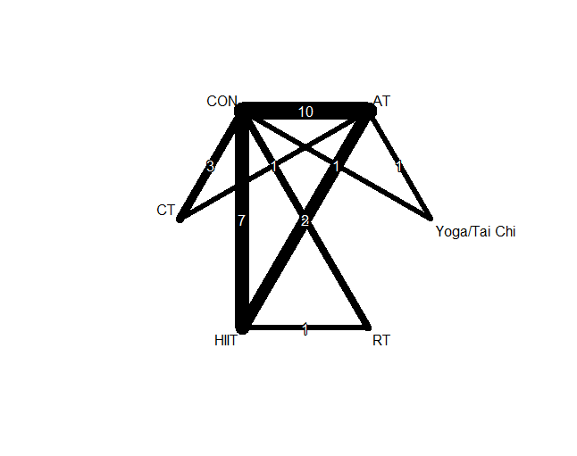 Supplementary Figure 9. Network geometric map of studies investigating the effect of exercise training on fasting glucose
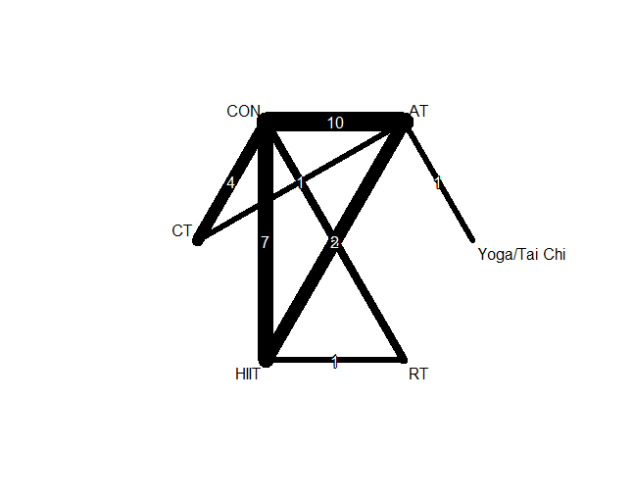 Supplementary Figure 10. Network geometric map of studies investigating the effect of exercise training on fasting insulin
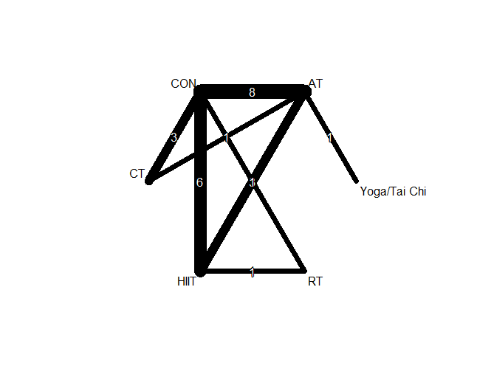 Supplementary Figure 11. Network geometric map of studies investigating the effect of exercise training on insulin resistance

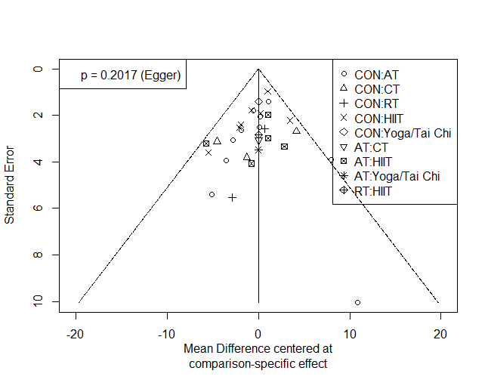
Supplementary Figure 12. Network meta-analysis of funnel plots for fasting glucose

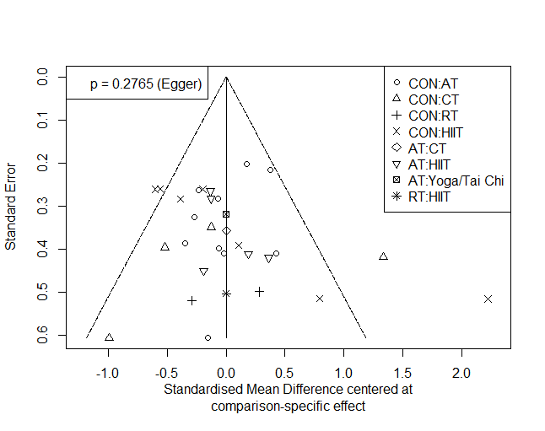 Supplementary Figure 13. Network meta-analysis of funnel plots for fasting insulin

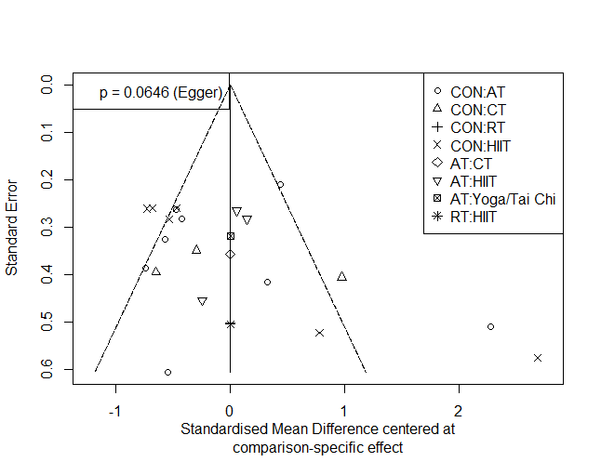 Supplementary Figure 14. Network meta-analysis of funnel plots for insulin resistance
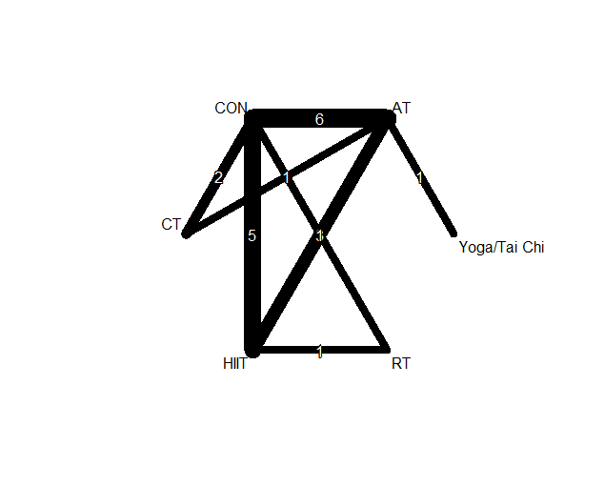 Supplementary Figure 15. Network geometric map of studies investigating the effect of exercise training on TG
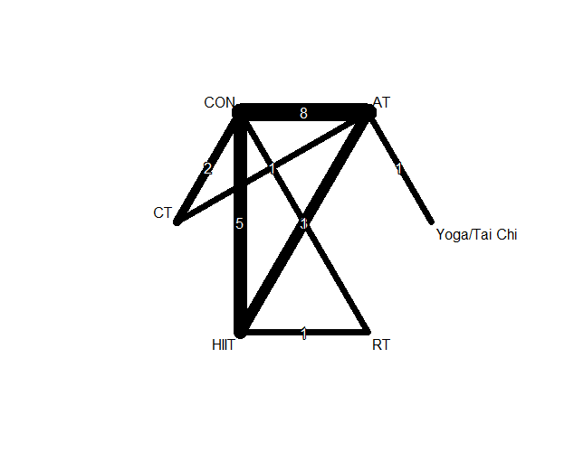 Supplementary Figure 16. Network geometric map of studies investigating the effect of exercise training on TC
Supplementary Figure 17. Network geometric map of studies investigating the effect of exercise training on LDL
Supplementary Figure 18. Network geometric map of studies investigating the effect of exercise training on HDL
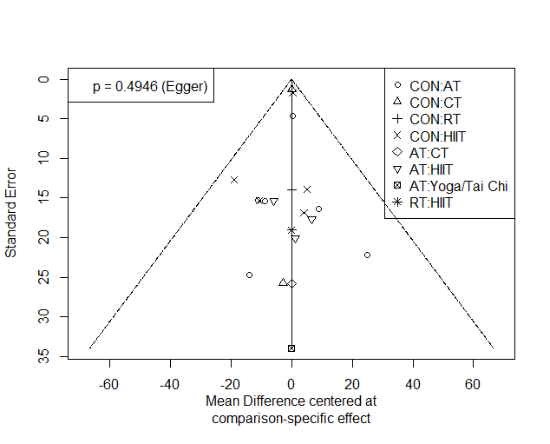 Supplementary Figure 19. Network meta-analysis of funnel plots for TG
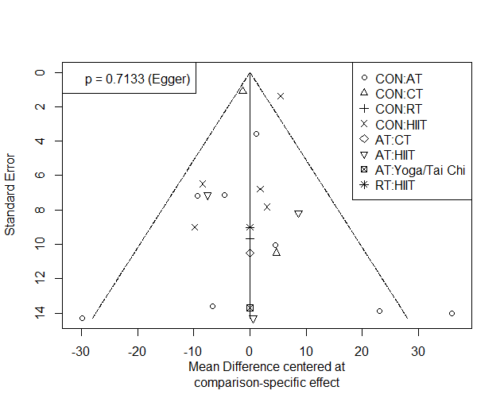 Supplementary Figure 20. Network meta-analysis of funnel plots for TC
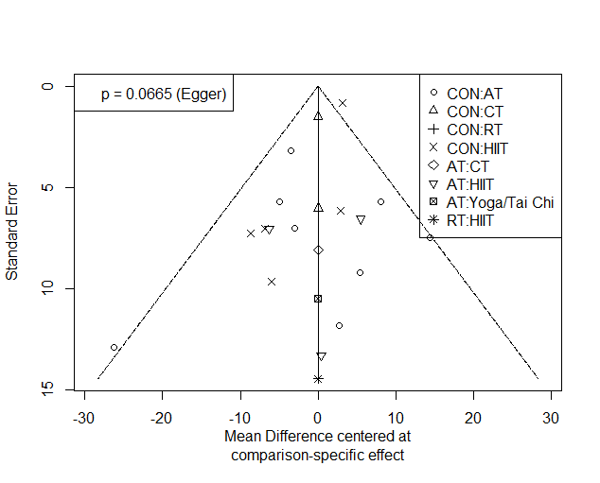 Supplementary Figure 21. Network meta-analysis of funnel plots for LDL

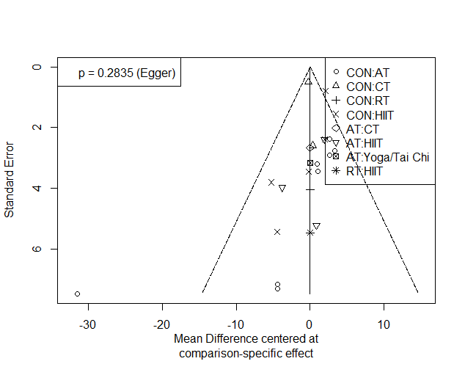 Supplementary Figure 22. Network meta-analysis of funnel plots for HDL
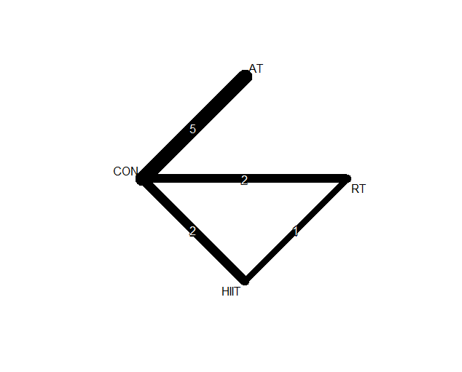 Supplementary Figure 23. Network geometric map of studies investigating the effect of exercise training on CRP
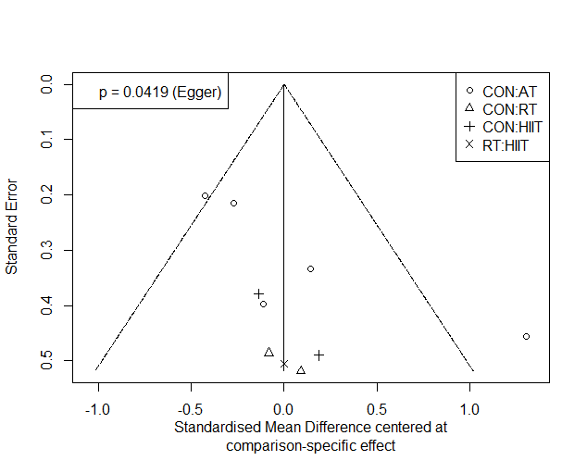 Supplementary Figure 24. Network meta-analysis of funnel plots for CRP

