Prevalence of Breastfeeding-Related Musculoskeletal Pain Among Lactating Mothers in Arab Countries
You are invited to participate in a research study entitled:
“Prevalence of Breastfeeding-Related Musculoskeletal Pain Among Lactating Mothers in Arab Countries.”
Completing this questionnaire will take approximately 10–15 minutes. All responses will be treated with the strictest confidentiality, and your identity will remain anonymous. Participation is voluntary, and you may withdraw at any time without providing a reason.
We sincerely thank you in advance for your valuable contribution.
Researcher:
Mrs. Fareedah AlMohri
Clinical Instructor, Department of Physical Therapy
Kuwait University

Section I: Personal, Educational, and Occupational Information
- Are you currently a breastfeeding mother for at least one month?
- Yes
- No
- Are you currently pregnant?
- Yes
- No
- What is your age (in years)?
- 18–22
- 23–26
- 27–30
- 31–35
- 36–40
- 41–44
- 45 and above
- Approximate weight (in kilograms) enter number only.
- Approximate height (in centimeters) enter number only.
- Nationality:
- Kuwait
- Bahrain
- Saudi Arabia
- United Arab Emirates
- Oman
- Qatar
- Egypt
- Lebanon
- Syria
- Jordan
- Maghreb region
- Iraq
- Palestine
- Yemen
- Other
- Place of residence:
- Kuwait
- Bahrain
- Saudi Arabia
- United Arab Emirates
- Oman
- Qatar
- Egypt
- Lebanon
- Syria
- Jordan
- Maghreb region
- Iraq
- Palestine
- Yemen
- Other
- Marital status:
- Married
- Divorced
- Widowed
- Educational level:
- Secondary school or below
- Diploma
- University degree
- Postgraduate degree
- Employment status:
- Employed
- Unemployed
- Self-employed
- Retired
- How would you describe the physical activity level of your job?
- Sedentary job (sitting most of the time, e.g., office work)
- Light activity job (mostly sitting with occasional light activity)
- Active job (e.g., teaching, nursing)
- Homemaker with light activity (more than one housemaid)
- Homemaker with moderate activity (one housemaid)
- Homemaker with high activity (no housemaid)
- How often do you engage in regular physical activity or exercise per week?
- Daily, 7 days a week
- Several times per week (2–4 times)
- Once per week
- Never
- Number of children:
- 1
- 2
- 3
- 4
- 5
- 6 or more
- Type of most recent delivery:
- Vaginal delivery (with or without induction)
- Assisted vaginal delivery (e.g., vacuum extraction)
- Primary cesarean section
- Repeat cesarean section
- Age of breastfeeding children (in months):
- 0–1
- 2–6
- 7–12
- 13–18
- 19–24
- 25–36
- Approximate current weight of the breastfeeding child (in kilograms):
- Less than 5 kg
- 5–6.9 kg
- 7–8.9 kg
- 9–10.9 kg
- 11–12.9 kg
- More than 13 kg
- Among your children, how many have you breastfed for at least three months?
- 0
- 1
- 2
- 3
- 4
- 5
- 6 or more
- Presence of twins or multiple births:
- None
- Yes, and I breastfeed them all
- Yes, but I breastfeed only one
- Do you have any diagnosed musculoskeletal injuries or conditions?
- No previous musculoskeletal injuries or conditions
- Yes, and symptoms worsened after breastfeeding
- Yes, and symptoms did not change after breastfeeding
- Yes, and symptoms improved after breastfeeding
- If yes, please specify the condition briefly:

Section II: Information on Breastfeeding Factors and Positions
- Type of breastfeeding:
- Exclusive breastfeeding directly from the breast
- Exclusive breastfeeding directly from the breast with occasional expressed (pumped) milk
- Expressed (pumped) breast milk always given by bottle
- Combination of breast milk and formula (bottle feeding)
- If using milk expression (pumping), what type do you use?
- Manual pump
- Electric pump
- Wearable electric pump
- I do not use pumping
- Which position do you most commonly use when breastfeeding your child (see illustrations)?
- Cradle position (infant in your lap, head resting in the bend of your arm) 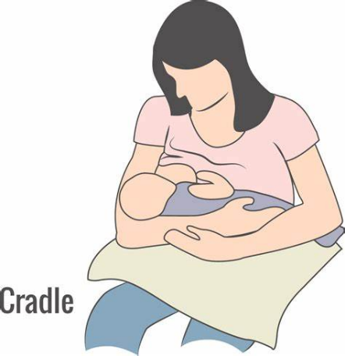
- Cross-cradle position (infant in the opposite direction of the cradle position, with head supported by your hand instead of the arm bend) 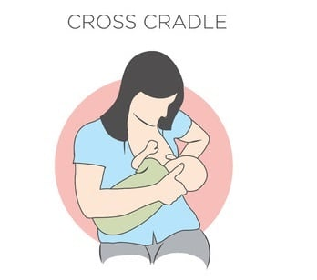
- Football/Clutch position (infant’s legs tucked under the mother’s arm) 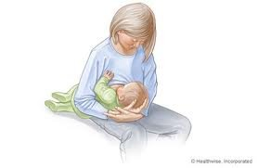
- Side-lying position (mother lies on her side with the infant positioned side-lying, facing her)
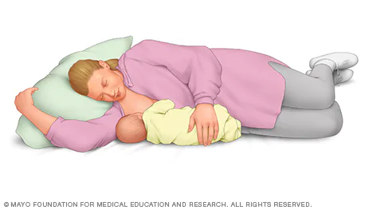
- Semi-reclined position (infant lying on his/her stomach on the mother’s chest) 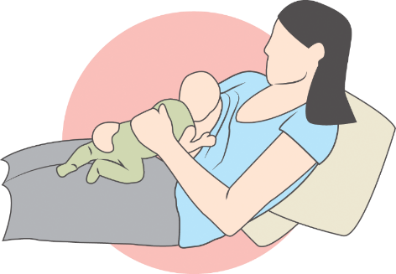
- On average, how many times do you breastfeed your child per day?
- Fewer than 4 times
- 4–6 times
- 7–9 times
- 9–12 times
- More than 12 times
- On average, how long does one breastfeeding session last?
- Less than 5 minutes
- 5–10 minutes
- 11–15 minutes
- 16–20 minutes
- 21–25 minutes
- 26–30 minutes
- More than 30 minutes
- Do you support your back and arm while breastfeeding (e.g., using a nursing chair or breastfeeding pillow)?
- Yes, I always support both my back and arm
- Yes, I always support my arm
- Yes, I always support my back
- I sometimes provide support
- I do not support my back or arm
- Have you received education or awareness about the importance of breastfeeding during pregnancy or after childbirth? (You may select more than one option)
- Yes, through medical consultations
- Yes, through courses and workshops
- Yes, through family and friends
- Yes, through social media
- Yes, through reading and self-learning
- No, I did not receive any form of awareness
- If you received awareness/education, did it include information about correct body positions during breastfeeding and possible musculoskeletal pain?
- Yes
- No
- Not sure

Section III: Musculoskeletal Pain Related to Breastfeeding
These questions relate to the highest intensity of pain you have experienced, even occasionally, due to breastfeeding.
Based on specific body regions (neck, shoulder/arm/hand, back), the following questions address the musculoskeletal pain you have felt during the past days (while breastfeeding, after breastfeeding, or continuously).

- Have you experienced musculoskeletal pain related to breastfeeding in the shoulder, arm/hand, neck, or back?
- Yes, always
- Yes, most of the time
- Yes, sometimes
- Yes, rarely
- No pain at all
- Please rank the most painful area for you.
- Based on the body diagram provided, please indicate the area where you feel the most pain. This will direct you to the corresponding set of questions: 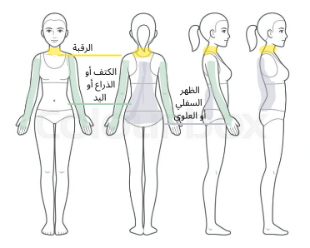
- Neck
- Upper or lower back
- Shoulder, arm, or hand
- No pain

Note: Participants will be directed to the most appropriate functional outcome measurement tool according to the area chosen in the previous question.

Section IV: Neck Pain–Related Disability Index (NDI)
Vernon H, Mior S. The Neck Disability Index: A study of reliability and validity. J Manipulative Physiol Ther. 1991;14(7):409–415.
This questionnaire consists of ten parts and is designed to help us understand the extent to which neck pain affects your ability to perform daily activities.

32. Part 1: Pain Intensity
- I have no neck pain at the moment.
- The pain is very mild at the moment.
- The pain is moderate at the moment.
- The pain is fairly severe at the moment.
- The pain is very severe at the moment.
- The pain is the worst imaginable at the moment.
33. Part 2: Personal Care (washing, dressing, etc.)
- I can look after myself normally without causing extra pain in my neck.
- I can look after myself normally but it causes extra pain in my neck.
- It is painful to look after myself and I am slow and careful.
- I need some help but manage most of my personal care.
- I need help every day in most aspects of self-care.
- I cannot dress or wash myself and I stay in bed.
34. Part 3: Lifting
- I can lift heavy weights without extra pain in my neck.
- I can lift heavy weights but it causes extra pain in my neck.
- Neck pain prevents me from lifting heavy weights, but I can manage light to medium weights if they are conveniently positioned.
- Neck pain prevents me from lifting heavy weights from the floor, but I can do so if they are conveniently positioned (e.g., on a table).
- I can only lift very light weights.
- I cannot lift or carry anything at all.
35. Part 4: Reading
- I can read as much as I want with no neck pain.
- I can read as much as I want with slight neck pain.
- I can read as much as I want with moderate neck pain.
- I cannot read as much as I want because of moderate neck pain.
- I cannot read as much as I want because of severe neck pain.
- I cannot read at all.
36. Part 5: Headaches
- I have no headaches at all.
- I have slight headaches which come infrequently.
- I have moderate headaches which come infrequently.
- I have moderate headaches which come frequently.
- I have severe headaches which come frequently.
- I have headaches almost all the time.
37. Part 6: Concentration
- I can concentrate fully when I want with no difficulty.
- I can concentrate fully when I want with slight difficulty.
- I have a fair degree of difficulty in concentrating when I want.
- I have a lot of difficulty concentrating when I want.
- I have a great deal of difficulty concentrating when I want.
- I cannot concentrate at all.
38. Part 7: Work
- I can do as much work as I want.
- I can only do my usual work but nothing more.
- I can do most of my usual work but nothing more.
- I cannot do my usual work.
- I can hardly do any work at all.
- I cannot do any work at all.
39. Part 8: Driving
- I can drive my car without any neck pain.
- I can drive my car as long as I want with only slight neck pain.
- I can drive my car as long as I want with moderate neck pain.
- I cannot drive my car as long as I want because of moderate neck pain.
- I can hardly drive at all because of severe neck pain.
- I cannot drive my car at all.
- I do not drive.
40. Part 9: Sleeping
- I have no trouble sleeping.
- My sleep is slightly disturbed.
- My sleep is mildly disturbed.
- My sleep is moderately disturbed.
- My sleep is greatly disturbed.
- My sleep is completely disturbed.
41. Part 10: Recreation/Leisure Activities
- I am able to engage in all my leisure activities with no neck pain.
- I am able to engage in all my leisure activities with some neck pain.
- I am able to engage in most but not all of my leisure activities because of neck pain.
- I am able to engage in only a few of my leisure activities because of neck pain.
- I can hardly do any leisure activities because of neck pain.
- I cannot do any leisure activities at all.

42. What was the highest level of neck pain you experienced during the past week?
(0 = no pain; pain increases as the number increases)
43. What do you usually do to relieve the pain? (You may select more than one option)
- Complete rest
- Visit a physician
- Painkillers or medication
- Physiotherapy sessions
- Therapeutic exercises
- Reducing the number of breastfeeding sessions
- Stopping breastfeeding
- I do not do anything
**44. Does the pain cause you psychological distress (e.g., sadness, crying, irritability, anxiety, depression, tension)?
- Yes
- To some extent
- No
45. Does/did the pain affect your ability to complete a breastfeeding session?
- Yes
- Sometimes
- No
46. Have you considered or are you considering weaning (completely stopping breastfeeding) because of the pain?
- Yes, because of pain
- Yes, for other reasons
- Sometimes
- No
47. Do you have any comments or additional notes you would like to share?

Section V: Back Pain–Related Disability Scale
This questionnaire consists of ten parts and is designed to help us understand the extent to which back pain affects your ability to perform daily activities.

32. Section 1: Pain Intensity
- I have no back pain at the moment.
- The pain in my lower back is very mild at the moment.
- The pain in my lower back is moderate at the moment.
- The pain in my lower back is fairly severe at the moment.
- The pain in my lower back is very severe at the moment.
- The pain in my lower back is the worst imaginable.
33. Section 2: Personal Care (e.g., washing, dressing)
- I can look after myself normally without causing extra pain in my back.
- I can look after myself normally, but it causes extra pain in my back.
- It is painful to look after myself, and I am slow and careful.
- I need some help but can manage most of my personal care.
- I need help every day for most personal care activities.
- I remain in bed most of the time, and I have difficulty washing and dressing.
34. Section 3: Lifting and Carrying
- I can lift heavy weights without extra pain in my back.
- I can lift heavy weights, but it causes extra pain in my back.
- Back pain prevents me from lifting heavy weights from the floor, but I can lift light to moderate weights if conveniently positioned (e.g., on a raised surface).
- Back pain prevents me from lifting heavy weights, but I can lift light to moderate weights from a high surface.
- I can lift only very light weights.
- I cannot lift or carry anything at all.
35. Section 4: Walking
- Pain in my back does not prevent me from walking any distance (e.g., around the neighborhood).
- Pain prevents me from walking more than 1,500 meters.
- Pain prevents me from walking more than 1,000 meters.
- Pain prevents me from walking more than 400 meters.
- I cannot walk without the use of a cane or crutches.
- I remain in bed most of the time and crawl to the bathroom.
36. Section 5: Sitting
- I can sit in any chair as long as I like.
- I can only sit in a comfortable chair as long as I like.
- Pain prevents me from sitting more than 1 hour.
- Pain prevents me from sitting more than 30 minutes.
- Pain prevents me from sitting more than 10 minutes.
- I cannot sit at all because of pain.
37. Section 6: Standing
- I can stand as long as I want without extra pain in my back.
- I can stand as long as I want but it causes extra pain in my back.
- Pain prevents me from standing more than 1 hour.
- Pain prevents me from standing more than 30 minutes.
- Pain prevents me from standing more than 10 minutes.
- I cannot stand at all.
38. Section 7: Sleeping
- My sleep is never disturbed by back pain.
- My sleep is occasionally disturbed by back pain.
- Because of back pain, I sleep less than 6 hours per night.
- Because of back pain, I sleep less than 4 hours per night.
- Because of back pain, I sleep less than 2 hours per night.
- I cannot sleep at all because of back pain.
39. Section 8: Sexual Activity
- My sex life is normal and causes no extra back pain.
- My sex life is normal but causes some extra back pain.
- My sex life is nearly normal but causes severe back pain.
- My sex life is greatly reduced because of back pain.
- My sex life is nearly absent because of back pain.
- My sex life is completely prevented by back pain.
40. Section 9: Social Life
- My social life is normal and causes no extra back pain.
- My social life is normal but increases the degree of back pain.
- Back pain has no effect on my social life, but it limits my more energetic activities.
- Back pain has restricted my social life and I do not go out as often.
- Back pain has restricted my social life to my home.
- I have no social life because of back pain.
41. Section 10: Traveling
- I can travel anywhere without extra back pain.
- I can travel anywhere but it causes extra back pain.
- Back pain is severe, but I can manage journeys of up to 2 hours.
- Back pain restricts me to journeys of less than 1 hour.
- Back pain restricts me to necessary short journeys of less than 30 minutes.
- Back pain prevents me from traveling except to receive treatment.
- I have never traveled.

42. What was the highest level of back pain (upper or lower) you experienced during the past week? According to NRS
(0 = no pain; pain increases as the number increases, 10 = the highest pain)
43. What do you usually do to relieve the pain? (You may select more than one option)
- Complete rest
- Visit a physician
- Painkillers or medication
- Physiotherapy sessions
- Therapeutic exercises
- Reducing the number of breastfeeding sessions
- Stopping breastfeeding
- I do not do anything
44. Does the pain cause you psychological distress (e.g., sadness, crying, irritability, anxiety, depression, tension)?
- Yes
- To some extent
- No
45. Does/did the pain affect your ability to complete a breastfeeding session?
- Yes
- Sometimes
- No
46. Have you considered or are you considering weaning (completely stopping breastfeeding) because of the pain?
- Yes, because of pain
- Yes, for other reasons
- Sometimes
- No
47. Do you have any comments or additional notes you would like to share?

Section VI: Disabilities of the Arm, Shoulder and Hand (Quick DASH)
Hudak PL, Amadio PC, Bombardier C. Development of an upper extremity outcome measure: The DASH (Disabilities of the Arm, Shoulder and Hand). Am J Ind Med. 1996;29(6):602–608. DOI: 10.1002/(SICI)1097-0274(199606)29:6<602::AID-AJIM4>3.0.CO;2-L
Please rate your ability to do the following activities in the last week:

- Open a tight or new jar
- No difficulty
- Mild difficulty
- Moderate difficulty
- Severe difficulty
- Unable
- Do heavy household chores (e.g., wash walls, wash floors)
- No difficulty
- Mild difficulty
- Moderate difficulty
- Severe difficulty
- Unable
- Carry a shopping bag or briefcase
- No difficulty
- Mild difficulty
- Moderate difficulty
- Severe difficulty
- Unable
- Wash your back
- No difficulty
- Mild difficulty
- Moderate difficulty
- Severe difficulty
- Unable
- Use a knife to cut food
- No difficulty
- Mild difficulty
- Moderate difficulty
- Severe difficulty
- Unable
- Recreational activities in which you take some force or impact through your arm, shoulder or hand (e.g., golf, hammering, tennis, etc.)
- No difficulty
- Mild difficulty
- Moderate difficulty
- Severe difficulty
- Unable

During the past week:
- To what extent has your arm, shoulder, or hand problem interfered with your normal social activities with family, friends, neighbors, or groups?
- Not at all
- Slightly
- Moderately
- Quite a bit
- Extremely
- Were you limited in your work or other regular daily activities as a result of your arm, shoulder, or hand problem?
- Not limited at all
- Slightly limited
- Moderately limited
- Very limited
- Unable

Please rate the severity of the following symptoms in the last week:
- Arm, shoulder, or hand pain
- None
- Mild
- Moderate
- Severe
- Extreme
- Tingling (pins and needles) in your arm, shoulder, or hand
- None
- Mild
- Moderate
- Severe
- Extreme
- How much difficulty have you had sleeping because of the pain in your arm, shoulder, or hand?
- No difficulty
- Mild difficulty
- Moderate difficulty
- Severe difficulty
- So much difficulty that I cannot sleep
- What was the highest level of back pain (upper or lower) you experienced during the past week?
(0 = no pain; pain increases as the number increases)
- What do you usually do to relieve the pain? (You may select more than one option)
- Complete rest
- Visit a physician
- Painkillers or medication
- Physiotherapy sessions
- Therapeutic exercises
- Reducing the number of breastfeeding sessions
- Stopping breastfeeding
- I do not do anything
- Does the pain cause you psychological distress (e.g., sadness, crying, irritability, anxiety, depression, tension)?
- Yes
- To some extent
- No
- Does/did the pain affect your ability to complete a breastfeeding session?
- Yes
- Sometimes
- No
- Have you considered or are you considering weaning (completely stopping breastfeeding) because of the pain?
- Yes, because of pain
- Yes, for other reasons
- Sometimes
- No
- Do you have any comments or additional notes you would like to share?

