Supplementary materials
Table S1: Lower limits of detection for DAP metabolites.
Cycle | DMP(μg/L) | DEP(μg/L) | DMTP(μg/L) | DETP(μg/L) | DMDTP(μg/L) | DEDTP(μg/L)
1999–2000 | 0.58 | 0.2 | 0.18 | 0.09 | 0.08 | 0.05
2001–2002 | 0.5 | 0.2 | 0.4 | 0.1 | 0.1 | 0.1
2003–2004 | 0.5 | 0.1 | 0.5 | 0.2 | 0.1 | 0.1
2005–2006 | 0.47 | 0.37 | 0.55 | 0.56 | 0.51 | 0.39
2007–2008 | 0.47 | 0.37 | 0.55 | 0.56 | 0.51 | 0.39
2011–2012 | 0.1 | 0.1 | 0.1 | 0.1 | 0.1 | 0.1
2015–2016 | 0.1 | 0.1 | 0.1 | 0.1 | 0.1 | 0.1
2017–2018 | 0.1 | 0.1 | 0.1 | 0.1 | 0.1 | 0.1

Table S2: Posterior inclusion probabilities (PIPs) of DAP metabolites in age at menarche, age at menopause, and reproductive lifespan models via BKMR model.
DAP metabolites | PIPs
DAP metabolites | Age at menarche | Age at menopause | Reproductive lifespan
DMP | 0.000 | 0.652 | 0.580
DEP | 0.004 | 0.000 | 0.000
DMTP | 0.026 | 0.032 | 0.164
DETP | 0.000 | 0.000 | 0.020
DMDTP | 0.000 | 0.000 | 0.000
DEDTP | 0.000 | 0.006 | 0.008
Model was adjusted for age at screening, race/ethnicity, education, BMI, smoking, alcohol use, and parity.

Table S3: The weight of each concentration of DAP metabolites in age at menarche, age at menopause, and reproductive lifespan models via WQS model.
DAP metabolites | Weight
DAP metabolites | Age at menarche | Age at menopause | Reproductive lifespan
DMP | 0.033 | 0.573 | 0.634
DEP | 0.084 | 0.054 | 0.048
DMTP | 0.015 | 0.087 | 0.101
DETP | 0.786 | 0.170 | 0.097
DMDTP | 0.029 | 0.007 | 0.016
DEDTP | 0.052 | 0.109 | 0.104
Model was adjusted for age at screening, race/ethnicity, education, BMI, smoking, alcohol use, and parity.

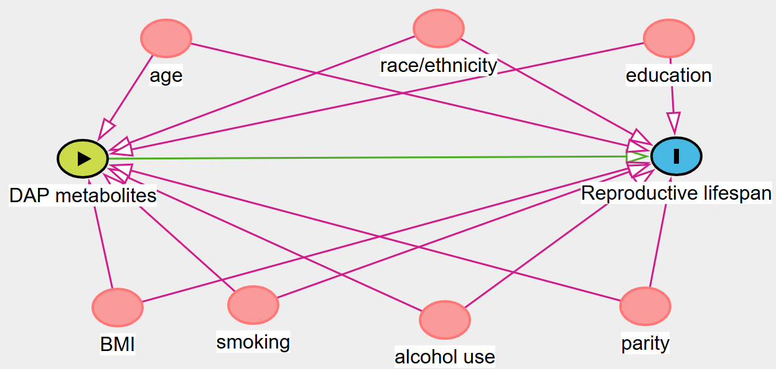
Fig. S1. The causal pathways between covariates (e.g., age, race/ethnicity, education, BMI, smoking, alcohol use, parity), exposure (DAP metabolites), and outcome (reproductive lifespan) in Directed Acyclic Graph (DAG).

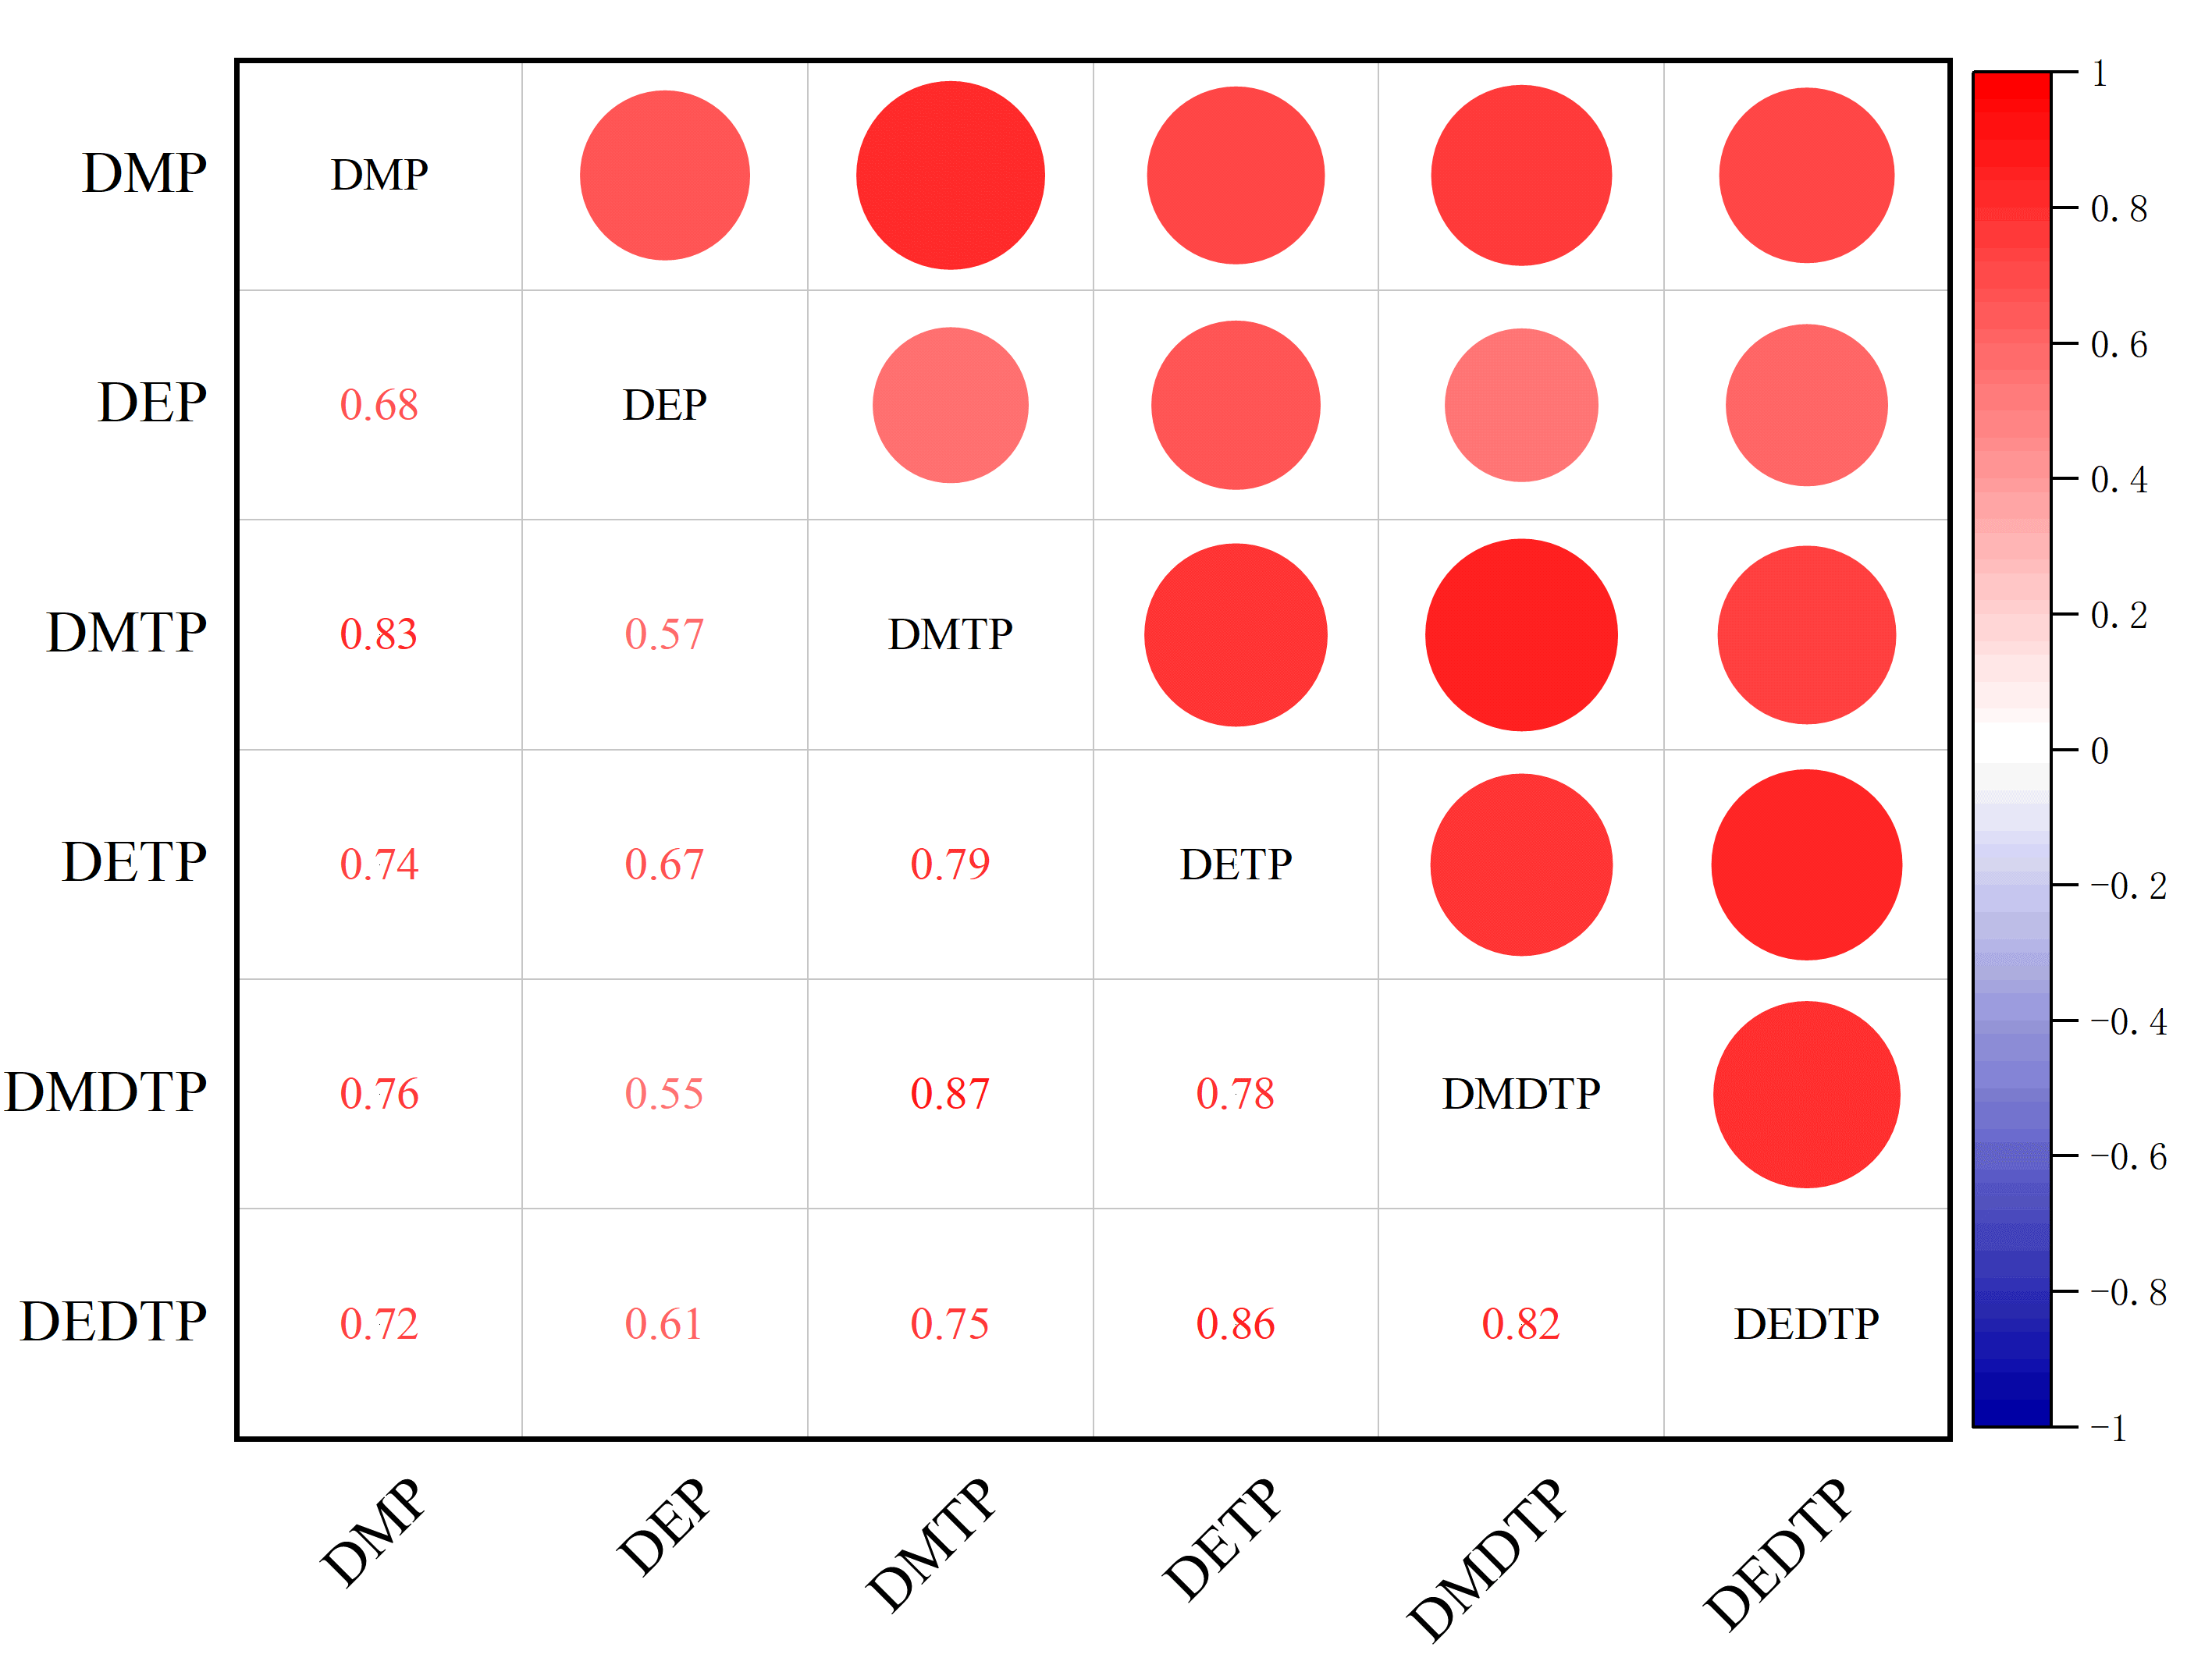
Figure S2. Pair-wise Pearson correlations between urinary DAP metabolites.
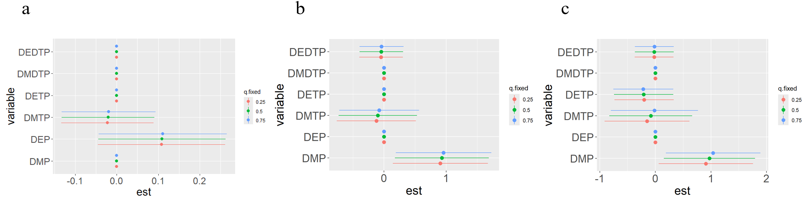
Fig. S3. Associations of each concentration of urinary DAP metabolites (estimates and 95%CI, estimated zero means null), the change in a latent continuous outcome of (a) age at menarche, (b) age at menopause, and (c) reproductive lifespan when each concentration of urinary DAP metabolites was at the 75th vs. 25th percentile, and while all other elements are at their 25th, 50th, or 75th percentiles in BKMR model. Model was adjusted for age at screening, race/ethnicity, education, BMI, smoking, alcohol use, and parity.

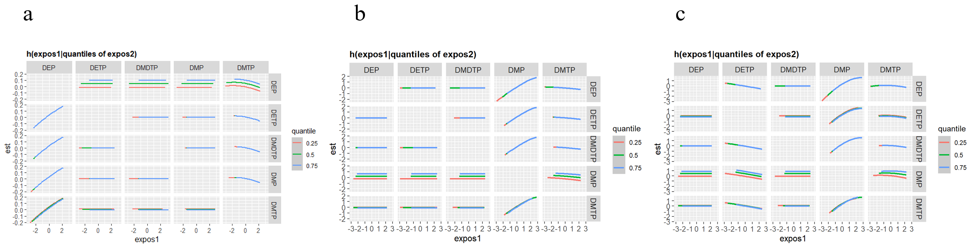
Fig. S4. Association between exposure 1 with (a) age at menarche, (b) age at menopause, and (c) reproductive lifespan in BKMR model, while fixing exposure 2 at different percentiles (here are the 25th, 50th, and 75th percentiles) all the others at their median levels. Model was adjusted for age at screening, race/ethnicity, education, BMI, smoking, alcohol use, and parity.

