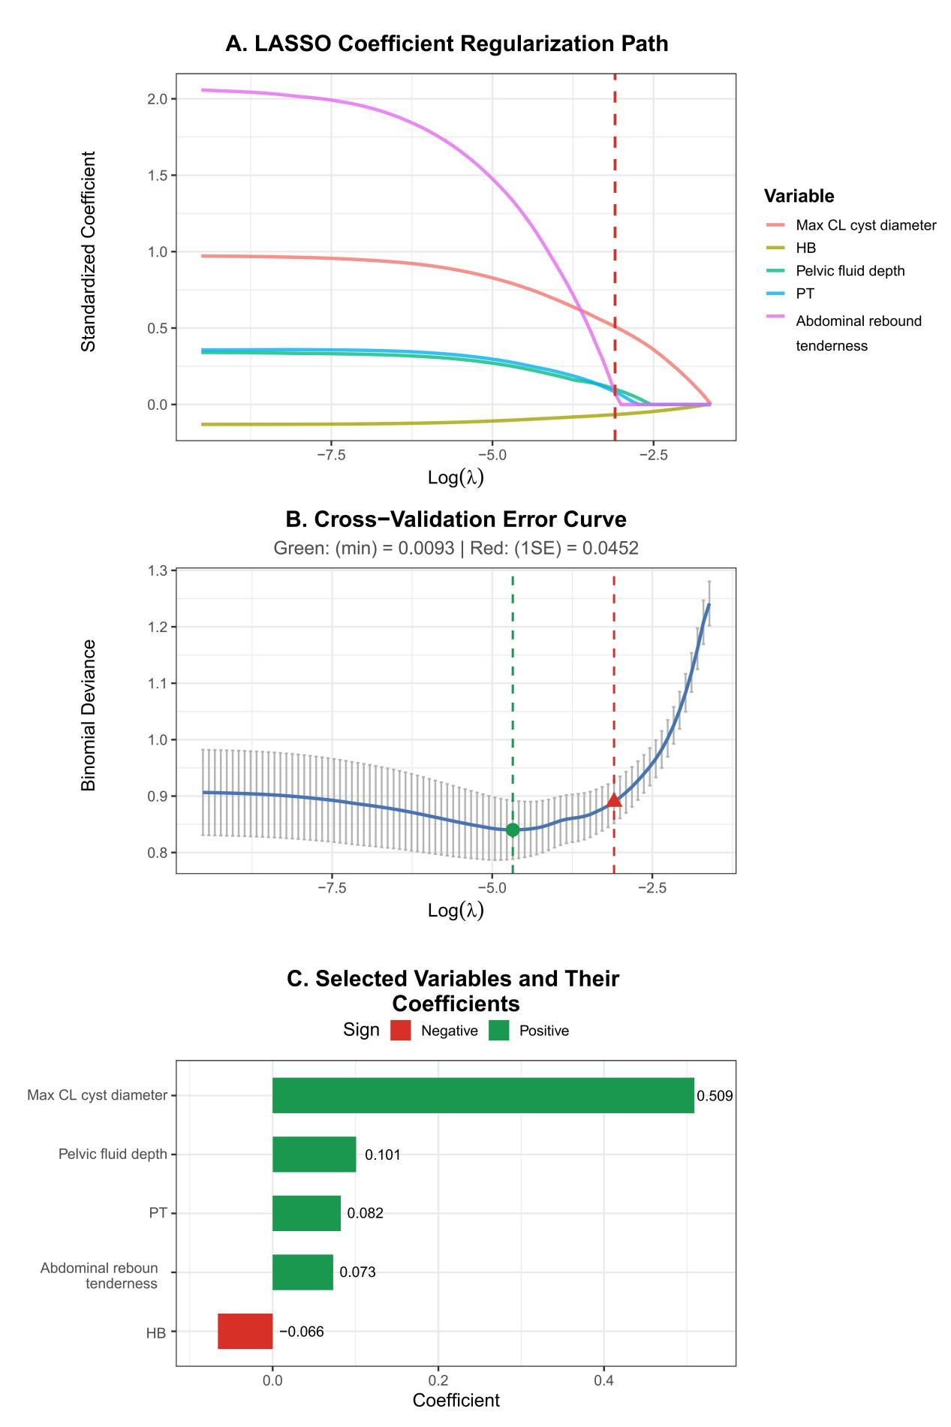
Supplementary Figure S1. LASSO regression analysis for variable selection.
Note: (A), showing coefficient paths; (B), cross-validation error curve; (C), retained variables with their coefficients at λ.1se.

