Supplementary Materials
Figure S1. Individual trajectories and distribution of Antral Follicle Count (AFC).
Violin plots overlaid with semi-transparent spaghetti lines illustrate the distribution and individual trajectories of AFC from baseline (V0) to Cycle 3 (V3). While strictly not statistically significant (p = 0.4315), a visible upward trend in the growing follicle pool was observed.
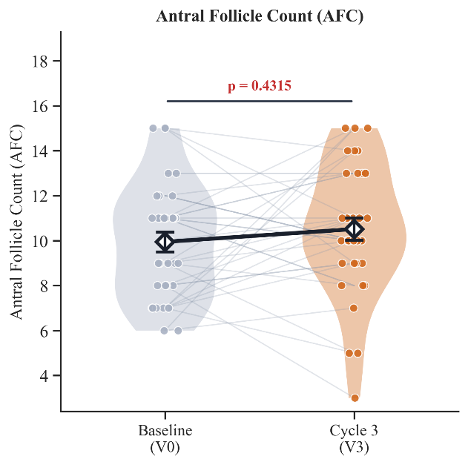

Table S1. Exploratory Secondary Endpoints (V0 vs. V3)
Data are presented as Mean ± SD. p-values were calculated using paired t-tests or Wilcoxon signed-rank tests depending on data normality.
Variable | Baseline (V0)  Mean ± SD | Cycle 3 (V3)  Mean ± SD | p value
Antral Follicle Count (AFC)  (count)(n=35) | 10.1 ± 2.6 | 10.8 ± 3.20 | 0.432
Luteinising Hormone (LH)  (mIU/mL) (n=36) | 5.87 ± 2.12 | 6.24 ± 2.87 | 0.963
Prolactin (PRL)  (mIU/L) (n=36) | 341.90 ± 183.82 | 394.91 ± 298.23 | 0.487
Testosterone (T)  (ng/mL) (n=36) | 0.24 ± 0.12 | 0.22 ± 0.11 | 0.144
Progesterone (P)  (ng/mL) (n=36) | 0.66 ± 2.5 | 1.63 ± 5.14 | 0.220

Table S2. Safety and Tolerability Profile
Data are presented as Mean ± SD. Routine hematological and biochemical markers showed no significant clinical alterations.
Variable | Baseline (V0)  Mean ± SD | Cycle 3 (V3)  Mean ± SD | p value
Liver Function
ALT (U/L) (n=36) | 16.83 ± 7.56 | 16.83 ± 6.54 | 0.886
AST (U/L) (n=36) | 19.67 ± 4.83 | 20.17 ± 4.56 | 0.635
Total Bilirubin  (μmol/L) (n=36) | 9.92 ± 3.87 | 9.99 ± 3.94 | 0.377
ALP (U/L) (n=36) | 64.19 ± 12.42 | 65.31 ± 13.28 | 0.760
GGT (U/L) (n=36) | 13.42 ± 8.21 | 13.83 ± 12.10 | 0.590
Renal Function
BUN (mmol/L) (n=36) | 4.57 ± 0.77 | 4.07 ± 0.89 | 0.014 *
Creatinine (μmol/L) (n=36) | 51.25 ± 6.23 | 49.06 ± 6.38 | 0.103
eGFR  (mL/min/1.73m²) (n=36) | 118.33 ± 3.70 | 119.44 ± 4.37 | 0.121
Haematology
WBC (×10⁹/L) (n=36) | 5.89 ± 1.37 | 5.95 ± 1.57 | 0.780
RBC (×10¹²/L) (n=36) | 4.30 ± 0.35 | 4.26 ± 0.30 | 0.337
Haemoglobin (g/L) (n=36) | 125.25 ± 11.64 | 125.28 ± 11.27 | 0.938
Platelets (×10⁹/L) (n=36) | 255.07 ± 58.80 | 249.17 ± 55.80 | 0.440

Figure.S2 Menstrual Status Questionnaire.
This instrument was designed to subjectively evaluate and grade five specific domains of menstrual characteristics: menstrual cycle regularity, menstrual duration, menstrual volume, dysmenorrhea (cycle pain), and cycle predictability. Each domain was scored on an ordinal scale (0, 3, or 5 points depending on the domain), and the five domain scores were summed to yield a total score ranging from 0 to 25, with higher scores indicating better menstrual health.
Menstrual Status Questionnaire
Participant ID: |  | Date of Record (Y/M/D):
Menstruation Onset Date (Y/M/D): |  | Menstruation End Date (Y/M/D):
Total Menstrual Duration (Days):
Domain | Scoring Criteria |  | Score
Cycle Regularity | Completely regular (21-35 days, fluctuation ≤ 2 days) → 5 points
Cycle Regularity | Mildly irregular (fluctuation 3-7 days) → 3 points
Cycle Regularity | Severely irregular (fluctuation > 7 days or amenorrhea) → 0 points
Menstrual Duration | 2-7 days → 5 points
Menstrual Duration | < 2 days or > 7 days → 2 points
Menstrual Volume | Light (< 5 sanitary pads/day) → 5 points
Menstrual Volume | Moderate (5-8 sanitary pads/day) → 3 points
Menstrual Volume | Heavy (> 8 sanitary pads/day or requiring overnight pads) → 0 points
Cycle Pain (Dysmenorrhea) | No pain → 5 points
Cycle Pain (Dysmenorrhea) | Occasional mild pain (does not affect daily life) → 3 points
Cycle Pain (Dysmenorrhea) | Persistent moderate-to-severe pain (requires medication for relief) → 0 points
Cycle Predictability | Accurately predictable (error ≤ 1 day) → 5 points
Cycle Predictability | Unpredictable → 0 points

