Appendix 1. Formative Focus Group Question Guide.

- What feelings come up when you think about physical activity?
  - Probe for: more negative or positive
  - If you were to begin a physical activity program or when you have begun one in the past, what would be/was your motivation?
    - Probe for: overall health, appearance, family
  - If you wanted to increase your physical activity level or begin a program, what would you do?
    - Probe for: reach out to a friend
  - What are your previous experiences with physical activity?
    - Probe for: past programs
  - Have there been any experiences with physical activity that you feel occurred because of your race?
    - Probe for: environment, access
  - Do you feel that there are additional concerns or considerations you have engaging in physical activity as a Black woman?
    - Probe for: family responsibilities
  - What are the biggest challenges you encounter when trying to increase your physical activity or stick to a physical activity program?
    - Probe for: time, financial resources, pain/discomfort
  - How have you overcome these challenges?
  - If someone close to you were to give you encouragement to be physically active, what would you want them to say?
  - During the program, all of the participants will be in a group chat to talk to each other, give each other support, and ask for advice. The research team is considering using WhatsApp as the chat function between participants (not between participants and researchers). Would WhatsApp be a form of communication that you are comfortable with?
    - Probe for: If no, what would you prefer?
  - We are also looking at time of day/days that would be best to hold weekly Zoom exercise/motivational session that will last an hour. We know that you are not going to be in the intervention, but we want to try to gather from you all when may be a good time to do this based on your schedule. What time of day and days of the week would be best for a one-hour Zoom session per week, if you were in the intervention?
  - If you have done a Zoom exercise class before, was the trainer playing music, giving motivational and technique cues, or a mix of both? What would you prefer?
Appendix 3. Sample workout for PAI group participants.
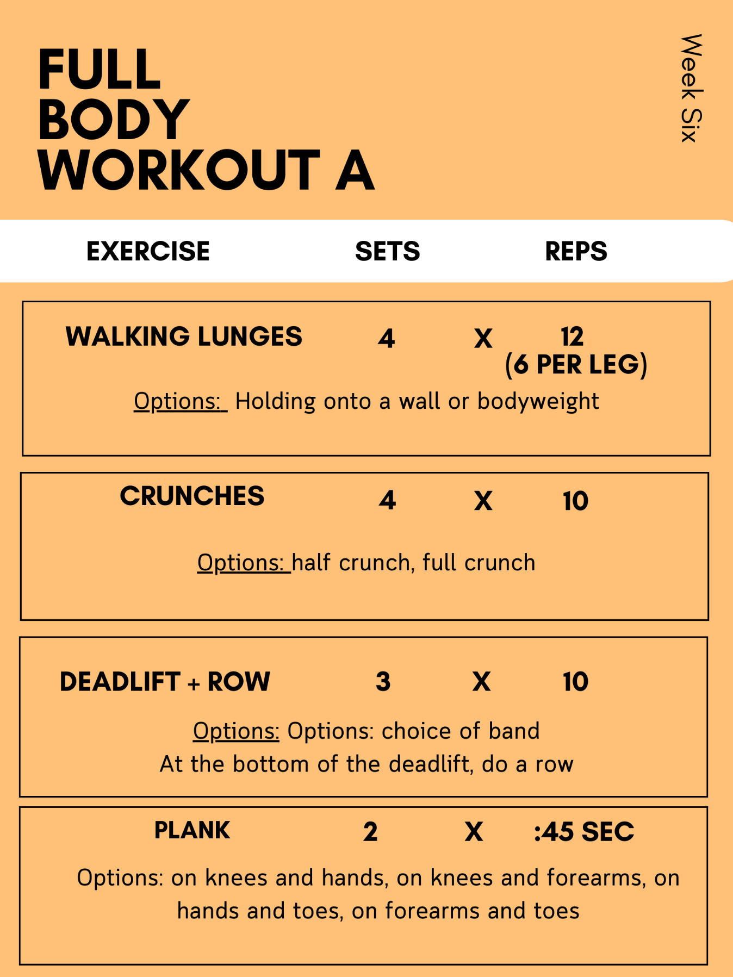

Appendix 2. Post-Intervention Focus Group Question Guide.

- What were your general reactions to the program overall?

- Which component of the intervention did you enjoy the most, and why?

  - Probe for: WhatsApp feature, weekly counseling, workouts, videos

- Which component of the intervention did you enjoy the least, and why?

  - Probe for: Same as question 2

- How could this program be improved in the future?

- What was the biggest change you noticed in yourself from before the intervention to the end?
  - Probe for: changes in perception of fitness, strength, connection with others

- Was there a type of topic that you would have liked to be covered in the group counseling sessions that wasn’t?
- How could you see yourself incorporating this program into your lives?

  - Probe for: workouts, motivational topics

