Supplementary Material
Immediate Histological Risk and One-Year Outcomes Following P16-Based Triage of HPV-Positive Women
Jiaxing He¹, Dongying Wang¹, Meiqi Fu¹, Yishi Wu¹, Shuying Wu¹, Fudi Sun¹, Yongxiang Wang¹, Ge Liu¹, and Tianmin Xu^{1*}
¹ Department of Gynaecology and Obstetrics, The Bethune Second Hospital of Jilin University, Changchun, Jilin, P.R. China.
* Correspondence:
Tianmin Xu: xutm@jlu.edu.cn
Supplementary Data
- Supplementary Tables

Supplementary Table 1. Baseline characteristics of women with and without histological confirmation.
Characteristics | Without histological confirmation, n (%) | With histological confirmation, n (%) | P value | Standardized difference
Total | 8,867 (100.0) | 2,396 (100.0) | - | -
Age <=45 years | 3,162 (35.66) | 1,180 (49.25) | <0.001 | 0.278
Age >45 years | 5,705 (64.34) | 1,216 (50.75) | <0.001 | 0.278
NILM cytology | 8,818 (99.45) | 793 (33.10) | <0.001 | 1.970
ASC-US+ cytology | 49 (0.55) | 1,603 (66.90) | <0.001 | 1.970
High-grade cytology (ASC-H+) | 20 (0.23) | 527 (21.99) | <0.001 | 0.738
HPV negative | 8,841 (99.71) | 877 (36.60) | <0.001 | 1.841
HPV16/18 positive | 9 (0.10) | 266 (11.10) | <0.001 | 0.493
Other hrHPV positive | 15 (0.17) | 1,216 (50.75) | <0.001 | 1.426
Multiple HPV infection | 2 (0.02) | 37 (1.54) | <0.001 | 0.173
P16 negative | 6,982 (78.74) | 1,082 (45.16) | <0.001 | 0.737
P16 positive | 1,885 (21.26) | 1,314 (54.84) | <0.001 | 0.737
Abbreviations: ASC-US, atypical squamous cells of undetermined significance; ASC-H, atypical squamous cells-cannot exclude high-grade squamous intraepithelial lesion; hrHPV, high-risk human papillomavirus; NILM, negative for intraepithelial lesion or malignancy. Note: Percentages were calculated within women with or without histological confirmation. P values compare the distribution of each characteristic between groups and are intended to describe referral enrichment and potential verification bias.
Supplementary Table 2. Distribution of HPV, cytology, and P16 results across histological categories.
Variables | Normal (n=887) | CIN1 (n=856) | CIN2 (n=294) | CIN3 (n=324) | Cancer (n=35) | P for trend
HPV positive | 244 (27.51%) | 651 (76.05%) | 275 (93.54%) | 316 (97.53%) | 33 (94.29%) | <0.001
HPV16/18 positive | 54 (6.09%) | 62 (7.24%) | 52(17.69%) | 79 (24.38%) | 19 (54.29%) | <0.001
Other hrHPV positive | 183 (20.63%) | 579 (67.64%) | 215(73.13%) | 227(70.06%) | 12 (34.29%) | <0.001
Multiple HPV infection | 7 (0.79%) | 10 (1.17%) | 8 (2.72%) | 10(3.09%) | 2 (5.71%) | <0.001
Cytology abnormal (≥ASC-US) | 371 (41.83%) | 632 (73.83%) | 262(89.12%) | 303(93.52%) | 35 (100.00%) | <0.001
High-grade cytology (ASC-H+) | 23 (2.59%) | 61 (7.13%) | 131 (44.56%) | 278(85.80%) | 34 (97.14%) | <0.001
P16 positive | 171(19.28%) | 546(63.79%) | 256(87.07%) | 306(94.44%) | 35 (100.00%) | <0.001
HPV16/18 positive and P16 positive | 11(1.24%) | 40(4.67%) | 45(15.31%) | 76(23.46%) | 19(54.29%) | <0.001
Other hrHPV positive and P16 positive | 69(7.78%) | 310(36.21%) | 185(62.93%) | 215(66.36%) | 12(34.29%) | <0.001
Cytology abnormal and P16 positive | 130(14.66%) | 485(56.66%) | 225(76.53%) | 285(87.96%) | 35(100.00%) | <0.001
Abbreviations: hrHPV, high-risk human papillomavirus; ASC-US, atypical squamous cells of undetermined significance, HSIL, high-grade squamous intraepithelial lesion, NA, not available from aggregated data. P for trend was calculated using the Cochran–Armitage trend test across ordered histological categories (Normal, CIN1, CIN2, CIN3, and cancer). Note: High-grade cytology (ASC-H+) was defined as ASC-H, HSIL, AGC, and cancer cytology.

Supplementary Table 3. Clinical performance of the same simulated triage strategies for detecting CIN2+ among women with available histological outcomes
Triage strategies | Sensitivity No./Total No. (%) (95% CI) | Specificity No./Total No. (%) (95% CI) | PPV No./Total No. (%) (95% CI) | NPV No./Total No. (%) (95% CI) | Referral | No. of CIN2+ detected | NNR
HPV16/18+ or ASC-US+ | 611/653 (93.57) [91.42–95.21] | 678/1743 (38.90) [36.64–41.21] | 611/1676 (36.46) [34.18–38.79] | 678/720 (94.17) [92.20–95.62] | 1676/2396 (69.95) | 611 | 2.74
HPV16/18+ or p16+ | 607/653 (92.96) [90.73–94.68] | 961/1743 (55.13) [52.79–57.46] | 607/1389 (43.70) [41.11–46.32] | 961/1007 (95.43) [93.96–96.56] | 1389/2396 (57.97) | 607 | 2.29
Other hrHPV+ & ASC-US+ | 419/653 (64.17) [60.41–67.75] | 1235/1743 (70.85) [68.68–72.94] | 419/927 (45.20) [42.02–48.42] | 1235/1469 (84.07) [82.14–85.85] | 927/2396 (38.69) | 419 | 2.21
Other hrHPV+ & p16+ | 412/653 (63.09) [59.33–66.71] | 1364/1743 (78.26) [76.26–80.13] | 412/791 (52.09) [48.60–55.55] | 1364/1605 (84.98) [83.15–86.65] | 791/2396 (33.01) | 412 | 1.92
ASC-US+ & p16+ | 545/653 (83.46) [80.42–86.11] | 1128/1743 (64.72) [62.44–66.92] | 545/1160 (46.98) [44.13–49.86] | 1128/1236 (91.26) [89.56–92.71] | 1160/2396 (48.41) | 545 | 2.13
ASC-H+ or p16+ | 631/653 (96.63) [94.95–97.76] | 989/1743 (56.74) [54.40–59.05] | 631/1385 (45.56) [42.95–48.19] | 989/1011 (97.82) [96.73–98.56] | 1385/2396 (57.80) | 631 | 2.19
Other hrHPV+ & ASC-US+ & p16+ | 388/653 (59.42) [55.61–63.12] | 1448/1743 (83.08) [81.24–84.76] | 388/683 (56.81) [53.07–60.47] | 1448/1713 (84.53) [82.74–86.17] | 683/2396 (28.51) | 388 | 1.76
Abbreviations: PPV, positive predictive value; NPV, negative predictive value; NNR, number needed to refer; hrHPV, high-risk human papillomavirus; ASC-US, atypical squamous cells of undetermined significance; ASC-H, atypical squamous cells-cannot exclude high-grade squamous intraepithelial lesion. Note: This table includes the absolute sensitivity and specificity for CIN2+ detection, with 95% confidence intervals, the computed PPV and NPV, referral positivity, the number of CIN2+ cases detected, and the NNR (number needed to refer to colposcopy to find 1 case of CIN2+).
Supplementary Table 4. Risk stratification and triage performance of P16 and HPV16/18 genotyping among HPV-positive women with NILM cytology.
Strategy | No. of  women | Referral rate, % | No. of  CIN2+ | CIN2+ risk, %  (95% CI) | No. of  CIN3+ | CIN3+ risk, %  (95% CI) | Sensitivity for CIN3+, %  (95% CI) | Specificity for CIN3+, %  (95% CI)
P16 positive | 140 | 37.43 | 34 | 24.29  (17.93–32.01) | 12 | 8.57  (4.97-14.38) | 63.16  (41.04-80.85) | 63.94  (58.82–68.76)
HPV16/18 positive | 73 | 19.52 | 11 | 15.07  (8.63–25.00) | 7 | 9.59  (4.72-18.50) | 36.84  (19.15-58.96) | 81.41  (77.03–85.11)
HPV16/18 positive or P16 positive | 184 | 49.20 | 36 | 19.57  (14.48–25.89) | 13 | 7.07  (4.18–11.71) | 68.42  (46.01-84.64) | 51.83  (46.64–56.98)
HPV16/18 positive and P16 positive | 29 | 7.75 | 9 | 31.03  (17.28–49.23) | 6 | 20.69  (9.85–38.39) | 31.58  (15.36-53.99) | 93.52  (90.47–95.64)
Other hrHPV positive and P16 positive | 108 | 28.88 | 24 | 22.22  (15.41–30.94) | 6 | 5.56  (2.57–11.59) | 31.58  (15.36-53.99) | 71.27  (66.35–75.73)
Note: This subgroup analysis was restricted to HPV-positive women with NILM cytology. For each triage strategy, women meeting the specified criterion were considered referred to colposcopy. CIN2+ and CIN3+ risks were calculated within each strategy-defined subgroup. Sensitivity and specificity were calculated using CIN3+ as the clinical endpoint. HPV-positive women included those with multiple HPV infections, whereas genotype-specific strata were restricted to mutually exclusive HPV16/18-positive only and other hrHPV-positive only groups; therefore, genotype-specific strata do not necessarily sum to the total HPV-positive population.

Supplementary Table 5. Logistic regression analysis of baseline predictors for one-year composite high-risk outcomes.
Variable | No. of women | Composite high-risk outcome, n (%) | Univariate OR (95% CI) | P value
Age >45 years | 328 | 57 (17.4%) | 2.62 (1.66–4.13) | <0.001
HPV16/18 positivity | 98 | 22 (22.4%) | 2.58 (1.51–4.41) | 0.001
Cytology ≥ASC-US | 544 | 77 (14.2%) | 2.73 (1.48–5.02) | <0.001
P16 positivity | 412 | 79 (19.2%) | 7.53 (3.94–14.39) | <0.001
Baseline CIN1 | 528 | 84 (15.9%) | 7.51 (3.24–17.41) | <0.001
Note: The analysis was restricted to baseline HPV-positive women with valid cytology and P16 results, baseline histology <CIN2, and eligible 1-year follow-up data. The composite high-risk outcome was defined as any of the following at 1 year: persistent HPV positivity with ASC-US+ cytology, P16 positivity, or histologically confirmed CIN2+/CIN3+ if available. Univariate ORs were calculated using logistic regression. Reference groups were age ≤45 years, HPV16/18 negative or other hrHPV, NILM cytology, P16 negativity, and baseline normal histology. OR, odds ratio; CI, confidence interval.

Supplementary Table 6. Multivariable bias-reduced logistic regression for one-year CIN2+ detection.
Predictor | Adjusted OR | 95% CI | P value
Baseline p16 positive | 9.53 | 3.80-23.95 | <0.001
Age >45 years | 2.52 | 0.97-6.55 | 0.057
HPV16/18 positive | 5.53 | 1.72-17.79 | 0.004
Baseline ASC-US+ cytology | 19.17 | 5.53-66.49 | <0.001
Baseline CIN1 histology | 81.00 | 4.50-1458.30 | 0.003
Note: The one-year follow-up cohort was restricted to baseline HPV-positive women with valid baseline cytology and p16 results, baseline histology <CIN2, and eligible one-year follow-up data. The outcome variable was histologically confirmed CIN2+ detected during one-year follow-up. Adjusted odds ratios (ORs), 95% confidence intervals (CIs), and P values were estimated using Firth’s bias-reduced logistic regression because of the limited number of one-year CIN2+ events

- Supplementary Figures
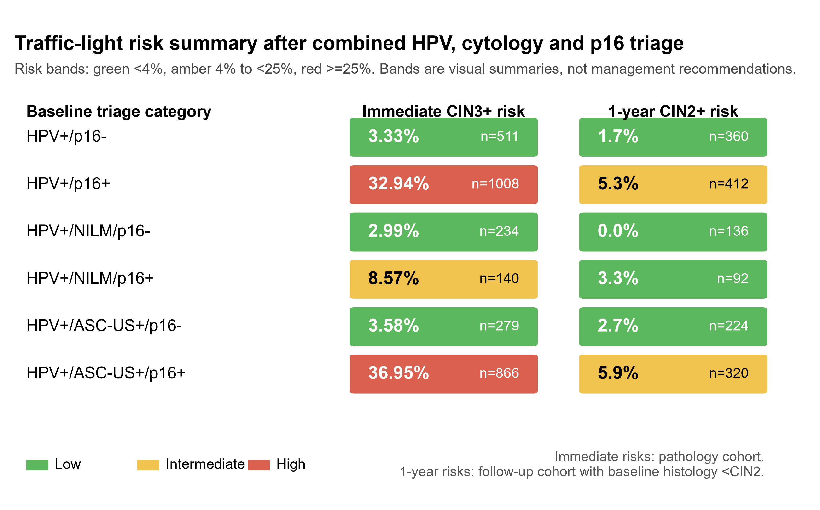
Supplementary Figure 1. Traffic-light risk summary of immediate and one-year risks after combined HPV, cytology and p16 triage. Green indicates risk <4%, amber indicates risk 4% to <25%, and red indicates risk >=25%. Immediate risks were calculated for CIN3+ in the pathology-confirmed cohort, whereas one-year risks were calculated for histologically confirmed CIN2+ in the follow-up cohort with baseline histology <CIN2.

