Additional file 1

- Table S1. 17-Item Hamilton Scale for Depression: Differences between Baseline and T1 (after 4 Interventions) in the Hyperthermic Bath Group compared to the Placebo Group, N = 30).

- Table S2. 17-Item Hamilton Scale for Depression: Differences between Baseline and T2 (4 weeks after treatment) in the Hyperthermic Bath Group compared to the Placebo Group, N = 28).

- Table S3. Summary of Adverse Events

- Figure S1. Effects of Hyperthermic Baths (HTB) and Green Light (Placebo) in Depressed Patients.

- Figure S2. Effects of Hyperthermic Baths (HTB) and Green Light (Placebo) in Depressed Patients. 17-Hamilton Scale for Depression Subscales.

Table S1. 17-Item Hamilton Scale for Depression: Differences between Baseline and T1 (after 4 Interventions) in the Hyperthermic Bath Group compared to the Placebo Group, N = 30).

 |  |  | HTB  Group  N = 14 | Placebo  Group  N = 16 | P§ | Cohen  d^{b}
 |  | ¹HAM-D_{total score}ª | 5.29 ± 6.62 | 1.44 ± 4.02 | 0.031* | 0.72  [-0.03-1.46]
 | ²HAM-D_{insomnia}ª |  | 1.14 ± 1.88 | 0.19 ± 1.11 | 0.048* | 0.63  [-0.11-1.36]
 | ²HAM-D_{mood}ª |  | 2.86 ± 3.37 | 1.00 ± 2.37 | 0.045* | 0.65  [-0.09-1.38]
 | ²HAM-D_{somatic}ª |  | 0.71 ± 1.07 | 0.25 ± 1.53 | 0.175 | 0.34  [-0.38-1.07]

Abbreviations: HTB, hyperthermic baths; HAM-D, Hamilton Scale for Depression.
ªIndicates differences between HTB and placebo in the change from T0 to T1 to each patient’s own end point for the change in depression rating.
^{b}Computed as the difference between the means, M2 − M1, divided by the pooled standard deviation, sigma (σ_{pooled}) of both groups. Data are shown as mean and standard deviation (SD).
§1-tailed t test.
¹Primary outcome.
²Secondary outcome.
*P < .05.

Table S2. 17-Item Hamilton Scale for Depression: Differences between Baseline and T2 (4 weeks after treatment) in the Hyperthermic Bath Group compared to the Placebo Group, N = 28*).

 |  |  |  |  |  | HTB  Group  N = 13 |  | Placebo  Group  N = 15 |  | P§ |  | Cohen  d^{b}
 |  |  |  | ¹HAM-D_{total score}ª |  | 6.38 ± 7.74 |  | 4.13 ± 6,105 |  | 0.199 |  | 0.33  [-0.42-1.07]
 |  |  | ²HAM-D_{insomnia}ª |  |  | 1.15 ± 1.91 |  | 0.80 ± 1.97 |  | 0.317 |  | 0.18  [-0.56-0.92]
 |  |  | ²HAM-D_{mood}ª |  |  | 3.62 ± 4.05 |  | 2.00 ± 2.65 |  | 0.109 |  | 0.48  [-0.27-1.23]
 |  | ²HAM-D_{somatic}ª |  |  | 0.92 ± 1.50 |  | 0.80 ± 1.42 |  | 0.413 |  | 0.08  [-0.66-0.83]

Abbreviations: HTB, hyperthermic baths; HAM-D, Hamilton Scale for Depression.
ªIndicates differences between HTB and placebo in the change from T0 to T2 to each patient’s own end point for the change in depression rating.
^{b}Computed as the difference between the means, M1 − M2, divided by the pooled standard deviation, sigma (σ_{pooled}) of both groups.
Data are shown as mean ± standard deviation (SD).
§1-tailed t test.
¹Primary outcome.
²Secondary outcome.
* missing data from 2 participants
Table S3. Summary of Adverse Events

 | No. (%)
Adverse Events | HTB Group  (n = 14) | Placebo Group  (n = 16)
No adverse events | 2 (14) | 7 (44)
Minor adverse events | 10 (71) | 8 (50)
Moderate adverse events | 2 (14) | 1 (6)
Severe adverse events | 0 (0) | 0 (0)
Adverse events total | 12 (86) | 9 (56)

Figure S1. Effects of Hyperthermic Baths (HTB) and Green Light (Placebo) in Depressed Patients.

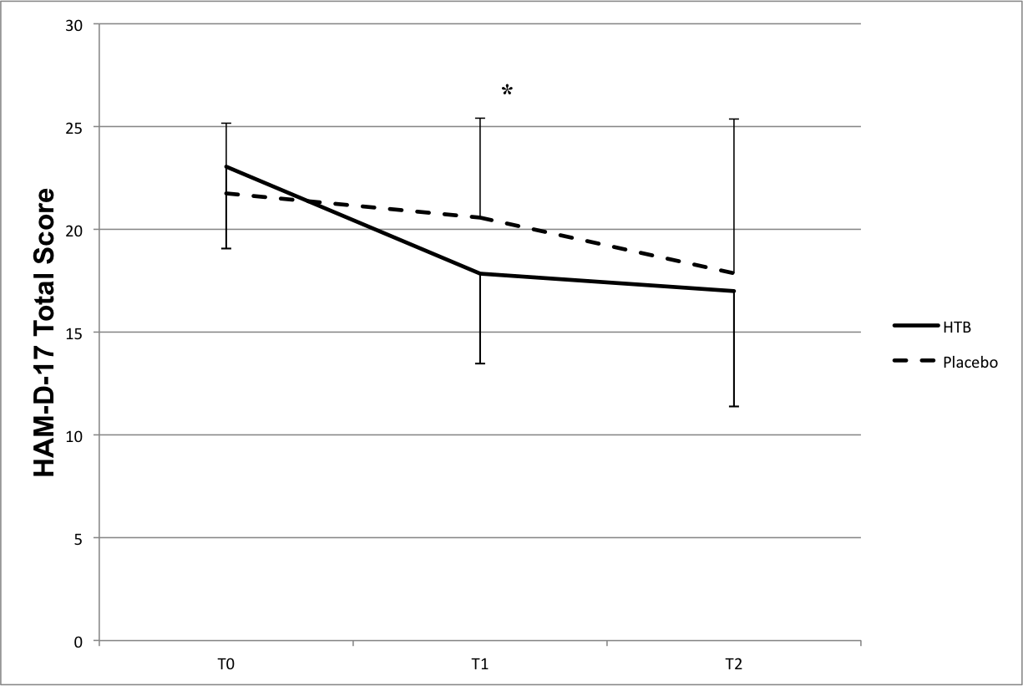

Data are depicted as means; error bars show the standard deviation.
Measures include the 17-Hamilton Scale for Depression total scores.
T0 N=36 (n=17 HTB group, n=19 placebo group).
T1 indicates after 2 weeks of treatment (4 HTB), N=30 (n=14 HTB group, n=16 placebo group).
T2 indicates 4 weeks after discontinuation of treatment, N=28 (n=13 HTB group, n=15 placebo group).
*P = .031.
Figure S2. Effects of Hyperthermic Baths (HTB) and Green Light (Placebo)
in Depressed Patients. 17-Hamilton Scale for Depression Subscales.

T0 T1 T2
*
*P = .045*
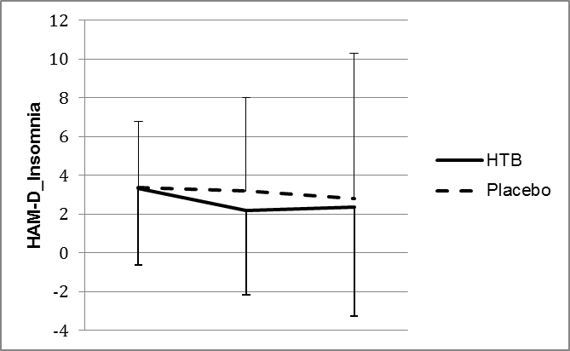
*P = .048*
*
T0 T1 T2
*
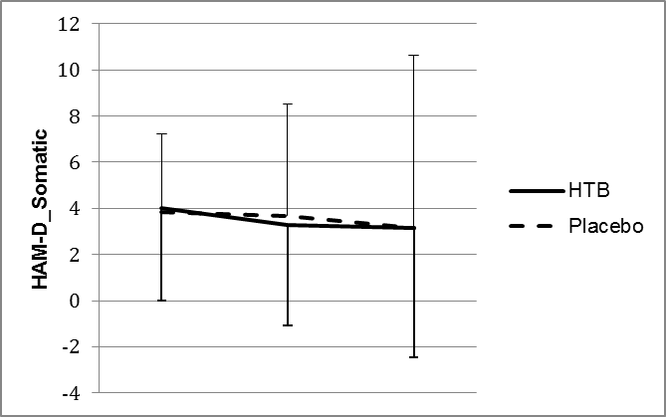
Data are depicted as means; error bars show the standard deviation.
T0 N=36 (n=17 HTB group, n=19 placebo group).
T1 indicates after 2 weeks of treatment (4 HTB), N=30 (n=14 HTB group, n=16 placebo group).
T2 indicates 4 weeks after discontinuation of treatment, N=28 (n=13 HTB group, n=15 placebo group).

T0 T1 T2

