ADDITIONAL FILES
Supplementary Methods
TrueNorth Health Center water-only fasting protocol
Pre-fast
Preparation (at least 2 days prior)
- Eliminate all recreational drugs (i.e., coffee, alcohol, nicotine, etc.).
- Eliminate grains, legumes, dairy, meat, sugar, oils, salt and all processed foods.
- Consume only raw fruits and vegetables and steamed vegetables.
Examinations
- Detailed patient history
- Comprehensive physical exam, including height, weight, temperature, blood pressure, pulse
- Basic neurological and psychological status
- Complete blood count (CBC) with differential
- Comprehensive metabolic panel (CMP)
- Urine analysis (UA)
- Additional tests as clinically indicated
Medications and Supplements
- Taper off and discontinue all medications that can be safely discontinued.
- Replacement medications (i.e., thyroid medications) can be continued at reduced dosage.
- Taper off and discontinue all supplements.
- If medications cannot be discontinued modified fasting is indicated.

Fast
Therapy
- Steam-distilled water (min. 40 ounces/day)
- Limit excessive physical activity.
- Rest and relaxation
- Termination: condition resolves; patient requests; or medically necessary
Examinations
- Symptom inquiry (2X/day)
- Blood pressure and temperature and pulse (2X/day)
- CBC, CMP, UA (1X/week)
- Additional tests as clinically indicated (as needed)
Treatments & Education Options
- Medical
- Psychological
- Chiropractic
- Naturopathic
- Massage and body work
- Acupuncture
- Meditation
- Gentle yoga
- Daily lectures
- Cooking demonstrations
- Educational DVDs
Post-fast
Standard Refeeding*
- Duration is half of the fast length.
- Chew food thoroughly.
- 1 day on each phase for every 7-10 days of water-only fasting
Phase 1: Fruit and vegetable juice (4X/day)
Phase 2: Raw fruits (except citrus) and raw juicy vegetables (3X/day)
Phase 3: Raw fruits and vegetables, steamed vegetables (3X/day)
Phase 4: Raw fruits and vegetables, steamed vegetables, grains, soups, and nuts (up to 1 oz/day) or avocado (half/day) (3X/day)
Phase 5: Unrestricted plant food diet free of added sugar, oil, and salt (3X/day)
* Sensitive refeeding plans optional
Examinations
- Twice daily check-ins with clinical staff
- Exit appointment with clinician
Miscellaneous
- Bowel movements begin gradually over course of refeeding; guidance provided.
- Increase physical activity slowly.

Relative Contraindications
- Cachexia
- Anorexia
- Severe liver or kidney disease
- Advanced cerebral vascular insufficiency
- Certain cancers
- Medium-chain acyl CoA dehydrogenase deficiency
- Certain psychological disorders
- Pregnancy or nursing
- Porphyria
- Higher-grade cardiac arrhythmias
- Active gastric ulcer disease
Serious Complications
- Severe electrolyte imbalance
Minor Reactions
- Mild hypoglycemia
- Electrolyte disturbances
- Headache
- Acute back pain
- Nausea
- Vomiting
- Muscle cramps
- Insomnia
- Orthostatic hypotension
- Stomach and reflux symptoms

SUPPLEMENTARY TABLE

Table S1. Total AEs grouped by System Organ Class.
 |  |  | AE Grade
MedDRA term | Total n (%) |  | 1 | 2 | 3 | 4 | 5
Cardiac disorders
Palpitations | 94 (1.6) |  | 92 | 2 | - | - | -
Ventricular arrhythmia | 2 (0) |  | 2 | 0 | 0 | 0 | 0
Gastrointestinal disorders
Nausea | 328 (5.5) |  | 284 | 44 | 0 | - | -
Dyspepsia | 252 (4.2) |  | 242 | 10 | 0 | - | -
Abdominal pain | 158 (2.7) |  | 136 | 12 | 10 | - | -
Diarrhea | 146 (2.4) |  | 122 | 16 | 8 | 0 | 0
Vomiting | 123 (2.1) |  | 101 | 17 | 5 | 0 | 0
Flatulence | 85 (1.4) |  | 83 | 2 | - | - | -
Gastrointestinal pain | 68 (1.1) |  | 57 | 9 | 2 | - | -
Constipation | 54 (0.9) |  | 42 | 8 | 4 | 0 | 0
Bloating | 47 (0.8) |  | 47 | 0 | 0 | - | -
General disorders and administration site conditions
Fatigue | 550 (9.2) |  | 305 | 230 | 15 | - | -
Pain | 77 (1.3) |  | 61 | 13 | 3 | - | -
Malaise | 31 (0.5) |  | 24 | 7 | - | - | -
Metabolism and nutrition disorders
Dehydration | 9 (0.2) |  | 7 | 1 | 1 | 0 | 0
Hyponatremia | 5 (0.1) |  | 1 | - | 2 | 2 | 0
Musculoskeletal and connective tissue disorders
Back pain | 273 (4.6) |  | 218 | 35 | 20 | - | -
Pain in extremity | 161 (2.7) |  | 131 | 17 | 13 | - | -
Arthralgia | 131 (2.2) |  | 104 | 16 | 11 | - | -
Buttock pain | 75 (1.3) |  | 67 | 5 | 3 | - | -
Neck pain | 69 (1.2) |  | 59 | 7 | 3 | - | -
Chest wall pain | 50 (0.8) |  | 46 | 2 | 2 | - | -
Nervous system disorders
Headache | 327 (5.5) |  | 235 | 60 | 32 | - | -
Presyncope | 253 (4.2) |  | - | 253 | - | - | -
Dizziness | 51 (0.9) |  | 44 | 4 | 3 | 0 | 0
Syncope | 12 (0.2) |  | - | - | 12 | - | -
Other
Other | 1356 (22.7) |  | 1235 | 104 | 17 | 0 | 0
Psychiatric disorders
Insomnia | 358 (6) |  | 252 | 66 | 40 | - | -
Renal and urinary disorders
Hematuria | 43 (0.7) |  | 41 | 2 | 0 | 0 | 0
Renal calculi | 1 (0) |  | 0 | 1 | 0 | 0 | 0
Respiratory, thoracic and mediastinal disorders
Sore throat | 75 (1.3) |  | 74 | 1 | 0 | - | -
Postnasal drip | 48 (0.8) |  | 45 | 3 | - | - | -
Skin and subcutaneous tissue disorders
Rash acneiform | 78 (1.3) |  | 73 | 5 | 0 | 0 | 0
Rash maculo-papular | 10 (0.2) |  | 8 | 2 | 0 | - | -
Vascular disorders
Hypertension | 561 (9.4) |  | 252 | 214 | 95 | 0 | 0
Total
Total | 5961 |  | 4490 | 1168 | 301 | 2 | 0
Includes MedDRA terms that were experienced in greater than 5% of the visits. A single dash (-) indicates CTCAE grade is not available.

SUPPLEMENTARY FIGURE
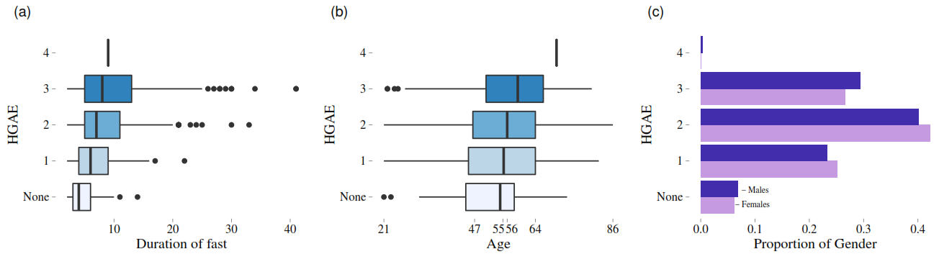
Figure S1. Highest grade adverse event (HGAE) during each visit by gender and age. Box plots (boxes show interquartile range and median, whiskers show 10th and 90th centiles, and circles are outliers) of HGAE and fast duration (a) and age (b). Spearman’s coefficient (ρ = 0.28) and paired t-test (p = <0.001) indicate that fast duration is positively correlated with HGAE. Spearman’s coefficient (ρ = 0.11) and paired t-test (p = 0.002) indicate that age is positively correlated with HGAE. Bar graph of the proportion of males and females with HGAE (c). There was no difference between genders for HGAE (p = 0.628 by Fisher’s exact test).

