Additional file 4: Effects of bioactive compounds from DS on restoring cell viability against Hcy-Ado-TNF in EA.hy926 cells determined by MTT assay.

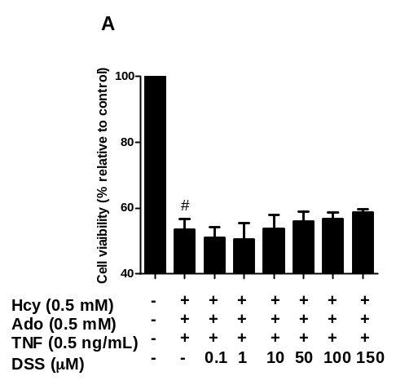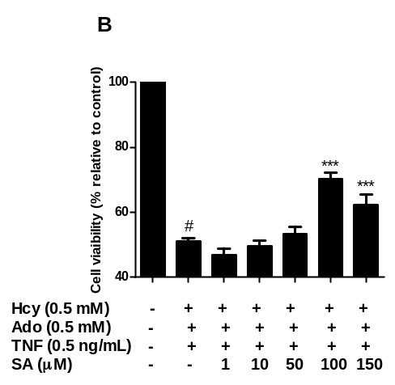
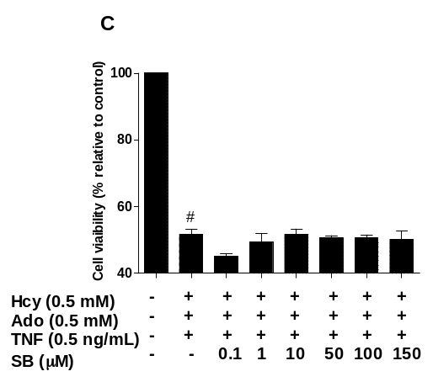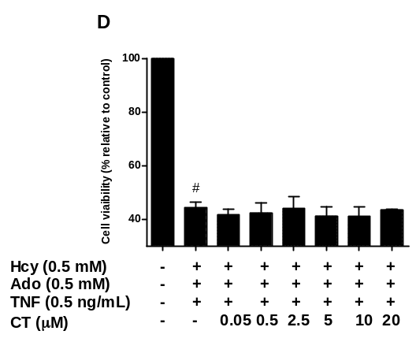
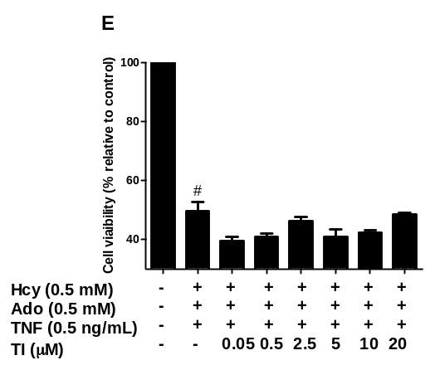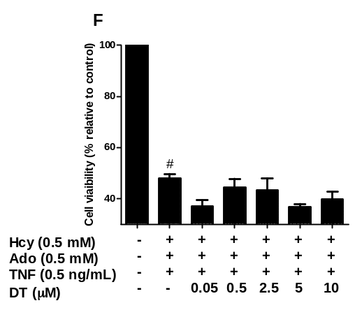
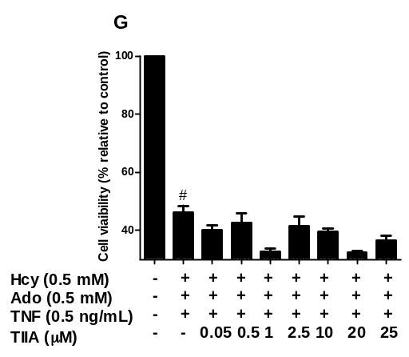

Effects of bioactive compounds from DS on restoring cell viability against Hcy-Ado-TNF in EAhy 926 cells determined by MTT assay. Cell viability, as determined by MTT for DSS (A), SA (B), SB (C), CT (D), T1 (E), DT (F) and TIIA (G) following treatments with Hcy-Ado-TNF in EAhy 926 cells. Cell viability was expressed as a percentage compared to control. ‘Stim’ here represents Hcy-Ado-TNF stimulation group. All results were expressed as mean ± S.E.M. from three separate experiments in triplicate. * P< 0.05, ** P<0.01, *** P < 0.001 in comparison with other combinations in the respective cell lines.

