Supplementary material
Additional file 1: Table S1. Plants used in study with their parts, family with accession numbers.

Plant (Botanical name) | Family | Collection  Site | Common name | Part used | Accession no.
Cornus capitata Wall. | Cornaceae | Mandi,  Himachal Pradesh, India. | Himalayan strawberry, Evergreen dogwood | Leaves | 7373
Clematis grata Wall. | Ranunculaceae | Palampur,  Himachal Pradesh, India. | Charming clematis  (Dnanwali, Garol) | Whole plant | 7374
Roylea cinerea (D.Don) Baill. | Lamiaceae | Palampur,  Himachal Pradesh, India. | Ashy roylea  (Titpatti, Pitkarui) | Stem, Leaves | 7376

Additional file 1: Table S2. Chemical structures of Reported chemical constituuents from Cornus capitata prepared via Chemsketch for Docking a) Arjunolic acid b) Betulin c) Betulinic acid d) Epibetulin e) Lupeol f) Maslinic acid.
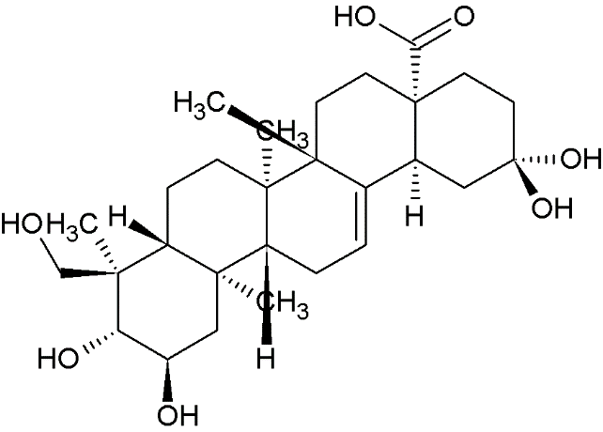  a) | 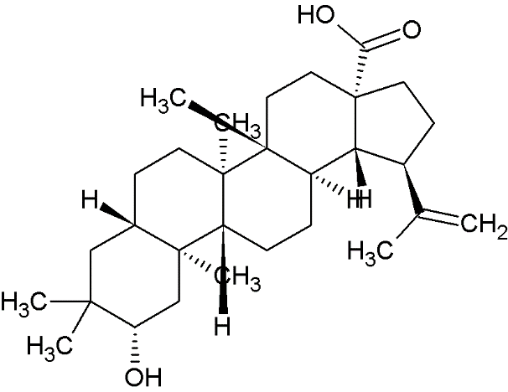  b) | 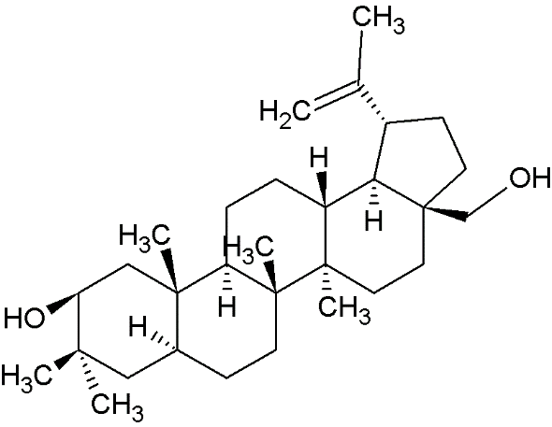  c)
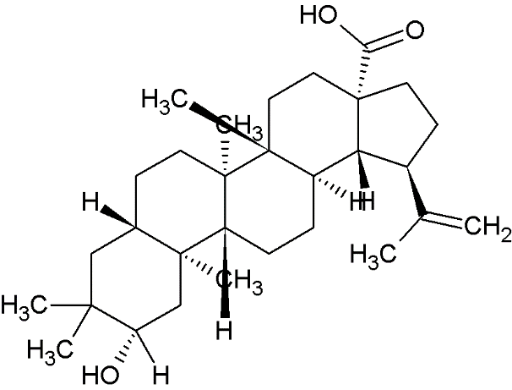  d) | 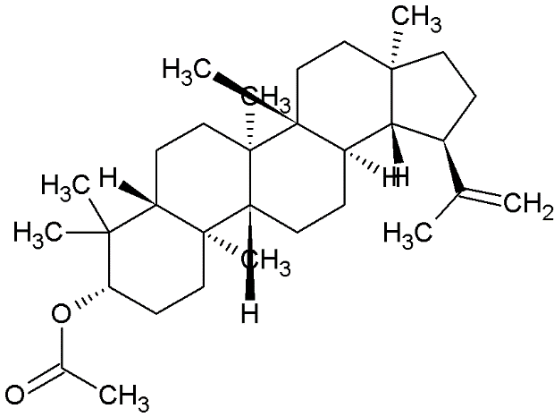  e) | 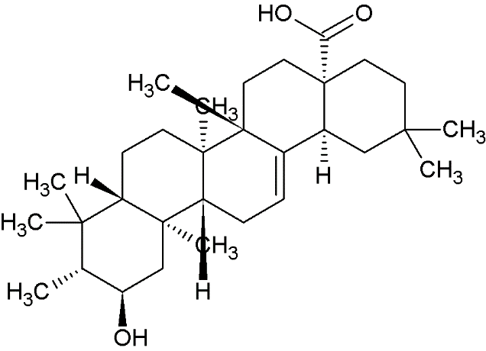  f)

