Table S1. Diagnosis codes used in the study
Disease Name | ICD-9-CM codes
Type 2 diabetes mellitus | 250.x, except 250.x1 and 250.x3
Chronic kidney disease | 580.x-588.x, 250.4x, 274.1x, 283.11, 403.x1, 404.x2, 404.x3, 440.1, 442.1, 447.3, 572.4, 642.1x, 646.2x and 791.0
End-stage renal disease (permanent dialysis) | 39.95, v45.1, v56.0, and v56.8, catastrophic illness code “03”
Ischemic heart disease | 410, 411, 412
Heart failure | 401.91, 402.01, 402.11, 404.01, 404.03, 404.11, 404.91, 404.93, and 428
Hypertension | 401-405
Hyperlipidemia | 272
Hyperuricemia | 274
Cerebrovascular disease | 430-438
Chronic Obstructive Pulmonary Disease | 491, 492, and 496
Abbreviation: ICD-9-CM, International Classification of Disease, 9th Revision, Clinical Modification

Table S2. Medications codes used in this study
Medicine Name | ATC codes
Angiotensin converting enzyme inhibitor (ACEi) | C09C, C09D
Angiotensin II Receptor Blockers (ARB) | C09A, C09B
Direct renin inhibitors (DRI) | C09XA
α-blocker | C02CA
β-blockers | C07
Calcium channel blockers (CCB) | C08C, C08D
Central-acting agents | C02
Vasodilators | C04
Diuretics | C03
Insulin | A10A
α-glucosidase inhibitor | A10BF
Biguanides | A10BA
Sulfonylureas (SU) | A10BB
Dipeptidyl peptidase-4 inhibitor (DPP4i) | A10BH
Glucagon-like peptide-1 | A10BX07, A10BX14, A10BJ02, A10BX04, A10BJ01
Thiazolidinedione (TZD) | A10BG
Other hypoglycemic agents | A10BD, A10BX
Statin | C10AA, C10B
Fibrate | C10AB
Other lowering lipid agents | C10AC, C10AD, C10AX
Acetaminophen | R05X, N02BE51, M03BC51, N02BE01, M03BB53, M03BB52, N02BE71, N02BA57
Nonsteroidal anti-inflammatory drug (NSAID) | M01AA, M01AB, M01AC, M01AE, M01AG, M01AX
Selective COX-2 inhibitors | M01AH
Aspirin | J05AX, N02BA01, B01AC06, M01BA03, N02BA51, B01AC04, B01AC30, R05X
Erythropoietin (EPO) | B03XA01, B03XA02, B03XA03

Table S3. The CKD stage and albuminuria of DN patients when diagnosed in the Department of Nephrology, Chang Gung Memorial Hospital, Taiwan, from 2004 to 2012. (n = 5384 with 136 normoalbuminuria patients)
Description of data: Validation of the study protocol to identify patients with DN by applying the same protocol to the hospital-based database.
 |  |  | Albuminuria (mg/g)$
CKD stage* | Subjects | Percentage | mean | ±SD
1 | 31 | 0.58 | 1,442.72 | ±4,123.09
2 | 649 | 12.05 | 665.91 | ±1,436.48
3a | 676 | 12.56 | 1,141.13 | ±2,176.83
3b | 1,151 | 21.38 | 1,414.36 | ±2,265.08
4 | 1,505 | 27.95 | 2,963.59 | ±5,802.20
5 | 1,236 | 22.96 | 3,746.97 | ±2,724.54
*CKD stage was classified by estimated glomerular filtration rate calculated according to the modification of diet in renal disease equation
$Albuminuria was calculated by urine albuminuria-creatinine ratio, < 30 mg/g regarded as normoalbuminuria

Table S4. Demographic and medical history of patients with incident diabetic nephropathy during 2004–2006 (N = 107,294)
 |  |  | TCM users  (n= 65,812) |  | TCM nonusers  (n= 41,482) |  | p-value
Gender |  |  |  |  |  |  | <0.001
 |  | Female | 33,524 | (50.9%) | 17,985 | (43.4%)
 |  | Male | 32,288 | (49.1%) | 23,497 | (56.6%)
Age (years) |  |  |  |  |  |  | <0.001
 |  | -20 | 151 | (0.2%) | 56 | (0.1%)
 |  | 21-40 | 3,192 | (4.9%) | 1,189 | (2.9%)
 |  | 41-60 | 26,298 | (40.0%) | 11,502 | (27.7%)
 |  | 61- | 36,171 | (55.0%) | 28,735 | (69.3%)
Insured level (NTD/month) |  |  |  |  |  |  | <0.001
 |  | 0-20,000 | 50,681 | (77.0%) | 35,014 | (84.4%)
 |  | 20,001-40,000 | 9,613 | (14.6%) | 3,822 | (9.2%)
 |  | 40,001- | 5,518 | (8.4%) | 2,646 | (6.4%)
Geolocation |  |  |  |  |  |  | <0.001
 |  | 1 (more urban) | 15,317 | (26.0%) | 9,339 | (24.8%)
 |  | 2 | 17,262 | (29.2%) | 10,350 | (27.5%)
 |  | 3 | 9,615 | (16.3%) | 5,690 | (15.1%)
 |  | 4 | 9,890 | (16.8%) | 6,711 | (17.8%)
 |  | 5 | 1,342 | (2.3%) | 1,246 | (3.3%)
 |  | 6 | 3,001 | (5.1%) | 2,300 | (6.1%)
 |  | 7 (more rural) | 2,596 | (4.4%) | 1,968 | (5.2%)
Previous TCM users |  |  | 12,395 | (18.8%) | 3,293 | (7.9%) | <0.001
Co-morbidities
 | Hypertension |  | 37,534 | (57.0%) | 26,528 | (64.0%) | <0.001
 | Hyperlipidemia |  | 22,777 | (34.6%) | 12,710 | (30.6%) | <0.001
 | Heart failure |  | 2,911 | (4.4%) | 2,754 | (6.6%) | <0.001
 | IHD |  | 12,086 | (18.4%) | 8,273 | (19.9%) | <0.001
 | CVD |  | 4,225 | (6.4%) | 4,311 | (10.4%) | <0.001
 | Hyperuricemia |  | 7,084 | (10.8%) | 4,930 | (11.9%) | <0.001
 | COPD |  | 7,971 | (12.1%) | 5,047 | (12.2%) | 0.79
 | Charlson’s mortality index |  | 3.6 | (2.0) | 4.1 | (2.0) | <0.001
 | Modified DCSI score |  | 1.3 | (1.2) | 1.5 | (1.3) | <0.001
Confounding drugs
 | Diabetic drugs
 | Insulin analogs |  | 5,679 | (8.6%) | 4,577 | (11.0%) | <0.001
 | Biguanides |  | 35,258 | (53.6%) | 23,037 | (55.5%) | <0.001
 | SU |  | 40,961 | (62.2%) | 26,573 | (64.1%) | <0.001
 | Alpha-glucosidase inhibitors |  | 6,515 | (9.9%) | 4,329 | (10.4%) | 0.005
 | TZD |  | 9,039 | (13.7%) | 5,374 | (13.0%) | <0.001
 | Others |  | 4,297 | (6.5%) | 3,193 | (7.7%) | <0.001
 | Lipid-lowering agent
 | Statin |  | 15,302 | (23.3%) | 9,443 | (22.8%) | 0.065
 | Fibrate |  | 7,663 | (11.6%) | 4,509 | (10.9%) | <0.001
 | Others |  | 178 | (0.3%) | 103 | (0.2%) | 0.49
 | Anti-hypertensives
 | ACEi |  | 15,648 | (23.8%) | 11,043 | (26.6%) | <0.001
 | ARB |  | 15,012 | (22.8%) | 11,249 | (27.1%) | <0.001
 | α-blocker |  | 3,849 | (5.8%) | 3,136 | (7.6%) | <0.001
 | β-blocker |  | 18,486 | (28.1%) | 12,296 | (29.6%) | <0.001
 | CCB |  | 25,711 | (39.1%) | 18,843 | (45.4%) | <0.001
 | Diuretics |  | 15,235 | (23.1%) | 12,608 | (30.4%) | <0.001
 | Vasodilator |  | 7,883 | (12.0%) | 5,444 | (13.1%) | <0.001
 | Central-acting agent |  | 3,849 | (5.8%) | 3,136 | (7.6%) | <0.001
 | Analgesics, aspirin
 | NSAIDs |  | 24,082 | (36.6%) | 12,420 | (29.9%) | <0.001
 | COX-2 inhibitors |  | 3,025 | (4.6%) | 2,055 | (5.0%) | 0.007
 | Acetaminophen |  | 20,117 | (30.6%) | 10,467 | (25.2%) | <0.001
 | Aspirin |  | 20,444 | (31.1%) | 14,281 | (34.4%) | <0.001
Abbreviations: ACEi, angiotensin converting enzyme inhibitor; ARB, angiotensin II receptor blocker; CCB, calcium channel blocker; CCI, Charlson’s comorbidity index; COPD, chronic obstructive pulmonary disease; COX-2, cyclooxygenase-2 inhibitor; DCSI, Diabetes Complications Severity Index; NSAID, nonsteroidal anti-inflammatory drug; NTD, new Taiwan dollar; SU, Sulfonylureas; TCM, traditional Chinese medicine; TZD, Thiazolidinediones

Table S5. Comparable demographic features among TCM users and non-TCM users after 1:1 propensity score matching, in which caliper was set to 0.00001. The standard mean differences between two groups become smaller than the cohort matched by PSM with caliper 0.2 under this condition.

 |  |  | TCM users  (n= 24,807) |  | TCM nonusers  (n= 24,807) |  |  | Standardized mean difference
Gender |  |  |  |  |  |  |  | -0.009
 |  | Female | 11,547 | (46.5%) | 11,433 | (46.1%)
 |  | Male | 13,260 | (53.5%) | 13,374 | (53.9%)
Age (years) |  |  |  |  |  |  |  | 0.016
 |  | -20 | 27 | (0.1%) | 33 | (0.1%)
 |  | 21-40 | 811 | (3.3%) | 885 | (3.6%)
 |  | 41-60 | 8,032 | (32.4%) | 8,098 | (32.6%)
 |  | 61- | 15,937 | (64.2%) | 15,791 | (63.7%)
Insured level (NTD/month) |  |  |  |  |  |  |  | -0.003
 |  | 0-20,000 | 20,359 | (82.1%) | 20,348 | (82.0%)
 |  | 20,001-40,000 | 2,680 | (10.8%) | 2,664 | (10.7%)
 |  | 40,001- | 1,768 | (7.1%) | 1,795 | (7.2%)
Geolocation |  |  |  |  |  |  |  | 0.011
 |  | 1 (more urban) | 6,239 | (25.2%) | 6,275 | (25.3%)
 |  | 2 | 7,023 | (28.3%) | 7,108 | (28.7%)
 |  | 3 | 3,875 | (15.6%) | 3,891 | (15.7%)
 |  | 4 | 4,365 | (17.6%) | 4,284 | (17.3%)
 |  | 5 | 661 | (2.7%) | 669 | (2.7%)
 |  | 6 | 1,420 | (5.7%) | 1,395 | (5.6%)
 |  | 7 (more rural) | 1,224 | (4.9%) | 1,185 |  | (4.8%)
Previous TCM users |  |  | 2,311 | (9.3%) | 2,238 |  | (9.0%) | 0.009
Co-morbidities
 | Hypertension |  | 14,998 | (60.5%) | 14,763 |  | (59.5%) | 0.019
 | Hyperlipidemia |  | 8,176 | (33.0%) | 7,918 |  | (31.9%) | 0.022
 | Heart failure |  | 1,329 | (5.4%) | 1,272 |  | (5.1%) | 0.010
 | IHD |  | 4,844 | (19.5%) | 4,697 |  | (18.9%) | 0.015
 | CVD |  | 1,853 | (7.5%) | 1,814 |  | (7.3%) | 0.006
 | Hyperuricemia |  | 2,809 | (11.3%) | 2,821 |  | (11.4%) | -0.002
 | COPD |  | 2,937 | (11.8%) | 2,890 |  | (11.6%) | 0.006
 | CCI |  | 3.9 | (1.9) | 3.8 |  | (1.9) | 0.022
 | Modified DCSI score |  | 1.4 | (1.2) | 1.3 |  | (1.2) | 0.024
Confounding drugs
 | Diabetic drugs
 | Insulin analogs |  | 2,384 | (9.6%) | 2,310 |  | (9.3%) | 0.010
 | Biguanides |  | 13,502 | (54.4%) | 13,448 |  | (54.2%) | 0.004
 | SU |  | 15,619 | (63.0%) | 15,589 |  | (62.8%) | 0.003
 | Alpha-glucosidase inhibitors |  | 2,474 | (10.0%) | 2,447 |  | (9.9%) | 0.004
 | TZD |  | 3,283 | (13.2%) | 3,276 |  | (13.2%) | 0.001
 | Others |  | 1,761 | (7.1%) | 1,717 |  | (6.9%) | 0.007
 | Lipid-lowering agent
 | Statin |  | 5,812 | (23.4%) | 5,563 |  | (22.4%) | 0.024
 | Fibrate |  | 2,893 | (11.7%) | 2,769 |  | (11.2%) | 0.016
 | Others |  | 59 | (0.2%) | 66 |  | (0.3%) | -0.005
 | Anti-hypertensives
 | ACEi |  | 6,313 | (25.4%) | 6,170 |  | (24.9%) | 0.013
 | ARB |  | 6,207 | (25.0%) | 6,034 |  | (24.3%) | 0.016
 | α-blocker |  | 1,626 | (6.6%) | 1,600 |  | (6.4%) | 0.004
 | β-blocker |  | 7,344 | (29.6%) | 7,021 |  | (28.3%) | 0.029
 | CCB |  | 10,509 | (42.4%) | 10,232 |  | (41.2%) | 0.023
 | Diuretics |  | 6,618 | (26.7%) | 6,413 |  | (25.9%) | 0.019
 | Vasodilator |  | 3,118 | (12.6%) | 3,025 |  | (12.2%) | 0.011
 | Central-acting agent |  | 2,426 | (9.8%) | 2,404 |  | (9.7%) | 0.003
 | Analgesics
 | NSAID |  | 8,036 | (32.4%) | 7,908 |  | (31.9%) | 0.011
 | COX-2 inhibitors |  | 1,224 | (4.9%) | 1,193 |  | (4.8%) | 0.006
 | Acetaminophen |  | 6,788 | (27.4%) | 6,601 |  | (26.6%) | 0.017
 | Aspirin |  | 8,154 | (32.9%) | 7,854 |  | (31.7%) | 0.026
Abbreviations: ACEi, angiotensin converting enzyme inhibitor; ARB, angiotensin II receptor blocker; CCB, calcium channel blocker; CCI, Charlson’s comorbidity index; COPD, chronic obstructive pulmonary disease; COX-2, cyclooxygenase-2 inhibitor; DCSI, Diabetes Complications Severity Index; NSAID, nonsteroidal anti-inflammatory drug; NTD, new Taiwan dollar; SU, Sulfonylureas; TCM, traditional Chinese medicine; TZD, Thiazolidinediones

Figure S1. Competing analysis on ESRD in the matched groups, by TCM users and nonusers. Caliper was set to 0.00001 when performing PSM and the result was similar to the cohort matched by using PSM with caliper 0.02.
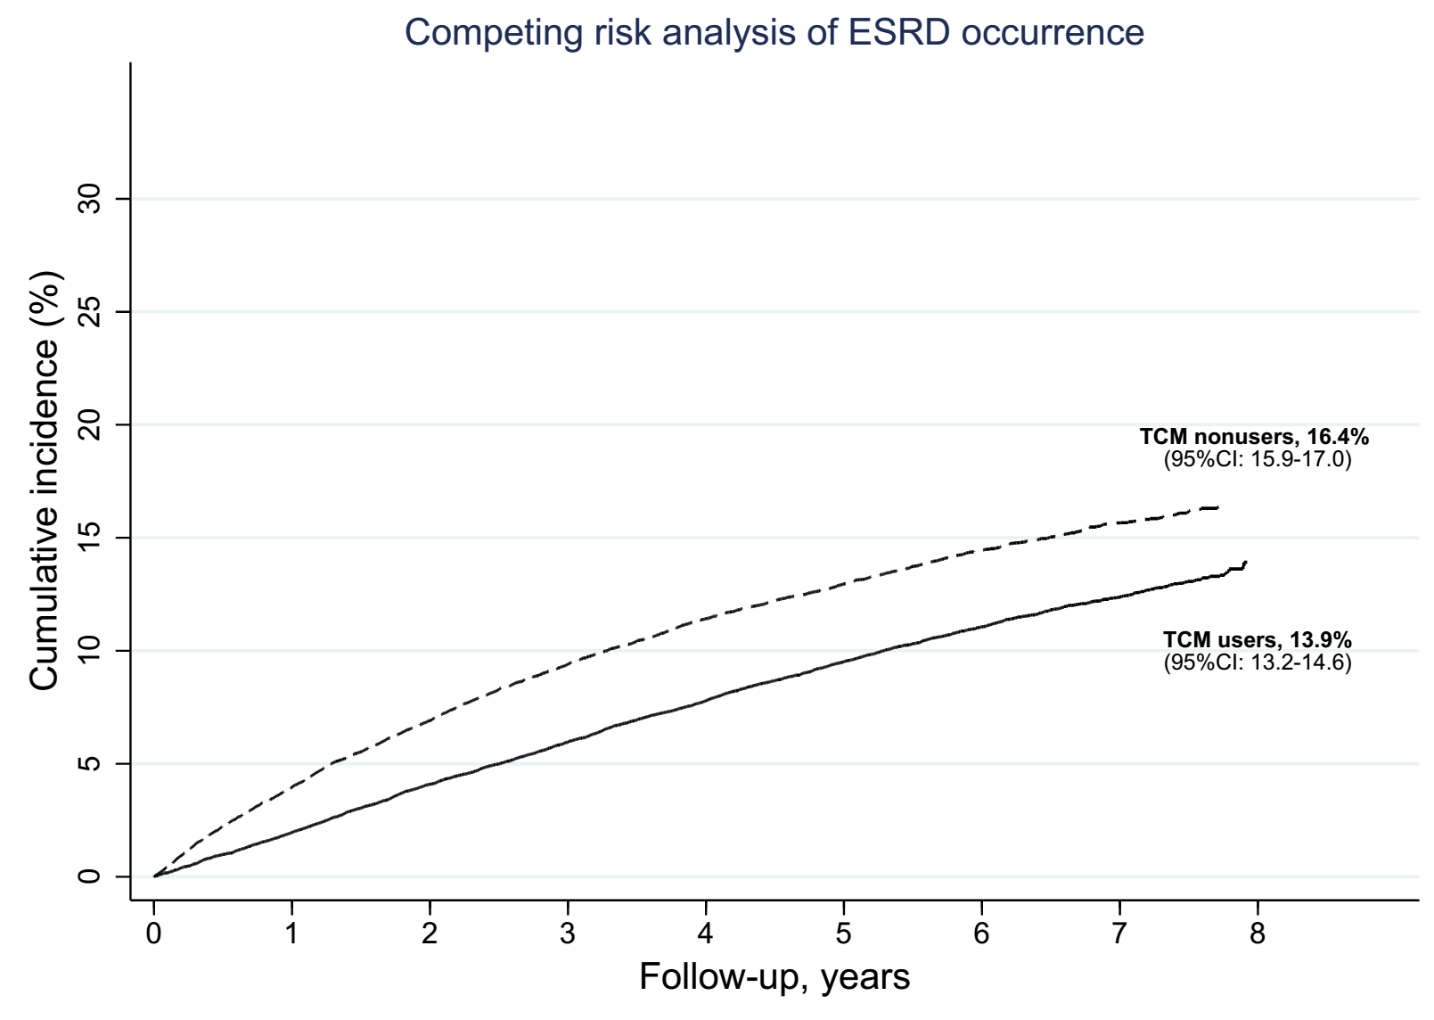
Figure S2. Survival analysis on mortality rate in the matched groups, by TCM users and nonusers. Caliper was set to 0.00001 when performing PSM and the result was similar to the cohort matched by using PSM with caliper 0.02.
