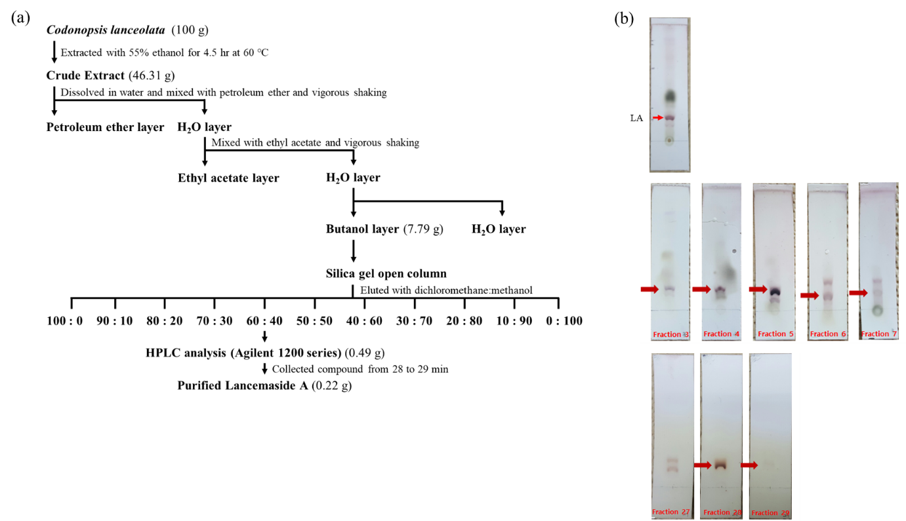

Additional file 1 Figure S1. Determination of lancemaside A (LA) from C. lanceolata. (a) Scheme showing the isolation of LA from C. lanceolata. (b) Thin-layer chromatography, TLC analysis was performed to identify LA in the n-butanol-soluble portion (top panel). Open column was packed with the silica gel fractions (3−7) eluted by a dichloromethane-methanol solvent gradient (middle panel) and HPLC fractions (27−29) were separated by a linear gradient of solvent mixtures of 0.05% trifluoroacetic acid in H₂O (TFA, solvent A) and acetonitrile (solvent B) (bottom panel).

