Table S1. Median lethal dose (LD₅₀) determination for Arthrocnemum machrostachyum methanolic extract.
Group Number | Dose  (mg/kg) | Number of animals/group | Number of dead animals | Z | d | Z X d
1 | 300 | 5 | 0 | 0.5 | 600 | 300
2 | 900 | 5 | 1 | 1.5 | 600 | 900
3 | 1500 | 5 | 2 | 2.5 | 600 | 1500
4 | 2100 | 5 | 3 | 3.5 | 600 | 2100
5 | 2700 | 5 | 4 | 4.5 | 600 | 2700
6 | 3300 | 5 | 5 | 0 | 0 | 0
LD₅₀ = Least lethal dose - Σ(Z×d) / N
d: dose difference. For example, difference between doses in group 1 and 2 equals 600 (900-300 = 600). This should be equal among all groups.
N: the number of animals in each group which is 5.
Z: mean mortality. For example, mean mortality of group 3 equals 2.5 [(2+3)/2 = 2.5].
So the LD₅₀ for Arthrocnemum machrostachyum methanolic extract is 1800 mg/kg body weight based on this calculation:
LD50 = 3300 –7500/5= 3300-1500 = 1800 mg/kg body weight.

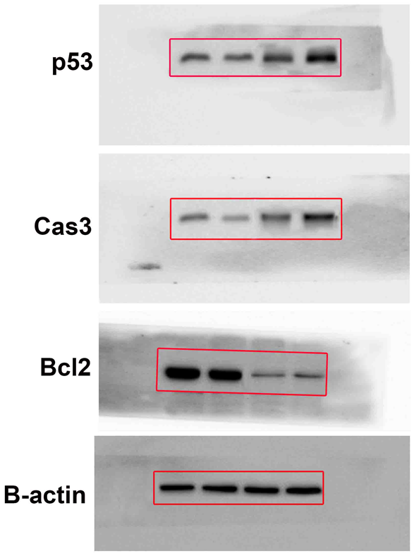

Fig. S1. Full blots of proteins.

