Supplementary materials
For
Regulation effects of total flavonoids in Morus alba L. on hepatic cholesterol disorders in orotic acid induced NAFLD rats
Yucheng Hu^{1†}, Jingqi Xu^{2†}, Qian Chen¹, Mengyang Liu², Sijian Wang¹, Haiyang Yu¹, Yi Zhang^{2*} and Tao Wang^{1*}

Figure Legend for Supplementary Data
Supplementary Figure 1. Full scans of western-blot data were shown in Figure 4. Rectangles delimit cropped areas used in the indicated panels in Figure 4.

Supplementary Figure 2. Full scans of western-blot data were shown in Figure 6. Rectangles delimit cropped areas used in the indicated panels in Figure 6.

Supplementary Figure 1
Figure 4A
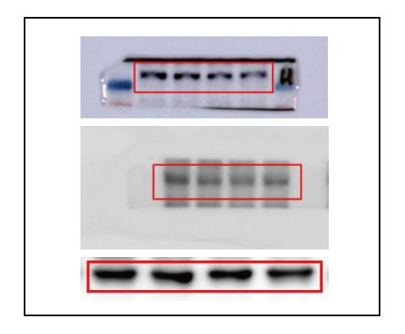

Supplementary Figure 2
Figure 6A
