Additional file 1
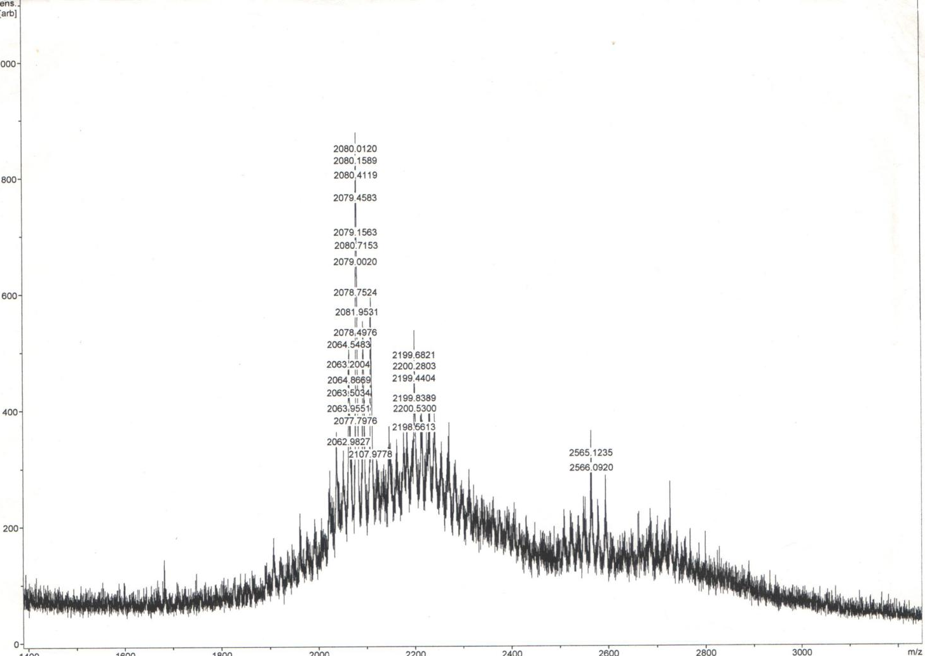

Relative intensity

mass/charge (m/z)

Additional file 1: MALDI TOF MS data showing monoisotopic mass/charge ratios for the peptide-rich pre-purified aqueous extracts of Calliandra porturescensis collected from South-west Nigeria. Identified peptide masses ranges from 2.0 KDa to 2.6 KDa.

