Supplementary Materials:
SF1: Figures for Flexible Docking with BRD2.
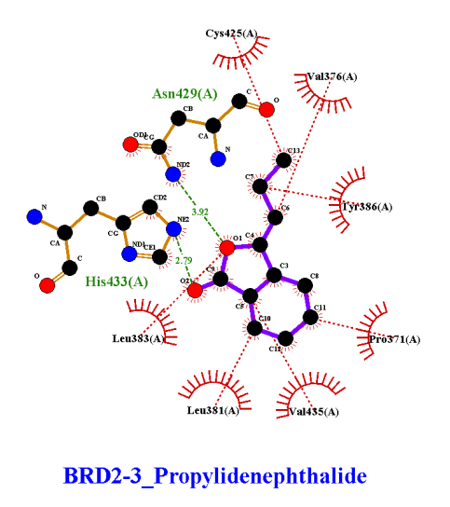 | 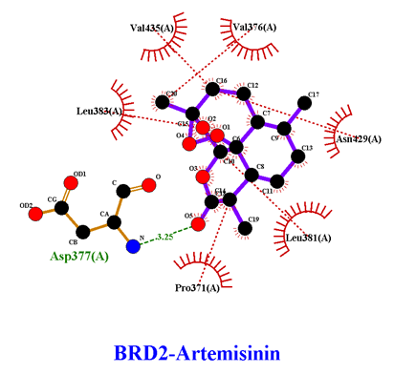 | 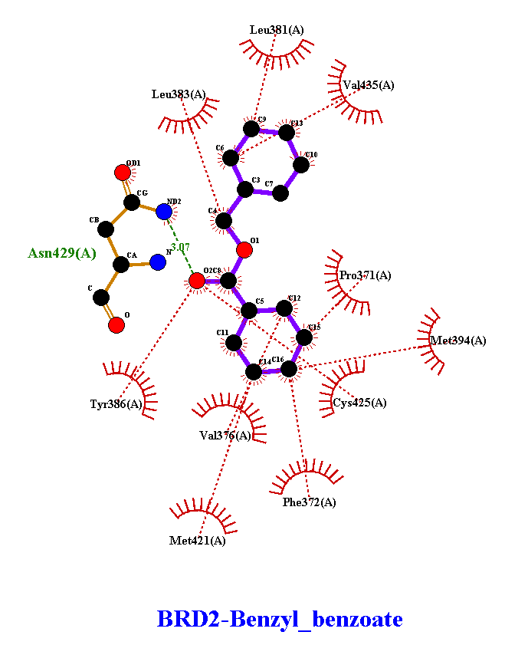
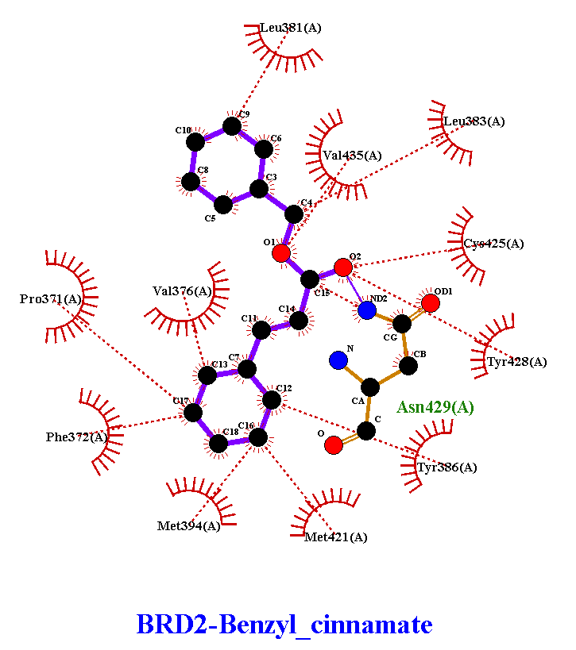 | 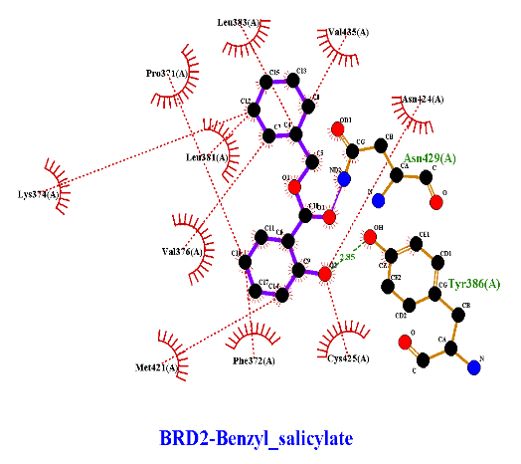 | 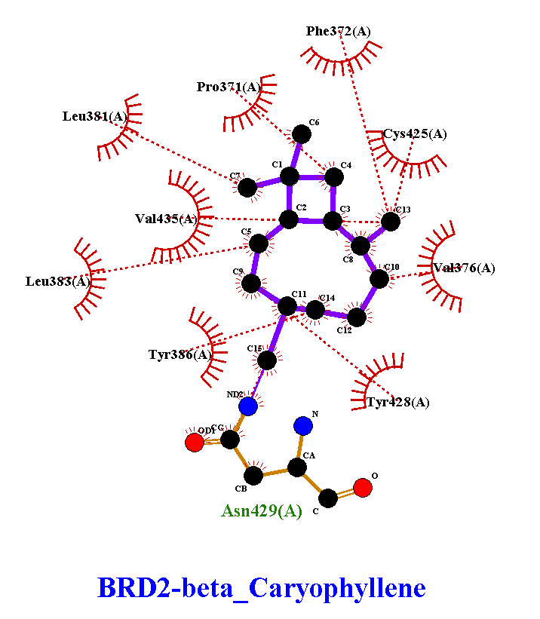
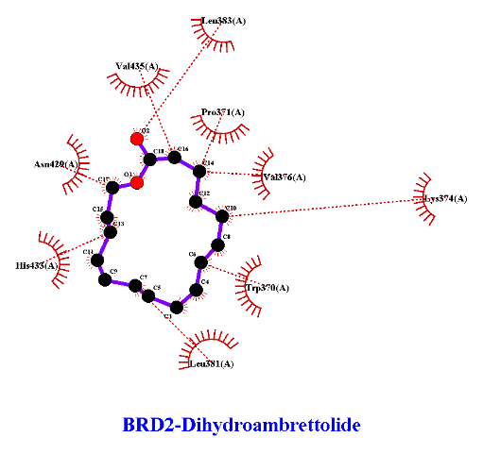 | 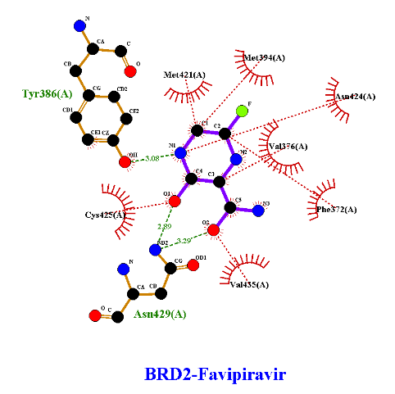 | 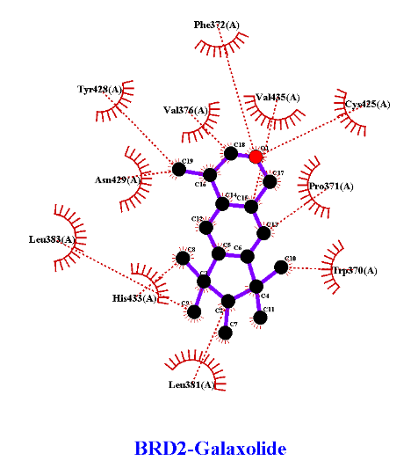
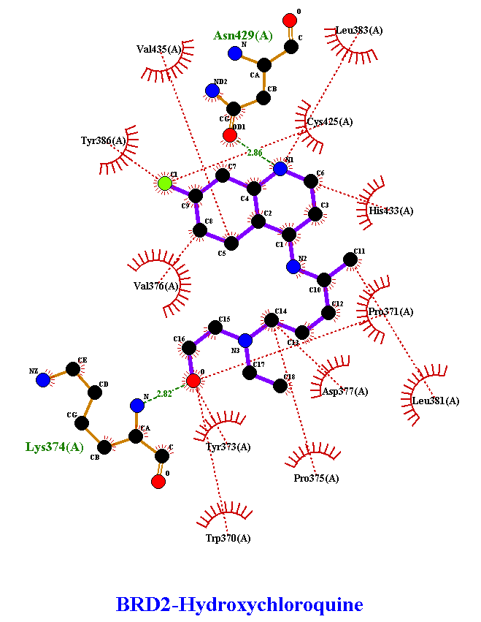 | 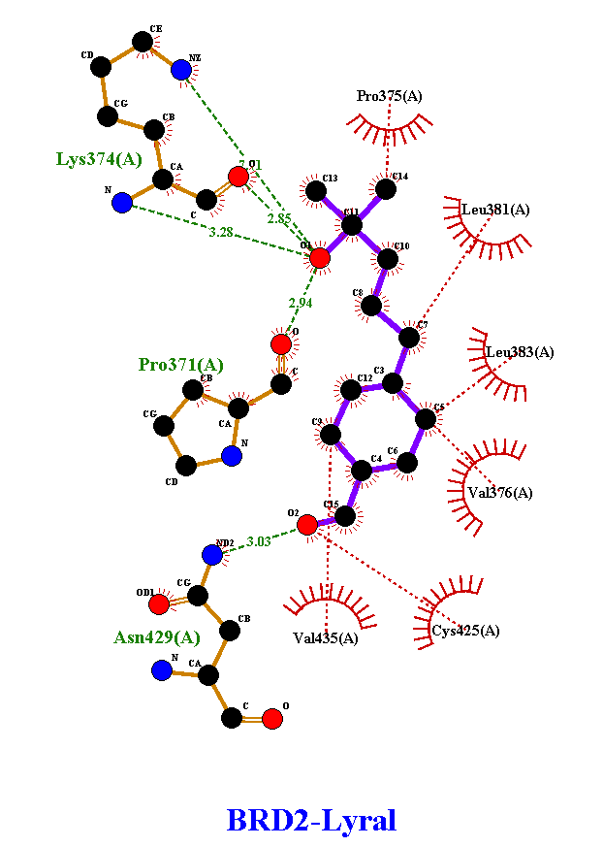 | 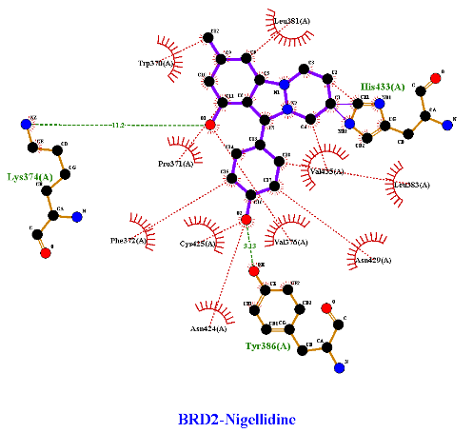
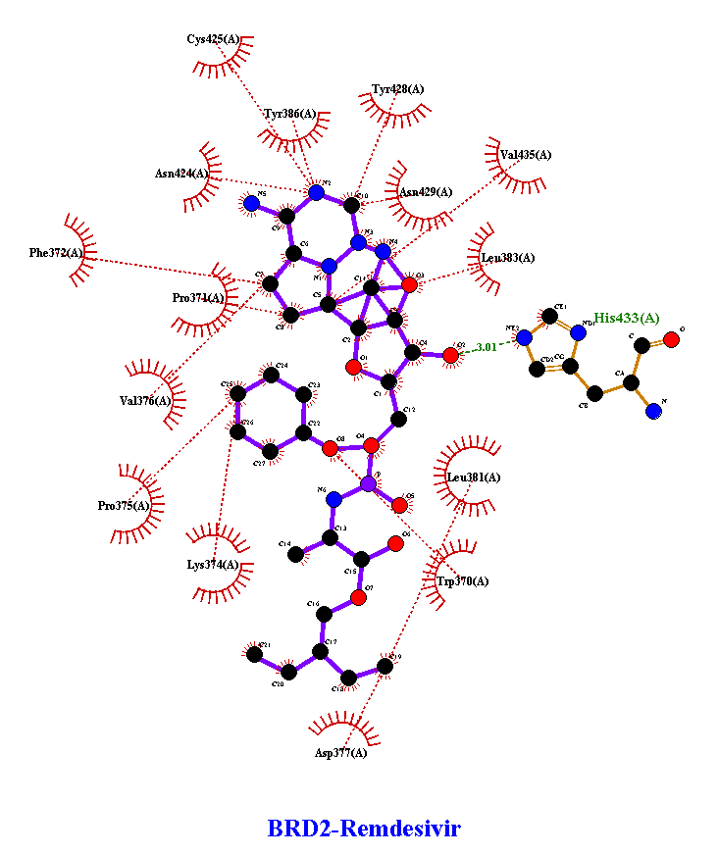 | 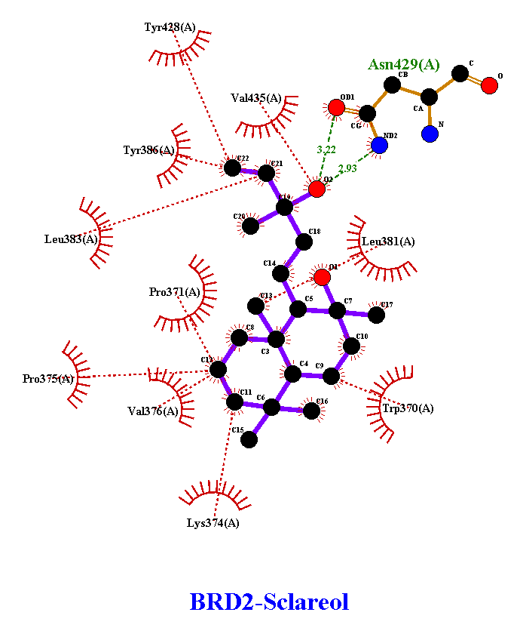 | 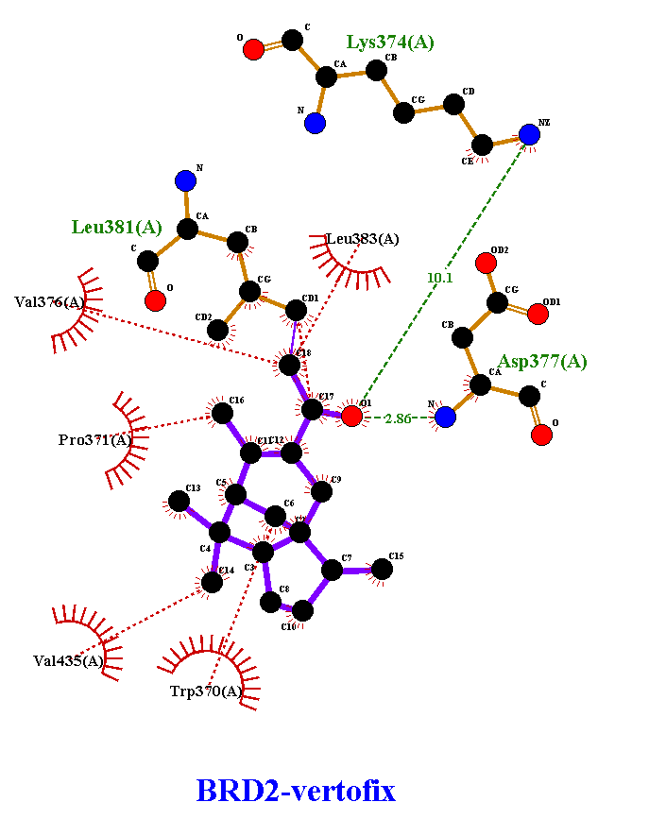

SF2: Figures for Flexible Docking with Mpro.
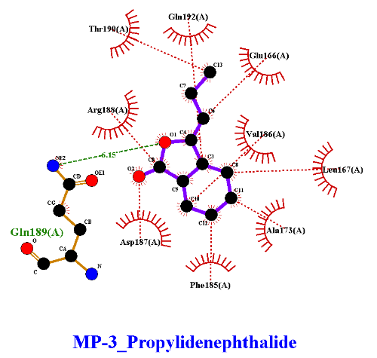 | 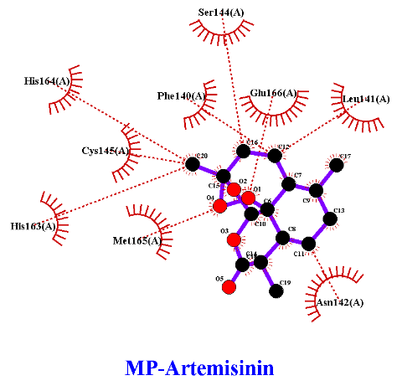 | 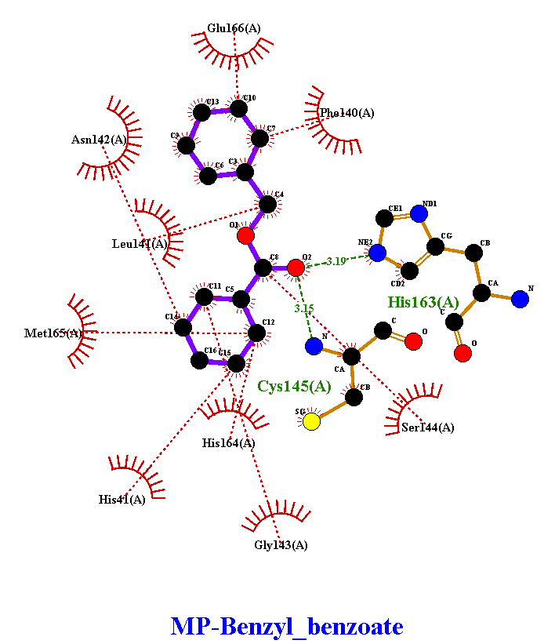
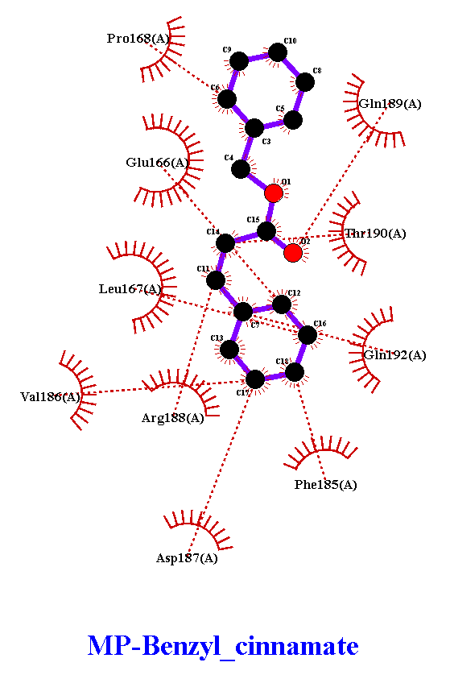 | 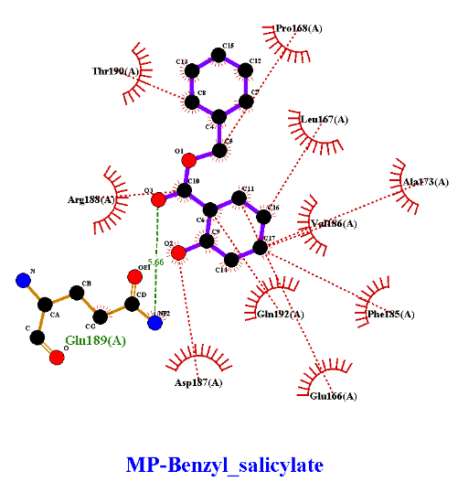 | 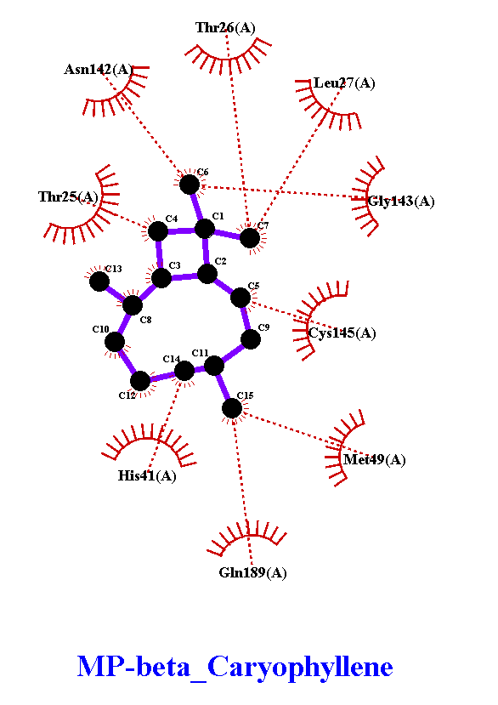
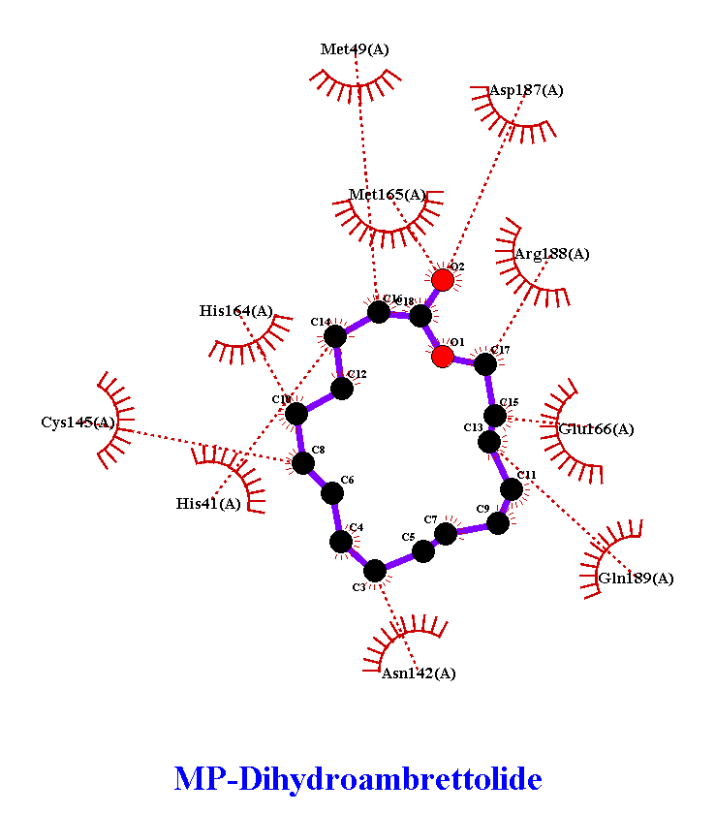 | 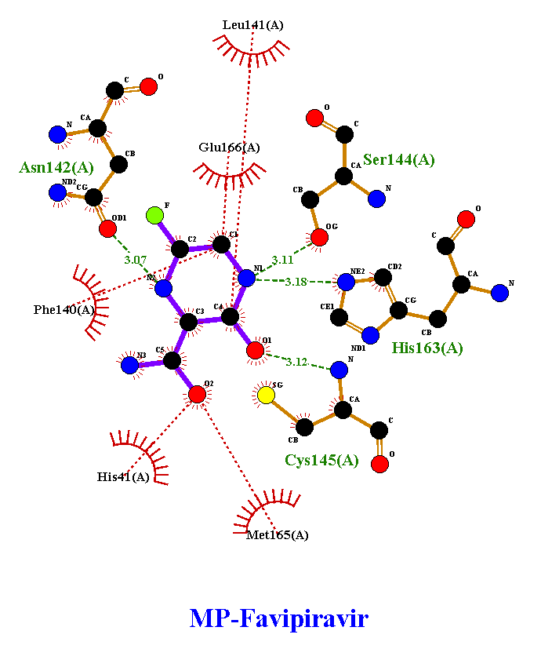 | 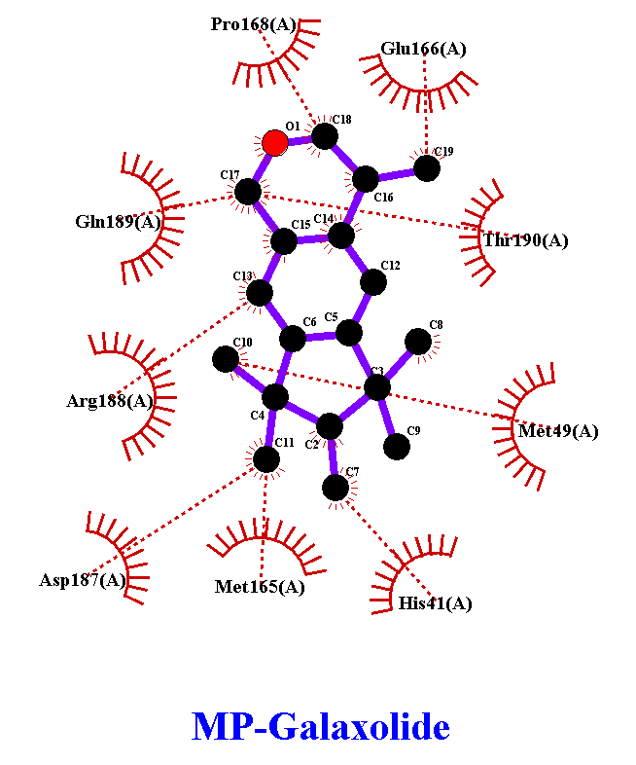
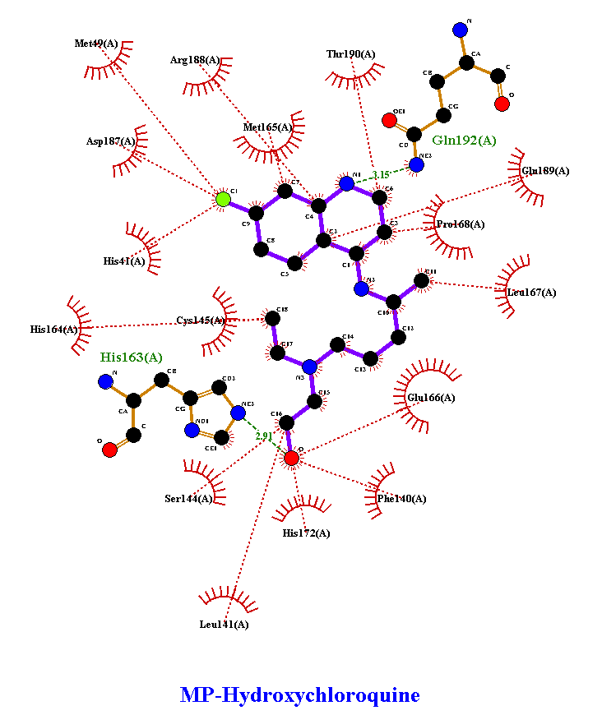 | 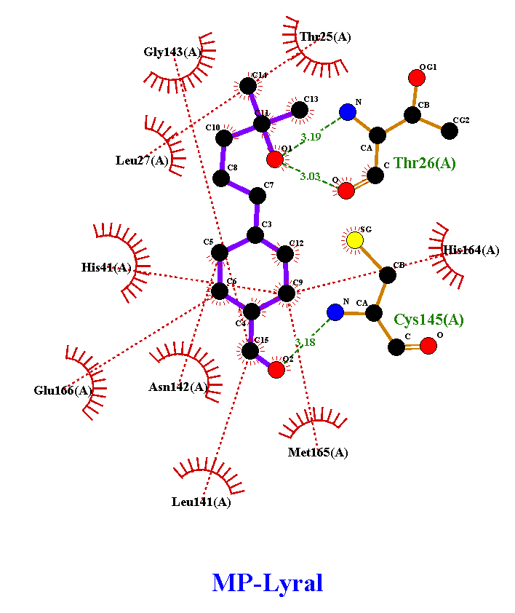 | 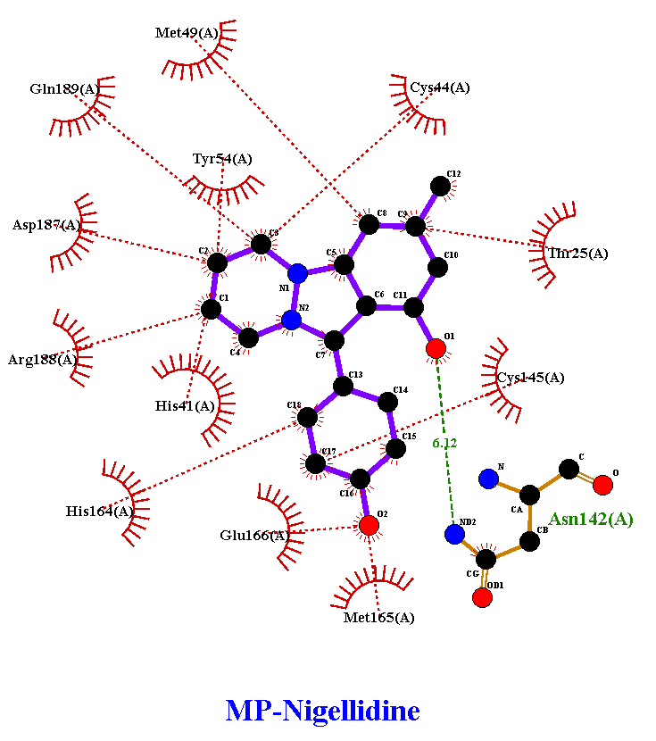
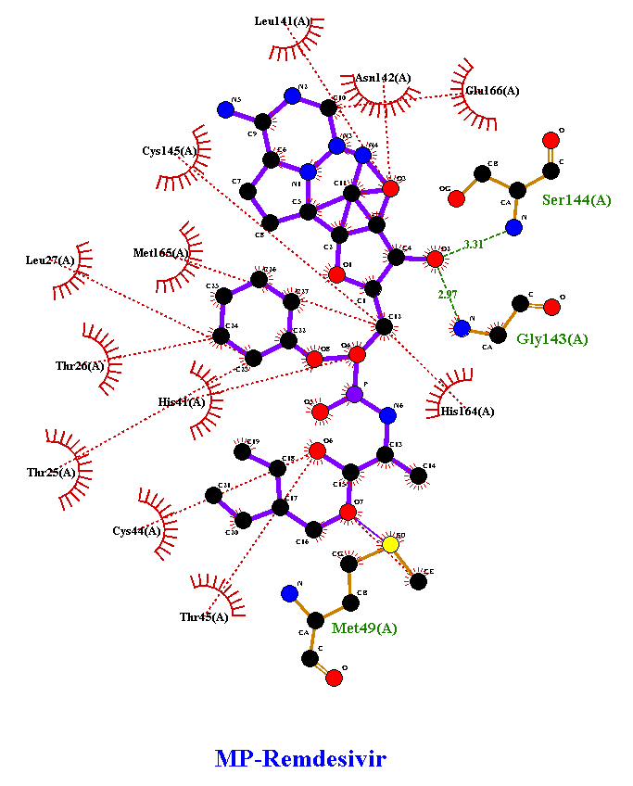 | 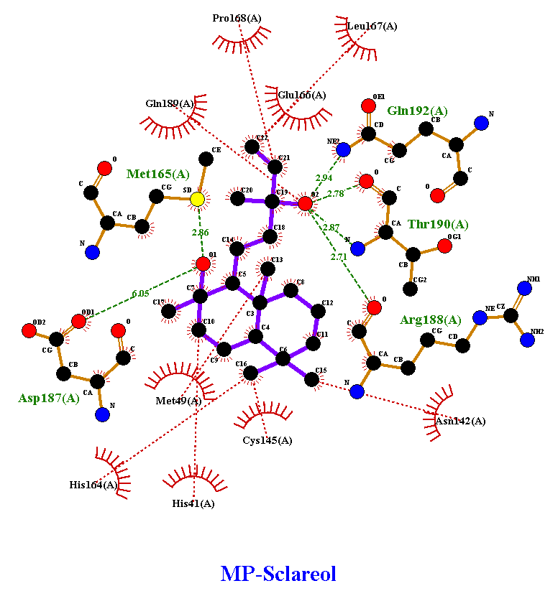 | 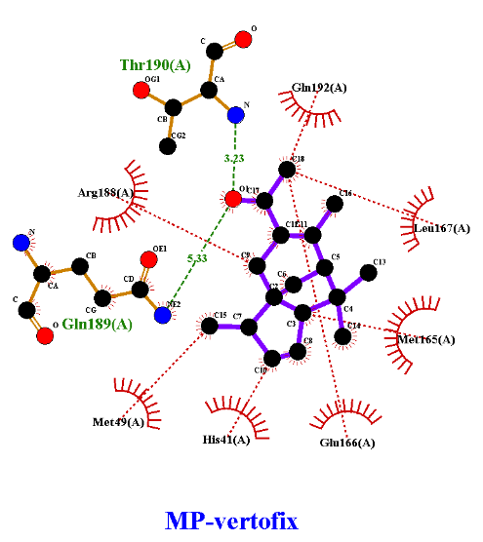

SF3: Figures AutoDock poses for BRD2.
Artemisinin
3-PROPYLIDENE PHTHALIDE
BENZYL CINNAMATE
BENZYL BENZOATE
BENZYL SALICYLATE
BETA CARYOPHYLLENE
DIHYDROAMBRETTOLIDE
Favipiravir
Hydroxychloroquine
GALAXOLIDE
LYRAL
Nigellidine
SCLAREOL
Remdesivir
VERTOFIX (ALPHA ACETYL CEDRENE)

SF4: Figures AutoDock poses for MPro.
Artemisinin
3-PROPYLIDENE PHTHALIDE
BENZYL CINNAMATE
BENZYL BENZOATE
BETA CARYOPHYLLENE
BENZYL SALICYLATE
Favipiravir
DIHYDROAMBRETTOLIDE
GALAXOLIDE
Hydroxychloroquine
LYRAL
Nigellidine
Remdesivir
SCLAREOL
VERTOFIX (ALPHA ACETYL CEDRENE)
Table S1: Mean binding affinity (kcal/mol) calculated by Vina. Selected top 9 compounds in this study, previously reported compounds, and binding affinities ≤ -6 kcal/mol were printed in bold letters.
 | BRD2 |  | Main Protease |  | Nucleocapsid |  | Receptor Bimding Domain
 | Mean | SEM | Mean | SEM | Mean | SEM | Mean | SEM
3-PROPYLIDENE PHTHALIDE | -6.50 | 0.00 | -5.43 | 0.02 | -5.83 | 0.03 | -5.18 | 0.03
ACETYL ISOEUGENOL | -6.30 | 0.00 | -5.50 | 0.00 | -5.10 | 0.00 | -5.00 | 0.00
ALPHA AMYL CINNAMALDEHYDE | -6.08 | 0.26 | -4.98 | 0.02 | -5.30 | 0.00 | -4.63 | 0.17
ALPHA AMYLCINNAMYL ALCOHOL | -6.20 | 0.07 | -5.25 | 0.03 | -5.20 | 0.04 | -4.53 | 0.02
ALPHA DAMASCONE | -5.80 | 0.00 | -5.25 | 0.05 | -5.05 | 0.03 | -4.80 | 0.00
ALPHA HEXYL CINNAMALDEHYDE | -6.10 | 0.33 | -4.85 | 0.12 | -5.03 | 0.14 | -4.78 | 0.17
ALPHA ISOMETHYLIONONE | -5.58 | 0.18 | -5.00 | 0.06 | -4.78 | 0.11 | -4.43 | 0.08
ALPHA PINENE | -5.10 | 0.00 | -5.10 | 0.00 | -4.00 | 0.00 | -4.23 | 0.02
ALPHA TERPINENE | -5.75 | 0.03 | -4.80 | 0.00 | -5.18 | 0.03 | -4.40 | 0.00
ALPHA TERPINEOL | -5.33 | 0.03 | -5.18 | 0.03 | -4.75 | 0.03 | -4.35 | 0.03
AMYL SALICYLATE | -6.10 | 0.07 | -4.83 | 0.03 | -5.15 | 0.09 | -4.95 | 0.03
ANETHOLE | -5.95 | 0.03 | -4.78 | 0.02 | -4.68 | 0.23 | -4.18 | 0.03
ANISE ALCOHOL | -5.23 | 0.14 | -4.68 | 0.03 | -4.33 | 0.13 | -4.18 | 0.03
BENZALDEHYDE | -4.80 | 0.00 | -4.08 | 0.02 | -4.33 | 0.03 | -4.15 | 0.09
BENZYL ALCOHOL | -4.73 | 0.05 | -4.23 | 0.08 | -4.25 | 0.05 | -4.00 | 0.10
BENZYL BENZOATE | -6.98 | 0.02 | -6.15 | 0.26 | -5.93 | 0.08 | -5.73 | 0.18
BENZYL CINNAMATE | -7.30 | 0.04 | -6.40 | 0.14 | -5.90 | 0.10 | -6.15 | 0.10
BENZYL SALICYLATE | -7.20 | 0.00 | -6.28 | 0.06 | -5.93 | 0.08 | -6.13 | 0.05
BETA CARYOPHYLLENE | -6.60 | 0.00 | -5.68 | 0.03 | -5.90 | 0.00 | -5.00 | 0.00
BETA DAMASCENONE | -5.58 | 0.02 | -5.80 | 0.00 | -5.30 | 0.00 | -5.20 | 0.00
BETA DAMASCONE | -5.70 | 0.00 | -5.80 | 0.00 | -5.23 | 0.02 | -5.15 | 0.03
BETA PINENE | -4.90 | 0.00 | -5.20 | 0.00 | -3.93 | 0.03 | -4.10 | 0.00
CAMPHOR | -4.60 | 0.00 | -5.15 | 0.03 | -3.48 | 0.06 | -4.20 | 0.00
CARVONE | -6.00 | 0.00 | -5.10 | 0.00 | -5.05 | 0.05 | -4.50 | 0.00
CINNAMALDEHYDE | -5.30 | 0.00 | -4.58 | 0.02 | -4.73 | 0.05 | -4.15 | 0.05
CINNAMYL ALCOHOL | -5.18 | 0.19 | -4.58 | 0.13 | -4.68 | 0.13 | -4.30 | 0.07
CITRAL | -5.40 | 0.04 | -4.53 | 0.02 | -4.55 | 0.12 | -4.15 | 0.03
CITRONELLOL | -5.10 | 0.06 | -4.68 | 0.09 | -4.33 | 0.03 | -3.80 | 0.12
COUMARIN | -6.30 | 0.00 | -5.10 | 0.00 | -5.23 | 0.02 | -4.80 | 0.00
DELTA DAMASCONE | -5.70 | 0.00 | -5.60 | 0.00 | -5.10 | 0.00 | -5.25 | 0.05
DIHYDROAMBRETTOLIDE | -6.20 | 0.00 | -6.50 | 0.00 | -6.03 | 0.02 | -5.28 | 0.02
DIMETHYLBENZYLCARBINYL ACETATE | -6.00 | 0.00 | -6.20 | 0.00 | -5.03 | 0.06 | -4.63 | 0.05
EBANOL | -6.00 | 0.00 | -6.23 | 0.02 | -5.08 | 0.05 | -4.73 | 0.02
EUGENOL | -5.80 | 0.00 | -4.90 | 0.00 | -4.80 | 0.00 | -4.53 | 0.02
EUGENYL ACETATE | -6.10 | 0.00 | -5.30 | 0.00 | -5.00 | 0.00 | -4.83 | 0.03
FARNESOL | -5.88 | 0.46 | -4.93 | 0.23 | -4.83 | 0.14 | -4.20 | 0.11
GALAXOLIDE | -6.95 | 0.03 | -6.60 | 0.00 | -5.98 | 0.02 | -5.55 | 0.15
GERANIOL | -5.33 | 0.05 | -4.65 | 0.22 | -4.63 | 0.03 | -4.05 | 0.09
GERANYL ACETATE | -5.85 | 0.03 | -5.20 | 0.06 | -4.75 | 0.05 | -4.50 | 0.00
HYDROXYCITRONELLAL | -5.33 | 0.33 | -4.95 | 0.06 | -4.23 | 0.23 | -4.18 | 0.31
ISO E SUPER | -5.88 | 0.03 | -6.23 | 0.02 | -5.25 | 0.03 | -5.10 | 0.00
ISOEUGENOL | -5.75 | 0.25 | -5.10 | 0.17 | -4.90 | 0.10 | -4.55 | 0.03
LILIAL (BUTYLPHENYL METHYLPROPIONAL) | -5.90 | 0.57 | -5.48 | 0.13 | -5.35 | 0.05 | -4.63 | 0.13
LIMONENE | -5.60 | 0.00 | -4.70 | 0.00 | -4.80 | 0.00 | -4.30 | 0.00
LINALOOL | -4.95 | 0.13 | -4.53 | 0.14 | -4.33 | 0.08 | -4.40 | 0.14
LINALYL ACETATE | -5.45 | 0.05 | -5.10 | 0.00 | -4.68 | 0.05 | -4.83 | 0.08
LYRAL | -6.79 | 0.09 | -6.73 | 0.02 | -5.43 | 0.28 | -5.05 | 0.03
MAJANTOL | -6.03 | 0.02 | -5.05 | 0.03 | -5.08 | 0.02 | -4.68 | 0.03
MENTHOL | -5.80 | 0.00 | -4.70 | 0.00 | -4.88 | 0.03 | -4.58 | 0.02
METHL-2-OCTYNOATE | -5.13 | 0.23 | -4.23 | 0.06 | -4.05 | 0.05 | -3.80 | 0.04
METHYL SALICYLATE | -5.63 | 0.03 | -5.03 | 0.02 | -4.70 | 0.00 | -4.53 | 0.02
SALICYLALDEHYDE | -5.15 | 0.03 | -4.50 | 0.00 | -4.30 | 0.00 | -4.33 | 0.03
SANTALOL | -5.75 | 0.06 | -5.83 | 0.14 | -5.23 | 0.02 | -4.58 | 0.12
SCLAREOL | -5.83 | 0.09 | -6.50 | 0.00 | -5.30 | 0.16 | -5.80 | 0.00
TERPINOLENE | -5.90 | 0.00 | -4.80 | 0.00 | -4.70 | 0.00 | -4.50 | 0.00
VANILLIN | -5.40 | 0.00 | -4.88 | 0.03 | -4.50 | 0.00 | -4.88 | 0.03
VERTOFIX (ALPHA ACETYL CEDRENE) | -6.30 | 0.00 | -6.63 | 0.03 | -5.13 | 0.03 | -5.20 | 0.00
Artemisinin | -6.98 | 0.02 | -7.20 | 0.00 | -6.03 | 0.02 | -6.05 | 0.03
Favipiravir | -5.50 | 0.00 | -4.70 | 0.00 | -4.00 | 0.00 | -4.43 | 0.02
Hydroxychloroquine | -6.18 | 0.15 | -5.83 | 0.14 | -4.80 | 0.14 | -4.50 | 0.08
Nigellidine | -8.20 | 0.00 | -7.40 | 0.00 | -5.45 | 0.06 | -5.88 | 0.03
Remdesivir | -6.90 | 0.08 | -6.65 | 0.13 | -5.95 | 0.29 | -6.95 | 0.13

Table S2: Reranked scores from Molegro Virtual Docker. Top nine molecules from Vina results and previously reported compounds printed in bold letters.
 | BRD2 | Main Protease | Nucleocapsid | Receptor Binding Domain
3-PROPYLIDENE PHTHALIDE | -46.80 | -47.72 | -42.92 | -53.55
ACETYL ISOEUGENOL | -55.28 | -63.85 | -15.72 | -54.26
ALPHA AMYL CINNAMALDEHYDE | -61.94 | -70.20 | -50.68 | -65.18
ALPHA AMYLCINNAMYL ALCOHOL | -59.09 | -73.69 | -60.25 | -42.07
ALPHA DAMASCONE | -49.19 | -61.78 | -43.18 | -49.09
ALPHA HEXYL CINNAMALDEHYDE | -60.74 | -77.78 | -61.62 | -61.11
ALPHA ISOMETHYLIONONE | -43.65 | -54.98 | -22.34 | -42.55
ALPHA PINENE | -32.69 | -49.66 | -27.11 | -36.65
ALPHA TERPINENE | -42.96 | -54.79 | -34.60 | -44.95
ALPHA TERPINEOL | -50.03 | -56.77 | -41.78 | -42.07
AMYL SALICYLATE | -59.78 | -81.63 | -42.17 | -60.79
ANETHOLE | -49.89 | -49.86 | -55.41 | -46.65
ANISE ALCOHOL | -41.78 | -50.33 | -53.67 | -43.09
BENZYL ALCOHOL | -35.02 | -45.54 | -45.48 | -36.59
BENZYL BENZOATE | -58.28 | -70.43 | -75.74 | -48.56
BENZYL CINNAMATE | -66.03 | -70.12 | -68.95 | -49.24
BENZYL SALICYLATE | -52.66 | -76.54 | -65.86 | -60.78
BETA CARYOPHYLLENE | -17.83 | -49.10 | 66.48 | -51.20
BETA DAMASCENONE | -57.01 | -49.79 | -43.56 | -56.51
BETA DAMASCONE | -54.18 | -51.68 | -41.65 | -50.02
BETA PINENE | -29.62 | -47.82 | -27.00 | -35.30
CAMPHOR | -15.60 | -60.16 | -13.15 | -34.24
CARVONE | -46.78 | -56.60 | -51.28 | -48.83
CINNAMALDEHYDE | -45.48 | -52.64 | -48.71 | -41.38
CINNAMYL ALCOHOL | -44.92 | -55.74 | -49.01 | -33.53
CITRAL | -50.15 | -54.75 | -56.65 | -47.66
CITRONELLOL | -49.00 | -57.72 | -38.38 | -48.98
COUMARIN | -37.97 | -52.33 | -51.28 | -36.50
DELTA DAMASCONE | -41.74 | -46.16 | -44.61 | -55.09
DIHYDROAMBRETTOLIDE | -28.82 | -49.49 | -48.30 | -58.99
DIMETHYLBENZYLCARBINYL ACETATE | -48.94 | -60.93 | -35.93 | -50.46
EBANOL | -55.15 | -58.66 | -44.04 | -55.18
EUGENOL | -51.07 | -64.13 | -66.82 | -52.15
EUGENYL ACETATE | -52.37 | -57.57 | -41.08 | -54.81
FARNESOL | -63.59 | -88.32 | -62.75 | -50.89
GALAXOLIDE | -45.93 | -64.23 | -7.08 | -56.72
GERANIOL | -52.34 | -59.89 | -58.16 | -54.21
GERANYL ACETATE | -58.23 | -75.64 | -57.13 | -54.44
HYDROXYCITRONELLAL | -66.07 | -60.19 | -61.01 | -47.50
ISO E SUPER | -41.89 | -40.88 | 2.33 | -44.72
ISOEUGENOL | -47.78 | -70.12 | -68.40 | -53.89
LILIAL (BUTYLPHENYL METHYLPROPIONAL) | -50.95 | -59.22 | -47.27 | -46.66
LIMONENE | -40.21 | -45.37 | -39.08 | -47.11
LINALOOL | -44.57 | -54.75 | -49.28 | -42.29
LINALYL ACETATE | -51.61 | -61.89 | -42.43 | -51.35
LYRAL (HYDROXYISOHEXYL-3-CYCLOHEXENE CARBOXALDEHYDE) | -67.75 | -62.46 | -40.17 | -47.32
MAJANTOL | -42.97 | -62.09 | -37.85 | -46.70
MENTHOL | -44.18 | -50.87 | -13.54 | -46.98
METHL-2-OCTYNOATE | -51.54 | -64.29 | -60.74 | -51.83
METHYL SALICYLATE | -44.47 | -64.58 | -37.12 | -48.89
SALICYLALDEHYDE | -38.55 | -55.48 | -34.42 | -42.89
SANTALOL | -54.84 | -65.81 | -49.04 | -53.84
SCLAREOL | -34.02 | -74.88 | 41.09 | -59.10
TERPINOLENE | -40.80 | -50.49 | -24.96 | -46.65
VANILLIN | -44.27 | -66.26 | -46.84 | -48.40
VERTOFIX (ALPHA ACETYL CEDRENE) | -47.27 | -49.31 | -22.09 | -56.30
Artemisinin | -54.01 | -17.63 | -5.73 | -29.13
Favipiravir | -57.67 | -67.64 | -73.96 | -50.66
Hydroxychloroquine | -74.13 | -92.39 | -73.65 | -55.37
Nigellidine | -72.07 | -99.17 | -77.09 | -61.11
Remdesivir | -118.45 | -137.03 | -54.14 | -95.58

