DATA COLLECTION FORM
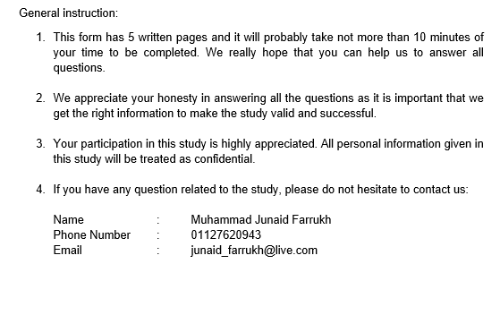
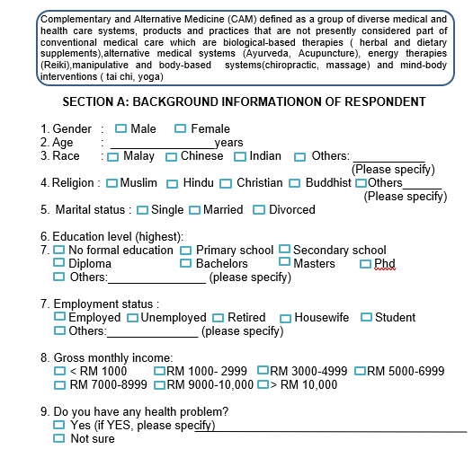

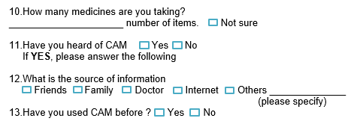

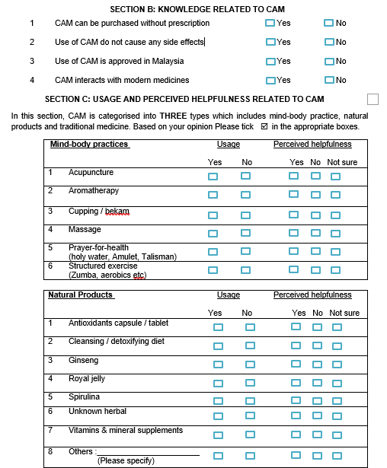

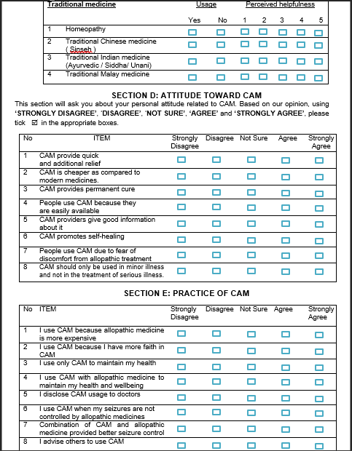

Section: F
BMQ- Epilepsy Specific
6- item AED- Necessity Scale
 | Strongly Disagree | Disagree | Uncertain | Agree | Strongly Agree
I would be very ill without epilepsy medication
I would prefer to take the epilepsy medication than having the risk of seizure
My life would be difficult without epilepsy medicine
My health in the future is dependent on my epilepsy medication
My life now is dependent on my epilepsy medication
The epilepsy medication helps my health from becoming worse
10-item AED –Concerns Scale
I sometimes worry on the long term effect of the epilepsy medication
I sometimes worry that the epilepsy medicine slow me down
I have sufficient information on the epilepsy medication
My epilepsy medicines are a mystery to me
I feel I am labelled ‘sick’ because I take this medicines
I sometimes worry that this medicine impacts my relationship with others
Having to take epilepsy medicine worries me
I sometimes worry that I am too dependent on the medicine
The epilepsy medicine causes unpleasant side effects
The epilepsy medicine disrupts my life

Section: G
Scale | Item | No  problem | Mild problem | Moderate  problem | Serious  Problem
Fatigue | I am less enthusiastic about day to day activities
Slowing | My mind does not work as fast as it should
Memory | I have difficulties remembering names of people
Concentration | I have difficulties following a book or a film
Motor co- | I feel clumsy
Language | I have problems finding the correct word
Fatigue | I am less capable of undertaking initiatives
Slowing | My thinking has slowed down
Memory | I forget things, for example an appointment or where I put an object
Concentration | I have difficulties concentrating on the things I am doing
Motor co- | I cannot use a pen or pencil accurately
Language | I have problems understanding what I read
Fatigue | I get tired easily and have little energy
Slowing | It takes me longer to do day to day things
Memory | I forget things that people have said to me
Concentration | I can’t concentrate for more than a short period of time
Motor co- | I constantly bump against tales, doorposts, etc
Fatigue | I feel worn out
Slowing | It costs more time for me to get started
Memory | I get confused and forget what I was doing
Concentration | I get distracted more easily
Language | I sometimes stutter or am unable to find the correct words
Slowing | I feel I react too slowly to things that are said to me
Fatigue | I cannot keep an activity going for long

Section: H
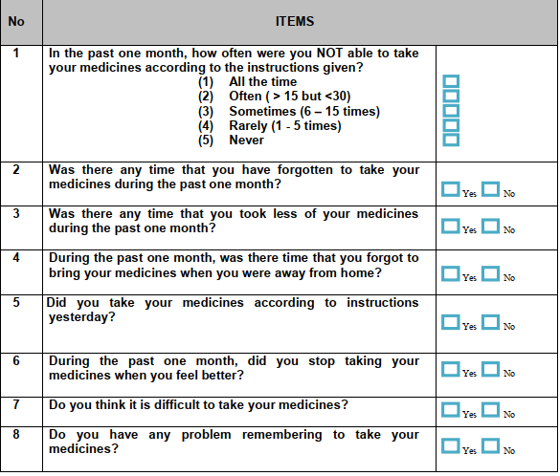

Section: I

By putting a tick () in one box in each group below, please indicate which statements best describe your own health state today.
Mobility
I have no problems in walking around
I have some problems in walking around
I am confined to bed
Self-Care
I have no problems with self-care
I have some problems taking a bath/shower, or dressing myself
I am unable to take a bath/shower, or dress myself
Usual Activities (e.g. work, study, housework, family or leisure activities)
I have no problems with performing my usual activities
I have some problems with performing my usual activities
I am unable to perform my usual activities
Pain / Discomfort
I have no pain or discomfort
I have moderate pain or discomfort
I have extreme pain or discomfort
Anxiety / Depression
I am not anxious or depressed
I am moderately anxious or depressed
I am extremely anxious or depressed

To help people say how good or bad a health state is, we have drawn a scale (rather like a thermometer) on which the best state you can imagine is marked 100 and the worst state you can imagine is marked 0.
We would like you to indicate on this scale how good or bad your own health is today, in your opinion. Please do this by drawing a line from the box below (where ‘Your own health state today’ is written) to whichever point on the scale indicates how good or bad your health state is today.
Best imaginable health state
9 0
8 0
7 0
6 0
5 0
4 0
3 0
2 0
1 0
100
0

Your own health state today
Worst imaginable health state

