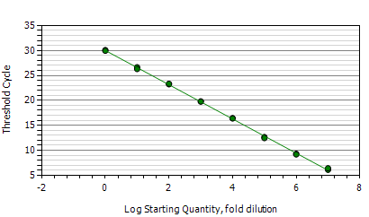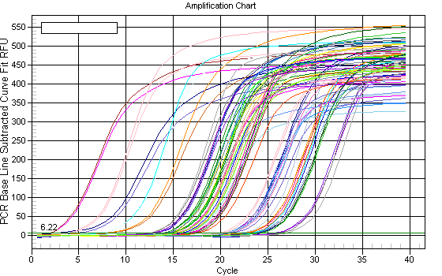
B
A
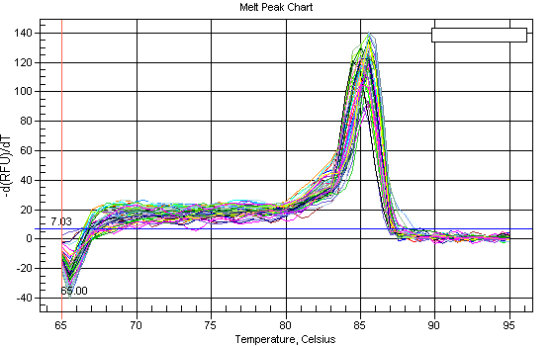
C
Figure S7. The detection Figure of Bifidobacterium by RT-qPCR
A Standard curve; B Amplification curves; C Melting curve

