Studies on the bioactive flavonoids isolated from Rumex abyssinicus

Irene Chinda Kengne¹, Léonel Donald Tsamo Feugap², Abdel Jélil Njouendou³, Claudia Darille Jouogo Ngnokam², Mahamat Djamalladine Djamalladine², David Ngnokam², Laurence Voutquenne-Nazabadioko⁴ and Jean-De-Dieu Tamokou^{1,}*

Supporting information

List of Contents
Cover page 1
Figure S1. ¹H NMR Spectrum of Compound 1 3
Figure S2. ¹³C NMR Spectrum of Compound 1 3
Figure S3. ¹H-¹H COSY Spectrum of Compound 1 4
Figure S4. HSQC Spectrum of Compound 1 4
Figure S5. HMBC Spectrum of Compound 1 5
Figure S6. ¹H-NMR Spectrum of Compound 2 6
Figure S7. ¹³C-NMR Spectrum of Compound 2 6
Figure S8. ¹H-¹H COSY Spectrum of Compound 2 7
Figure S9. HSQC Spectrum of Compound 2 7
Figure S10. HMBC Spectrum of Compound 2 8
Figure S11. ¹H-NMR Spectrum of Compound 3 9
Figure S12. ¹³C-NMR Spectrum of Compound 3 9
Figure S13. ¹H-¹H COSY Spectrum of Compound 3 10
Figure S14. HSQC Spectrum of Compound 3 10
Figure S15. HMBC Spectrum of Compound 3 11
Figure S16. 1H-NMR Spectrum of Compound 4 12
Figure S17. 13C-NMR Spectrum of Compound 4 12
Figure S18. 1H-1H COSY Spectrum of Compound 4 13
Figure S19. HSQC Spectrum of Compound 4 13
Figure S20. HMBC Spectrum of Compound 4 14
Figure S21. 1H-NMR Spectrum of Compound 5 15
Figure S22. 13C-NMR Spectrum of Compound 5 15
Figure S23. 1H-1H COSY Spectrum of Compound 5 16
Figure S24. HSQC Spectrum of Compound 5 16
Figure S25. HMBC Spectrum of Compound 5 17
Figure S26. 1H-NMR Spectrum of Compounds 6 and 7 18
Figure S27. 13C-NMR Spectrum of Compounds 6 and 7 18
Figure S28. 1H-1H COSY Spectrum of Compounds 6 and 7 19
Figure S29. HSQC Spectrum of Compounds 6 and 7 19
Figure S30. HMBC Spectrum of Compounds 6 and 7 20
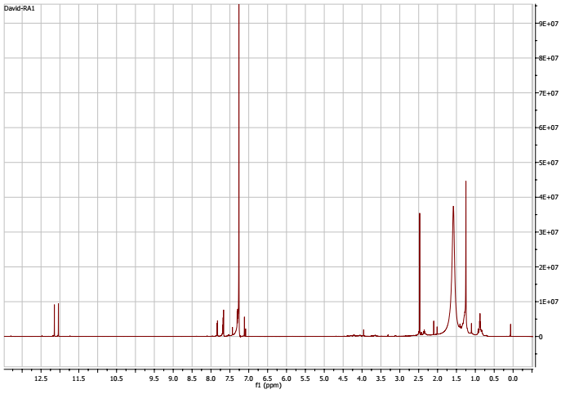
Figure S1: ¹H-NMR Spectrum of compound 1
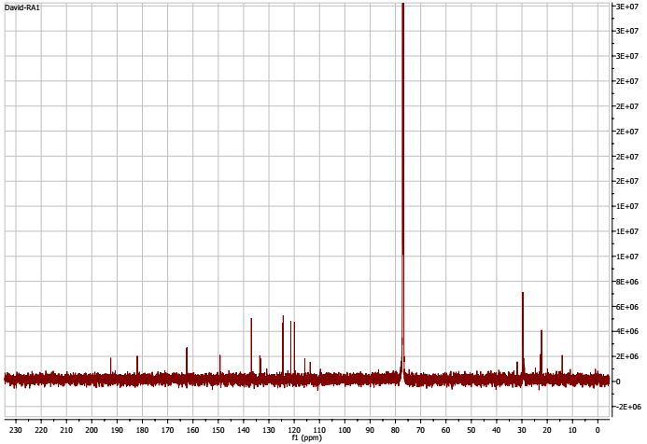
Figure S2: ¹³C-NMR Spectrum of compound 1
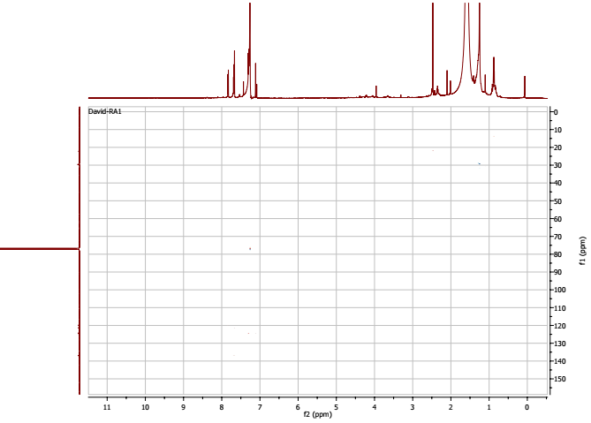
Figure S3: HSQC Spectrum of compound 1
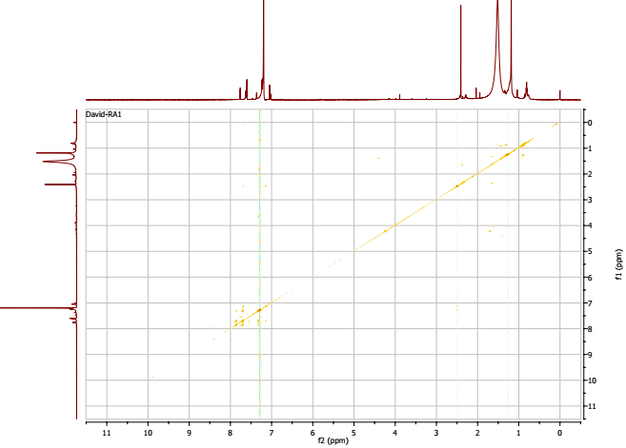
Figure S4: ¹H-¹HCOSY Spectrum of compound 1
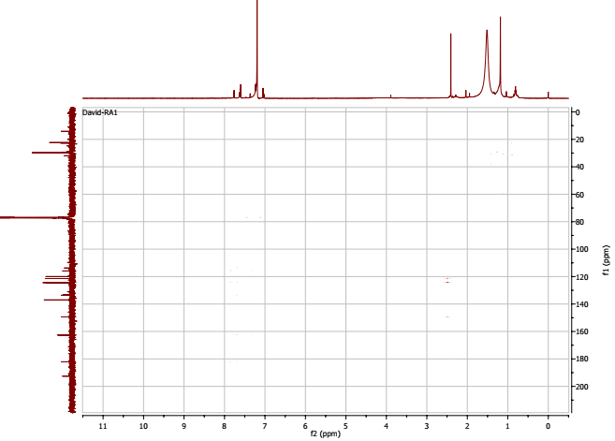
Figure S5: HMBC Spectrum of compound 1

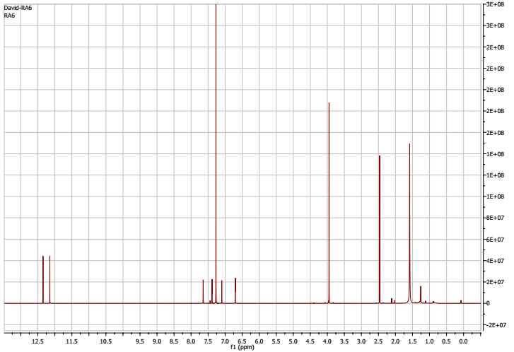
Figure S6: ¹H-NMR Spectrum of compound 2

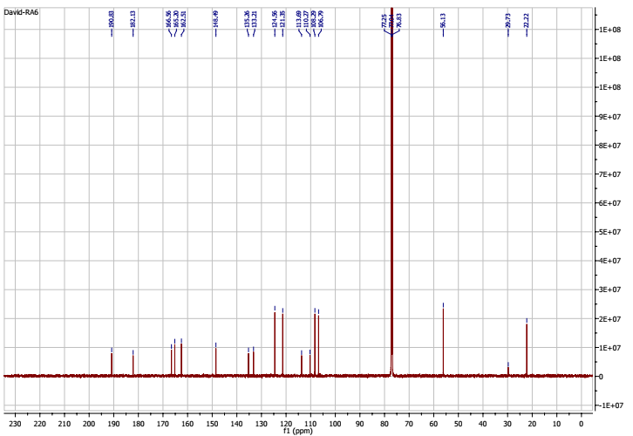
Figure S7: ¹³C-NMR Spectrum of compound 2

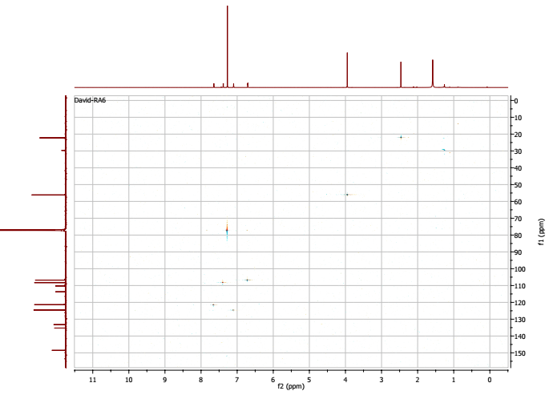
Figure S8: HSQC Spectrum of compound 2
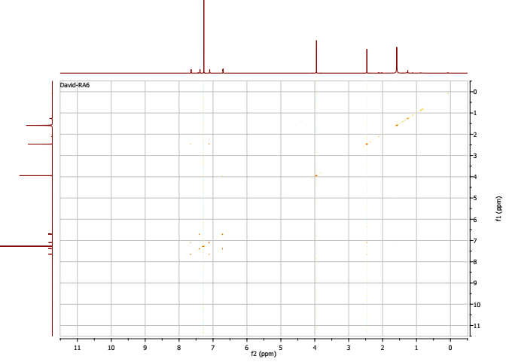
Figure S9: COSY Spectrum of compound 2

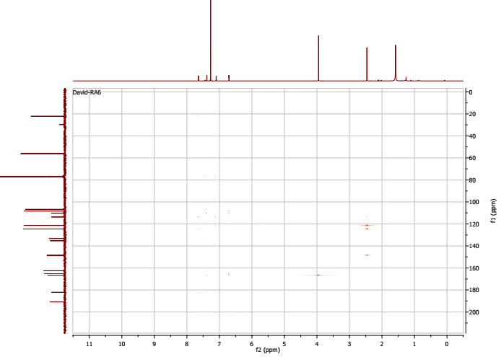
Figure S10: HMBC Spectrum of compound 2

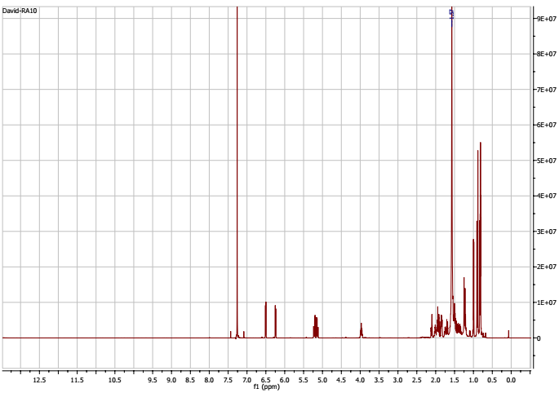
Figure S11: ¹H-NMR Spectrum of compound 3

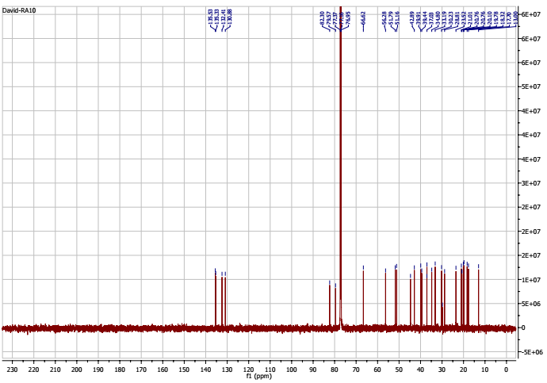
Figure S12: ¹³C-NMR Spectrum of compound 3

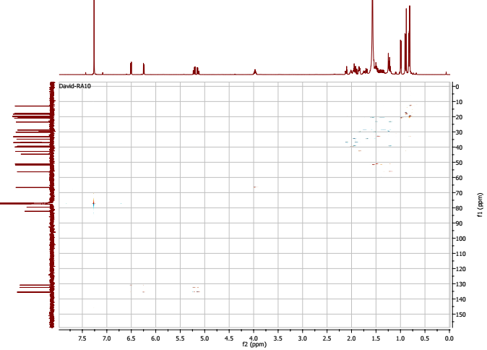
Figure S13: HSQC Spectrum of compound 3
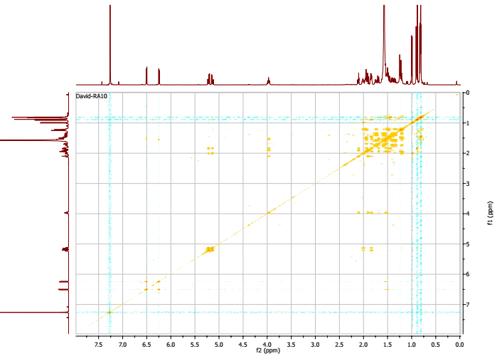
Figure S14: ¹H-¹H COSY Spectrum of compound 3

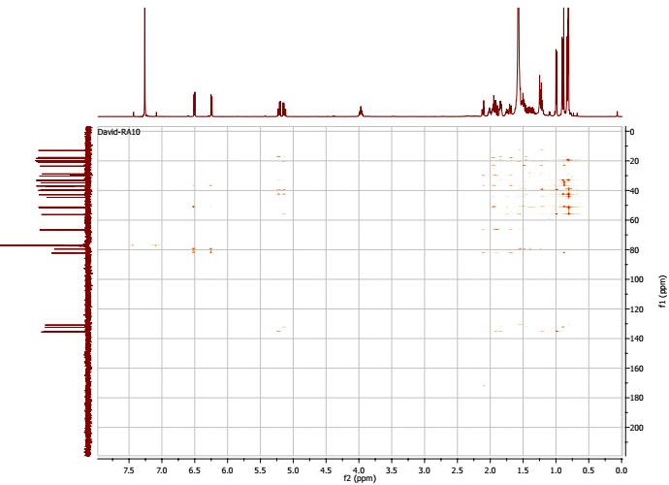
Figure S15: HMBC Spectrum of compound 3

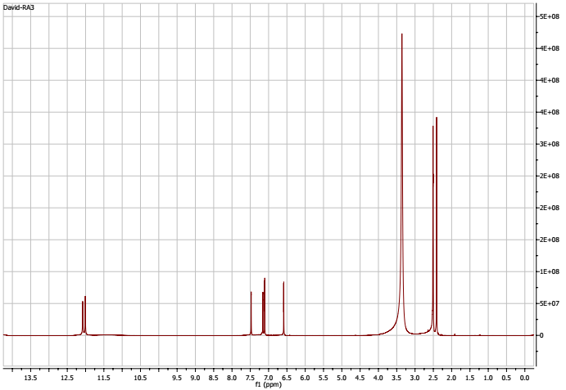
Figure S16: ¹H-NMR Spectrum of compound 4
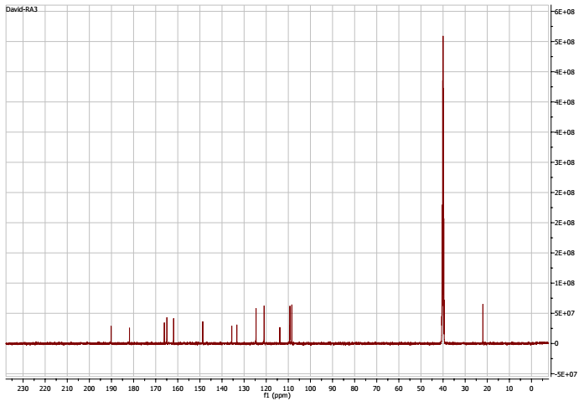
Figure S17: ¹³C-NMR Spectrum of compound 4
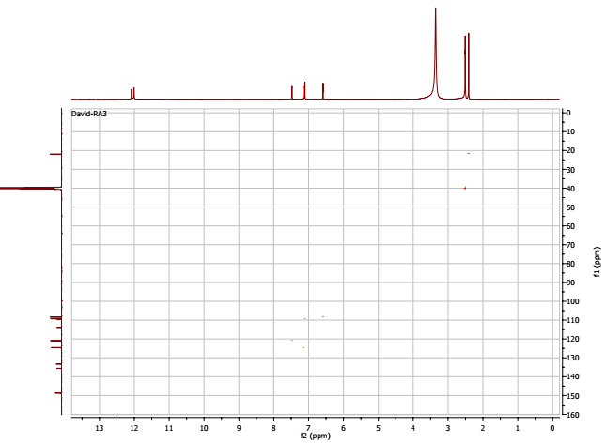
Figure S18: HSQC Spectrum of compound 4

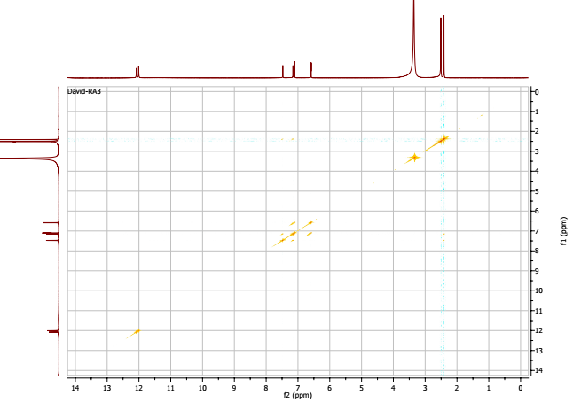
Figure S19: ¹H-¹HCOSY Spectrum of compound 4
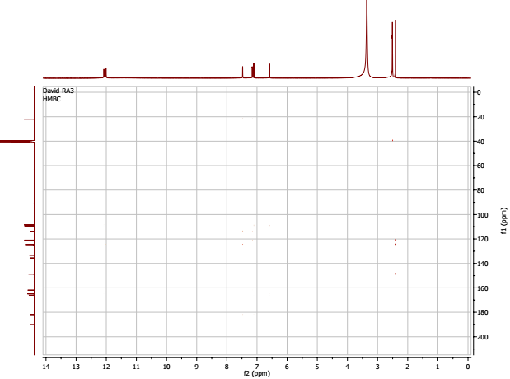
Figure S20: HMBC Spectrum of compound 4

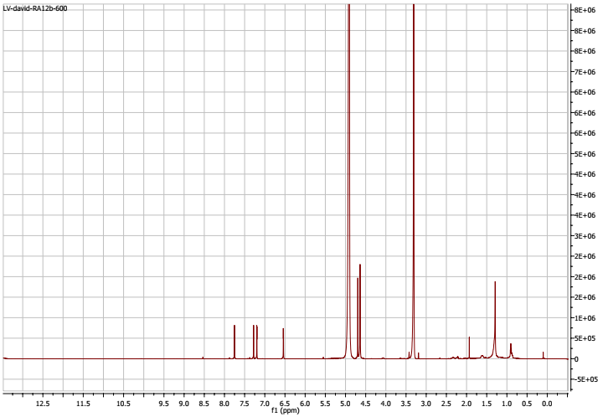
Figure S21: ¹H-NMR Spectrum of compound 5

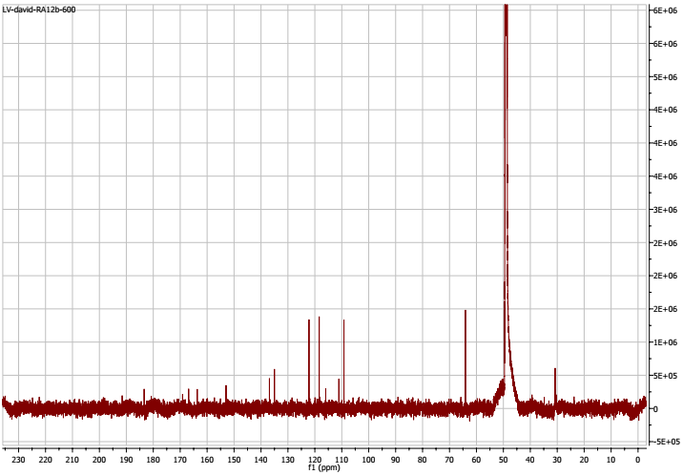
Figure S22: ¹³C-NMR Spectrum of compound 5

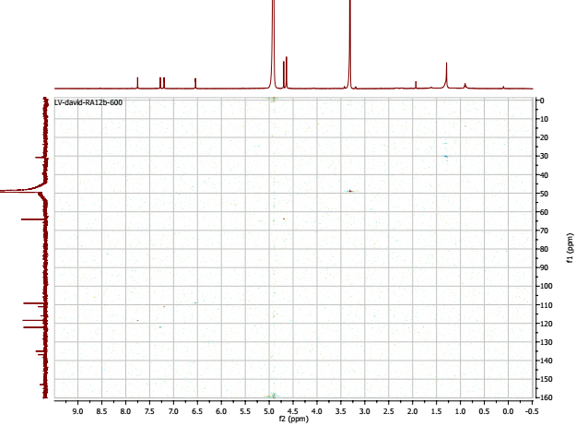
Figure S33: HSQC Spectrum of compound 5
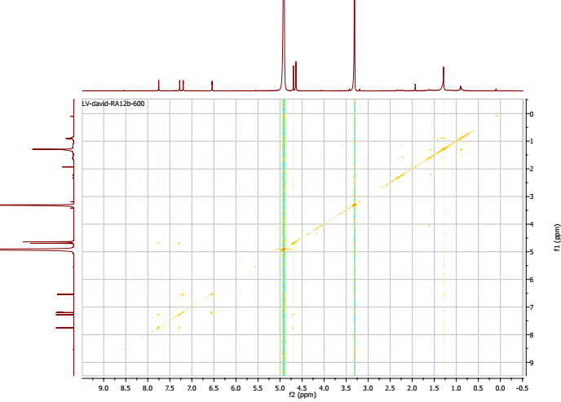
Figure S24: ¹H-¹H COSY Spectrum of compound 5
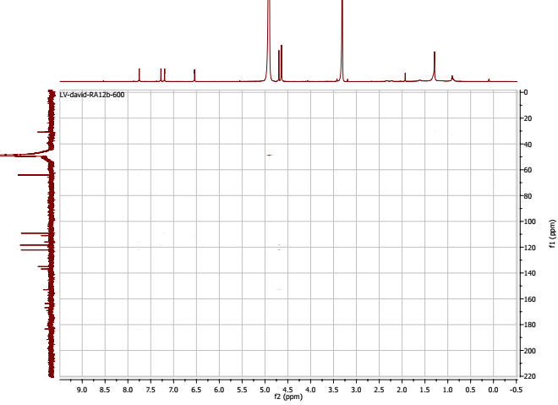
Figure S25: HMBC Spectrum of compound 5

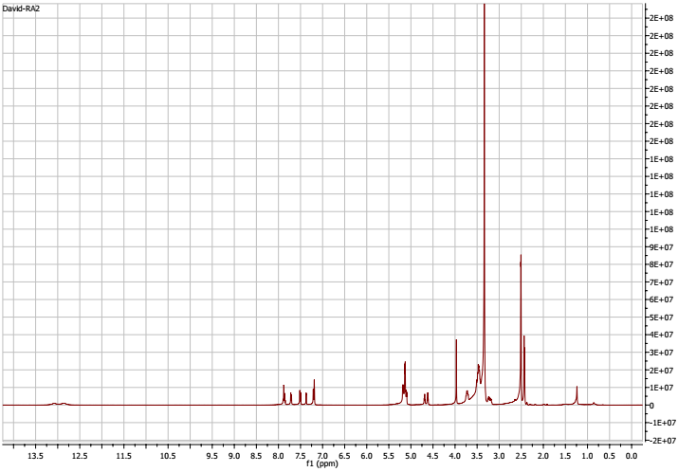
Figure S26: ¹H-NMR Spectrum of compounds 6 and 7

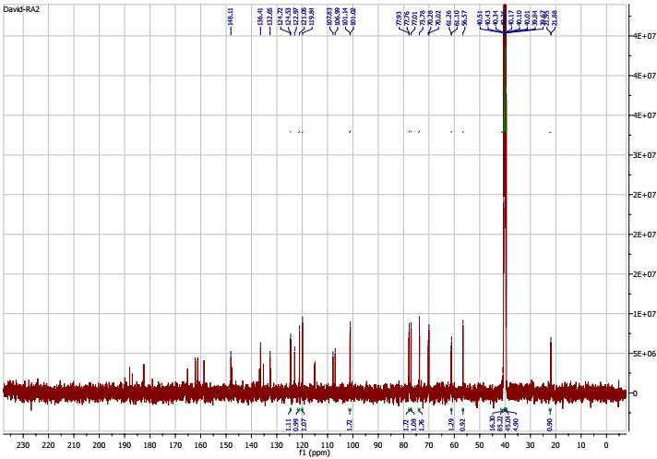
Figure S27: ¹³C-NMR Spectrum of compounds 6 and 7

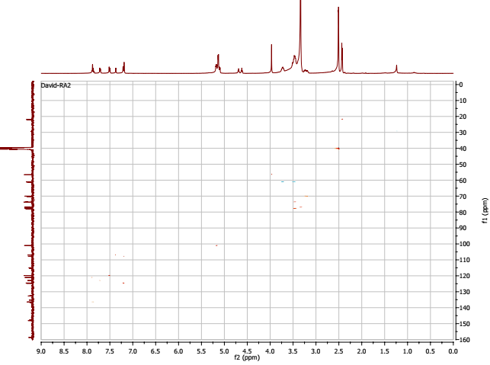
Figure S28: HSQC Spectrum of compounds 6 and 7

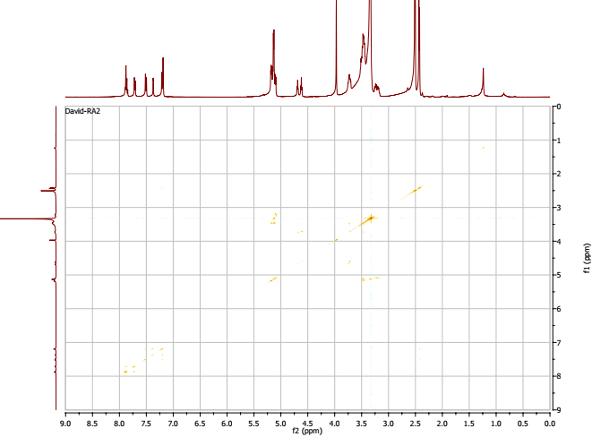
Figure S29: ¹H-¹HCOSY Spectrum of compounds 6 and 7
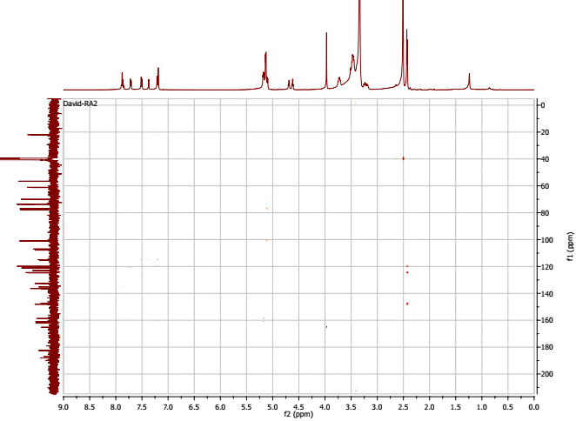
Figure S30: HMBC Spectrum of compounds 6 and 7

