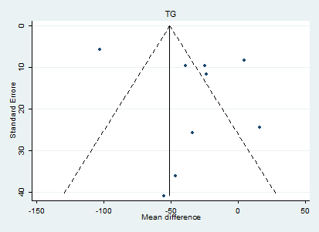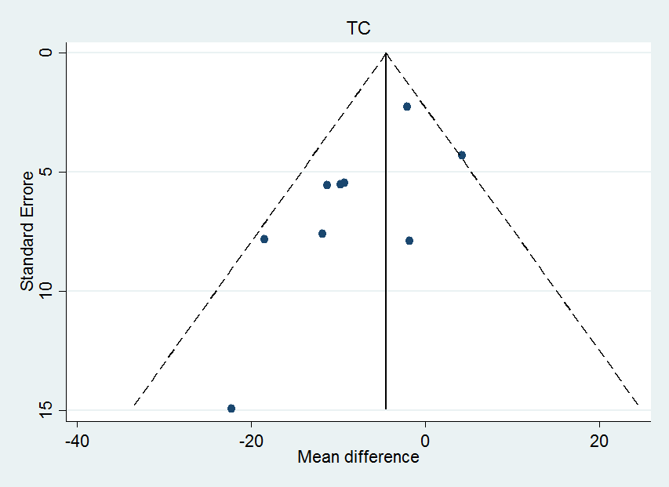
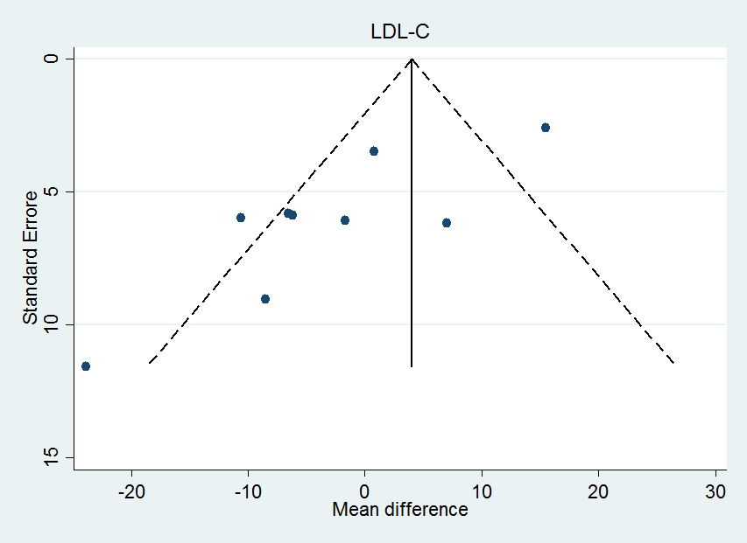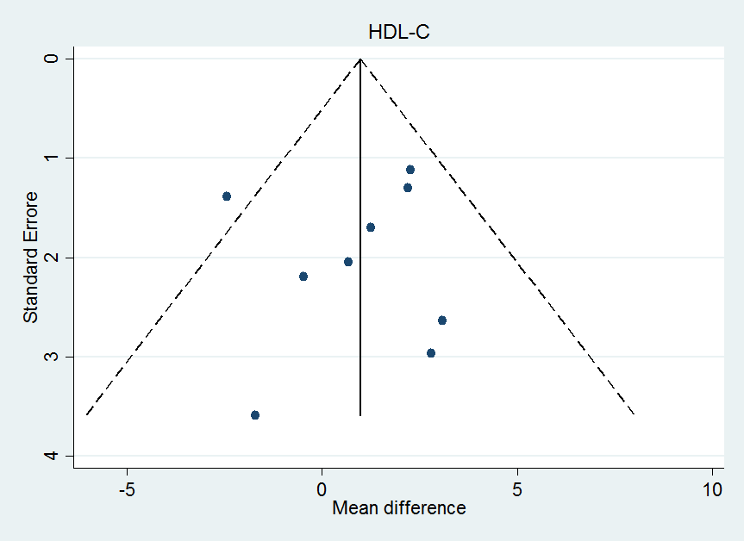
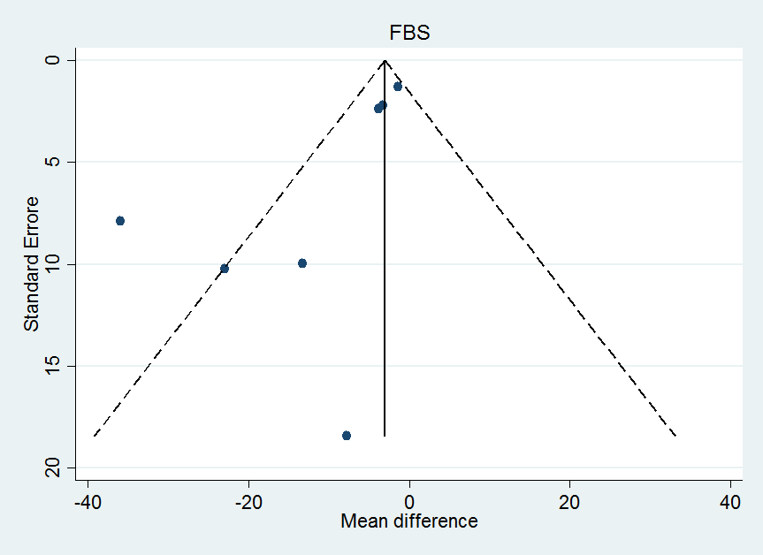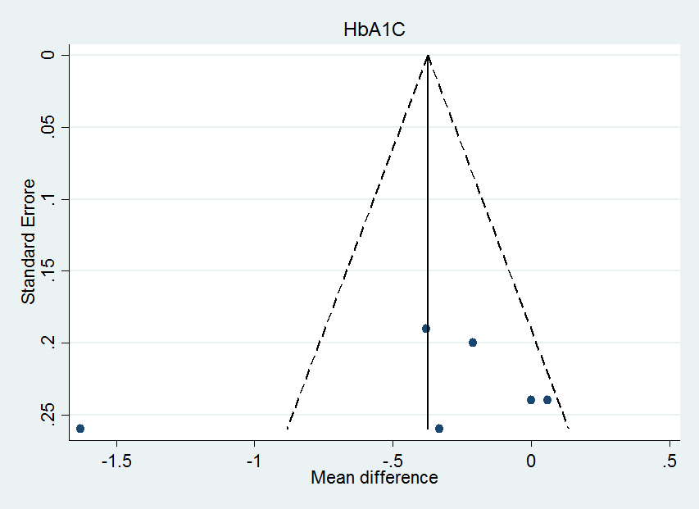
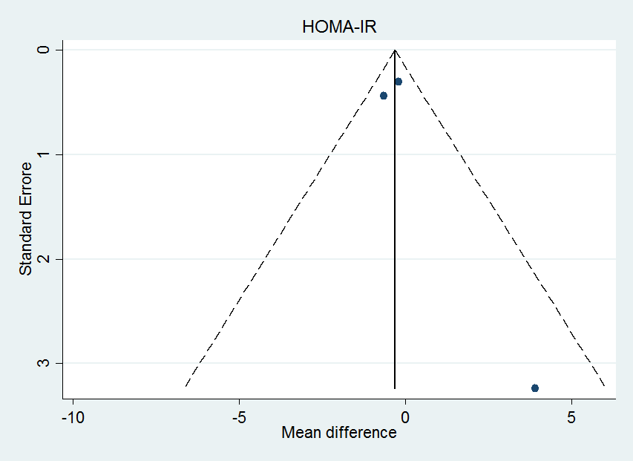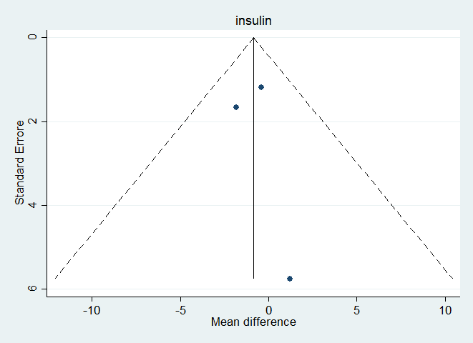
Supplemental Figure 2. Funnel plot illustrating publication bias in the studies reporting effect of apple cider vinegar intake on the lipid profiles and glycemic related markers. Abbreviations: TG: Triacylglycerol; TC: Total-Cholesterol; LDL-C: Low-density Lipoprotein Cholesterol; HDL-C: High-density Lipoprotein Cholesterol; FBS: Fasting Blood Glucose; HOMA-IR: Homeostatic Model Assessment of Insulin Resistance.

