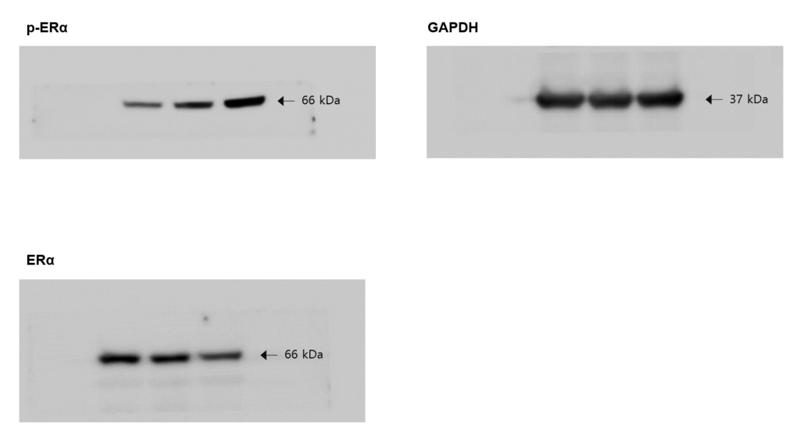
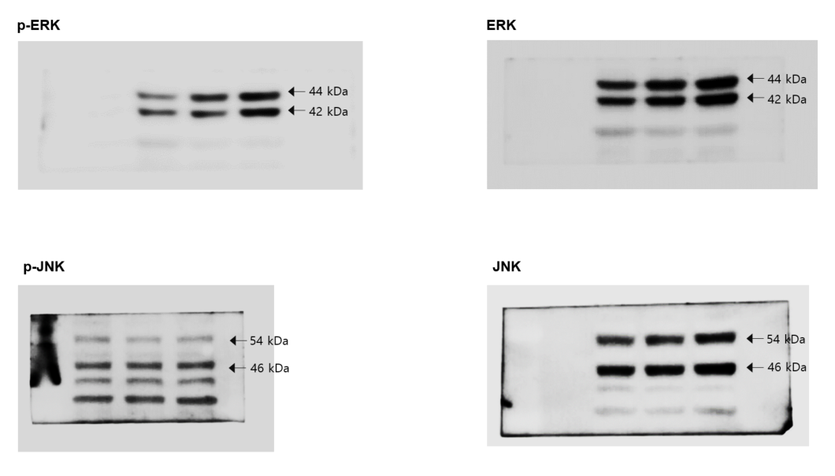
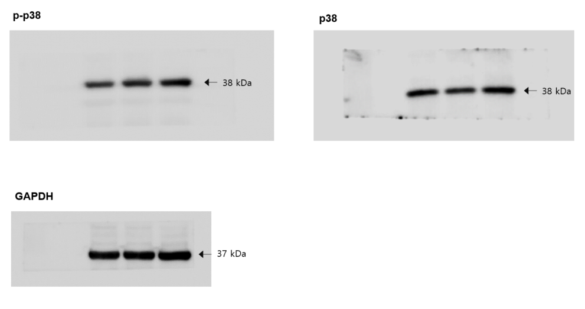
Supplementary Figure S1. Levels of estrogen receptor α (ERα) and MAPKs phosphorylation in MCF-7 cells, determined by western blotting, are shown by the dose of CME.

