In vitro anti-HIV and cytotoxic effects of pure compounds isolated from Croton macrostachyus Hochst. Ex Delile
Ermias Mergia Terefe ^{1,2,}*, Faith A. Okalebo² , Solomon Derese³, Moses K Langat ⁴, Eduard Mas-Claret⁴, Nada H. Aljarba⁵, Saad Alkahtani⁶, Gaber El-Saber Batiha⁷, Arabinda Ghosh⁸, Eman A. El-Masry⁹, and Joseph Muriuki¹⁰
¹ Department of Pharmacology and Pharmacognosy, School of Pharmacy and Health Sciences, United States International University-Africa, P.O. BOX 14634 – 00800, Nairobi, Kenya; eterefe@usiu.ac.ke
² Department of Pharmacology and Pharmacognosy, College of Health Sciences, University of Nairobi, Nairobi, Kenya; faith.okalebo@uonbi.ac.ke; eterefe@usiu.ac.ke
³ Department of Chemistry, University of Nairobi, Nairobi, Kenya; sderese@uonbi.ac.ke
⁴ Royal Botanic Gardens, Kew, Kew Green, Richmond, Surrey, TW9 3AE, UK; m.langat@kew.org; e.masclaret@kew.org
⁵ Department of Biology, College of Science, Princess Nourah bint Abdulrahman University, P. O. Box 84428, Riyadh 11671, Saudi Arabia. nhaljarba@pnu.edu.sa
⁶ Department of Zoology, College of Science, King Saud University, P. O. Box 2455, Riyadh 11451, Saudi Arabia. salkahtani@ksu.edu.sa
⁷ Department of Pharmacology and Therapeutics, Faculty of Veterinary Medicine, Damanhour University, Damanhour 22511, AlBeheira, Egypt; gaberbatiha@gmail.com
⁸ Microbiology Division, Department of Botany, Gauhati University, Guwahati, Assam-781014, India; dra.ghosh@gauhati.ac.in
⁹ Microbiology and Immunology unit, Department of Pathology, College of Medicine, Jouf University, Al-Jouf,Sakaka, Saudi Arabia, ealmasry@ju.edu.sa
¹⁰ Centre for Virus Research, Kenya Medical Research Institute, Nairobi, Kenya; jmuriuki@kemri.org
* Correspondence: eterefe@usiu.ac.ke; Tel.: +254746272742
Table of content

Figure 1 ¹H NMR spectra of 2-Methoxy benzyl benzoate (1) 4
Figure 2 ¹³C NMR spectra of 2-Methoxy benzyl benzoate (2) 5
Figure 3 DEPT spectrum of 2-Methoxy benzyl benzoate (1) 6
Figure 4 HSQCDEPT spectrum of 2-Methoxy benzyl benzoate (1) 7
Figure 5 HMBC spectrum of 2-Methoxy benzyl benzoate (1) 8
Figure 6 COSY spectrum of 2-Methoxy benzyl benzoate (1) 9
Figure 7 ¹H NMR spectrum of Lupenone (2) 10
Figure 8 ¹³C NMR spectrum of Lupenone (2) 11
Figure 9 DEPT spectrum of Lupenone (2) 12
Figure 10 HSQCDEPT spectrum of Lupenone (2) 13
Figure 11 HMBC spectrum of Lupenone (2) 14
Figure 12 COSY spectrum of Lupenone (2) 15
Figure 13 NOESY spectrum of Lupenone (2) 16
Figure 14 ¹H NMR spectrum of Lupeol acetate (3) 17
Figure 15 ¹³C NMR spectrum of Lupeol acetate (3) 18
Figure 16 DEPT spectrum of Lupeol acetate (3) 19
Figure 17 HSQCDEPT spectrum of Lupeol acetate (3) 20
Figure 18 HMBC spectrum of Lupeol acetate (3) 21
Figure 19 COSY spectrum of Lupeol acetate (3) 22
Figure 20 NOSEY spectrum of Lupeol acetate (3) 23
Figure 21 ¹H NMR spectrum of Betulin (4) 24
Figure 22 ¹³C NMR spectrum of Betulin (4) 25
Figure 23 DEPT spectrum of Betulin (4) 26
Figure 24 HSQCDEPT spectrum of Betulin (4) 27
Figure 25 HMBC spectrum of Betulin (4) 28
Figure 26 COSY spectrum of Betulin (4) 29
Figure 27 NOSEY spectrum of Betulin (4) 30
Figure 28 ¹H NMR spectrum of Lupeol (5) 31
Figure 29 ¹³C NMR spectrum of Lupeol (5) 32
Figure 30 DEPT spectrum of Lupeol (5) 33
Figure 31 HSQCDEPT spectrum of Lupeol (5) 34
Figure 32 HMBC spectrum of Lupeol (5) 35
Figure 33 COSY spectrum of Lupeol (5) 36
Figure 34 NOESY spectrum of Lupeol (5) 37
Figure 35 ¹H NMR Sitosterol (6) and stigmasterol (7) 38

Figure 1 ¹H NMR spectra of 2-Methoxy benzyl benzoate (1)

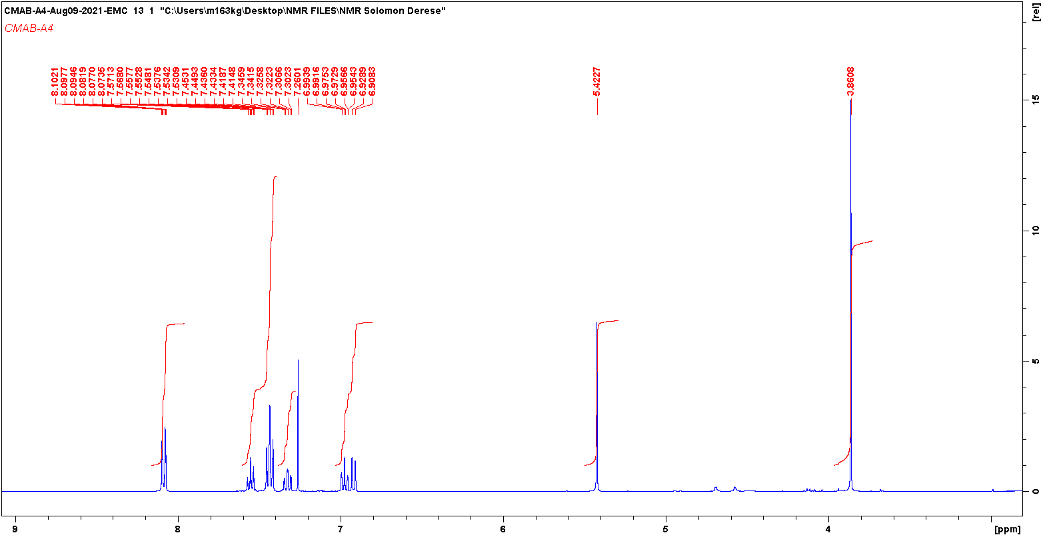

Figure 2 13C NMR spectra of 2-Methoxy benzyl benzoate (2)

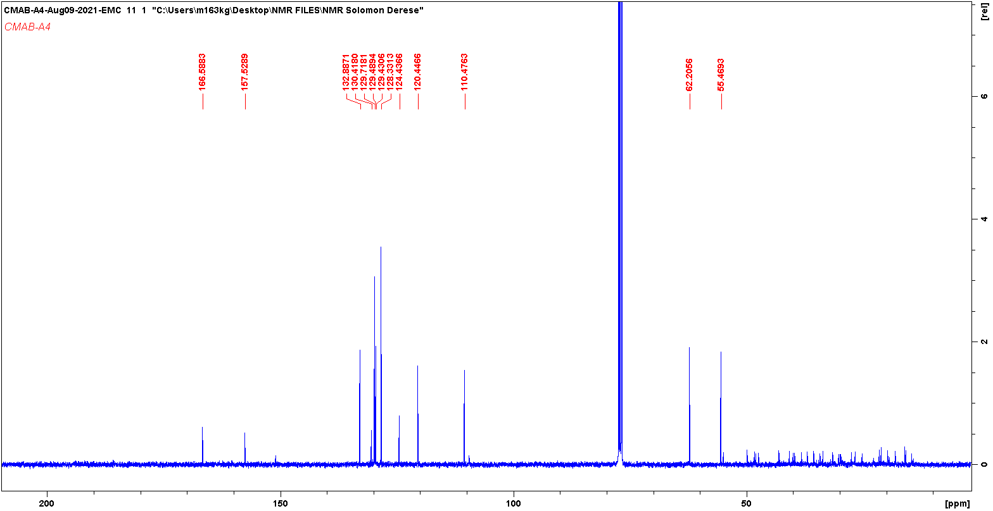

Figure 3 DEPT spectrum of 2-Methoxy benzyl benzoate (1)

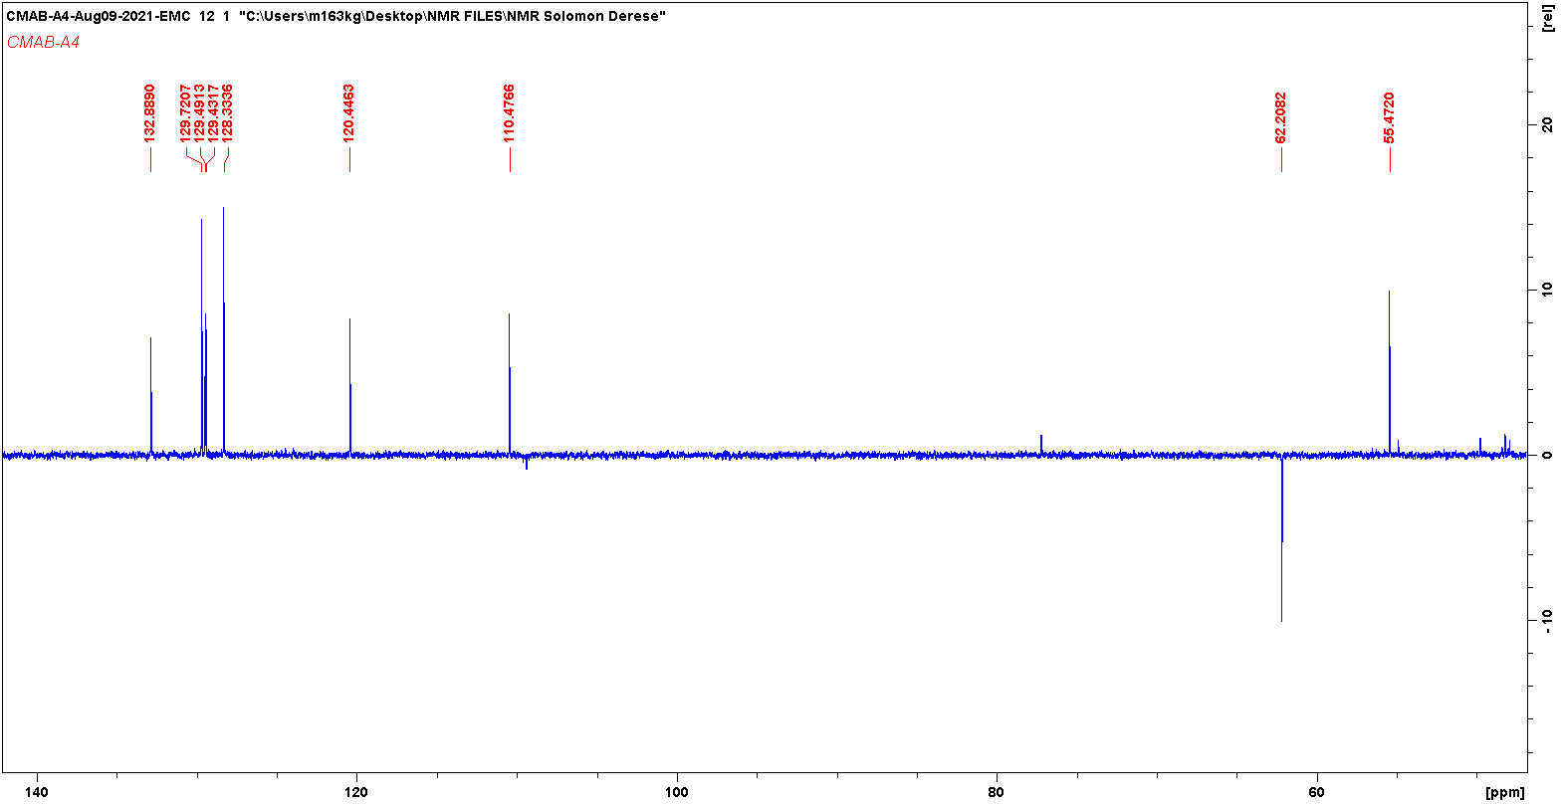

Figure 4 HSQCDEPT spectrum of 2-Methoxy benzyl benzoate (1)
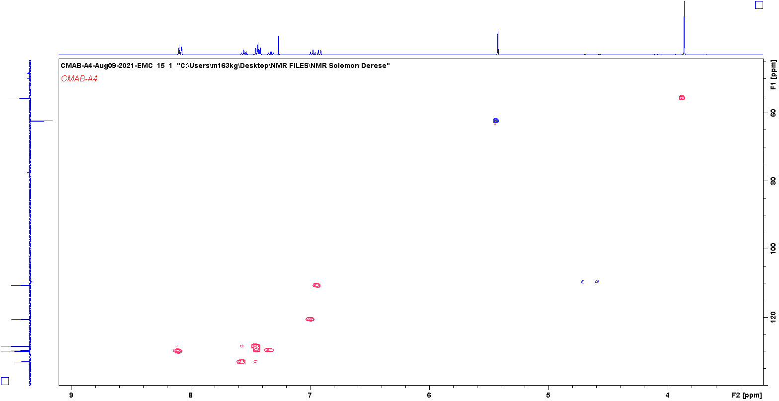

Figure 5 HMBC spectrum of 2-Methoxy benzyl benzoate (1)
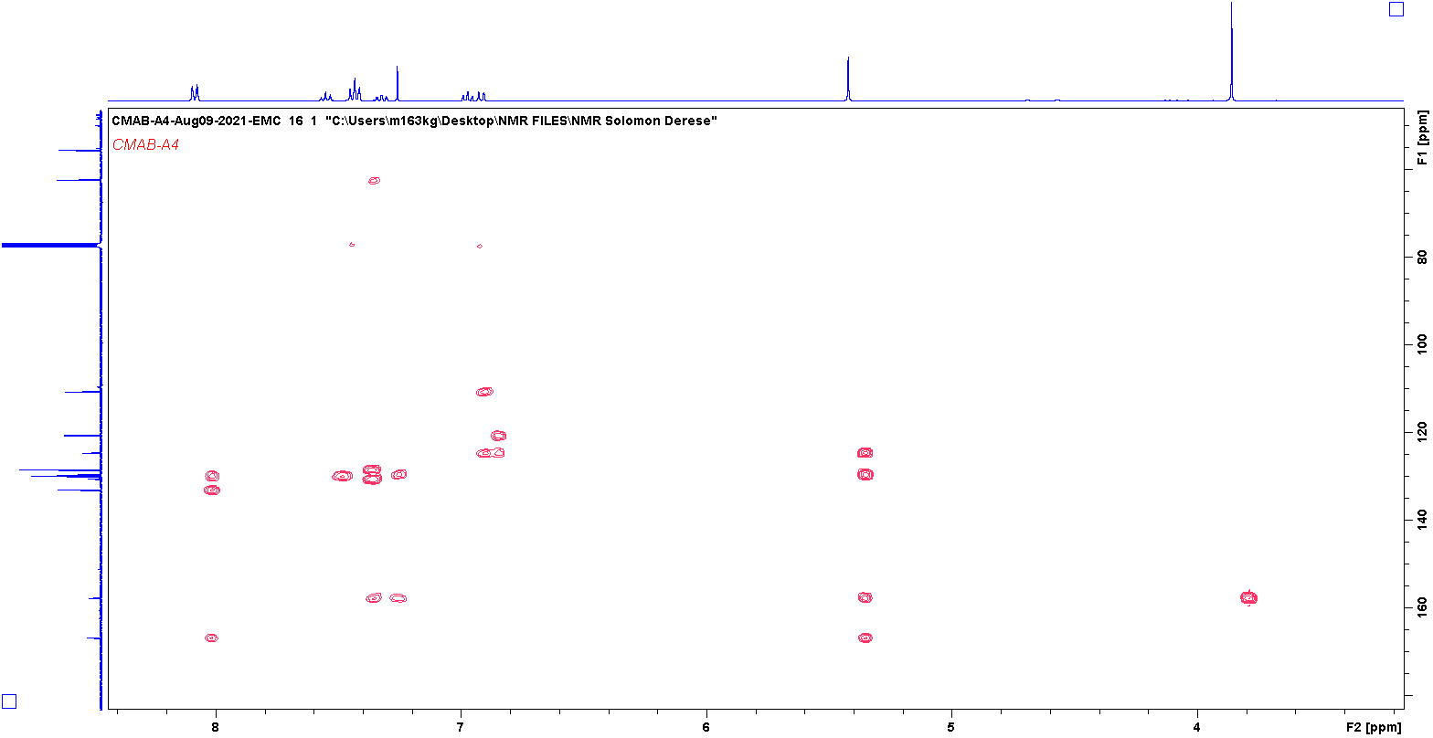

Figure 6 COSY spectrum of 2-Methoxy benzyl benzoate (1)
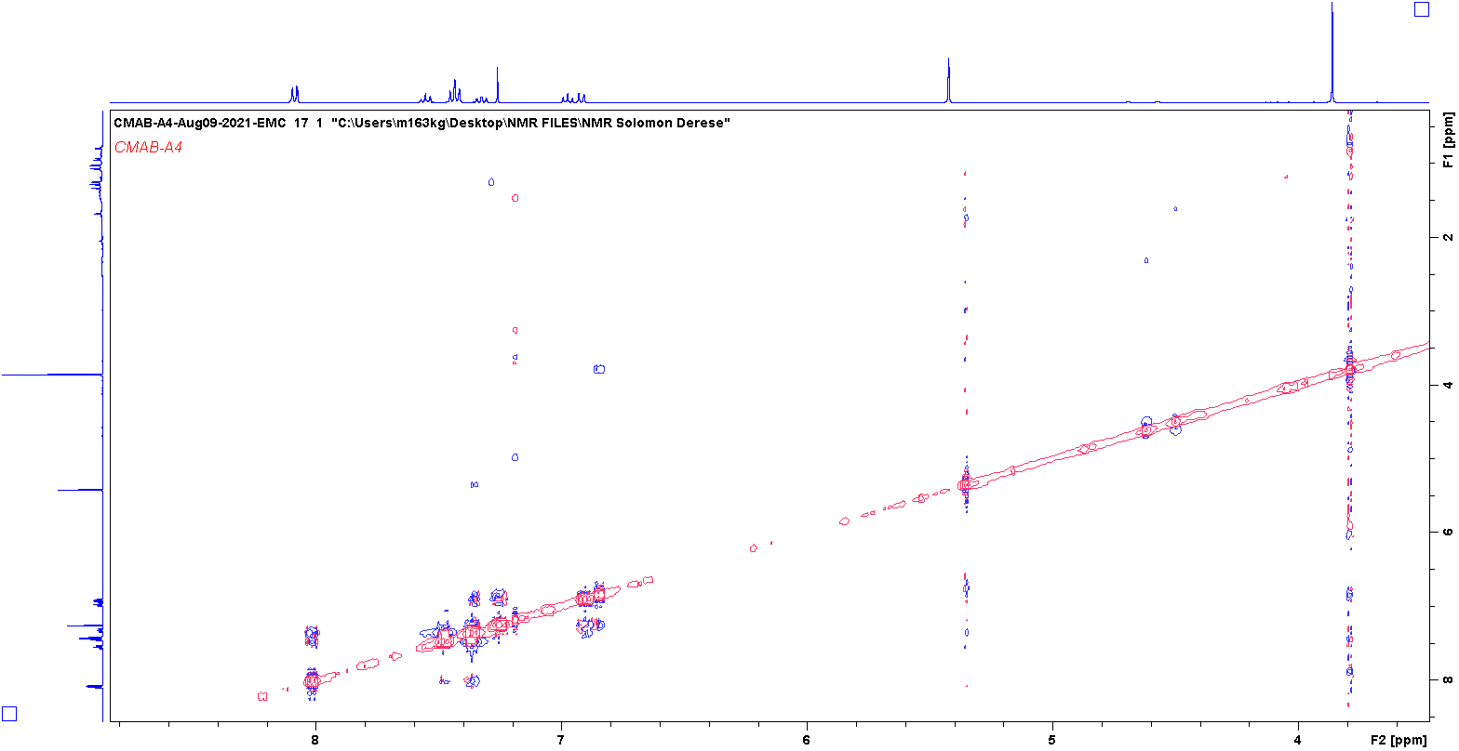

Figure 7 1H NMR spectrum of Lupenone (2)

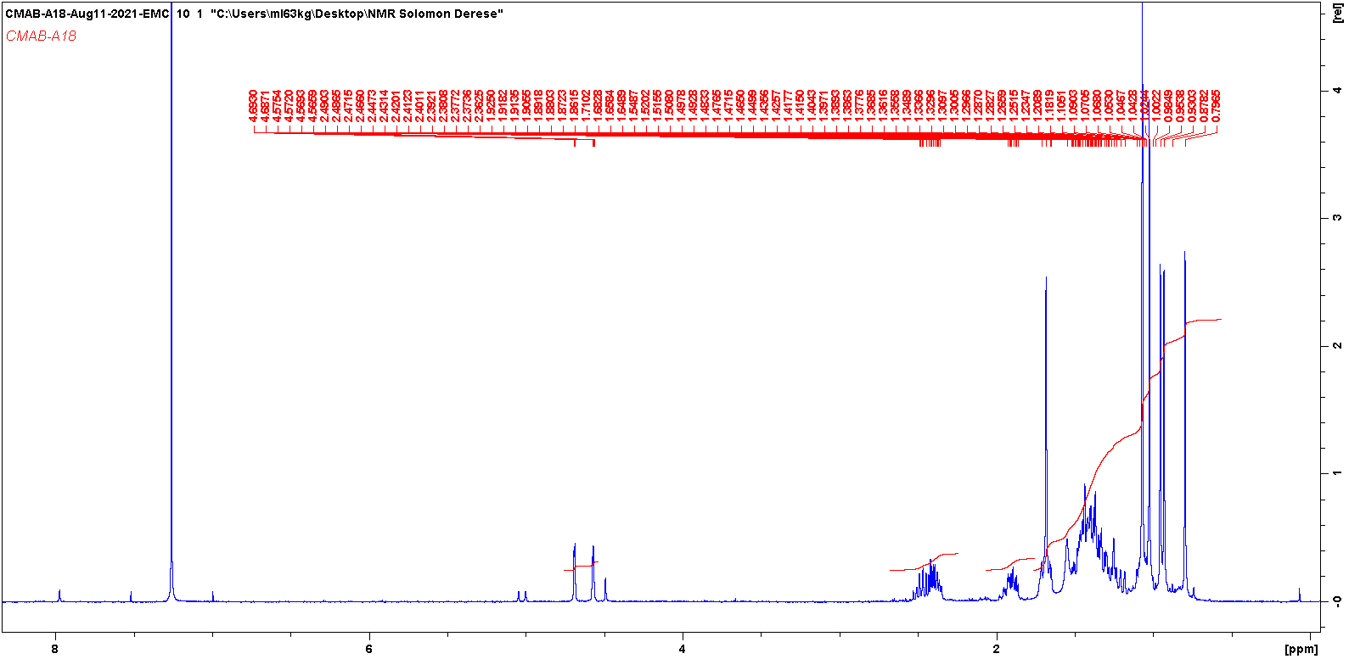

Figure 8 13C NMR spectrum of Lupenone (2)

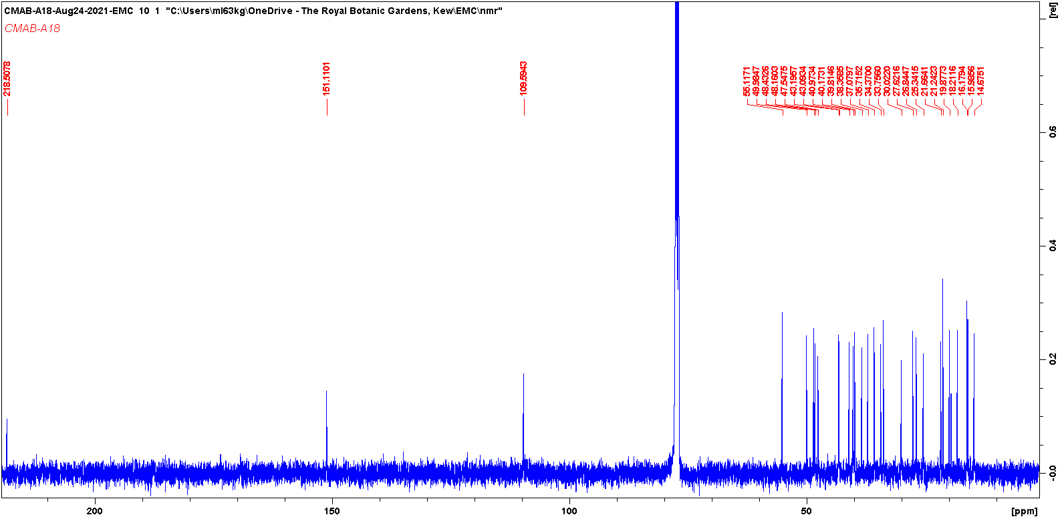

Figure 9 DEPT spectrum of Lupenone (2)

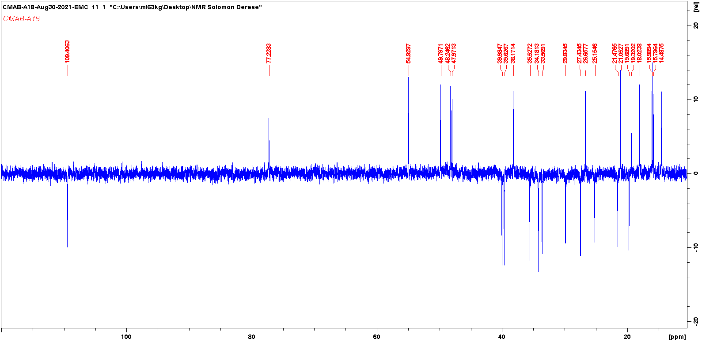

Figure 10 HSQCDEPT spectrum of Lupenone (2)
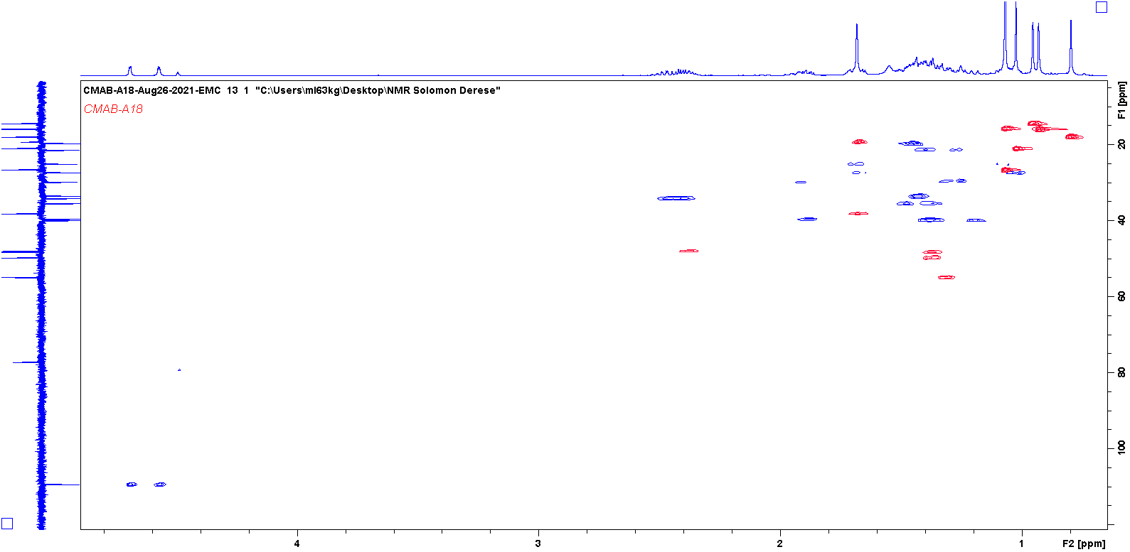

Figure 11 HMBC spectrum of Lupenone (2)
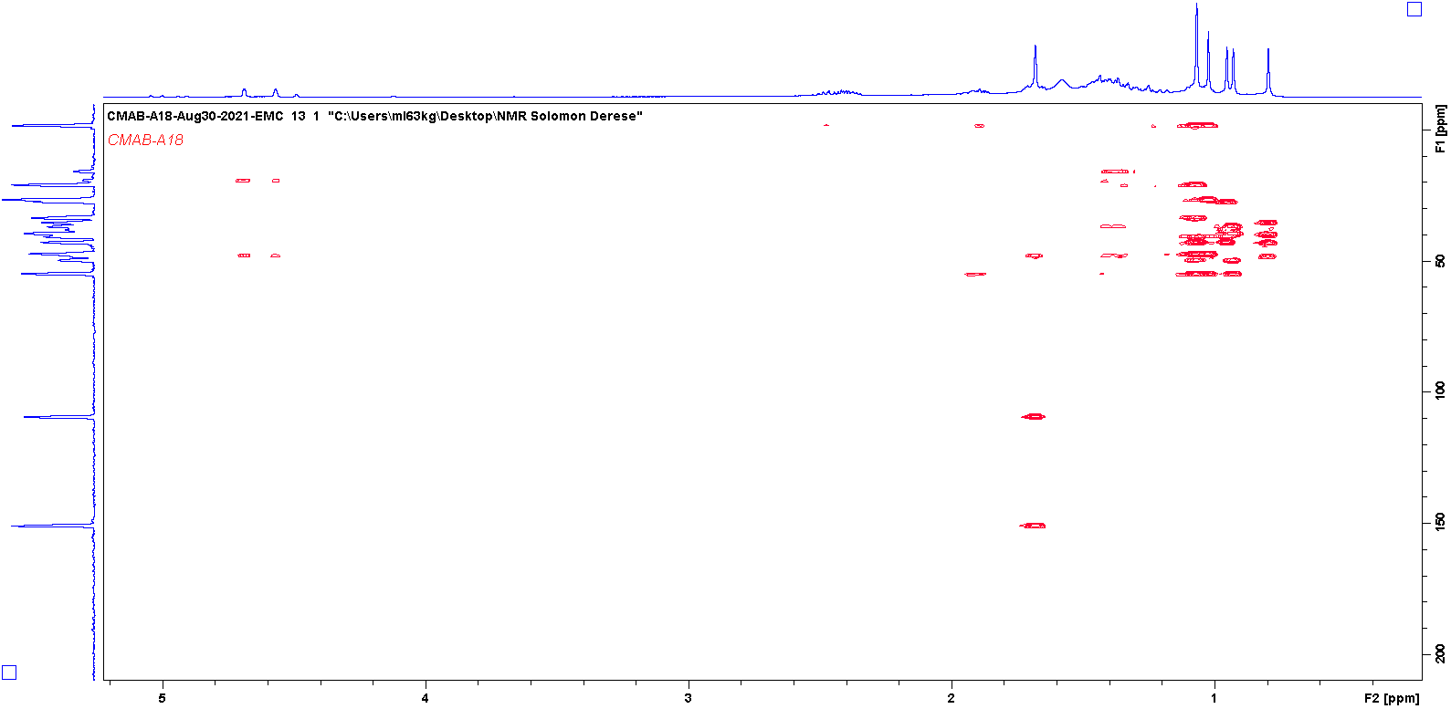

Figure 12 COSY spectrum of Lupenone (2)
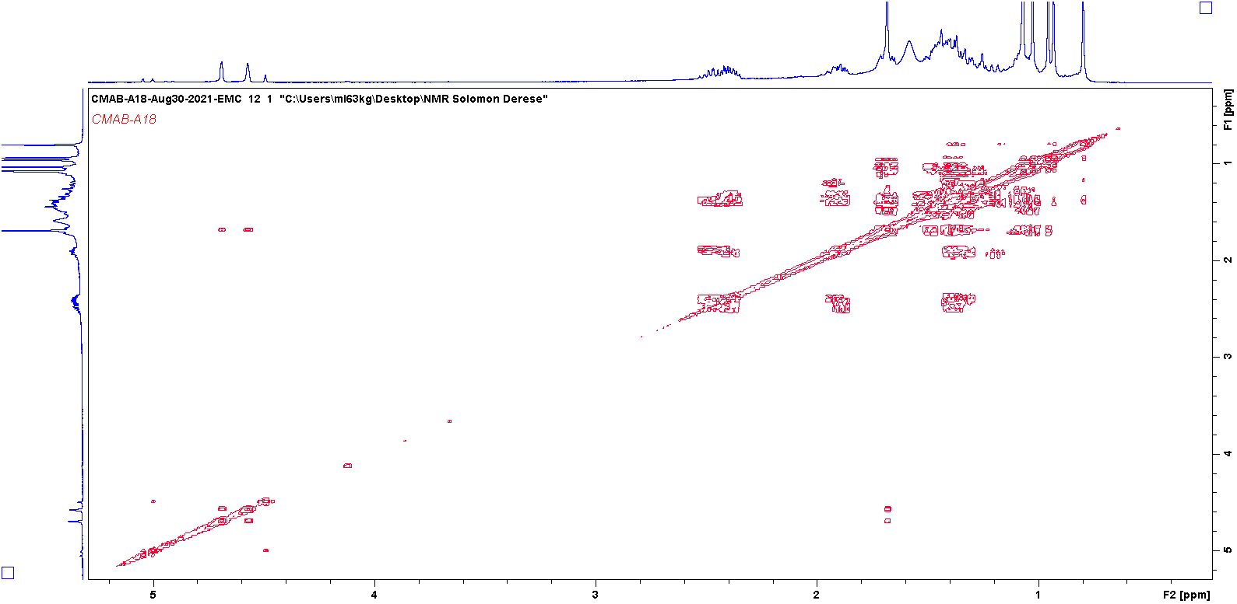

Figure 13 NOESY spectrum of Lupenone (2)
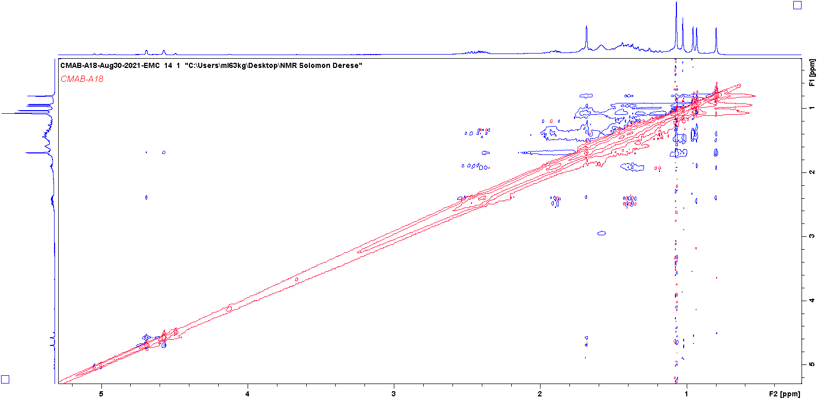

Figure 14 1H NMR spectrum of Lupeol acetate (3)
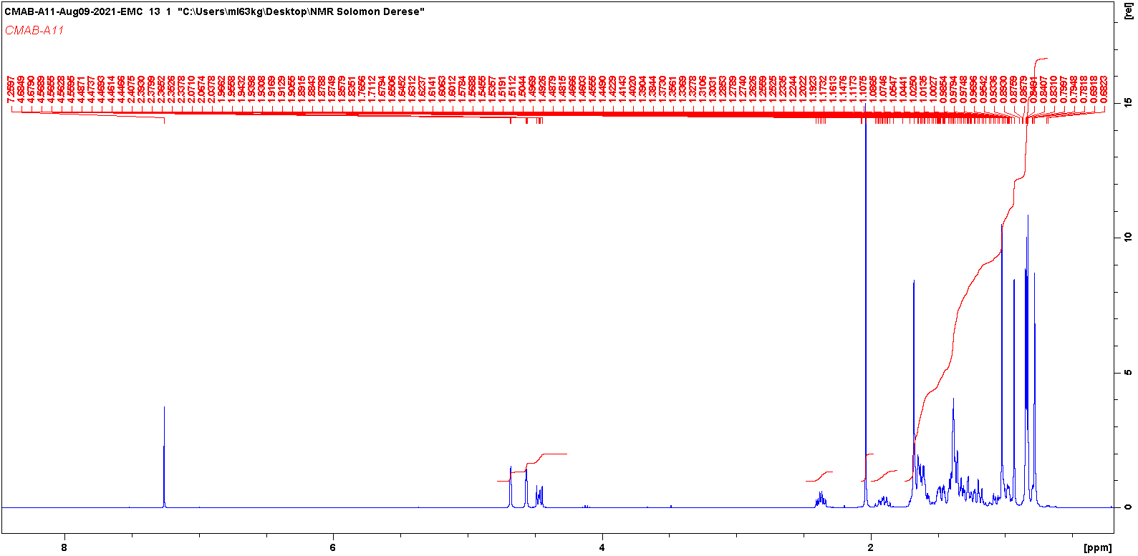

Figure 15 13C NMR spectrum of Lupeol acetate (3)
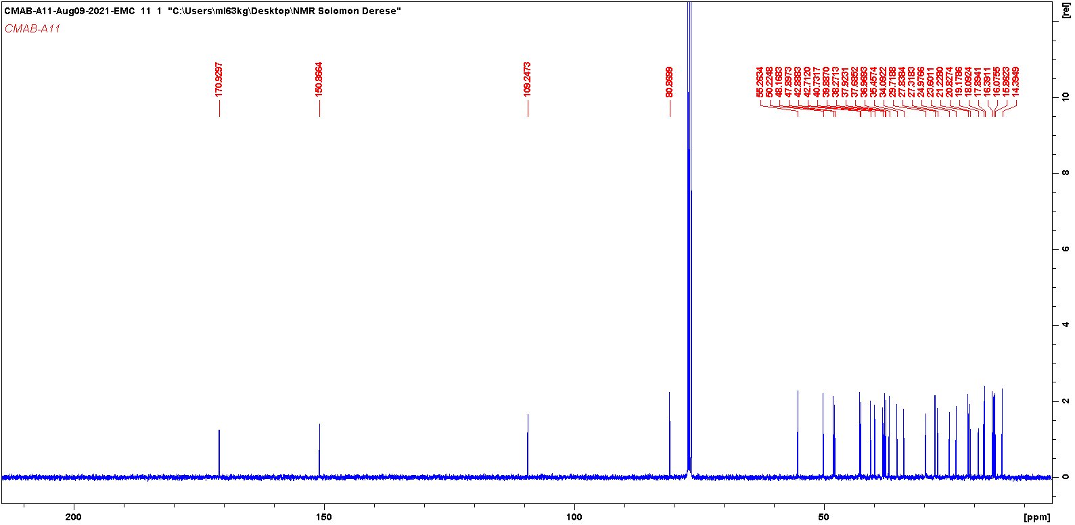

Figure 16 DEPT spectrum of Lupeol acetate (3)
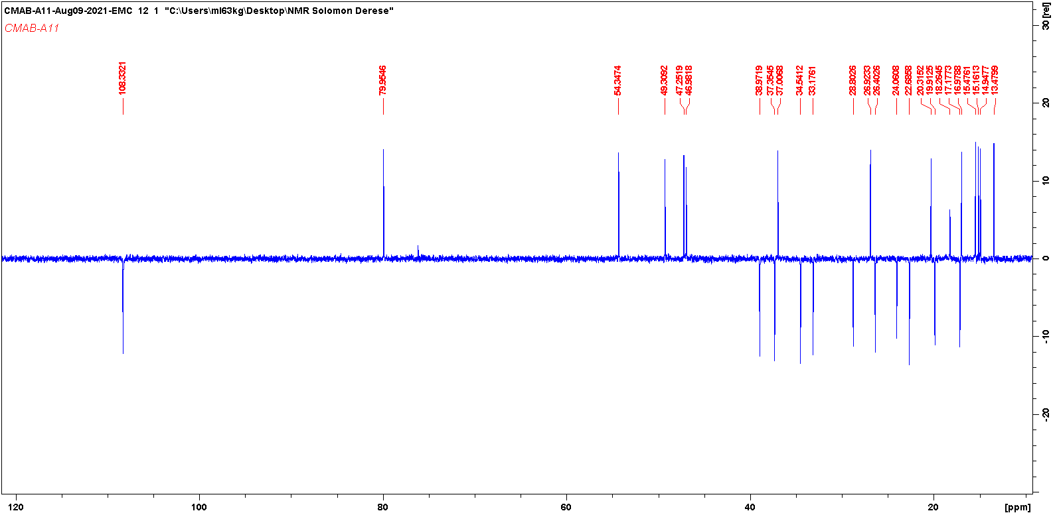

Figure 17 HSQCDEPT spectrum of Lupeol acetate (3)
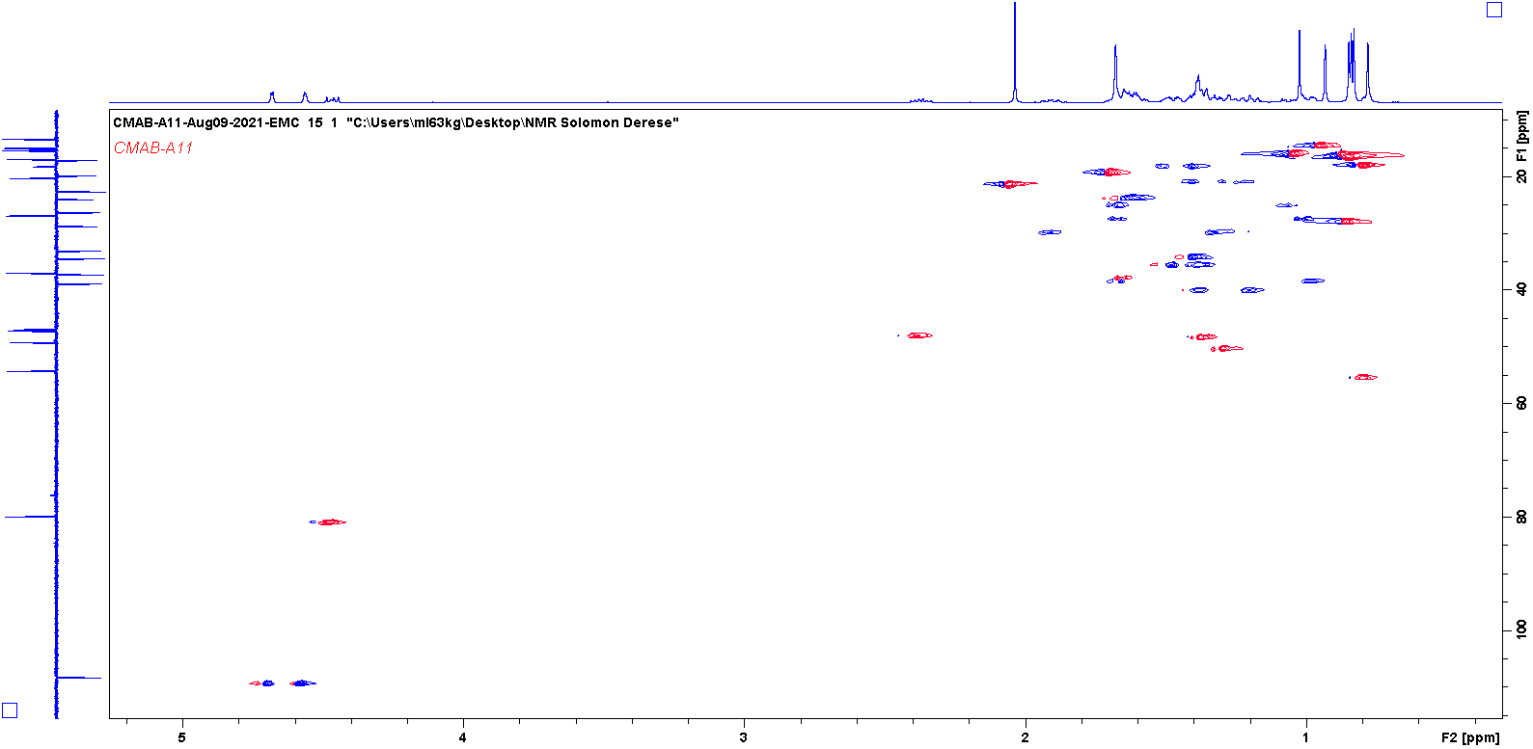

Figure 18 HMBC spectrum of Lupeol acetate (3)
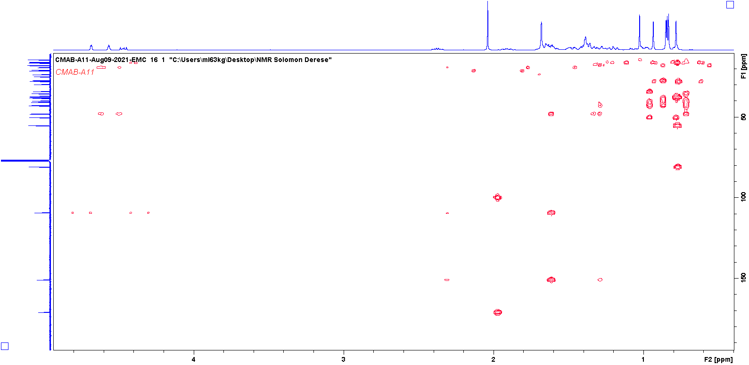

Figure 19 COSY spectrum of Lupeol acetate (3)
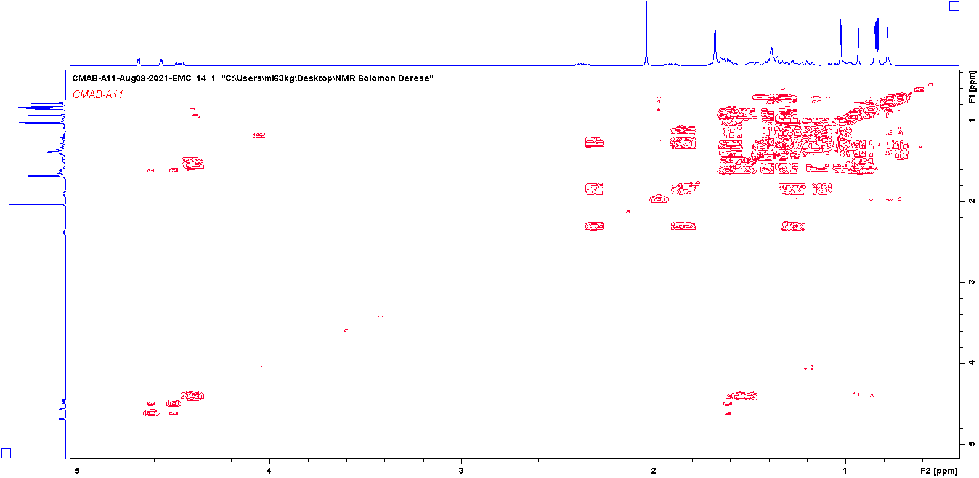

Figure 20 NOSEY spectrum of Lupeol acetate (3)
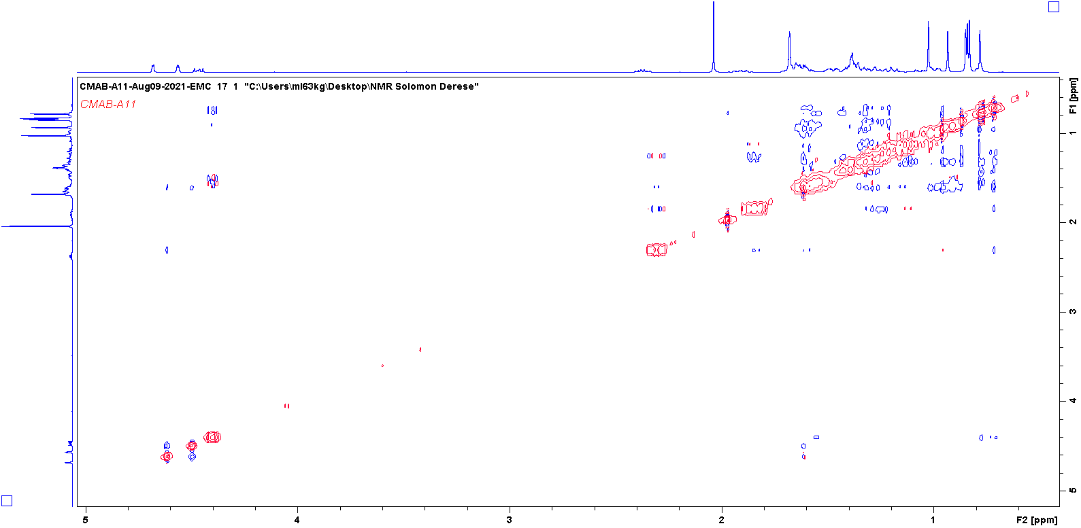

Figure 21 1H NMR spectrum of Betulin (4)

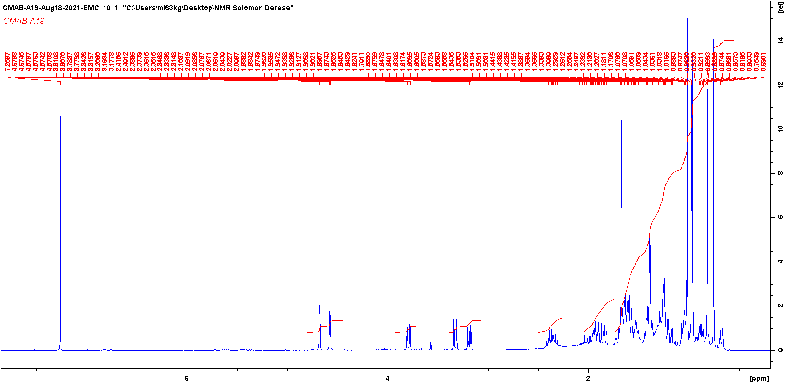

Figure 22 13C NMR spectrum of Betulin (4)

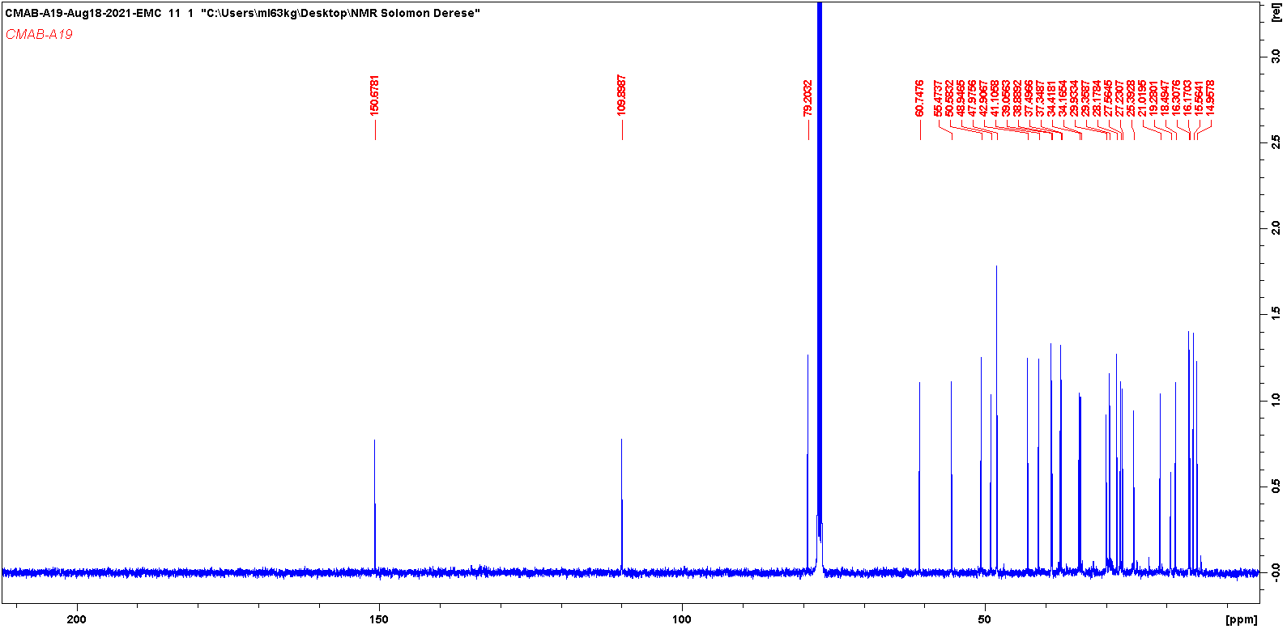

Figure 23 DEPT spectrum of Betulin (4)

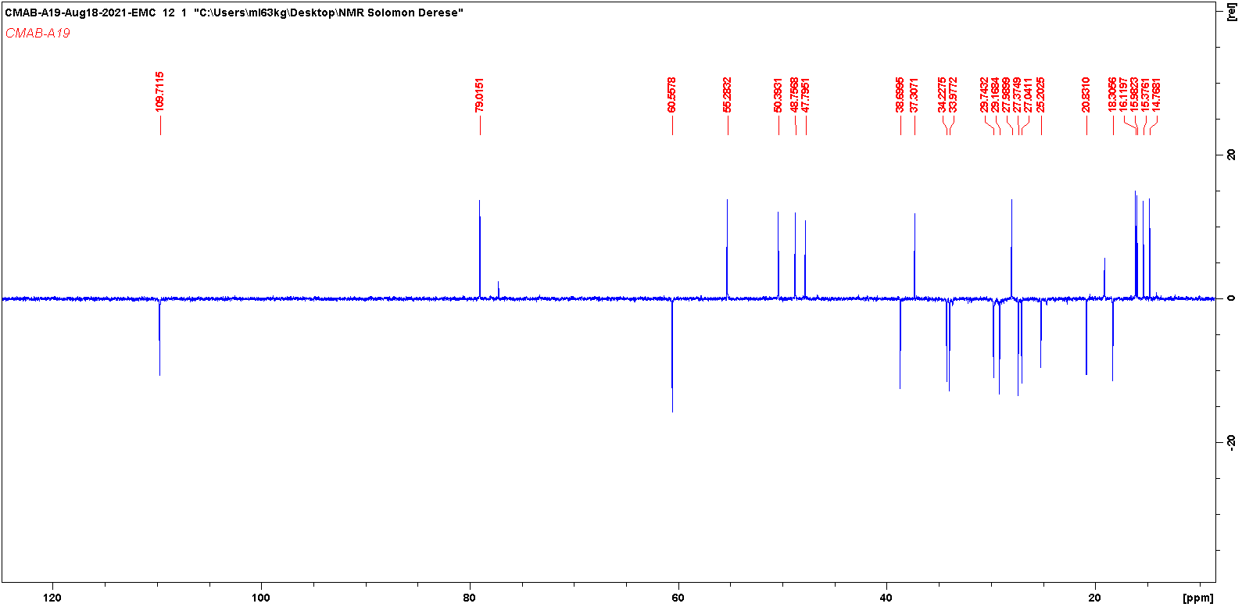

Figure 24 HSQCDEPT spectrum of Betulin (4)
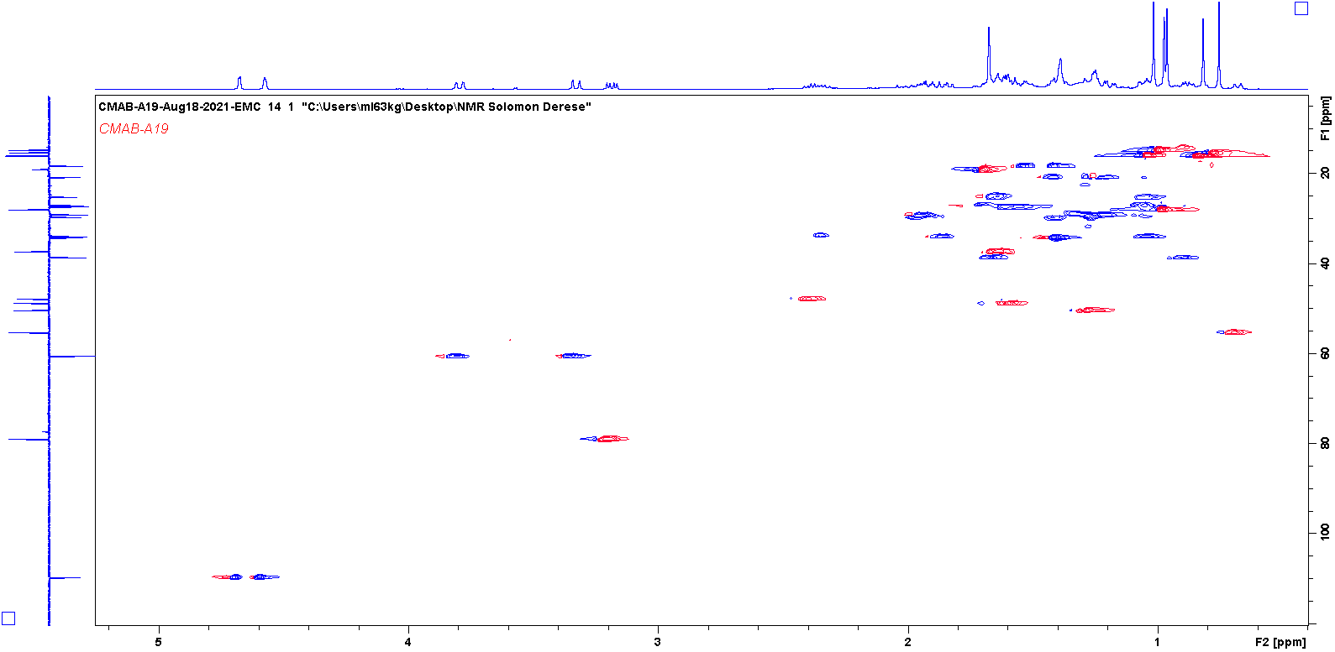

Figure 25 HMBC spectrum of Betulin (4)
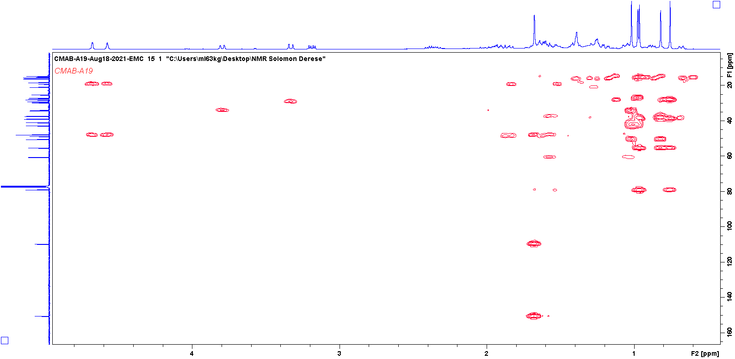

Figure 26 COSY spectrum of Betulin (4)
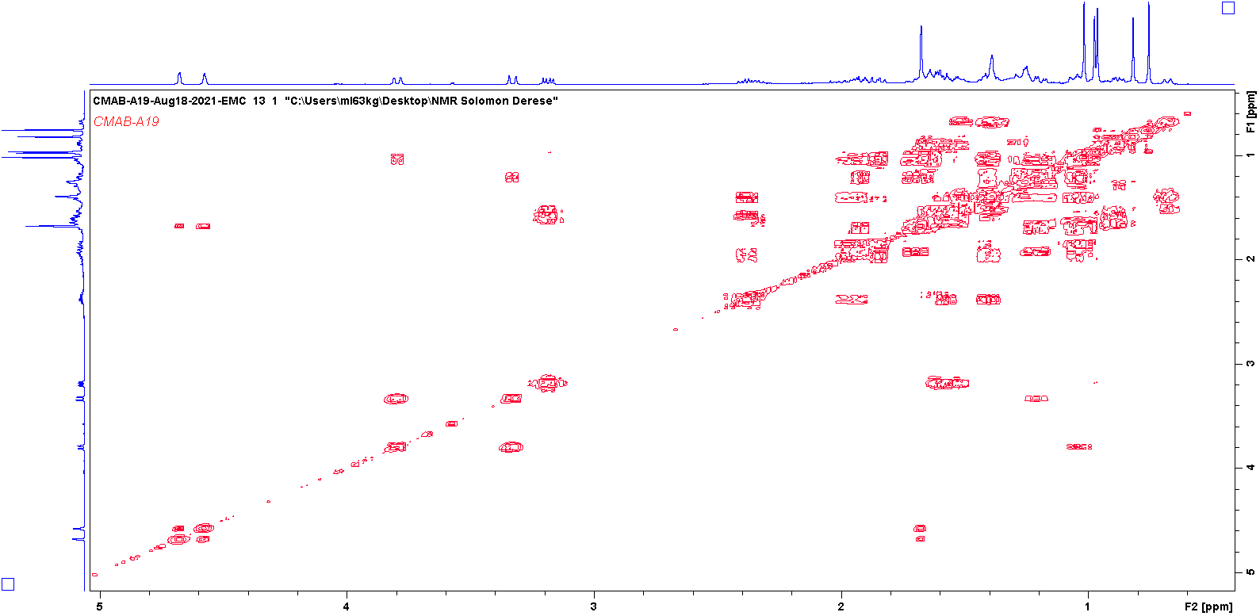

Figure 27 NOSEY spectrum of Betulin (4)
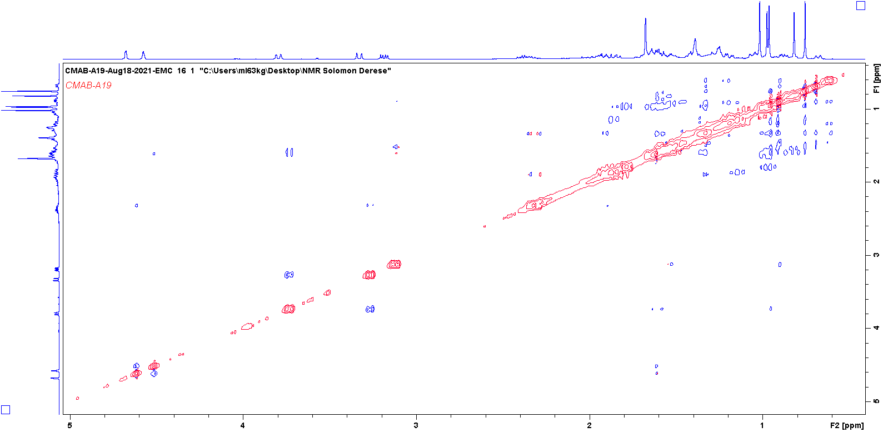

Figure 28 1H NMR spectrum of Lupeol (5)

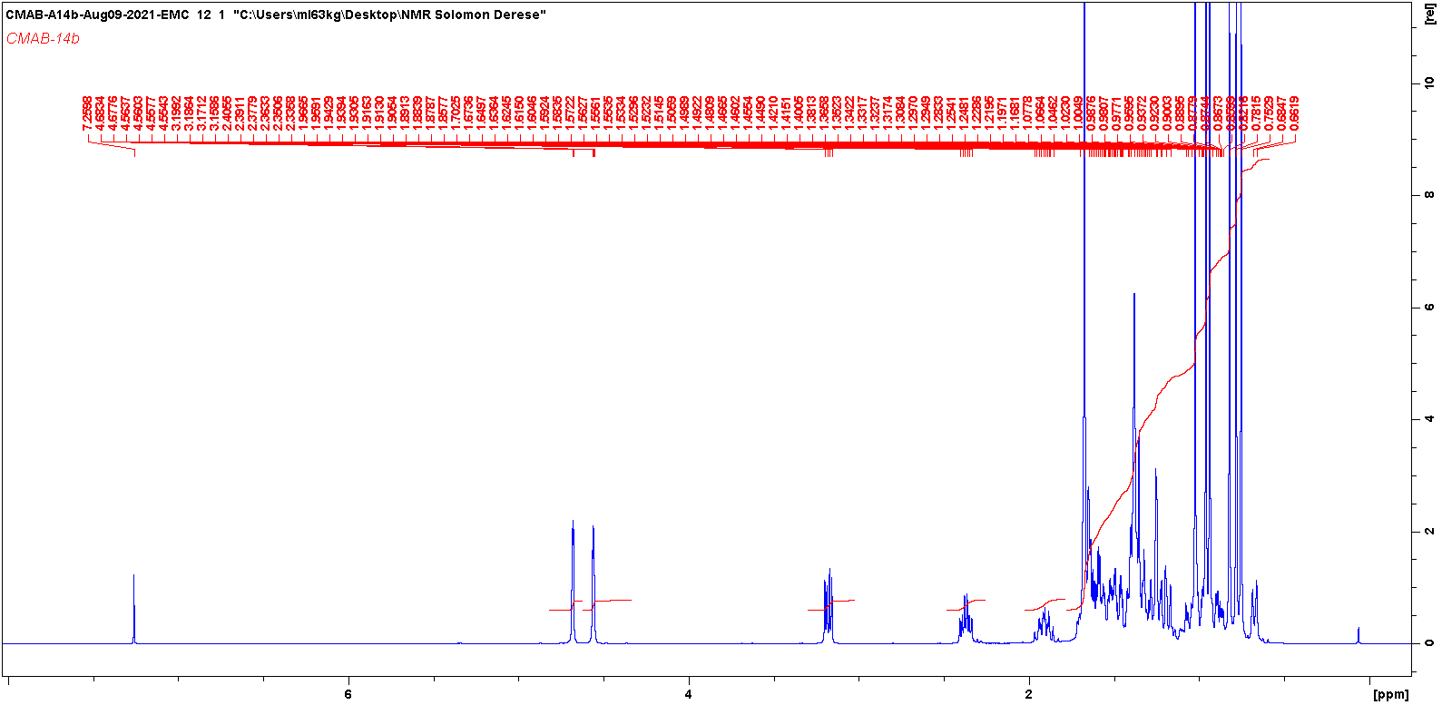

Figure 29 13C NMR spectrum of Lupeol (5)

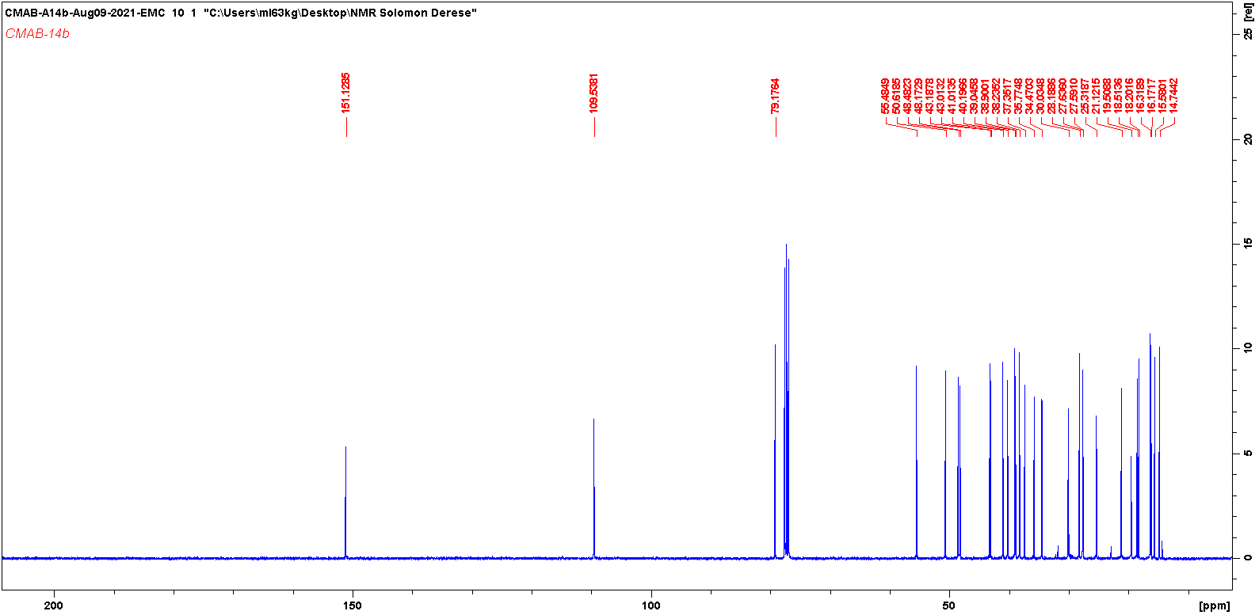

Figure 30 DEPT spectrum of Lupeol (5)

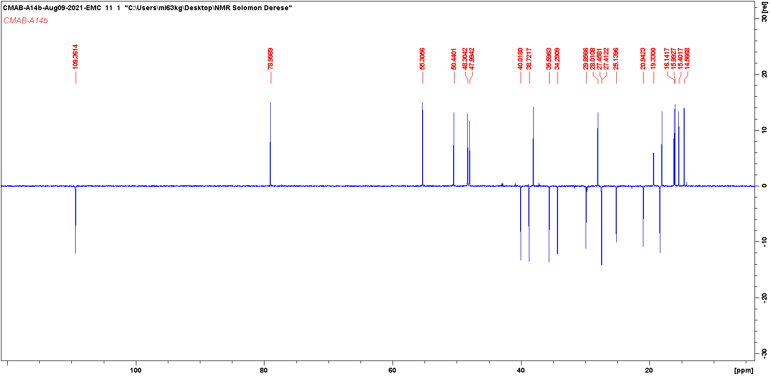

Figure 31 HSQCDEPT spectrum of Lupeol (5)
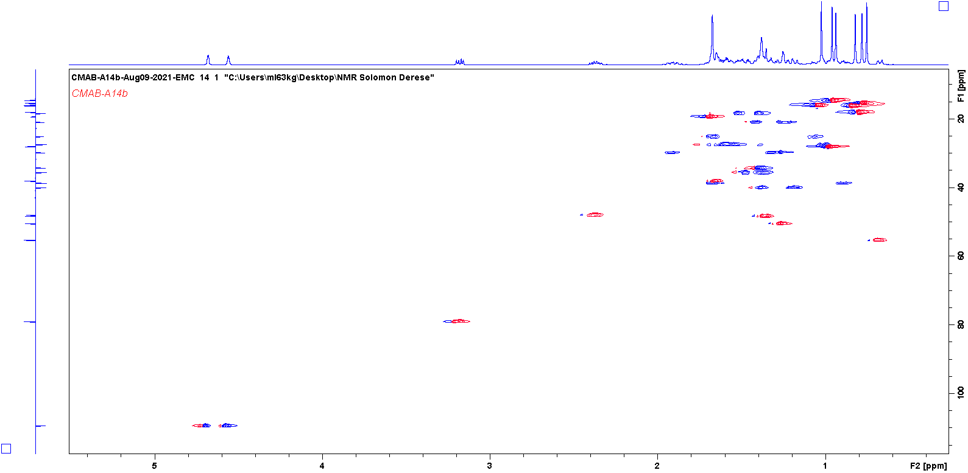

Figure 32 HMBC spectrum of Lupeol (5)
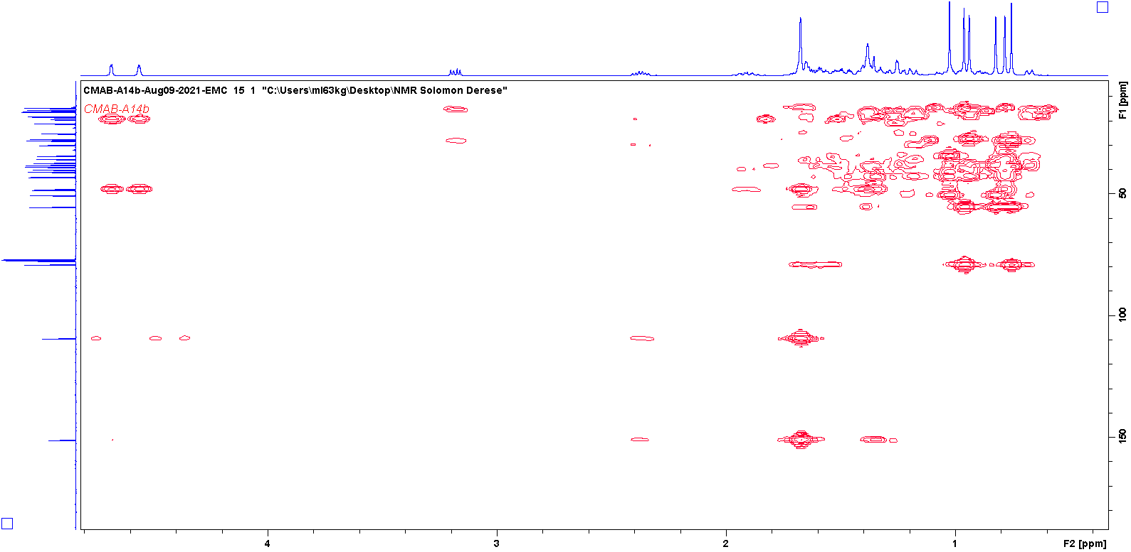

Figure 33 COSY spectrum of Lupeol (5)
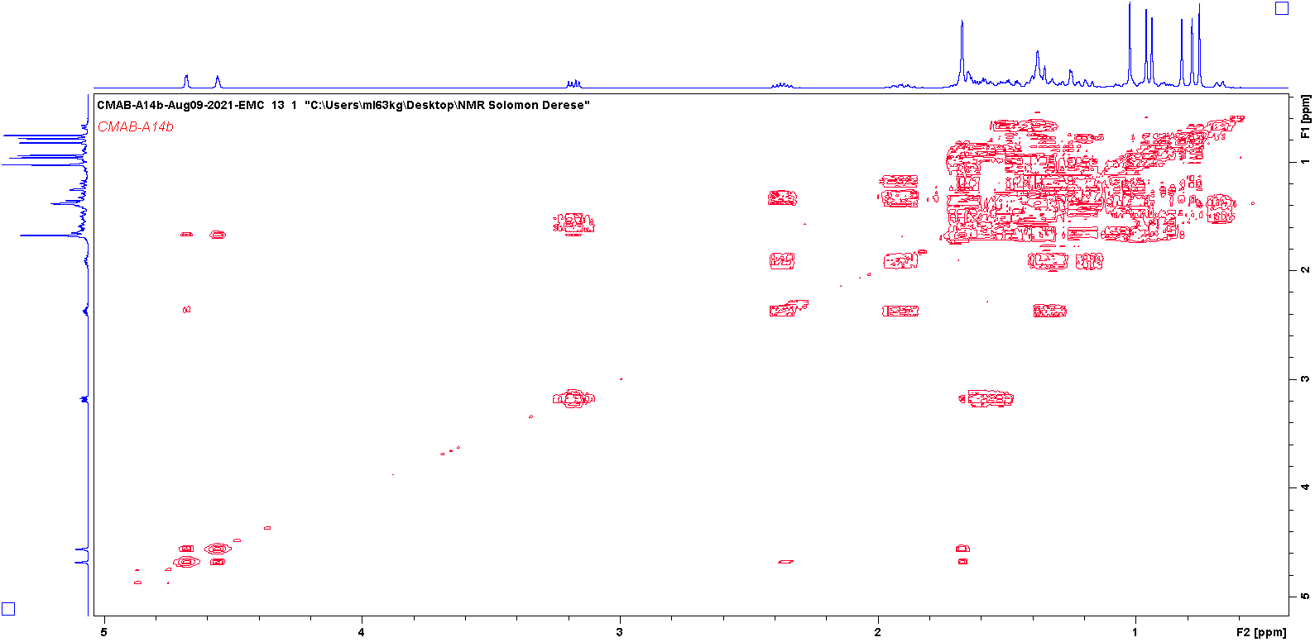

Figure 34 NOESY spectrum of Lupeol (5)
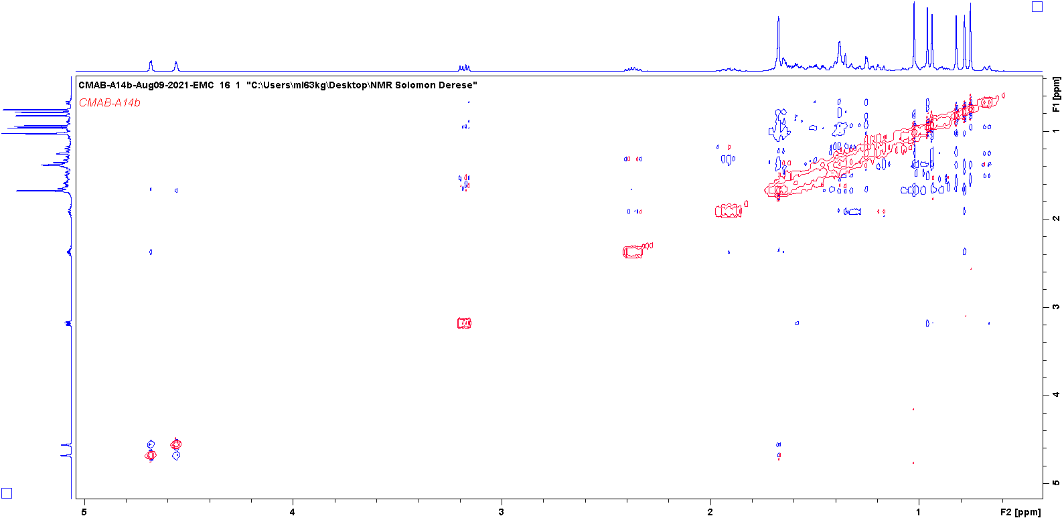

Figure 35 1H NMR Sitosterol (6) and stigmasterol (7)
