Antibacterial and antibiotic-potentiation activity of the constituents from aerial part of Donella welwitshii (Sapotaceae) against multidrug resistant phenotypes

Michel-Gael F. Guefack¹, Marcelle O. Ngangoue², Armelle T. Mbaveng¹, Paul Nayim^{1*}, Carine M. N. Ngaffo¹, Jenifer R. N. Kuete³, Godloves F. Chi⁴, Bathelemy Ngameni⁵, Bonaventure T. Ngadjui², Victor Kuete¹*

¹Department of Biochemistry, Faculty of Science, University of Dschang, Dschang, Cameroon;
² Department of Organic Chemistry, Faculty of Science University of Yaoundé 1, Yaoundé, Cameroon
³ Department of Chemistry, Faculty of Science, University of Dschang, Dschang, Cameroon
⁴ Department of Chemistry, Faculty of Science, University of Buea, Buea, Cameroon
⁵Department of Pharmacognosy and Pharmaceutical Chemistry, Faculty of Medicine and Biomedical Sciences, University of Yaoundé I, Yaoundé, Cameroon

*Corresponding author:
E-mail: armbatsa@yahoo.fr; ORCID: 0000-0003-4178-4967 (Prof. Dr. Armelle T. Mbaveng); E-mail: kuetevictor@yahoo.fr; ORCID: 0000-0002-1070-1236 (Prof. Dr. Victor Kuete)

Other authors emails:
Michel-Gael F. Guefack: michelfofack@gmail.com
Marcelle O. Ngangoue: marcellengangoue@yahoo.com
Paul Nayim: nayimpaul@yahoo.fr
Carine M. N. Ngaffo: ngaffocarine993@gmail.com
Jenifer R. N. Kuete: jeniferkuete@gmail.com
Godloves F. Chi: chigodloves@yahoo.com
Bathelemy Ngameni: bath_ngameni@yahoo.fr
Bonaventure T. Ngadjui: ngadjuibt@yahoo.fr

SM1. Physical properties and NMR data of Compounds 1 – 11.

Compound (1): 3-β-D-glucopyranosyl-2,4,6-trihydroxyl(4-phenyl)methanone, (C₁₉H₂₀O₁₀); red-brown paste soluble in MeOH, HRESI-MS [M+H]⁺ at m/z: 410.1210.¹H NMR (400 MHz, DMSO), δ (ppm): 7.58 (2H, d, J = 8.8 Hz, H-2’, H-6’), 6.79 (2H, d, J = 8.4 Hz, H-3’, H-5’), 5.96 (1H, s, H-5), 4.61 (1H, d, J = 9.6 Hz, H-1’’), 3.64 (1H, d, J = 9.2 Hz, H-2’’), 3.58 (1H, d, J = 13.8 Hz, H-3’’), 3.51 (1H, dd, J = 4.5 Hz, H-4’’), 3.20 (2H, dd, J = 6.6 Hz, H-6’’), 3.19 (1H, m, J = 16.5 Hz, H-5’’). ¹³C NMR (100 MHz, DMSO), δ (ppm): 195.1 (C-7), 161.8 (C-4’), 159.5 (C-4), 157.9 (C-3), 157.2 (C-2), 132.0 (C-2’, C-6’), 131.2 (C-1’), 115.1 (C-3’, C-5’), 107.4 (C-1), 104.1 (C-5), 95.3 (C-5), 81.6 (C-5’’), 78.8 (C-3’’), 75.1 (C-1’’), 72.3 (C-2’’), 70.1 (C-4’’), 61.0 (C-6’’) [1].

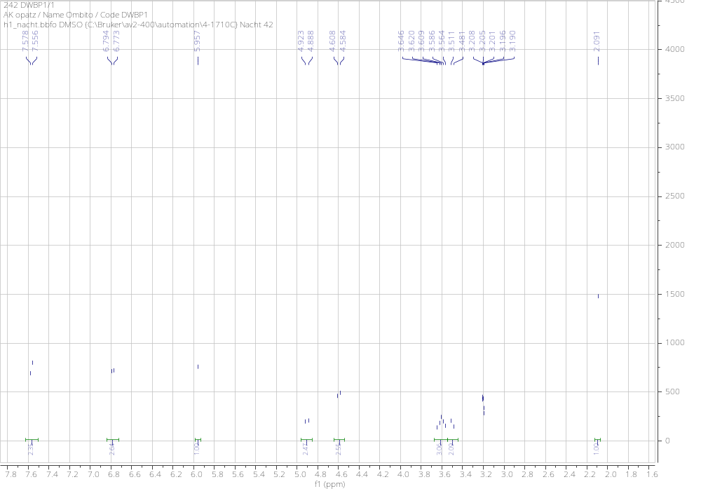
Figure S1: Figure S1: ¹H NMR spectrum of compound 1

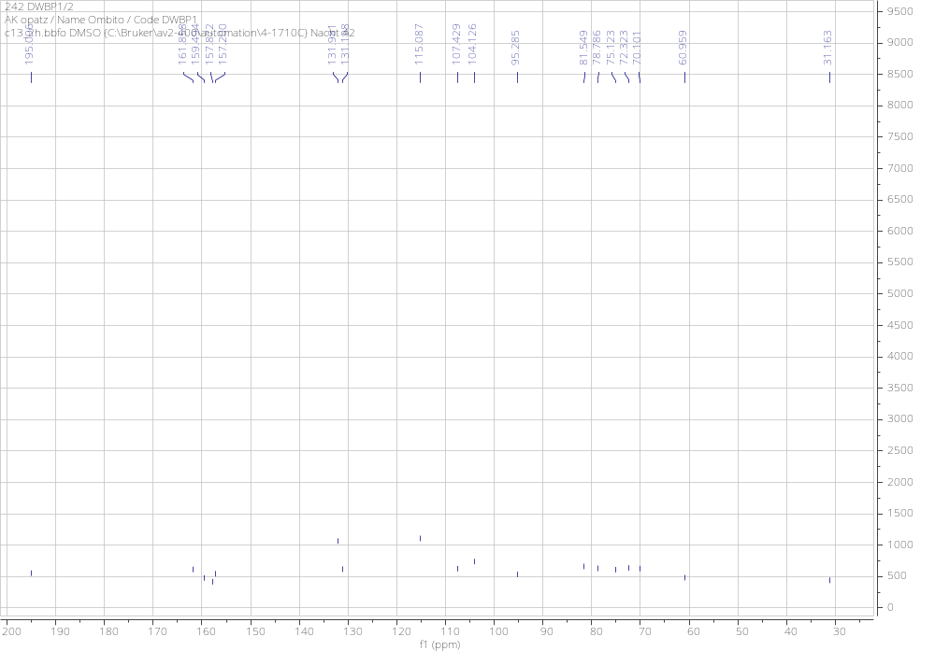
Figure S2: ¹³C NMR spectrum of compound 1
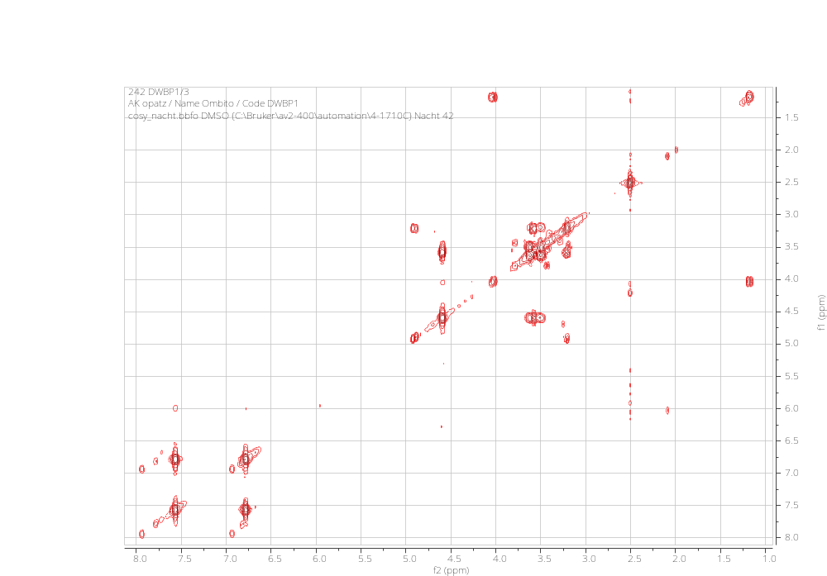
Figure S3: COSY NMR spectrum of compound 1.
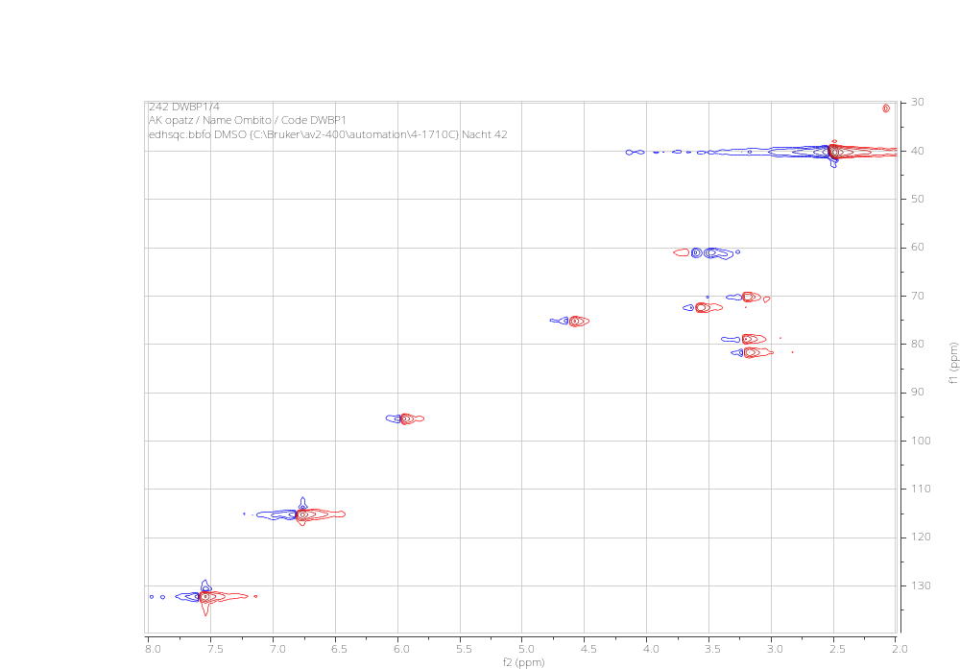
Figure S4: HSQC spectrum of compound 1.
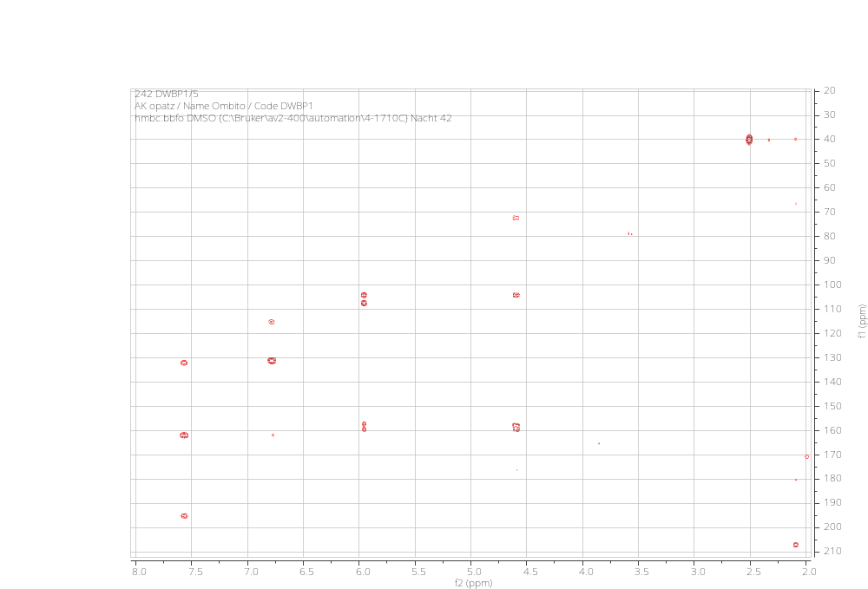
Figure S5: HMBC spectrum of compound 1.
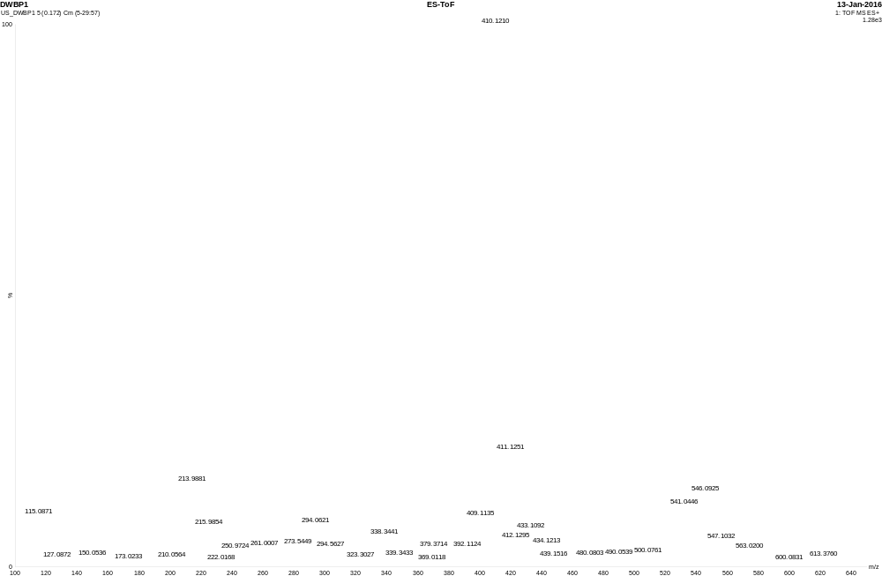
Figure S6: HRESI-Mass Spectrum of compound 1.

Figure S7: Chemical Dichroism spectrum of compound 1.

Compound (2): 3-α-D-glucopyranosyl-2,4,6-trihydroxyl(4-phenyl)methanone (C₁₉H₂₀O₁₀); red-brown paste soluble in MeOH, HRESI-MS [M+H]⁺ at m/z: 433.1112. ¹H NMR (400 MHz, DMSO), δ (ppm): 7.58 (2H, d, J = 8.4 Hz, H-2’, H-6’), 6.79 (2H, d, J = 8.4 Hz, H-3’, H-5’), 5.96 (1H, s, H-5), 4.78 (1H, d, J = 5.6 Hz, H-1’’), 4.60 (1H, t, J = 5.2, 10.0 Hz, H-2’’), 3.64 (1H, dd, J = 5.6, 11.6 Hz, H-3’’), 3.59 (1H, dd, J = 3.6, 5.2 Hz, H-4’’), 3.50 (2H, dd, J = 6.4 Hz, H-6’’), 3.20 (1H, brs, H-5’’). ¹³C NMR (100 MHz, DMSO), δ (ppm): 195.1 (C-7), 161.8 (C-4’), 159.5 (C-4), 157.8 (C-3), 157.2 (C-2), 132.0 (C-2’, C-6’), 131.2 (C-1’), 115.1 (C-3’, C-5’), 107.4 (C-1), 104.1 (C-5), 95.3 (C-5’), 81.5 (C-5’’), 78.8 (C-3’’), 75.1 (C-1’’), 72.3 (C-2’’), 70.1 (C-4’’), 60.9 (C-6’’) [2].

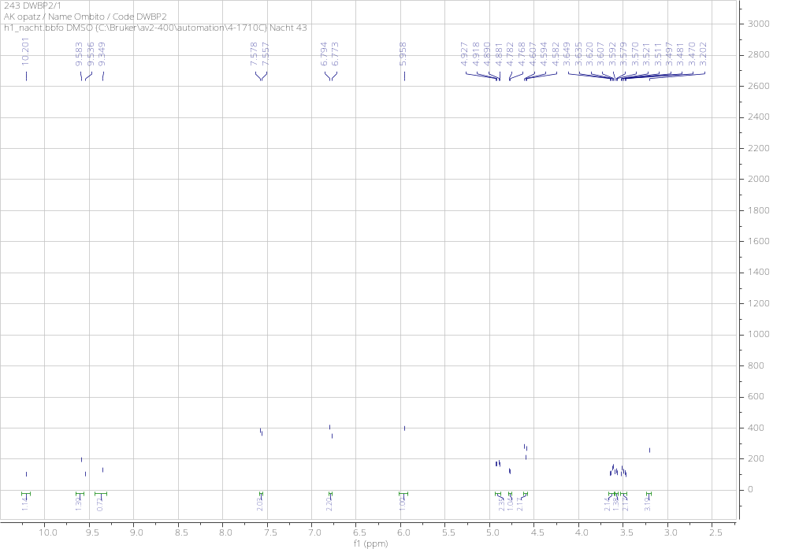
Figure S8: ¹H NMR spectrum of compound 2
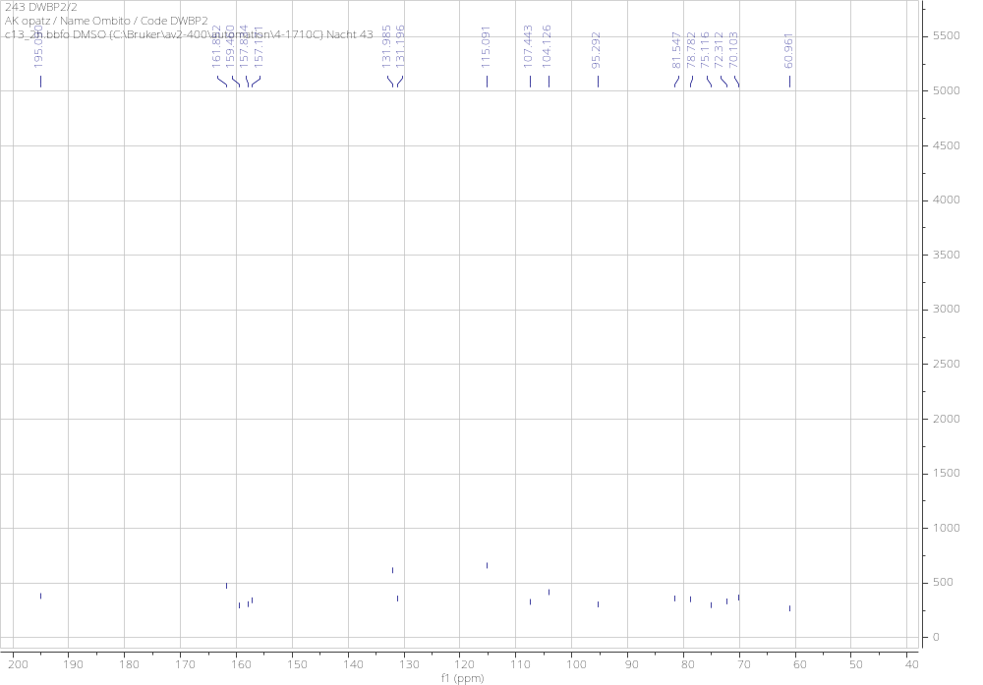
Figure S9: ¹³C NMR spectrum of compound 2.
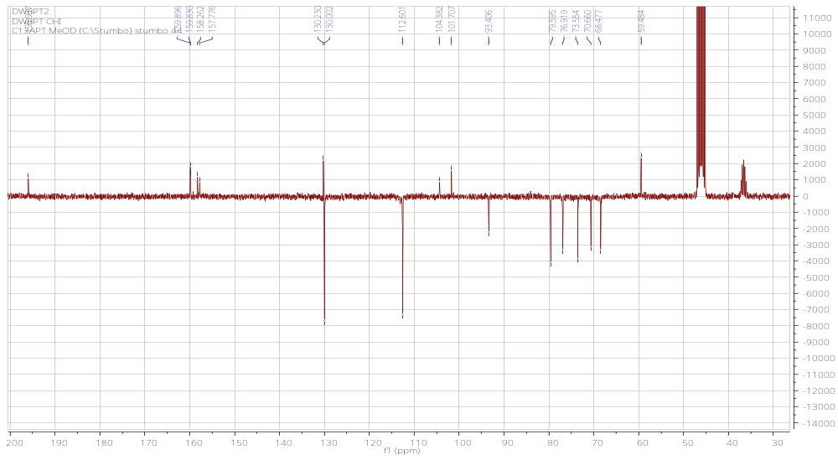
Figure S10: ¹³C DEPT 135 NMR spectrum of compound 2.

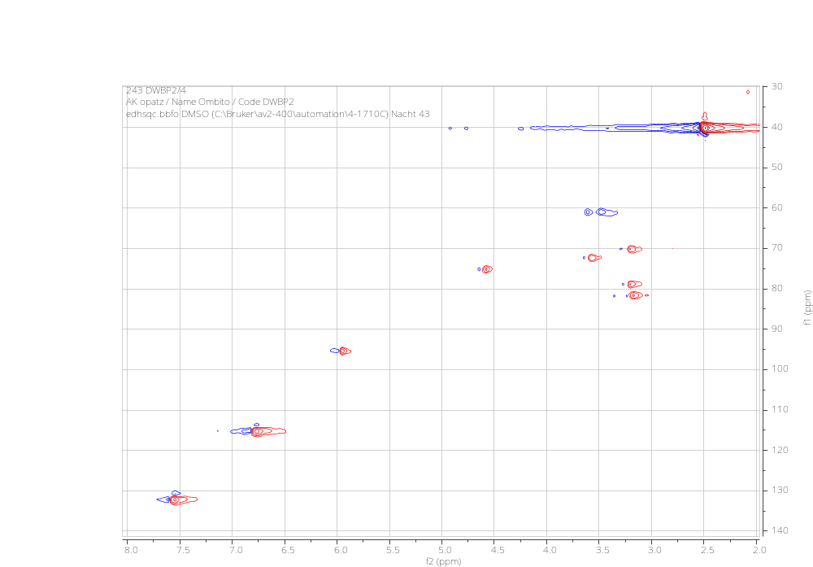
Figure S11: ¹³HSQC spectrum of compound 2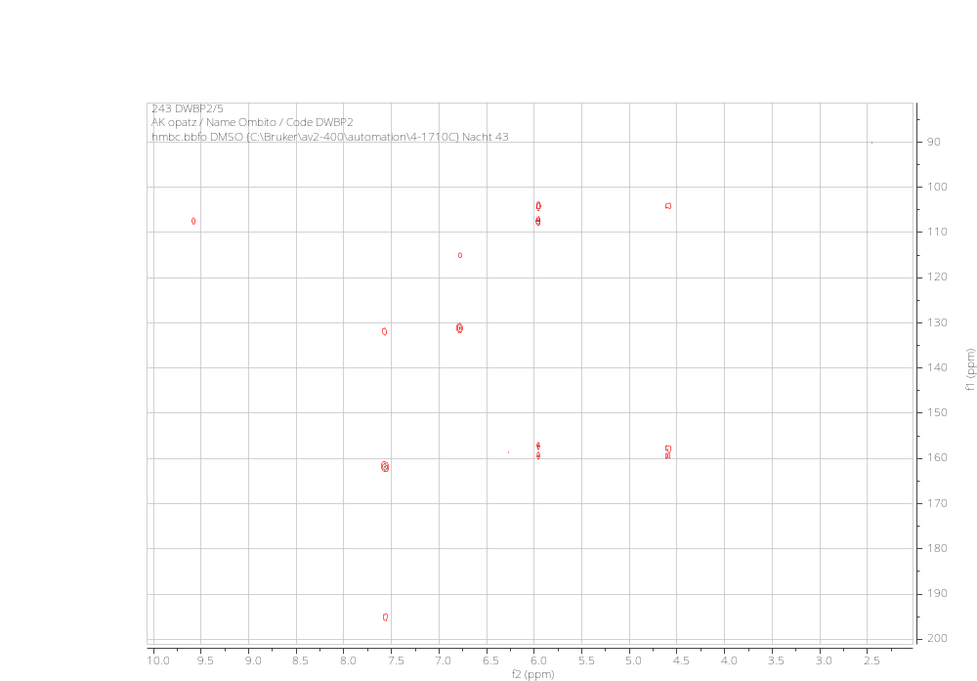
Figure S12: HMBC spectrum of compound 2.

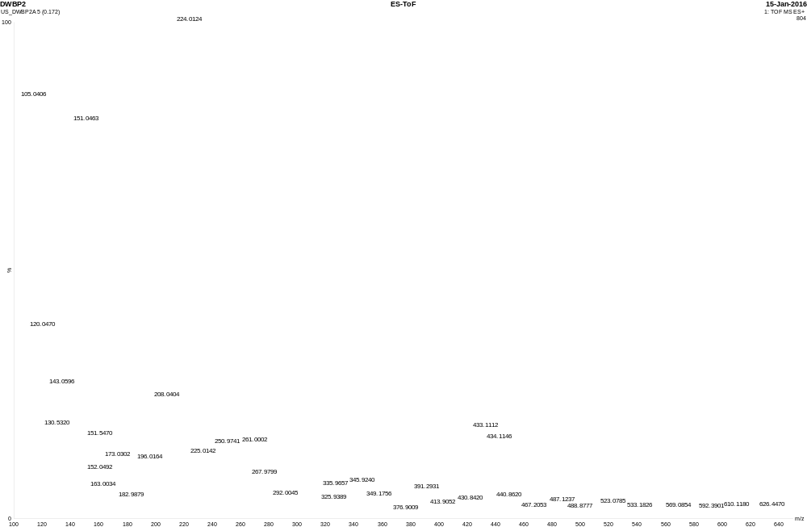
Figure S14: HR-ESI-Mass Spectrum of compound 2.

Figure S15: Chemical Dichroism Spectrum of compound 2.

Compound (3): 4-hydroxy-3-methoxybenzoic acid or vanillic acid (C₈H₈O₄); yellow solid soluble in pyridine. ¹H NMR (600 MHz, C₅D₅N), δ (ppm): 8.15 (1H, dd, J = 8.7, 2.4 Hz, H-6), 8.10 (1H, d, J = 8.7 Hz, H-2), 7.31 (1H, d, J = 8.7 Hz, H-5), 3.75 (1H, s, OCH₃). ¹³C NMR (150 MHz, C₅D₅N), δ (ppm): 169.8 (COOH), 153.3 (C-3), 148.9 (C-4), 125.4 (C-1), 123.1 (C-6), 116.7 (C-2), 114.3 (C-5), 55.6 (OCH₃) [3].

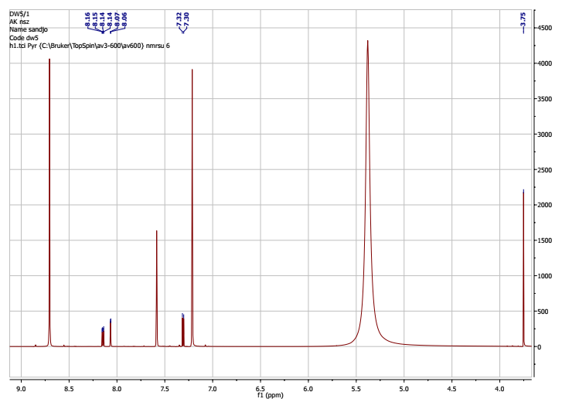
Figure S16: ¹H NMR of compound 3
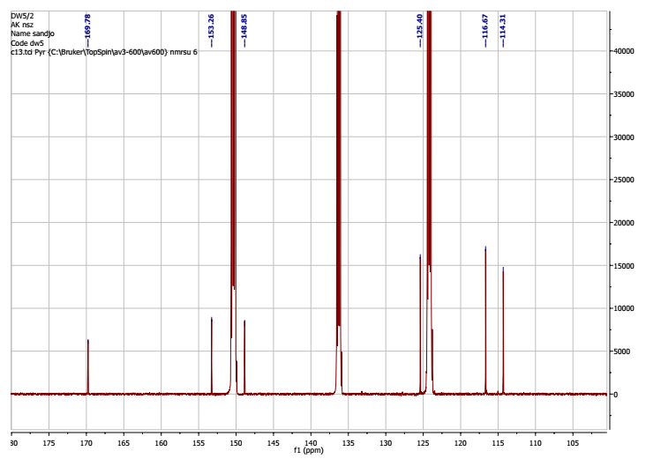
Figure S17: ¹³C NMR of compound 3.
Compound (4): Taraxerol (C₃₀H₅₀O); white powders soluble in dichloromethane. ¹H-NMR ¹³C (300 MHz, CDCl₃) δ(ppm): 5.60 (1H, dd, 8.1 and 3.3 Hz, H-15), 3.25 (1H, dd, 10.2 and 4.3 Hz, H-3), 2.10 (1H, dd, 12.6, 3.3 Hz, H-5), 1.99 (1H, dd, 11.7, 3.3 Hz, H-18), 1.80 – 1.32 (), 1.30 (6H, s, H-23), 1.14 (3H, s, H-26), 1.03 (3H, s, H-29), 1.00 (3H, s, H-25), 0.98 (3H, s, H-24), 0.96 (3H, s, H-30), 0.87 (3H, s, H-27), 0.85 (3H, s, H-28). ¹³C-NMR (75 MHz, CDCl₃) δ (ppm); 158.1 (C-14), 116.9 (C-15), 79.1 (C-3), 55.5 (C-5),49.3 (C-18) ,48.8 (C-9), 41.3 (C-19), 39.0 (C-4), 38.8 (C-8), 38.0 (C-1), 37.8 (C-10), 37.8 (C-17), 37.6 (C-13), 36.7 (C-16), 35.8 (C-12), 35.1 (C-7), 33.7 (C-21) , 33.1 (C-22), 30.0 (C-26), 29.9 (C-28), 29.7 (C-9), 28.0 (C-23), 27.2 (C-2), 25.9 (C-27), 21.4 (C-30), 18.8 (C-6 ), 17.5 (C-11), 15.5 (C-25), 15.5 (C-24) [4].

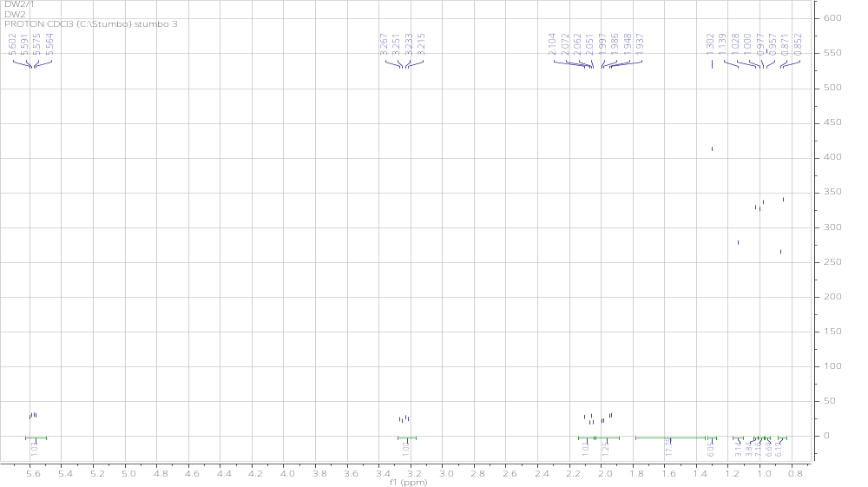
Figure S18: ¹H NMR Spectrum of compound 4.
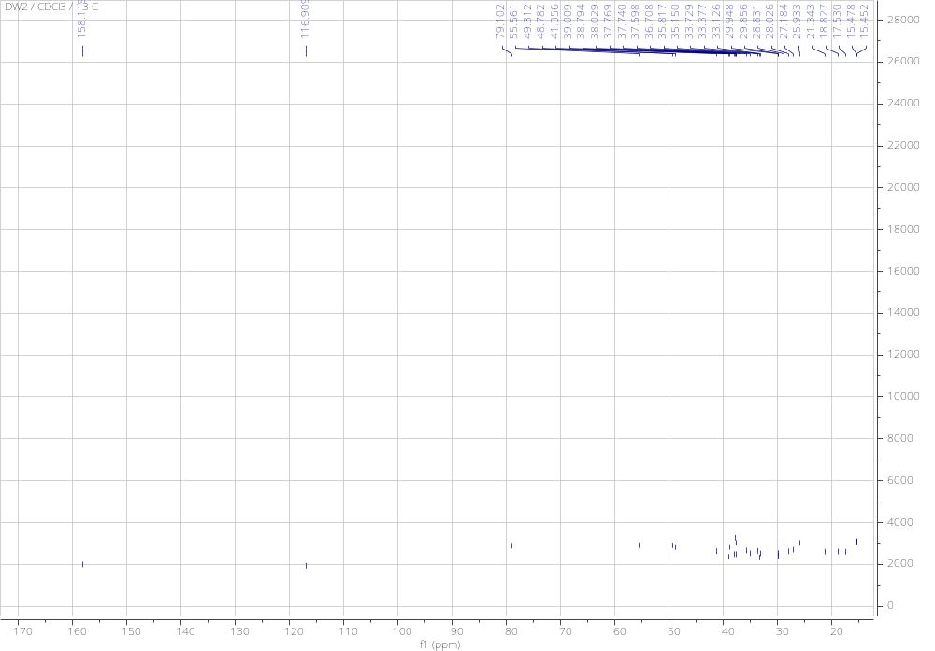
Figure S19: ¹³C NMR Spectrum of compound 4.

Compound (5): Taraxeryl acetate (C₃₂H₅₂O₂); white powders soluble in dichloromethane. ¹H-NMR ¹³C (300 MHz, CDCl₃) δ(ppm): 5.59 (1H, dd, 8.1 and 3.3 Hz, H-15), 4.51 (1H, dd, 10.2 and 4.3 Hz, H-3), 2.09 (3H, s, H-2’), 2.08 (1H, dd, 12.6, 3.3 Hz, H-5), 1.99 (1H, dd, 11.7, 3.3 Hz, H-18), 1.80 – 1.32 (CH₂ and CH), 1.14 (6H, s, H-23), 1.13 (3H, s, H-26), 1.00 (3H, s, H-29), 0.95 (3H, s, H-25), 0.95 (3H, s, H-24), 0.92 (3H, s, H-30), 0.90 (3H, s, H-27), 0.86 (3H, s, H-28). ¹³C-NMR (75 MHz, CDCl₃) δ (ppm); 171.0 (C-1’) 158.0 (C-14), 116.9 (C-15), 81.0 (C-3), 55.7 (C-5),49.2 (C-18) ,48.8 (C-9), 41.2 (C-19), 39.0 (C-4), 37.9 (C-8), 37.7 (C-1), 37.6 (C-10), 37.4 (C-17), 36.7 (C-13), 36.7 (C-16), 35.8 (C-12), 35.1 (C-7), 33.7 (C-21) , 33.4 (C-22), 33.1 (C-26), 29.9 (C-28), 29.9 (C-9), 28.8 (C-23), 23.5 (C-2), 21.4 (C-27), 21.3 (C-30), 18.7 (C-6 ), 17.5 (C-11), 16.6 (C-25), 15.5 (C-24) [5].

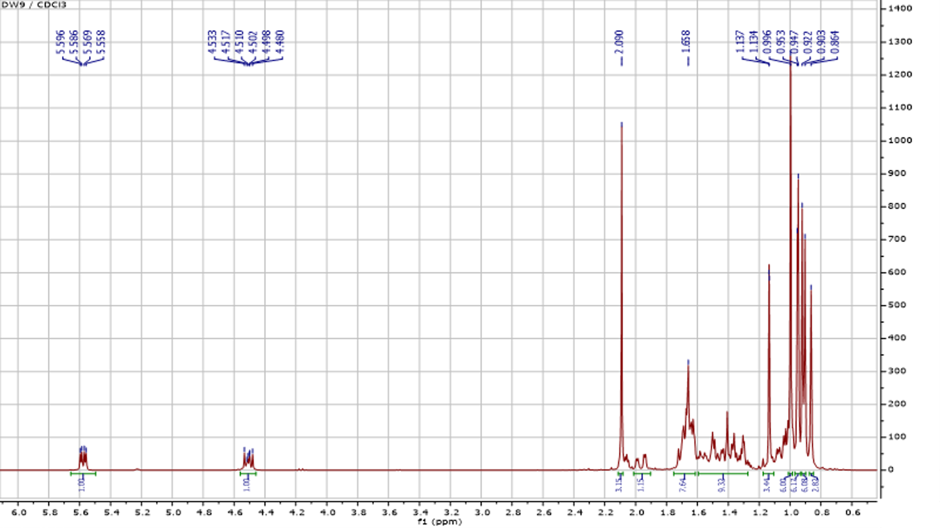
Figure S20: ¹H NMR Spectrum of compound 5.
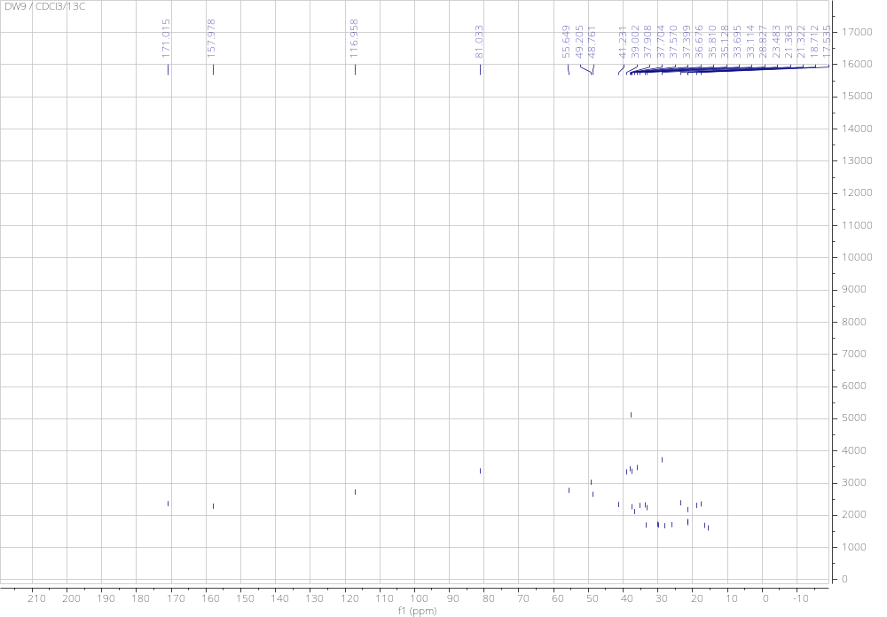
Figure S21: ¹³C NMR Spectrum of compound 5.
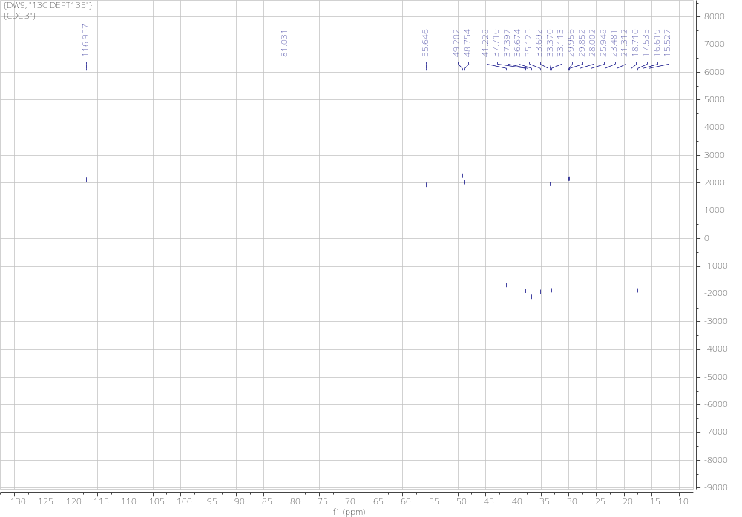
Figure S22: ¹³C DEPT 135 NMR Spectrum of compound 5.

Compound (6): Ursolic acid (C₃₀H₅₀O₂): white solid soluble in MeOH, ¹H NMR (600 MHz, CD₃OD), δ (ppm): 5.28 (1H, t, J = 3.6 Hz, H-12), 3.96 (1H, t, J = 2.9 Hz), 2.57 (1H, dt, J = 4.4 Hz, H-16a), 2.49 (1H, s, H-18), 1.36 (3H, s, H-27), 1.24 (3H, s, H-23), 1.18 (3H, s, H-29), 0.93 (3H, d, J = 6.7 Hz, H-30), 0.88 (3H, s, H-25), 0.81 (3H, s, H-26). ¹³C NMR (CD₃OD, 150 MHz) δ (ppm): 181.6 (C-28), 138.0 (C-13), 126.0 (C-12), 79.2 (C-3), 55.3 (C-5), 52.8 (C-18), 48.0 (C-9), 48.0 (C-17), 48.0 (C-19), 47.6 (C-9), 42.1 (C-14), 39.6 (C-1), 39.6 (C-4), 39.2 (C-20), 38.3 (C-8), 38.7 (C-10), 37.1 (C-22), 37.2 (C-1), 33.5 (C-2), 28.3 (C-2), 25.8 (C-29), 25.7 (C-21), 25.6 (C-11), 25.2 (C-16), 23.7 (C-27), 21.3 (C-23), 19.7 (C-6), 15.7 (C-26), 15.4 (C-30), 12.2 (C-25) [6].
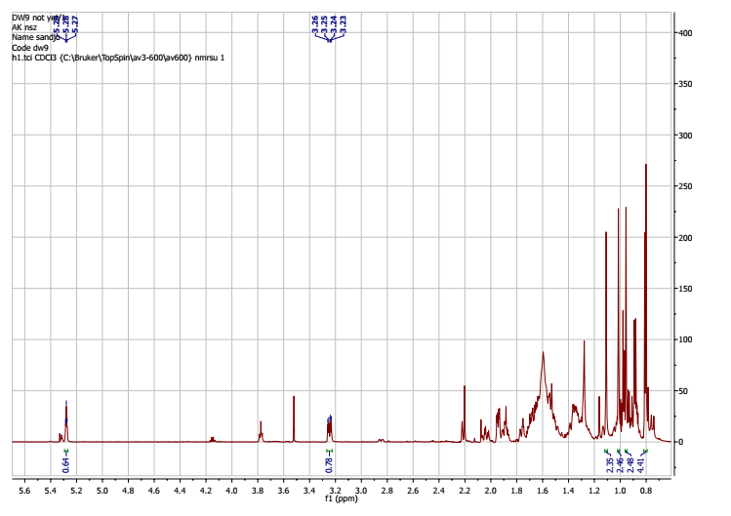
Figure S27: ¹H NMR Spectrum of compound 6.

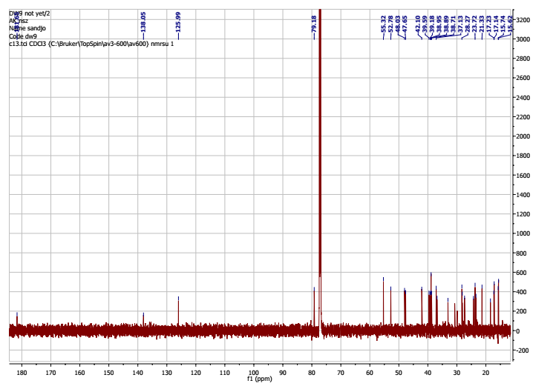
Figure S28: ¹³C NMR Spectrum of compound 6.

Compound (7): 3, 19-dihydroxyurs-12-en-24, 28-dioic acid or diospyric acid (C₃₀H₄₆O₆): white solid soluble in MeOH, HRESI-MS [M+H]⁺ at m/z: ¹H NMR (400 MHz, CD₃OD), δ (ppm): 5.28 (1H, t, J = 3.6 Hz, H-12), 3.96 (1H, t, J = 2.9 Hz), 2.57 (1H, dt, J = 4.4 Hz, H-16a), 2.49 (1H, s, H-18), 1.36 (3H, s, H-27), 1.24 (3H, s, H-23), 1.18 (3H, s, H-29), 0.93 (3H, d, J = 6.7 Hz, H-30), 0.88 (3H, s, H-25), 0.81 (3H, s, H-26). ¹³C NMR (CD₃OD, 100 MHz) δ (ppm): 180.9 (C-28), 179.9 (C-24), 138.4 (C-13), 128.2 (C-12), 72.1(C-19), 70.2 (C-3), 53.7 (C-18), 48.7 (C-9), 48.0 (C-17), 47.6 (C-4), 47.0 (C-9), 39.6 (C-8), 37.5 (C-10), 37.2 (C-1), 33.5 (C-2), 28.1 (C-15), 25.8 (C-29), 25.7 (C-21), 25.6 (C-11), 25.2 (C-16), 23.4 (C-27), 23.2 (C-23), 19.7 (C-6), 15.9 (C-26), 15.1 (C-30), 12.2 (C-25) [7].
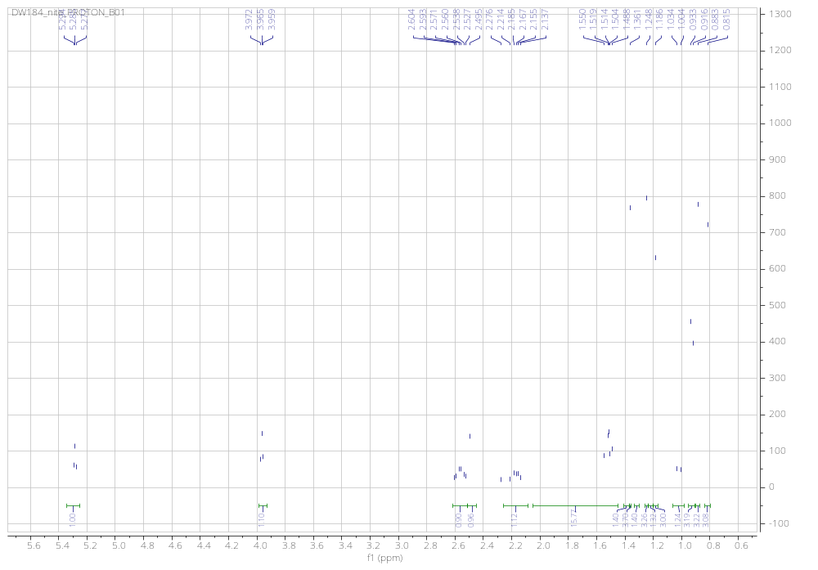
Figure S23: ¹H NMR Spectrum of compound 7.

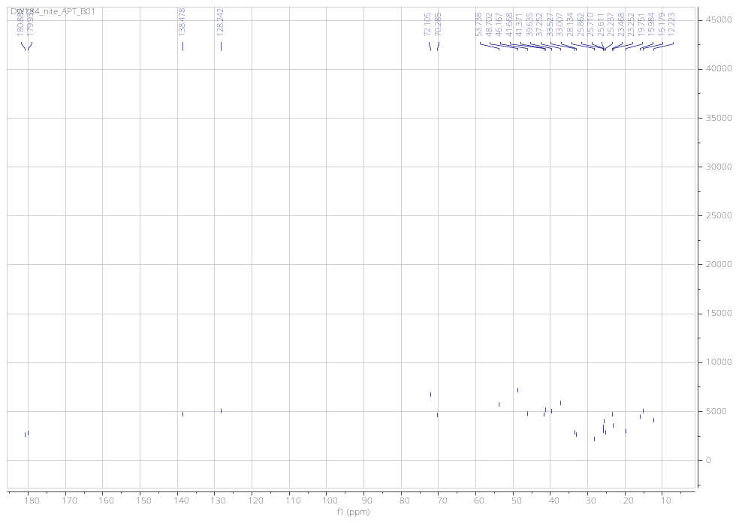
Figure S24: ¹³C NMR Spectrum of compound 7.

Compound (8): 28-hydroxy-β-amyrin (C₃₀H₅₀O₂): white solid soluble in MeOH, ¹H NMR (600 MHz, CD₃OD), δ (ppm): 5.28 (1H, t, J = 3.6 Hz, H-12), 3.96 (1H, t, J = 2.9 Hz), 2.57 (1H, dt, J = 4.4 Hz, H-16a), 2.49 (1H, s, H-18), 1.36 (3H, s, H-27), 1.24 (3H, s, H-23), 1.18 (3H, s, H-29), 0.93 (3H, d, J = 6.7 Hz, H-30), 0.88 (3H, s, H-25), 0.81 (3H, s, H-26). ¹³C NMR (CD₃OD, 150 MHz) δ (ppm): 145.6 (C-13), 123.5 (C-12), 79.7 (C-3), 67.8 (C-28), 56.7 (C-5), 47.8 (C-9), 42.8 (C-18), 41.9 (C-8), 39.9 (C-20), 39.8 (C-19), 38.1 (C-4), 38.0 (C-1), 36.8 (C-10), 33.7 (C-17), 33.7 (C-21), 32.3 (C-16), 32.0 (C-7), 31.8 (C-21), 28.7 (C-2), 26.5 (C-15), 24.6 (C-11), 24.0 (C-27), 23.2 (C-23), 19.7 (C-6), 17.3 (C-26), 16.3 (C-30), 16.0 (C-25) [8].

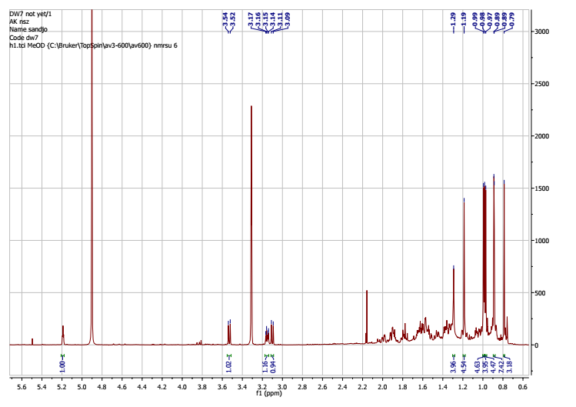
Figure S25: ¹H NMR Spectrum of compound 8.
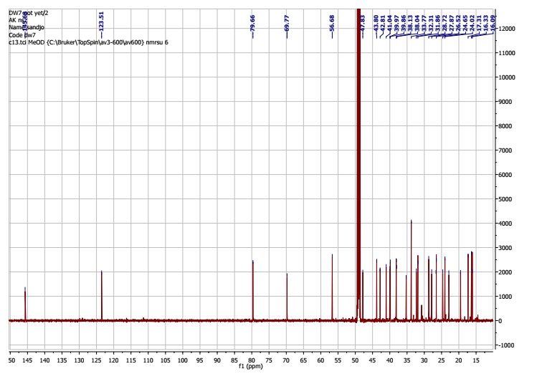
Figure S26: ¹³C NMR Spectrum of compound 8.

Compound (9): Oleanolic acid (C₃₀H₅₀O₂): Oleanolic acid (C₃₀H₅₀O₂): white solid soluble in CDCl₃, EI-MS m/z 456.4. ¹H NMR (400 MHz, CDCl₃) δ (ppm) 5.27 (1H, t, 4.0 Hz, H-12), 3.20 (1H, dd, 11.0, 5.1 Hz, H-3), 2.80 (1H, dd, 13.6, 4.4 Hz, H-18), 1.97 (1H, td, 4.0, 3.6, H-9), 1.12 (3H, s, H-27), .97 (3H, s, H-23), 0.91 (3H, s, H-26), 0.89 (3H, s, H-24), 0.88 (3H, s, H-25), 0.75 (3H, s, H-30), 0.74 (3H, s, H-29). ¹³C NMR (125 MHz, CDCl₃) δ (ppm): 180.4 (C-28), 145.1 (C-13), 123.2 (C-12), 79.2 (C-3), 55.3 (C-5), 52.9 (C-18), 48.0 (C-17), 47.7 (C-9), 42.8 (C-14), 39.6 (C-8), 39.2 (C-8), 39.0 (C-20), 38.9 (C-4), 37.1 (C-22), 34.5 (C-7), 32.3 (C-28), 30.0 (C-23), 28.3 (C-15), 23.7 (C-11), 21.3 (C-30), 17.2 (C-26), 17.1 (C-29), 15.7 (C-25), 15.6 (C-24) [9].

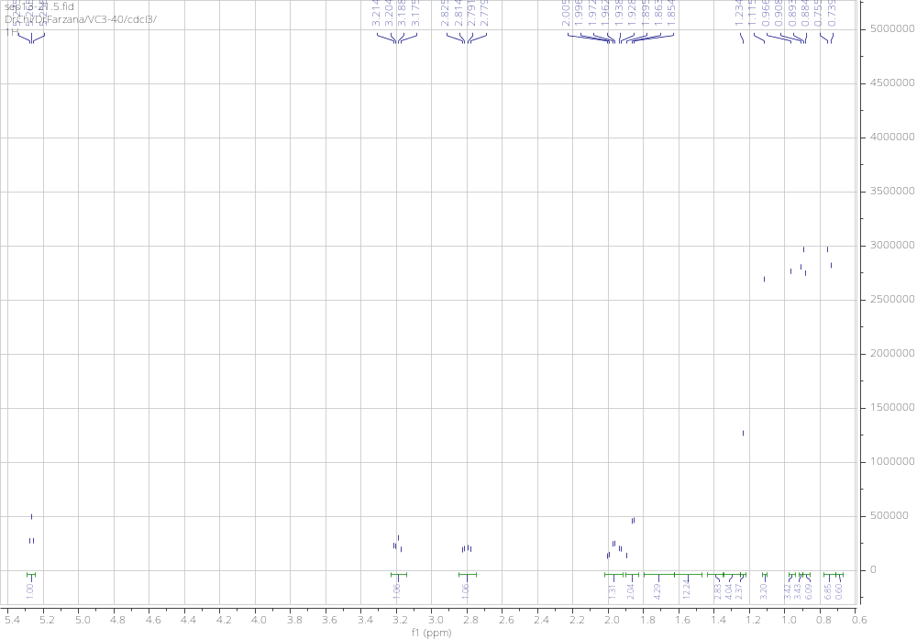
Figure S29: ¹H NMR Spectrum of compound 9.

Compound (10): α-Spinasterol (C₂₉H₄₈O), white crystalline solid soluble in CDCl₃, EI-MS m/z 412.4, melting point 168 - 169°C. ¹H NMR (300 MHz, CDCl₃) δ 5.10 (1H, dd, J = 8.7, 15.0 Hz, H-22), 5.06 (1H, dd, J = 8.7, 15.0 Hz, H-22), 4.96 (1H, dd, J = 6.9, 8.4, Hz, H-7), 3.54 (1H, m, J = 4.2, 6.3 Hz, H-3), 1.94 (2H, m, H-), 1.79 – 1.03 (25H, 9 CH₂ & 7 CH), 0.97 (3H, d, 6.3 Hz,H-21), 0.79 (3H, d, 6.3 Hz, H-27), 0.77 (3H, d, 3.3 Hz, H-26), 0.76 (3H, t, 3.3 Hz, H-29), 0.73 (3H, s, H-19), 0.48 (3H,s, H-18). ¹³C NMR (75 MHz, CDCl₃) δ 139.59 (C-8), 138.20 (C-22), 129.47(C-23), 117.49 (C-7), 71.08 (C-3), 55.93 (C-17), 55.16 (C-14), 51.28 (C-24), 49.48 (C-9), 43.31 (C-13), 40.86 (C-20), 40.29 (C-5), 39.50 (C-12), 38.01 (C-4), 37.18 (C-1), 34.25 (C-10), 31.91 (C-25), 31.49 (C-2), 29.67 (C-6), 28.54 (C-16), 25.43 (C-28), 23.05 (C-15), 21.58 (C-11), 21.41 (C-21), 21.13 (C-26), 19.03 (C-27), 13.07 (C-19), 12.28 (C-29), 12.08 (C-18) [10].

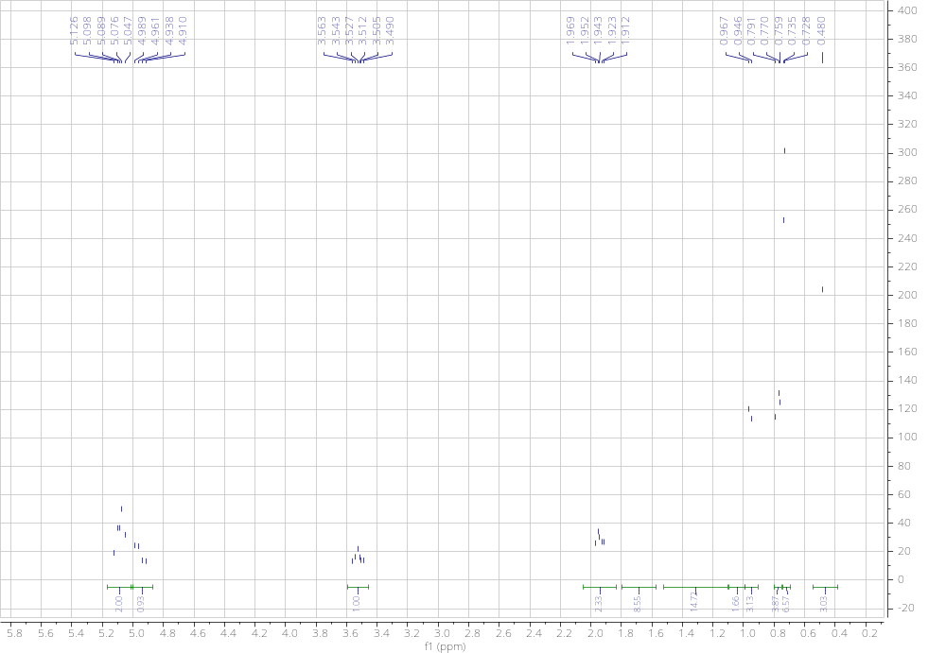
Figure S31: ¹H NMR Spectrum of compound 10.

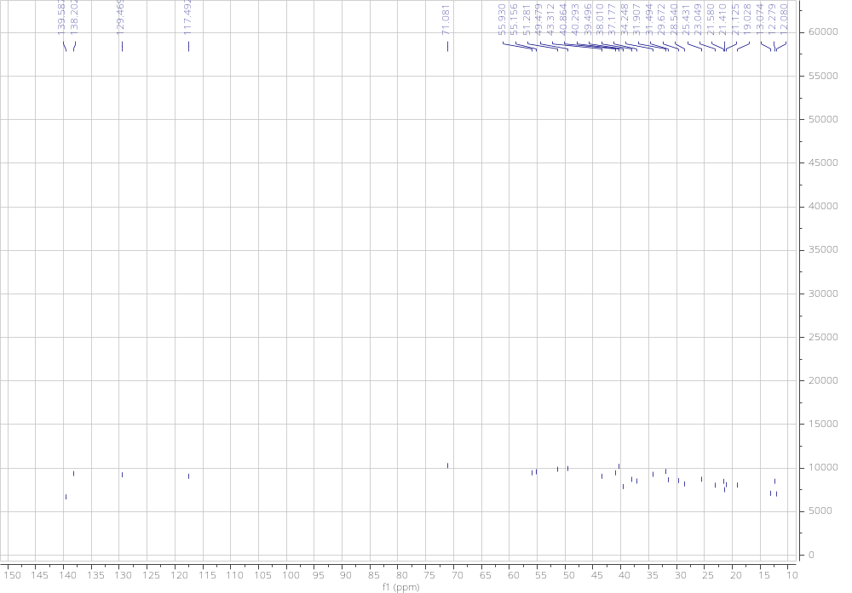
Figure S32: ¹³C NMR Spectrum of compound 10.

Compound (11): Spinasteryl-3-O-β-D-glucopyranoside or Spinasteryl glucoside (C₃₆H₆₀O₆), white crystalline solid soluble in C₅H₅N, EI-MS m/z 588.4, melting point 168 - 169°C. ¹H NMR (600 MHz, C₅D₅N) δ 5.10 (1H, dd, J = 8.7, 15.0 Hz, H-22), 5.06 (1H, dd, J = 8.7, 15.0 Hz, H-22), 4.96 (1H, dd, J = 6.9, 8.4, Hz, H-7), 3.54 (1H, m, J = 4.2, 6.3 Hz, H-3), 1.94 (2H, m, H-), 1.79 – 1.03 (25H, 9 CH₂ & 7 CH), 0.97 (3H, d, 6.3 Hz,H-21), 0.79 (3H, d, 6.3 Hz, H-27), 0.77 (3H, d, 3.3 Hz, H-26), 0.76 (3H, t, 3.3 Hz, H-29), 0.73 (3H, s, H-19), 0.48 (3H,s, H-18). ¹³C NMR (150 MHz, C₅D₅N) δ 139.59 (C-8), 138.20 (C-22), 129.47(C-23), 117.49 (C-7), 71.08 (C-3), 55.93 (C-17), 55.16 (C-14), 51.28 (C-24), 49.48 (C-9), 43.31 (C-13), 40.86 (C-20), 40.29 (C-5), 39.50 (C-12), 38.01 (C-4), 37.18 (C-1), 34.25 (C-10), 31.91 (C-25), 31.49 (C-2), 29.67 (C-6), 28.54 (C-16), 25.43 (C-28), 23.05 (C-15), 21.58 (C-11), 21.41 (C-21), 21.13 (C-26), 19.03 (C-27), 13.07 (C-19), 12.28 (C-29), 12.08 (C-18) [11].

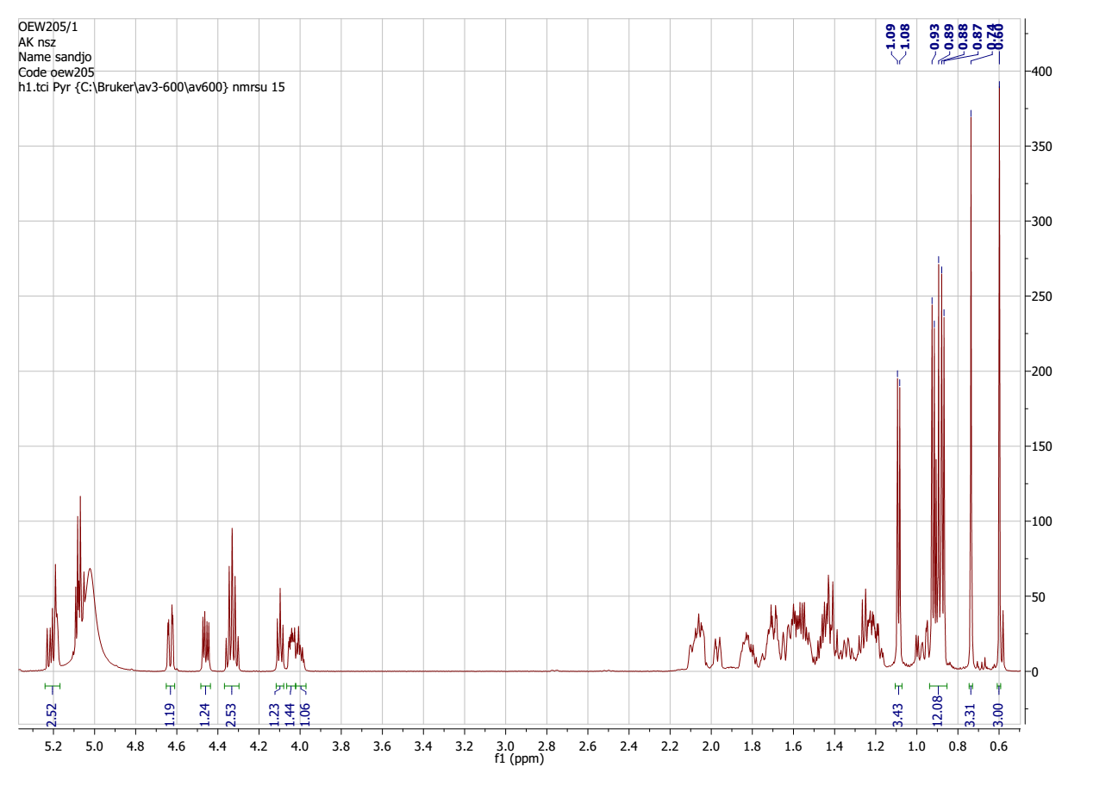
Figure S31: ¹H NMR Spectrum of compound 11.

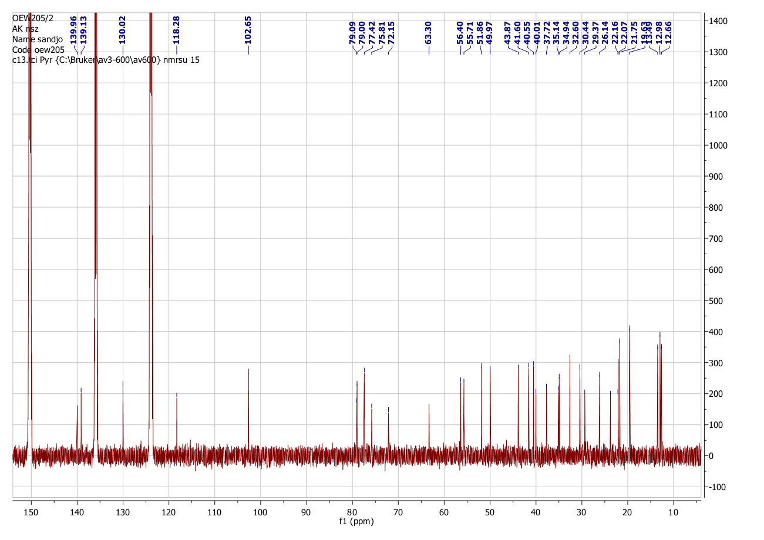
Figure S32: ¹³C NMR Spectrum of compound 11.

Supplementary material (SM2)

Table S1: Bacterial features of the tested of microorganisms

Bacteria strains |  | Characteristics | References
Escherichia  coli | ATTC10536 | Reference strains | [12]
Escherichia  coli | AG102 | AG 100 over expressing Acr AB pomps | [12]
Enterobacter aerogenes | ATCC13048 | Reference strains | [13, 14]
Enterobacter aerogenes | EA 27 | Clinical strain with energy dependent efflux to CHL and NOR; KAN^{r}, AMP^{r}, NAl^{r}, STR^{r}, TET^{r} | [13, 14]
Klebsiella pneumoniae | ATCC11296 | Reference strains of Klebsiella pneumoniae | Collection of the UMR-MD1 laboratory of the University of the Mediterranean, Marseille, France [12].
Klebsiella pneumoniae | Kp55 | Clinical strain: TET^{r}, AMP^{r}, ATM^{r}, CEF^{r}
Providencia stuartii | NEA16 | Clinical isolate of Providencia stuartii AcrAB-TolC
Providencia stuartii | PS2636 | AcrAB-TolcC associated with porin types OMPF and OMPC
Pseudomonas aeruginosa | PA01 | Reference strains | Collection of the UMR-MD1 laboratory of the University of the Mediterranean, Marseille, France [12, 15]
Pseudomonas aeruginosa | PA124 | Multi-drug resistant clinical strain MexAB-OprM
Staphylococcus aureus | ATCC25923 | Reference strain | [16, 17]
Staphylococcus aureus | MRSA3 | Clinical isolate: Ofxar, Kanr, Tetr, Ermr | [16, 17]
Staphylococcus aureus | MRSA6 | Clinical isolate: Ofxar, Flxr, Kanr, Tetr,  Cypr, IM/Csr, Chlr, Genr, Nisr, Ampr | [16, 17]
AMP^{r}, ATM^{r}, CEF^{r}, CHL^{r}, KAN^{r}, NAL^{r}, NOR^{r}, STR^{r} et TET^{r}, resistant to: ampicillin, aztreonam, cefepime, chloramphenicol, kanamycin, nalidixic acid, norfloxacin, streptomycin et tetracycline respectively; AcrAB-TolC, MexAB-OprM : efflux pomp.

References
1. Pan J, Yi X, Wang Y, Chen G, and He X. Benzophenones from Mango Leaves Exhibit ??-Glucosidase and NO Inhibitory Activities. J. Agric. Food Chem. 2016; 64(40), 7475–7480.
2. Suliman SN, Elnaggar MH, Elsbaey M,. El-gamil MM, and Badria FA. Bio-guided Isolation of Natural Iron Chelators from Mangifera indica Leaves and their Comparative Study to Desferal ®. 2021; 27(2), 78–85.
3. Chang SW, Kim KH, Lee IK, Choi SU, Ryu SY, and Lee KR. Phytochemical constituents of Bistorta manshuriensis. Nat. Prod. Sci. 2009; 15(4), 234–240.
4. Sangeetha K, Sujatha S, and Shanmuganathan V. Biochimica et Biophysica Acta 3 β -taraxerol of Mangifera indica , a PI3K dependent dual activator of glucose transport and glycogen synthesis in 3T3-L1 adipocytes. BBA - Gen. Sub. 2010; 1800(3). 359–366.
5. Díaz-Ruiz G, Hernández-Vázquez L, Luna H, Del Carmen Wacher-Rodarte M, and Navarro-Ocaña A. Growth inhibition of streptococcus from the oral cavity by α-Amyrin esters. Molecules. 2012; 17(11), 12603–12611.
6. Liu M, Yeng S, Jin L, Hu D, Wu Z, and Yang S. Chemical constituents of the ethyl acetate extract of belamcanda chinensis (L.) DC roots and their antitumor activities. Molecules. 2012; 17(5), 6156–6169.
7. Thuong PT, Lee CH, Dao TT, Nguyen PH, Kim WG, Lee SJ, Oh WK. Triterpenoids from the leaves of Diospyros kaki (persimmon) and their inhibitory effects on protein tyrosine phosphatase 1B. J. Nat. Prod. 2008; 71(10), 1775–1778.
8. S. B. Mahato and Kundu. A. P., “13C Nmr Spectra of Pentacyclic Triterpenoids-a and Some Salient Features,” Phytochemistry, 1994; 37, 1517–1575.
9. Seebacher W, Simic N, Weis R, Saf R, and Kunert O. Complete assignments of 1H and 13C NMR resonances of oleanolic acid, 18α-oleanolic acid, ursolic acid and their 11-oxo derivatives. Magn. Reson. Chem. 2003; 41(8), 636–638.
10. Ragasa CY, Galian RF, Arenal M, Tan V, and Shen CC. Research Journal of Pharmaceutical , Biological and Chemical Sciences In-vitro Antibacterial and Antifungal Effect of Areca Nut Extract. Res. J. Pharm. Biol. Chem. 2014; 282(7), 282–286.
11. Kim S, Hye Min, Ahn, Mi-Jeong; Lee. Isolation and identification of phytochemical constituents from Scrophularia takesimensis. J. Med. Plants Res. 2012; 22(6), 3923–3930.
12. Chevalier J, Bredin J, Mahamoud A, Mallea M, Barbe J, Pagès J-M. Inhibitors of antibiotic efflux in resistant Enterobacter aerogenes and Klebsiella pneumonia strains. Antimicrob. Agents Chemother. 2004; 48(1), 1043-1046.
13. Ghisalberti D, Masi M, Pagès J-M, Chevalier J. Chloramphenicol and expression of multidrug efflux pump in Enterobacter aerogenes. Biochem. Biophys. Commu. Res. 2005; 328(2), 1113-1118.
14. Malléa M, Chevalier J, Bornet C, Eyraud A, Pagès J-M, Davin-Régli A. Porin alteration and active efflux: two in vivo drug resistance strategies used by Enterobacter aerogenes. Microbiology. 1998, 144 : 3003–3009.
15. Lorenzi V, Muselli A, Bernadini AF, Berti L, Pagès J-M. Geraniol restores antibiotic activities against multidrug resistant isolates from Gram-negatives species. Antimicrob. Agents Chemother. 2009; 53(6), 2209-2211.
16. Paudel A, Hamamoto H, Kobayashi Y, Yokoshima S, Fukuyama T, Sekimizu K. Identification of novel deoxyribofuranosyl indoleantimicrobial agents. J. Antibiotics. 2012; 65(3), 53-57.
17. Dzoyem JP, Hamamoto H, Ngameni B, Ngadjui BT, Sekimizu K. Antimicrobial action mechanism of ﬂavonoids from Dorstenia species. Drug Discov. Ther. 2013; 7(1), 66–72.

