- ALB-male | - ALB-female | - TP-male | - TP-female
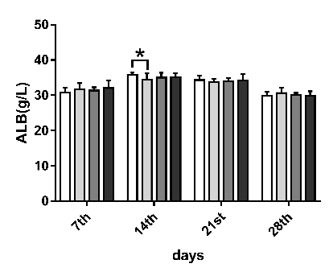 | 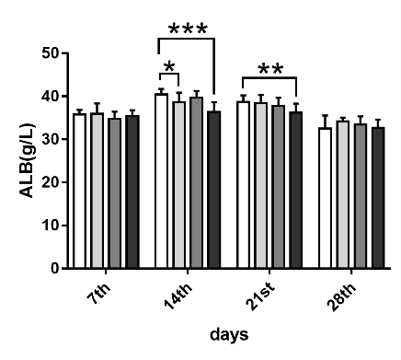 | 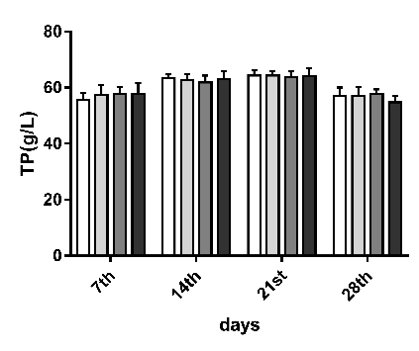 | 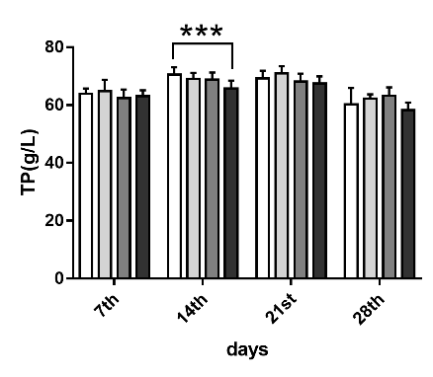 | 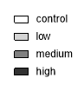
- Na⁺-male | - Na⁺-female | - K⁺-male | - K⁺-female
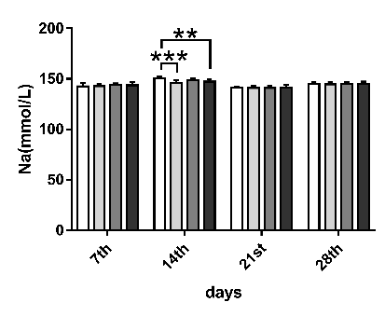 | 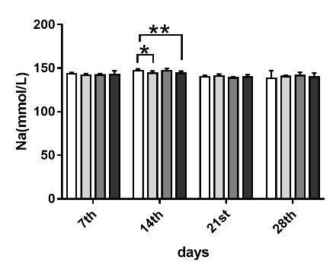 | 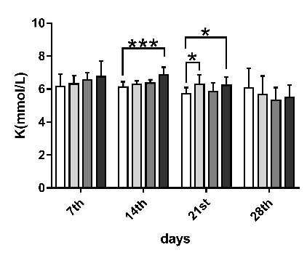 | 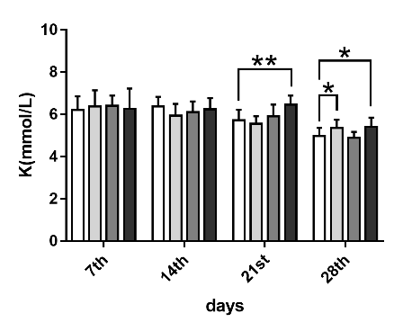
- Cl⁻-male | - Cl⁻-female
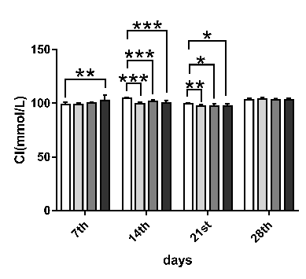 | 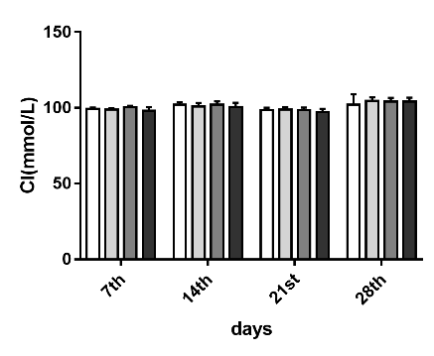
Figure S1 Results of plasma protein indexes and blood ion levels during the administration. Compared with vehicle control group ***: P < 0.001; **: P < 0.01; *: P < 0.05

A |  | B |  | C |  | D
E |  | F |  | G |  | H
I |  | J |  | K |  | L
M |  | N |  | O |  | P
 |  | Q |  | R
Figure. S2 Results of blood chemistry after the oral administration of TAZF. Compared with vehicle control group, ***: P < 0.001; **: P < 0.01; *: P < 0.05

 | Control-100x | Control-200x | Sample-100x | Sample-200x
liver | 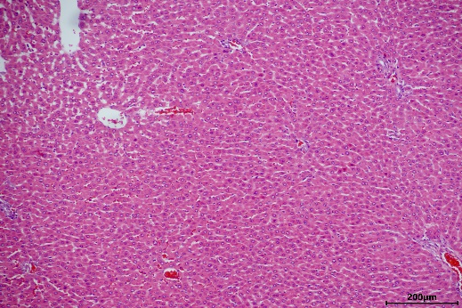 | 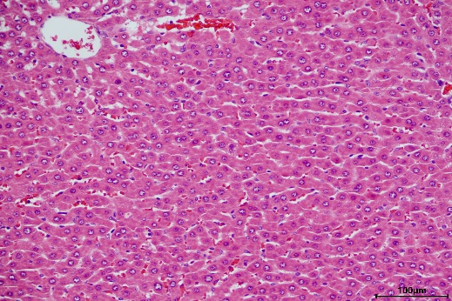 | 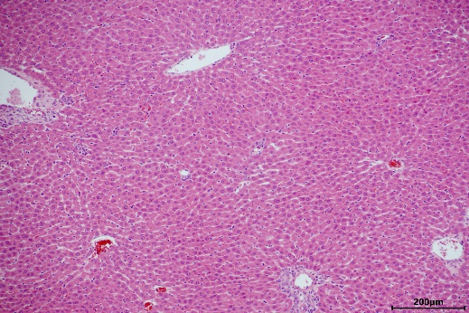 | 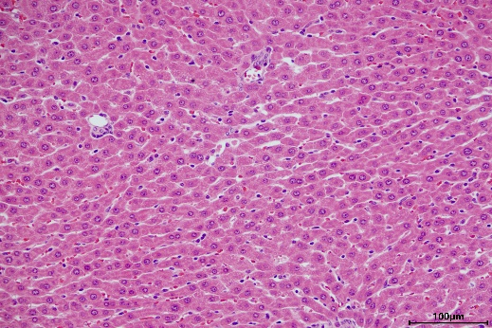
kidney | 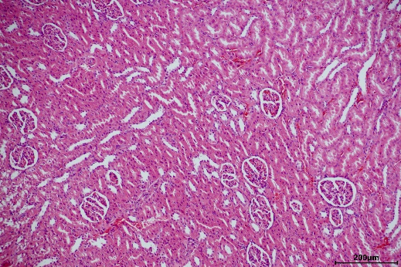 | 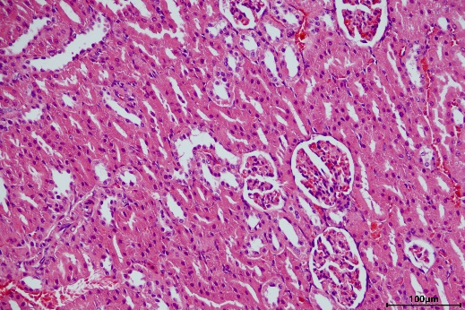 | 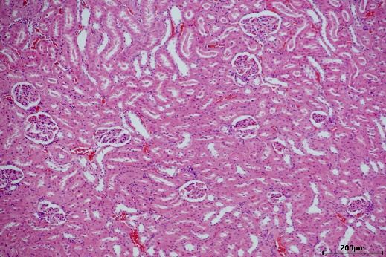 | 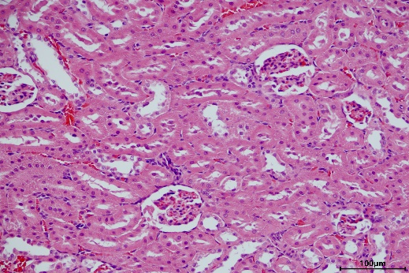
lung | 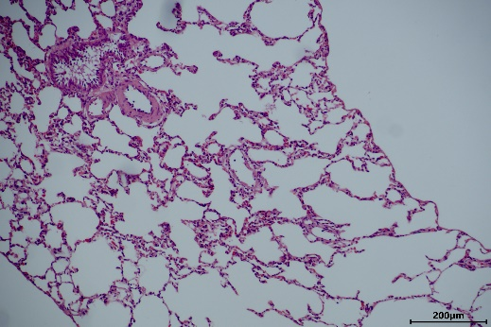 | 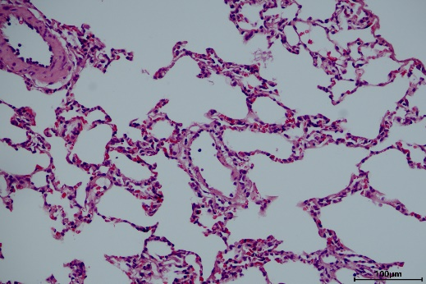 | 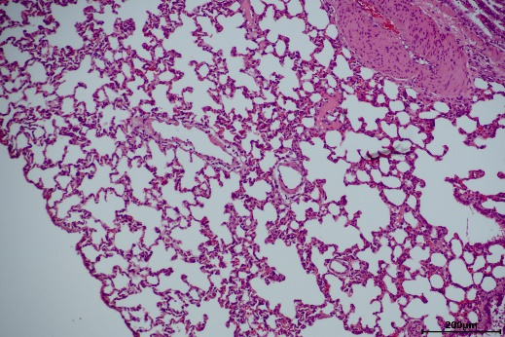 | 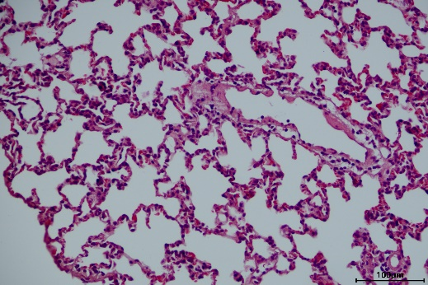
Figure. S3 Microphotographs of liver, kidney and lung in control group and high-dose group. No obvious toxic change was found. Each figure is a representative photomicrograph from a rat in each group.

 |  | Control | Sample
Brain | 40x | 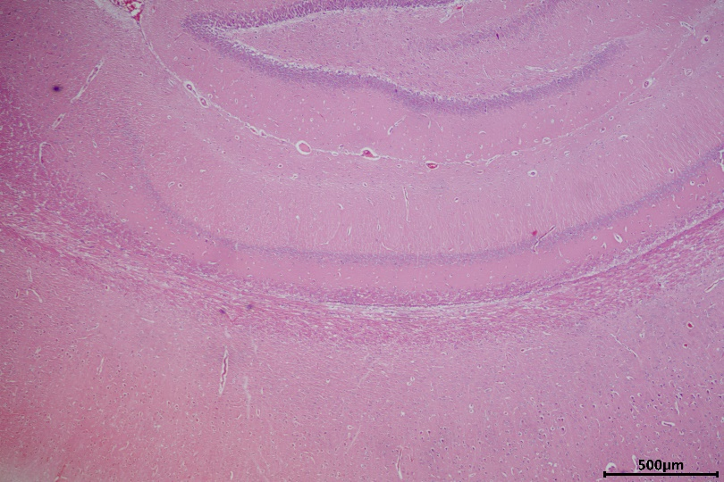 | 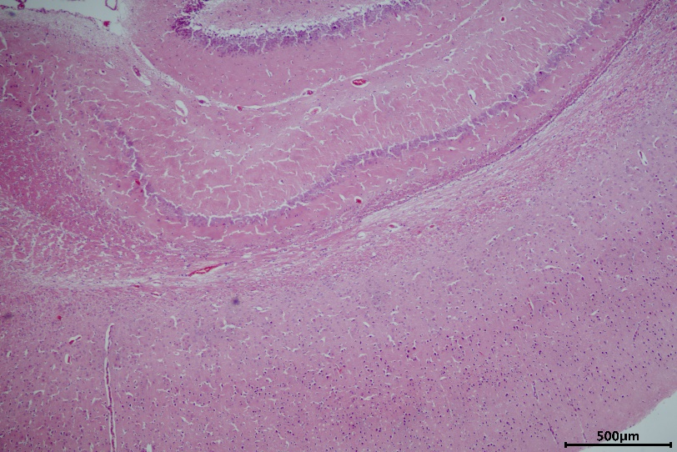
Stomach | 100x | 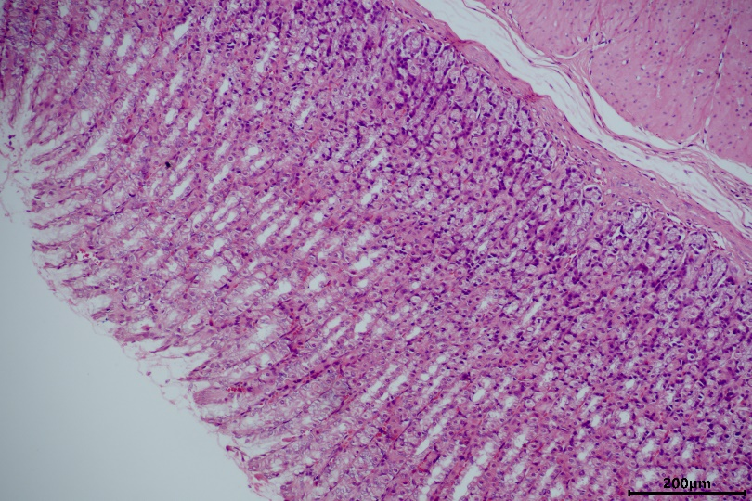 | 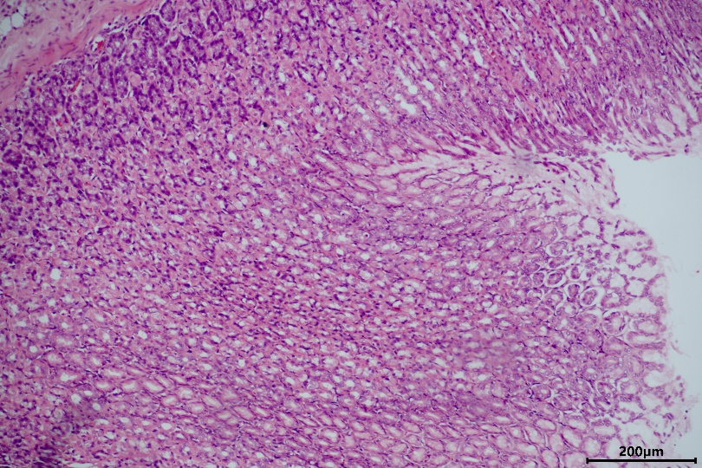
jejunum | 100x | 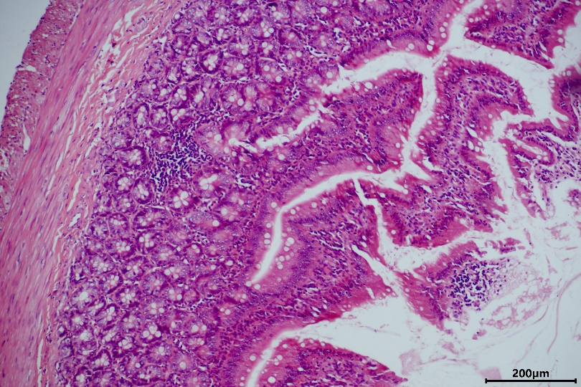 | 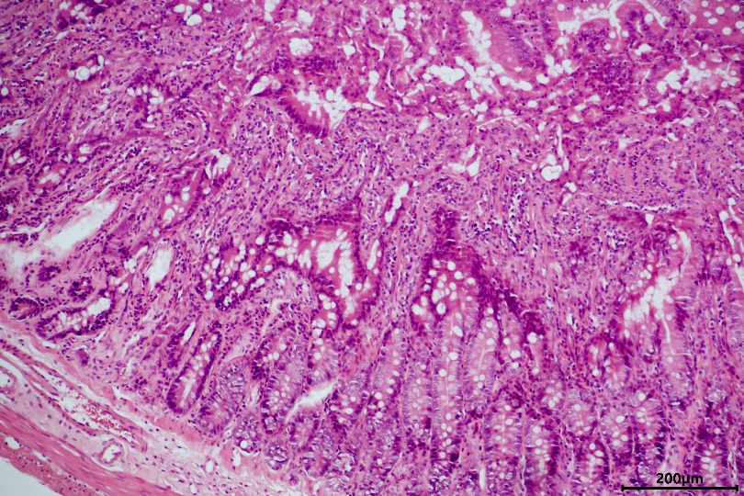
ileum | 100x | 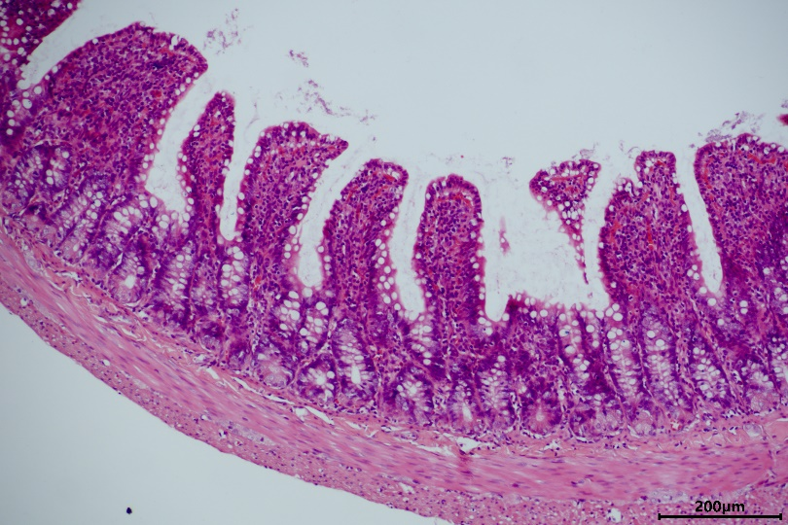 | 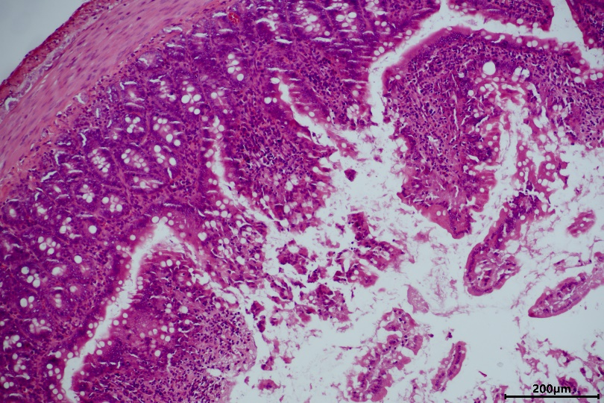
colon | 100x | 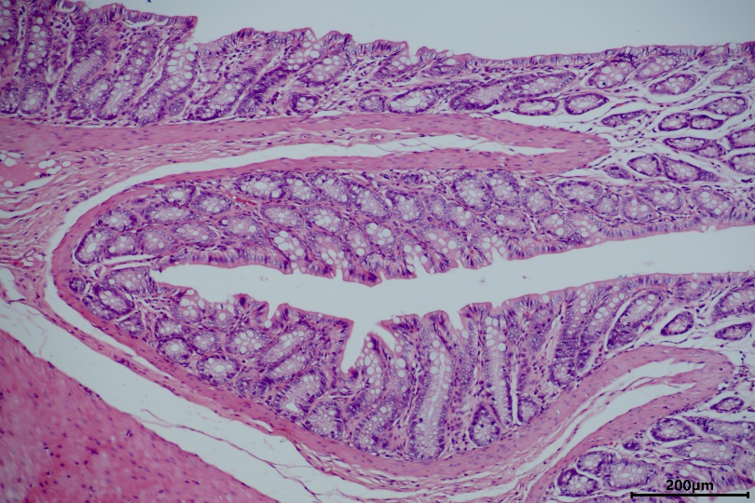 | 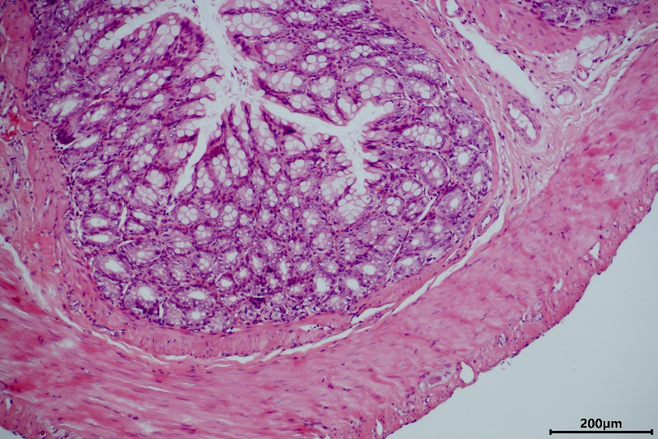
Figure. S4 Microphotographs of brain and digestive tract in control group and high-dose group. No obvious toxic change was found. Each figure is a representative photomicrograph from a rat in each group.

- Berberine-day 1 | - Berberine-day 28
- Epiberberine-day 1 | - Epiberberine-day 28
- Coptisine-day 1 | - Coptisine-day 28
- Palmatine-day 1 | - Palmatine-day 28
- Jatrorrhizine-day 1 | - Jatrorrhizine-day 28
- Columbamine-day 1 | - Columbamine-day 28
Figure. S5 Mean plasma concentration profiles of components in rat plasma after 1-day and 28-day oral administration of TAZF

Table. S1 OCs of lung, spleen and heart in male rats during (n=10) and after (n=6) administration
OC | After a 28-day administration |  |  |  |  |  |  |  |  | After a 14-day recovery
OC | control |  | low |  | medium |  | high |  |  | control |  | low |  | medium |  | high
OC | Mean | S.D. | Mean | S.D. | Mean | S.D. | Mean | S.D. |  | Mean | S.D. | Mean | S.D. | Mean | S.D. | Mean | S.D.
lung | 0.41 | 0.072 | 0.42 | 0.063 | 0.42 | 0.039 | 0.46 | 0.088 |  | 0.38 | 0.070 | 0.36 | 0.055 | 0.39 | 0.035 | 0.44 | 0.030
spleen | 0.22 | 0.049 | 0.22 | 0.032 | 0.23 | 0.032 | 0.21 | 0.036 |  | 0.17 | 0.014 | 0.19 | 0.16 | 0.20 | 0.022 | 0.18 | 0.034
heart | 0.36 | 0.032 | 0.35 | 0.032 | 0.38 | 0.098 | 0.36 | 0.033 |  | 0.34 | 0.026 | 0.33 | 0.021 | 0.32 | 0.027 | 0.38 | 0.076
kidney | 0.74 | 0.044 | 0.73 | 0.061 | 0.73 | 0.067 | 0.77 | 0.053 |  | 0.61 | 0.041 | 0.60 | 0.044 | 0.65 | 0.082 | 0.72** | 0.063
thymus | 0.19 | 0.033 | 0.18 | 0.016 | 0.17 | 0.039 | 0.13* | 0.073 |  | 0.17 | 0.112 | 0.11 | 0.021 | 0.13 | 0.018 | 0.13 | 0.038
**: compared with the control group in the same period P < 0.01 *: compared with the control group in the same period P < 0.05

Table. S2 OCs of lung, spleen and heart in female rats during (n=10) and after (n=6) administration
OC | After a 28-day administration |  |  |  |  |  |  |  |  | After a 14-day recovery
OC | control |  | low |  | medium |  | high |  |  | control |  | low |  | medium |  | high
OC | Mean | S.D. | Mean | S.D. | Mean | S.D. | Mean | S.D. |  | Mean | S.D. | Mean | S.D. | Mean | S.D. | Mean | S.D.
lung | 0.47 | 0.037 | 0.50 | 0.056 | 0.48 | 0.049 | 0.49 | 0.046 |  | 0.45 | 0.039 | 0.51 | 0.036 | 0.50 | 0.088 | 0.48 | 0.060
spleen | 0.22 | 0.024 | 0.21 | 0.027 | 0.23 | 0.040 | 0.22 | 0.040 |  | 0.20 | 0.018 | 0.22 | 0.012 | 0.28** | 0.16 | 0.21 | 0.037
heart | 0.37 | 0.028 | 0.37 | 0.020 | 0.36 | 0.024 | 0.38 | 0.043 |  | 0.36 | 0.026 | 0.35 | 0.019 | 0.35 | 0.023 | 0.38 | 0.025
kidney | 0.69 | 0.059 | 0.69 | 0.043 | 0.73 | 0.057 | 0.72 | 0.038 |  | 0.63 | 0.032 | 0.62 | 0.047 | 0.65 | 0.043 | 0.66 | 0.034
thymus | 0.21 | 0.040 | 0.22 | 0.036 | 0.21 | 0.035 | 0.21 | 0.058 |  | 0.20 | 0.040 | 0.21 | 0.038 | 0.21 | 0.085 | 0.20 | 0.049
ovary | 0.056 | 0.007 | 0.070 | 0.047 | 0.059 | 0.005 | 0.056 | 0.010 |  | 0.050 | 0.007 | 0.048 | 0.007 | 0.065 | 0.024 | 0.051 | 0.008
uterus | 0.25 | 0.118 | 0.25 | 0.111 | 0.25 | 0.076 | 0.24 | 0.093 |  | 0.22 | 0.103 | 0.21 | 0.116 | 0.20 | 0.087 | 0.19 | 0.017
Compared with the corresponding vehicle control group，** P < 0.01

Table. S3 Results of hematological examination in male rats during (n=10) and after (n=6) administration
results |  | After a 28-day administration |  |  |  |  |  |  |  |  | After a 14-day recovery
 |  | control |  | low |  | medium |  | high |  |  | control |  | low |  | medium |  | high
 |  | Mean | S.D. | Mean | S.D. | Mean | S.D. | Mean | S.D. |  | Mean | S.D. | Mean | S.D. | Mean | S.D. | Mean | S.D.
RBC | M/uL | 7.35 | 0.28 | 7.18 | 0.21 | 7.37 | 0.41 | 7.35 | 0.41 |  | 7.86 | 0.65 | 8.08 | 0.22 | 7.78 | 0.37 | 7.91 | 0.11
HGB | g/dL | 14.27 | 0.71 | 14.27 | 0.34 | 14.11 | 0.78 | 13.84 | 0.85 |  | 15.03 | 0.74 | 14.67 | 0.77 | 15.03 | 0.53 | 14.60 | 0.17
HCT | % | 42.98 | 1.72 | 42.41 | 1.50 | 43.20 | 2.57 | 41.96 | 3.09 |  | 43.10 | 2.31 | 42.83 | 1.92 | 43.87 | 1.83 | 42.70 | 1.64
MCV | fL | 56.78 | 2.42 | 57.51 | 2.23 | 56.75 | 1.88 | 56.36 | 2.37 |  | 54.97 | 2.91 | 53.07 | 3.09 | 56.52 | 3.43 | 54.00 | 2.25
MCH | pg | 19.40 | 0.97 | 19.74 | 0.79 | 19.40 | 0.69 | 19.11 | 0.66 |  | 19.17 | 0.97 | 18.17 | 1.26 | 19.37 | 1.24 | 18.43 | 0.49
MCHC | g/dL | 34.12 | 0.33 | 34.27 | 0.71 | 34.16 | 0.29 | 33.94 | 0.68 |  | 34.88 | 0.33 | 34.22* | 0.42 | 34.27 | 0.50 | 34.23 | 1.30
RET% | % | 5.96 | 1.02 | 6.53 | 2.15 | 5.52 | 1.30 | 5.36 | 2.06 |  | 3.62 | 0.56 | 4.20 | 0.38 | 3.64 | 1.20 | 3.94 | 2.42
WBC | K/uL | 6.19 | 2.03 | 7.44 | 1.79 | 7.72 | 5.00 | 6.58 | 3.81 |  | 10.62 | 3.09 | 7.51 | 2.22 | 5.88 | 3.43 | 6.91 | 4.10
NEUT% | % | 10.98 | 5.32 | 15.14 | 4.91 | 12.40 | 6.61 | 16.68 | 10.80 |  | 17.37 | 13.27 | 13.9 | 7.16 | 19.67 | 10.89 | 21.27 | 8.02
LYMPH% | % | 83.71 | 6.73 | 77.89 | 6.29 | 78.98 | 11.70 | 76.82 | 13.33 |  | 72.03 | 13 | 75.17 | 6.41 | 71.48 | 10.06 | 70.77 | 7.54
MONO% | % | 4.07 | 1.30 | 5.64 | 1.87 | 7.21 | 8.23 | 5.63 | 2.76 |  | 9.48 | 2.19 | 9.85 | 1.73 | 8.15 | 1.44 | 7.43 | 0.71
EO% | % | 1.10 | 0.56 | 1.11 | 0.67 | 1.33 | 1.13 | 0.72 | 0.30 |  | 0.97 | 0.21 | 0.95 | 0.59 | 0.55 | 0.30 | 0.40 | 0.36
BASO% | % | 0.14 | 0.12 | 0.21 | 0.11 | 0.08 | 0.08 | 0.14 | 0.12 |  | 0.15 | 0.05 | 0.13 | 0.08 | 0.15 | 0.20 | 0.13 | 0.15
PLT | K/uL | 916.10 | 88.43 | 961.71 | 50.97 | 917.80 | 175.68 | 885.33 | 147.51 |  | 811.83 | 74.47 | 832.17 | 91.51 | 852 | 90.13 | 798.67 | 48.39
PT | s | 12.27 | 0.32 | 12.49 | 0.20 | 12.59 | 0.57 | 12.53 | 0.55 |  | 12.98 | 0.66 | 13.27 | 0.37 | 12.83 | 0.34 | 13.03 | 0.65
*: compared with the control group in the same period P < 0.05

Table. S4 Results of haematological examination in female rats during (n=10) and after (n=6) administration
results |  | After a 28-day administration |  |  |  |  |  |  |  |  | After a 14-day recovery
 |  | control |  | low |  | medium |  | high |  |  | control |  | low |  | medium |  | high
 |  | Mean | S.D. | Mean | S.D. | Mean | S.D. | Mean | S.D. |  | Mean | S.D. | Mean | S.D. | Mean | S.D. | Mean | S.D.
RBC | M/uL | 7.22 | 0.32 | 7.25 | 0.44 | 7.30 | 0.42 | 7.23 | 0.34 |  | 7.75 | 0.45 | 7.52 | 0.19 | 7.27 | 0.52 | 7.38 | 0.44
HGB | g/dL | 14.30 | 0.65 | 13.99 | 0.80 | 14.24 | 0.82 | 13.29** | 0.72 |  | 14.52 | 0.71 | 15.02 | 0.21 | 14.40 | 0.63 | 14.58 | 0.46
HCT | % | 41.90 | 1.97 | 40.38 | 2.81 | 41.9** | 2.59 | 38.53 | 2.40 |  | 40.93 | 2.14 | 42.25 | 0.74 | 41.02 | 2.00 | 41.14 | 1.48
MCV | fL | 58.78 | 1.75 | 57.83 | 2.93 | 57.96 | 2.55 | 55.50** | 4.20 |  | 52.82 | 0.88 | 56.23* | 1.03 | 56.54* | 2.39 | 55.78 | 1.65
MCH | pg | 19.29 | 0.57 | 19.56 | 0.42 | 19.06 | 1.02 | 18.86 | 0.97 |  | 18.73 | 0.36 | 20.00** | 0.49 | 19.84* | 0.81 | 19.76* | 0.68
MCHC | g/dL | 32.82 | 0.37 | 33.89* | 1.44 | 32.91 | 1.03 | 34.03** | 1.32 |  | 35.47 | 0.62 | 35.55 | 0.37 | 35.12 | 0.29 | 35.44 | 0.52
RET% | % | 6.99 | 1.28 | 6.76 | 0.71 | 6.66 | 0.83 | 6.43 | 1.84 |  | 2.93 | 0.34 | 2.73 | 0.63 | 3.89 | 1.1 | 3.08 | 0.84
WBC | K/uL | 12.68 | 3.24 | 9.57* | 3.33 | 11.88 | 3.51 | 9.82* | 3.83 |  | 5.58 | 1.46 | 6.10 | 0.55 | 6.11 | 1.87 | 5.82 | 1.34
NEUT% | % | 14.25 | 5.38 | 17.45 | 6.20 | 14.42 | 6.20 | 14.44 | 10.38 |  | 21.02 | 5.20 | 14.13 | 7.66 | 23.14 | 17.71 | 22.00 | 5.47
LYMPH% | % | 79.89 | 5.37 | 75.44 | 7.05 | 78.76 | 6.86 | 79.46 | 11.14 |  | 71.37 | 6.10 | 77.97 | 7.07 | 67.82 | 17.36 | 68.72 | 6.75
MONO% | % | 5.14 | 1.26 | 6.28 | 1.55 | 5.99 | 1.88 | 5.41 | 1.53 |  | 6.25 | 0.65 | 6.93 | 1.31 | 8.08* | 0.73 | 8.38* | 1.97
EO% | % | 0.63 | 0.25 | 0.74 | 0.21 | 0.67 | 0.33 | 0.59 | 0.24 |  | 1.12 | 0.40 | 0.83* | 0.23 | 0.72* | 0.32 | 0.76*** | 0.17
BASO% | % | 0.09 | 0.06 | 0.09 | 0.07 | 0.16 | 0.13 | 0.10 | 0.11 |  | 0.25 | 0.18 | 0.13 | 0.10 | 0.24 | 0.05 | 0.14 | 0.09
PLT | K/uL | 922.90 | 89.48 | 834.2 | 193.65 | 880.70 | 142.84 | 924.44 | 117.40 |  | 802.83 | 36.84 | 810.33 | 61.11 | 880.40 | 110.83 | 755.80 | 97.96
PT | s | 12.61 | 0.35 | 12.46 | 0.54 | 12.48 | 0.64 | 12.12 | 0.72 |  | 12.53 | 0.50 | 12.77 | 0.47 | 12.82 | 0.44 | 12.98 | 0.61
*: compared with the control group in the same period P < 0.05; **: P < 0.01; ***: P < 0.001

Table.S5 Linearity and linear range of the components
components | linear range(ng/mL) | Regression Equation | r
berberine | 0.5 - 400 | y = 0.00394x + 0.00845 | 0.9977
epiberberine | 0.5 - 100 | y = 0.0069x + 0.0261 | 0.9978
coptisine | 0.5 - 100 | y = 0.00129x + 0.0271 | 0.9995
palmatine | 0.5 - 100 | y = 0.00608x + 0.0493 | 0.9984
jatrorrhizine | 0.5 - 100 | y = 0.00552x + 0.0131 | 0.9952
columbamine | 0.5 - 100 | y = 0.00208x - 0.000286 | 0.9975
evodiamine | 0.5 - 100 | y = 0.000364x + 0.000611 | 0.9977
rutaecarpine | 0.5 - 100 | y = 0.000473x - 0.00109 | 0.9957

Table.S6 Results of sensitivity and recovery
component | Nominal concentration (ng/ml) | Mean (ng/ml) | RSD | Recovery rate  (%) | RE%
berberine | 1.5 | 1.4 | 0.21 | 93.3 | 4.66
 | 100 | 80.8 | 0.17 | 80.8 | 19.17
 | 300 | 253.2 | 0.09 | 84.4 | 11.87
epiberberine | 1.5 | 1.2 | 0.15 | 80.0 | 17.22
 | 25 | 22.4 | 0.05 | 89.6 | 10.33
 | 75 | 62.5 | 0.09 | 83.3 | 16.62
coptisine | 1.5 | 1.5 | 0.19 | 100.7 | 0.81
 | 25 | 21.7 | 0.11 | 86.8 | 13.13
 | 75 | 68.5 | 0.09 | 91.3 | 8.73
palmatine | 1.5 | 1.6 | 0.11 | 106.7 | 3.44
 | 25 | 22.0 | 0.07 | 88.0 | 12.00
 | 75 | 64.5 | 0.10 | 86.0 | 14.04
jatrorrhizine | 1.5 | 1.4 | 0.08 | 93.3 | 4.44
 | 25 | 23.0 | 0.16 | 92.0 | 7.87
 | 75 | 60.7 | 0.08 | 80.9 | 19.07
columbamine | 1.5 | 1.7 | 0.13 | 113.3 | 13.44
 | 25 | 23.8 | 0.06 | 95.2 | 4.87
 | 75 | 64.0 | 0.07 | 85.3 | 14.64
evodiamine | 1.5 | 1.2 | 0.22 | 80.0 | 22.08
 | 25 | 20.9 | 0.18 | 83.6 | 16.27
 | 75 | 60.6 | 0.10 | 80.8 | 19.27
rutaecarpine | 1.5 | 1.3 | 0.33 | 86.7 | 16.93
 | 25 | 20.2 | 0.20 | 80.8 | 19.13
 | 75 | 61.3 | 0.13 | 81.7 | 18.33

Table. S7 Pharmacokinetic parameters of 6 components on the first and 28th day in male rats.
components | days | Dose  (mg/kg) | T_{1/2}  (h) |  | T_{max}  (h) |  | C_{max}  (ng/ml) |  | AUC_{0-t}  (ng/ml*h)
components | days | Dose  (mg/kg) | mean | S.D. | mean | S.D. | mean | S.D. | mean | S.D.
berberine | Day 1 | 8.01 | 42.28 | 30.18 | 10.00 | 9.93 | 221.60 | 179.72 | 1222.27 | 389.41
berberine | Day 1 | 24.03 | 176.75 | 151.08 | 1.83 | 1.55 | 299.00 | 148.50 | 1570.11 | 389.90
berberine | Day 1 | 72.08 | 13.11 | 1.68 | 3.00 | 1.41 | 219.33 | 24.42 | 1860.60 | 424.79
berberine | Day 28 | 8.01 | 15.39 | 3.19 | 1.08 | 0.72 | 460.50 | 275.96 | 699.29 | 643.96
berberine | Day 28 | 24.03 | 4.09 | 1.95 | 12.00 | 8.49 | 102.40 | 33.71 | 484.04 | 91.68
berberine | Day 28 | 72.08 | 11.68 | 6.22 | 3.50 | 4.60 | 135.93 | 77.87 | 608.14 | 203.22
epiberberine | Day 1 | 0.82 | 9.40 | 4.43 | 3.33 | 0.94 | 21.05 | 21.05 | 94.67 | 43.14
epiberberine | Day 1 | 2.47 | 39.62 | 23.38 | 1.67 | 1.65 | 25.37 | 16.50 | 201.57 | 35.93
epiberberine | Day 1 | 7.42 | 8.06 | 1.73 | 3.33 | 0.94 | 33.23 | 25.69 | 265.36 | 67.81
epiberberine | Day 28 | 0.82 | 6.90 | 5.85 | 0.83 | 0.82 | 28.67 | 33.82 | 38.92 | 10.07
epiberberine | Day 28 | 2.47 | 648.60 | 911.18 | 4.67 | 1.89 | 15.32 | 8.98 | 160.77 | 34.73
epiberberine | Day 28 | 7.42 | 7.60 | 3.72 | 7.33 | 1.89 | 31.27 | 7.23 | 451.56 | 79.31
coptisine | Day 1 | 1.38 | 13.22 | 6.23 | 3.33 | 0.94 | 32.43 | 33.02 | 131.79 | 55.97
coptisine | Day 1 | 2.47 | 31.11 | 16.98 | 1.83 | 1.55 | 44.23 | 25.22 | 195.05 | 48.20
coptisine | Day 1 | 7.42 | 8.64 | 0.80 | 3.33 | 0.94 | 32.30 | 9.08 | 239.83 | 65.50
coptisine | Day 28 | 1.38 | 6.11 | 2.88 | 1.08 | 0.72 | 45.49 | 57.63 | 17.32 | 11.02
coptisine | Day 28 | 2.47 | 2.60 | 1.24 | 12.00 | 8.49 | 14.92 | 4.51 | 60.21 | 10.20
coptisine | Day 28 | 7.42 | 7.81 | 5.59 | 4.08 | 4.24 | 20.05 | 13.57 | 81.65 | 9.48
palmatine | Day 1 | 2.03 | 12.88 | 6.07 | 3.33 | 0.94 | 52.47 | 52.73 | 236.12 | 103.55
palmatine | Day 1 | 6.09 | 26.57 | 12.53 | 0.67 | 0.24 | 71.53 | 51.37 | 318.68 | 67.35
palmatine | Day 1 | 18.26 | 10.38 | 0.58 | 3.33 | 0.94 | 51.33 | 17.52 | 342.51 | 66.62
palmatine | Day 28 | 2.03 | 12.22 | 6.98 | 0.83 | 0.82 | 67.20 | 74.82 | 36.98 | 18.55
palmatine | Day 28 | 6.09 | 2.90 | 1.39 | 12.00 | 8.49 | 22.63 | 3.35 | 102.21 | 20.79
palmatine | Day 28 | 18.26 | 11.01 | 8.44 | 4.08 | 4.24 | 32.93 | 24.17 | 110.18 | 34.30
jatrorrhizine | Day 1 | 0.31 | 52.89 | 40.88 | 10.00 | 9.93 | 11.85 | 10.79 | 51.95 | 20.41
jatrorrhizine | Day 1 | 0.93 | 68.04 | 32.15 | 1.83 | 1.55 | 15.41 | 10.60 | 74.52 | 18.30

Table. S7 (Continued)
components | days | Dose  (mg/kg) | T_{1/2}  (h) |  | T_{max}  (h) |  | C_{max}  (ng/ml) |  | AUC_{0-t}  (ng/ml*h)
components | days | Dose  (mg/kg) | mean | S.D. | mean | S.D. | mean | S.D. | mean | S.D.
jatrorrhizine | Day 1 | 2.80 | 9.68 | 3.31 | 4.00 | 1.63 | 17.66 | 10.96 | 101.24 | 35.32
jatrorrhizine | Day 28 | 0.31 | 11.10 | 6.50 | 0.83 | 0.82 | 16.40 | 15.98 | 8.62 | 3.21
jatrorrhizine | Day 28 | 0.93 | 2.72 | 1.29 | 12.00 | 8.49 | 7.78 | 1.76 | 33.28 | 3.59
jatrorrhizine | Day 28 | 2.80 | 4.48 | 0.81 | 1.17 | 0.62 | 7.97 | 7.64 | 25.64 | 6.74
columbamine | Day 1 | 0.66 | 47.75 | 36.46 | 10.00 | 9.93 | 32.13 | 28.69 | 152.81 | 54.87
columbamine | Day 1 | 1.98 | 59.95 | 28.26 | 1.83 | 1.55 | 41.70 | 28.23 | 206.76 | 40.77
columbamine | Day 1 | 5.93 | 10.86 | 3.08 | 4.00 | 1.63 | 46.47 | 30.26 | 275.76 | 91.98
columbamine | Day 28 | 0.66 | 7.52 | 2.12 | 0.83 | 0.82 | 44.17 | 42.31 | 31.11 | 2.21
columbamine | Day 28 | 1.98 | 4.07 | 1.92 | 12.00 | 8.49 | 21.37 | 4.71 | 90.56 | 9.79
columbamine | Day 28 | 5.93 | 11.25 | 8.42 | 4.08 | 4.24 | 16.44 | 11.77 | 65.14 | 6.74

Table. S8 Pharmacokinetic parameters of 6 components on the first and 28th day in female rats.
components | days | Dose  (mg/kg) | T_{1/2}  (h) |  | T_{max}  (h) |  | C_{max}  (ng/ml) |  | AUC_{0-t}  (ng/ml*h)
components | days | Dose  (mg/kg) | mean | S.D. | mean | S.D. | mean | S.D. | mean | S.D.
berberine | Day 1 | 8.01 | 5.11 | 2.47 | 0.42 | 0.12 | 148.77 | 72.99 | 121.57 | 17.07
berberine | Day 1 | 24.03 | 8.19 | 3.58 | 0.83 | 0.82 | 358.33 | 119.60 | 554.10 | 251.73
berberine | Day 1 | 72.08 | 13.19 | 5.78 | 0.50 | 0.35 | 218.70 | 118.35 | 306.28 | 94.72
berberine | Day 28 | 8.01 | 27.12 | 23.31 | 3.67 | 4.48 | 324.10 | 431.97 | 838.44 | 949.05
berberine | Day 28 | 24.03 | 9.51 | 5.23 | 1.33 | 0.47 | 19.10 | 3.28 | 115.09 | 56.44
berberine | Day 28 | 72.08 | 12.92 | 4.60 | 0.50 | 0.35 | 23.83 | 6.25 | 153.27 | 53.73
epiberberine | Day 1 | 0.82 | 4.13 | 0.49 | 0.42 | 0.12 | 9.96 | 4.38 | 11.57 | 1.08
epiberberine | Day 1 | 2.47 | 4.70 | 1.17 | 0.83 | 0.82 | 30.43 | 15.40 | 72.49 | 26.67
epiberberine | Day 1 | 7.42 | 10.46 | 5.44 | 2.42 | 2.55 | 17.80 | 7.13 | 128.90 | 48.41
epiberberine | Day 28 | 0.82 | 8.39 | 3.84 | 2.17 | 1.43 | 23.34 | 27.62 | 75.82 | 44.51
epiberberine | Day 28 | 2.47 | 14.71 | 16.38 | 2.08 | 1.53 | 14.50 | 2.54 | 138.58 | 54.58
epiberberine | Day 28 | 7.42 | 13.06 | 7.00 | 2.67 | 0.94 | 30.37 | 12.39 | 311.25 | 123.81
coptisine | Day 1 | 1.38 | \ | 0.00 | 0.50 | 0.00 | 18.11 | 11.11 | 9.49 | 2.79
coptisine | Day 1 | 2.47 | 2.93 | 1.45 | 0.83 | 0.82 | 50.00 | 19.72 | 63.81 | 31.66
coptisine | Day 1 | 7.42 | 2.76 | 0.38 | 0.50 | 0.35 | 31.07 | 15.51 | 57.11 | 10.26
coptisine | Day 28 | 1.38 | 8.19 | 6.46 | 0.33 | 0.12 | 52.53 | 72.46 | 99.93 | 135.02
coptisine | Day 28 | 2.47 | 10.60 | 4.99 | 1.17 | 0.62 | 2.95 | 2.29 | 4.65 | 4.06
coptisine | Day 28 | 7.42 | 4.07 | 2.02 | 0.50 | 0.35 | 2.82 | 0.87 | 10.74 | 6.60
palmatine | Day 1 | 2.03 | 5.96 | 2.81 | 0.42 | 0.12 | 27.93 | 13.97 | 18.08 | 4.07
palmatine | Day 1 | 6.09 | 3.29 | 1.62 | 0.83 | 0.82 | 77.60 | 35.30 | 90.31 | 50.76
palmatine | Day 1 | 18.26 | 5.18 | 1.21 | 0.50 | 0.35 | 46.60 | 27.16 | 38.00 | 16.92
palmatine | Day 28 | 2.03 | 80.32 | 108.44 | 0.42 | 0.12 | 55.94 | 72.88 | 116.47 | 138.20
palmatine | Day 28 | 6.09 | 9.33 | 4.40 | 1.33 | 0.47 | 4.16 | 0.97 | 14.65 | 10.78
palmatine | Day 28 | 18.26 | 3.98 | 0.56 | 0.83 | 0.82 | 5.67 | 2.58 | 24.07 | 12.21
jatrorrhizine | Day 1 | 0.31 | 2.64 | 1.25 | 2.33 | 2.59 | 11.04 | 7.79 | 25.63 | 30.02
jatrorrhizine | Day 1 | 0.93 | 3.57 | 0.37 | 0.83 | 0.82 | 14.64 | 6.91 | 19.94 | 9.16

Table. S8 (Continued)
components | days | Dose  (mg/kg) | T_{1/2}  (h) |  | T_{max}  (h) |  | C_{max}  (ng/ml) |  | AUC_{0-t}  (ng/ml*h)
components | days | Dose  (mg/kg) | mean | S.D. | mean | S.D. | mean | S.D. | mean | S.D.
 |  | 2.80 | 3.96 | 0.64 | 0.50 | 0.35 | 14.84 | 10.66 | 22.12 | 4.83
 | Day 28 | 0.31 | 3.39 | 1.60 | 4.17 | 4.17 | 11.15 | 15.03 | 23.94 | 27.68
 | Day 28 | 0.93 | 5.33 | 2.53 | 1.00 | 0.71 | 1.29 | 0.31 | 3.87 | 1.24
 | Day 28 | 2.80 | 4.98 | 0.56 | 1.33 | 0.47 | 2.08 | 0.41 | 11.36 | 1.79
columbamine | Day 1 | 0.66 | 4.31 | 1.44 | 2.33 | 2.59 | 29.98 | 20.67 | 71.44 | 80.14
columbamine | Day 1 | 1.98 | 7.78 | 3.08 | 0.83 | 0.82 | 39.63 | 18.46 | 59.20 | 20.55
columbamine | Day 1 | 5.93 | 8.24 | 3.78 | 0.50 | 0.35 | 37.70 | 30.37 | 41.10 | 10.03
columbamine | Day 28 | 0.66 | 10.95 | 7.08 | 0.42 | 0.12 | 30.29 | 40.03 | 68.10 | 76.87
columbamine | Day 28 | 1.98 | 10.65 | 3.18 | 1.50 | 1.77 | 1.35 | 0.97 | 9.42 | 7.32
columbamine | Day 28 | 5.93 | 12.44 | 3.46 | 1.17 | 0.62 | 2.98 | 0.24 | 12.23 | 4.52

