Additional File 7 6LU7’s native ligand redocking result

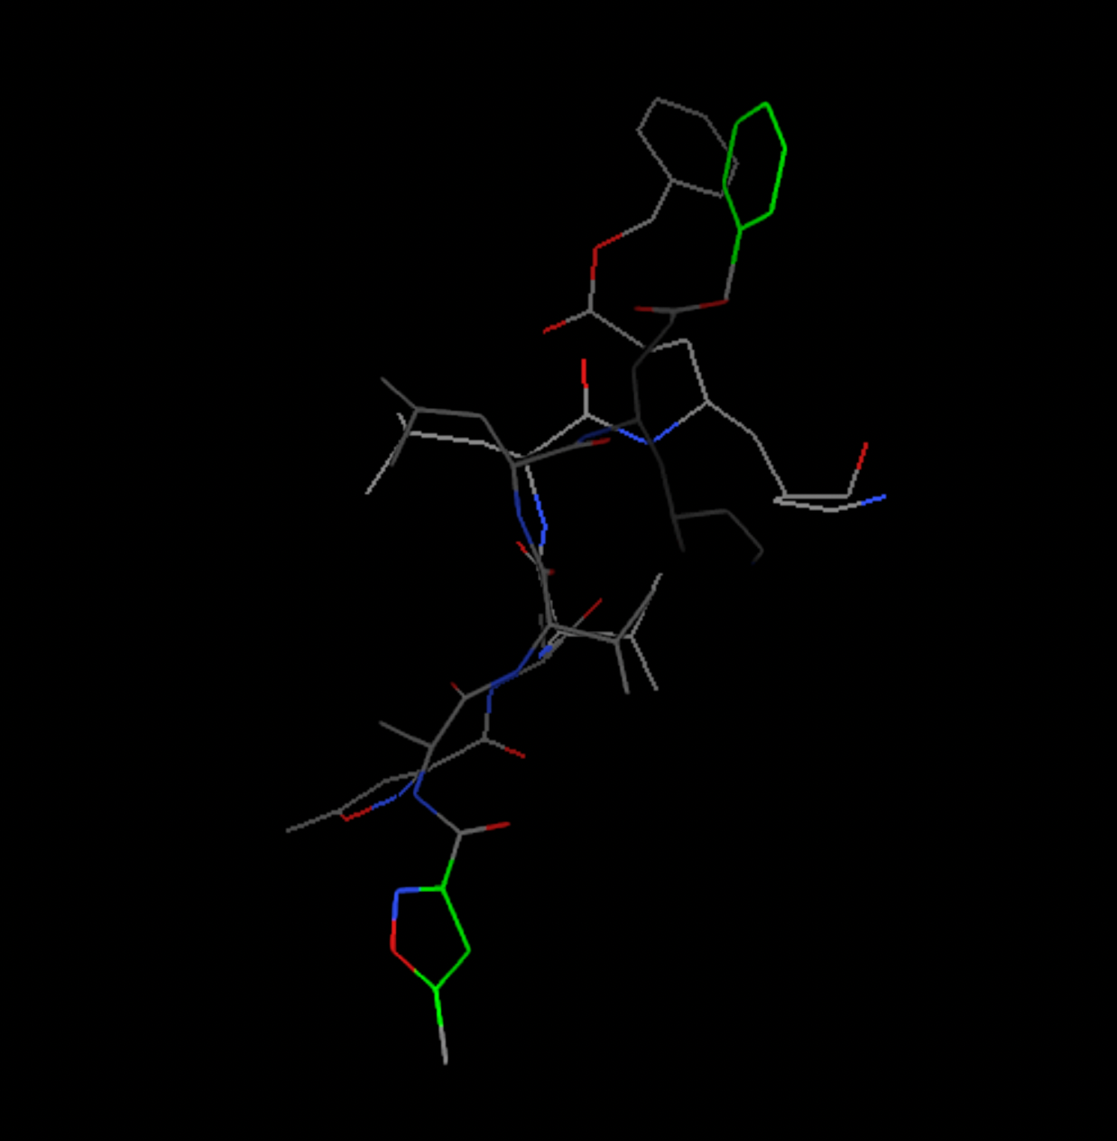

Coordinates of Central Grid Point of Maps = (-9.732, 11.403, 68.925) ; 40x56x40
Estimated Free Energy of Binding = -7.96 kcal/mol
RMSD = 1.78 A

