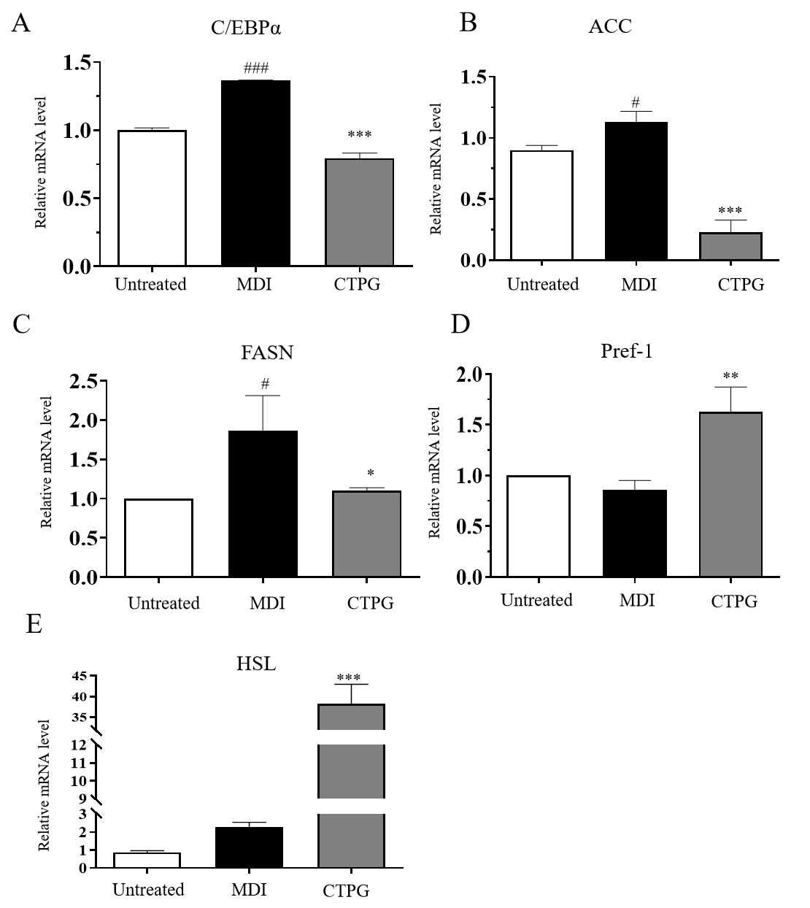
Figure S1. Effect of CTPG on the expression levels of lipogenesis genes in 3T3-L1 adipocytes. 3T3-L1 cells were treated with 100 μg/ml CTPG for 72h and the mRNA levels for C/EBPα (A) , ACC (B), FASN (C), Pref-1 (D) and HSL(E) were analyzed by qRT-PCR.

Table S1. The gene-specific primers.
Gene | Primer sequences (5' to 3' )
β-actin | F:GGCTGTATTCCCCTCCATCG | R:CCAGTTGGTAACAATGCCATGT
C/EBPα | F:CAAGAACAGCAACGAGTACCG | R:GTCACTGGTCAACTCCAGCAC
ACC | F:GCCTCAGGAGGATTTGCTGT | R:AGGATCTACCCAGGCCACAT
FASN | F:GGAAGTTGCCCGAGTCAGAG | R:CTTTCCAGACCGCTTGGGTA
HSL | F:TCAATGGAGACACTTGGCCC | R:TTGGCTTCAGCCTCTTCCTG
Pref-1 | F:AGTGCGAAACCTGGGTGTC | R:GCCTCCTTGTTGAAAGTGGTCA

