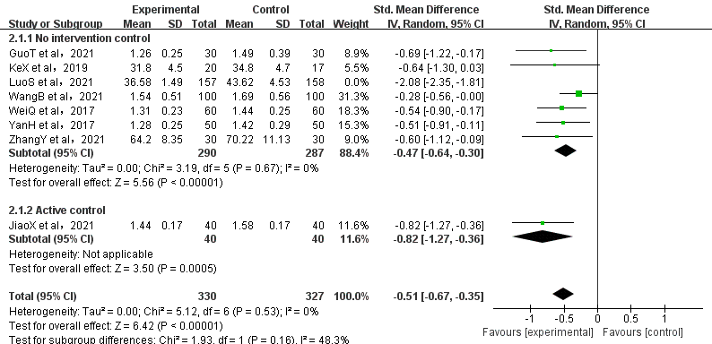
Figure S2. Sensitivity analysis of the effect of Qigong interventions on anxiety

