Supplementary data 1:
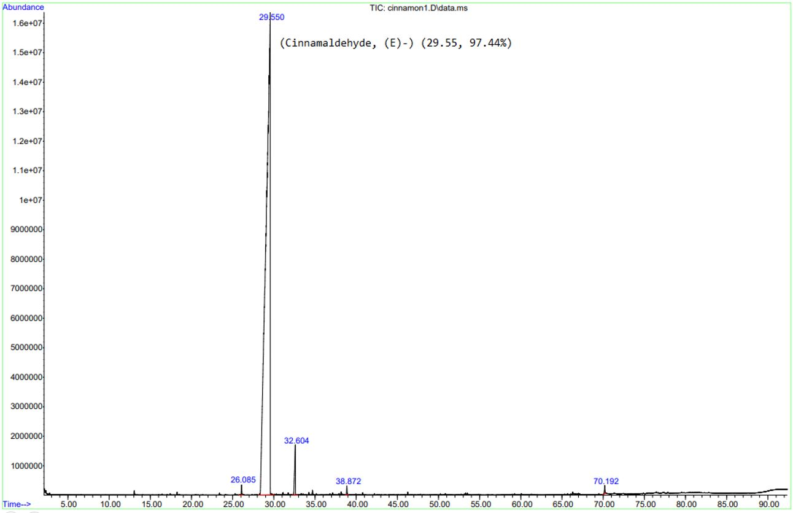
S₁. GC-MS analysis of cinnamon oil, revealing a high concentration of cinnamaldehyde as major constituent.

