Supplementary Data
Table S1: Preliminary qualitative analysis of the phytochemical constituents of 70 % ethanolic crude extract of T. bangwensis leaves and its fractions
Phytochemical constituents | T. bangwensis (70% crude extract) | T. bangwensis (Pet. Ether fraction) | T.  bangwensis (Chloroform fraction) | T. bangwensis (Ethyl acetate fraction) | T. bangwensis (Aqueous fraction)
Phenolic compounds | + | - | + | + | +
Flavonoids | + | - | - | + | +
Saponins | + | - | + | + | +
Phytosterols | + | + | + | - | -
Reducing sugar | + | + | + | + | +
+ Present - Absent

Table S2: Quantitative analysis of the total saponins of 70 % ethanolic crude extract and fractions of T. bangwensis leaves
Extract | Total saponins (% w/w)
Extract | 1 | 2 | 3
 | 11.22 | 6.71 | 8.96
  Crude
Petroleum ether | ND | ND | ND
Chloroform | 4.077 | 4.076 | 4.08
Ethyl acetate | 68.18 | 64.75 | 66.47
Aqueous | 5.68 | 5.11 | 5.39
ND – not detected from the qualitative phytochemical analysis

Table S3: Quantitative analysis of the total phenolic compounds of 70 % ethanolic crude extract and fractions of T. bangwensis leaves
Extract | Total phenolic compounds (mg/100 mg GAE)
Extract | 1 | 2 | 3
 | 8.217 | 610.285 | 9.169
  Crude
Petroleum ether | ND | ND | ND
Chloroform | 3.890 | 3.999 | 3.972
Ethyl acetate | 77.768 | 77.006 | 78.473
Aqueous | 11.400 | 12.108 | 12.162
ND – not detected from the qualitative phytochemical analysis

Table S4: Quantitative analysis of the total flavonoids of 70 % ethanolic crude extract and fractions of T. bangwensis leaves
Extract | Total flavonoids (mg/100 mg QE)
Extract | 1 | 2 | 3
 | 9.235 | 8.900 | 9.198
  Crude
Petroleum ether | ND | ND | ND
Chloroform | ND | ND | ND
Ethyl acetate | 44.823 | 44.971 | 43.240
Aqueous | 8.342 | 9.012 | 8.900
ND – not detected from the qualitative phytochemical analysis

Table S5: Quantitative analysis of the total reducing sugars of 70 % ethanolic crude extract and fractions of T. bangwensis leaves
Extract | Total reducing sugars (% w/w)
Extract | 1 | 2 | 3
 | 36.5217094 | 36.6965532 | 36.3468656
  Crude
Petroleum ether | 32.9082708 | 32.7917082 | 31.9174892
Chloroform | 33.607646 | 35.0063964 | 32.733427
Ethyl acetate | 33.2579584 | 33.7242085 | 33.1413959
Aqueous | 34.9481152 | 34.5984276 | 34.7149901
ND – not detected from the qualitative phytochemical analysis

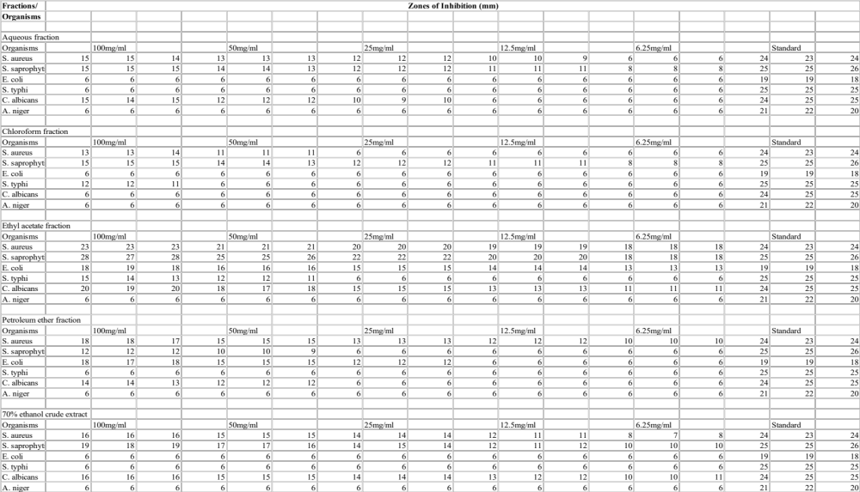
Figure S1: Antimicrobial activity of 70 % ethanolic crude extract and fractions of T. bangwensis leaves against test organisms
The susceptibility of the microorganisms to the extracts was tested using the agar well diffusion method.

Table S6 : Minimum inhibitory concentrations of 70 % ethanolic crude extract and fractions of T. bangwensis leaves against test organisms.
Organisms | Minimum inhibitory concentrations (mg/mL)
Organisms | Aqueous Fraction | Chloroform Fraction | Ethyl Acetate Fraction | Petroleum Ether Fraction | 70% Ethanol Crude Extract
S. aureus | 6.25 | 12.5 | 3.13 | 3.13 | 3.13
S. saprophyticus | 6.25 | 6.25 | 3.13 | 6.25 | 0.78
E. coli | 6.25 | 6.25 | 3.13 | 6.25 | 3.13
S. typhi | 25 | 6.25 | 3.13 | 6.25 | 3.13
C. albicans | 12.5 | 12.5 | 0.78 | 3.13 | 1.56
A. niger | >50 | 12.5 | >50 | >50 | >50
The susceptibility of the microorganisms to the extracts was tested using the broth diffusion method

Table S7: Minimum lethal concentrations of 70 % ethanolic crude extract and fractions of T. bangwensis leaves against test organisms
Organisms | Minimum lethal concentrations (mg/mL)
Organisms | Aqueous Fraction | Chloroform Fraction | Ethyl Acetate Fraction | Petroleum Ether Fraction | 70% Ethanol Crude Extract
S. aureus | >50 | >50 | 50 | >50 | >50
S. saprophyticus | >50 | >50 | 50 | >50 | 25
E. coli | >50 | >50 | 6.25 | >50 | >50
S. typhi | >50 | >50 | >50 | >50 | >50
C. albicans | >50 | >50 | 50 | >50 | >50
A. niger | >50 | >50 | >50 | >50 | >50
The susceptibility of the microorganisms to the extracts was tested using the broth diffusion method

