Supplementary Information

Supplementary Figure 2. Original western blotting for TGF-β1/SMAD3 and ERK pathways in TGF-β1- and PDGF-induced dermal fibroblasts
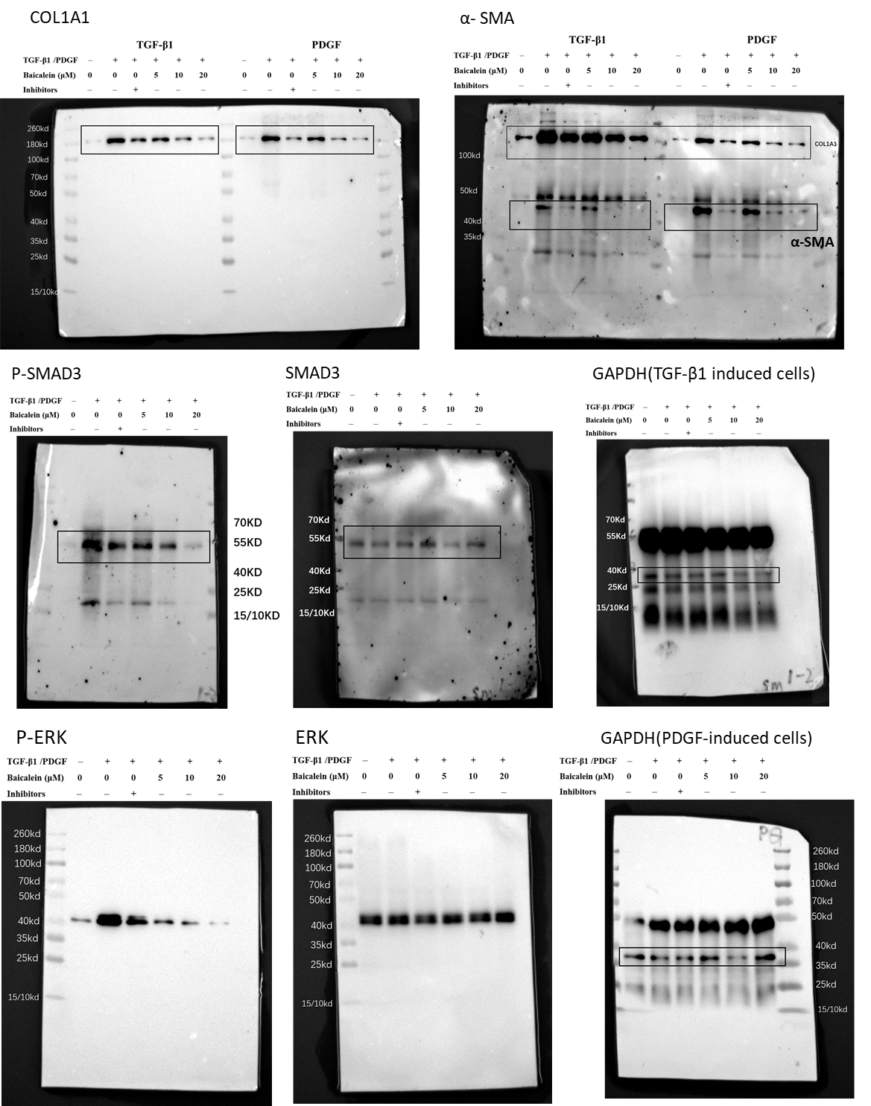

Supplementary Figure 3. Original western blotting for protein from lesional skins in bleomycin-induced mice. From left to right Lane1-3: NaCl control, Lane 4-6: BLM, Lane 7-9: BLM+baicalein (50mg/kg), Lane 10-12: BLM+baicalein (100mg/kg).
