Supplementary figure 1
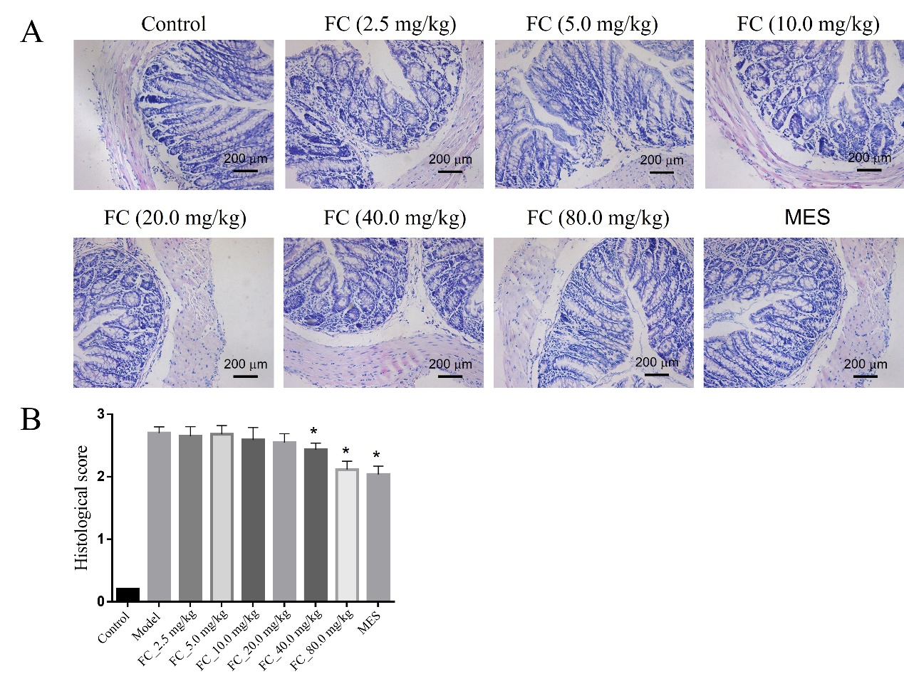
Figure S1 Therapeutic effects of FC on DSS-induced colitis
A. HE staining of colon tissues (200×, scale bar, 200μm); B. Histological score. Data are presented as the mean ± SD (n=10). *P< 0.05 versus model group.

Supplementary figure 2
Figure S2 Schematic graph of animal experiment

Supplementary figure 3
Figure S3 GEO datasets processing. (A) The boxplot of the normalized data. The x-axis represent samples and the y-axis represent the expression values. (B) PCA results before batch removal for multiple datasets. (C) PCA results after batch removal.

Supplementary figure 4

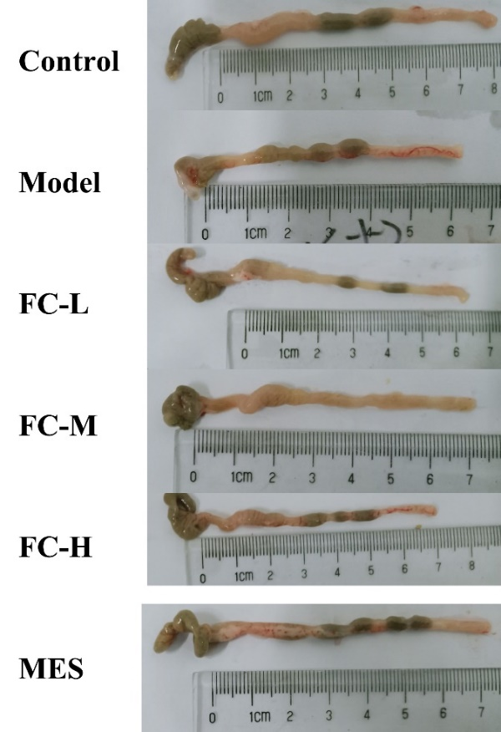

Figure S4 Representative picture of the colon (n=10).

