Figure 11A
IL-1β (17 kDa)
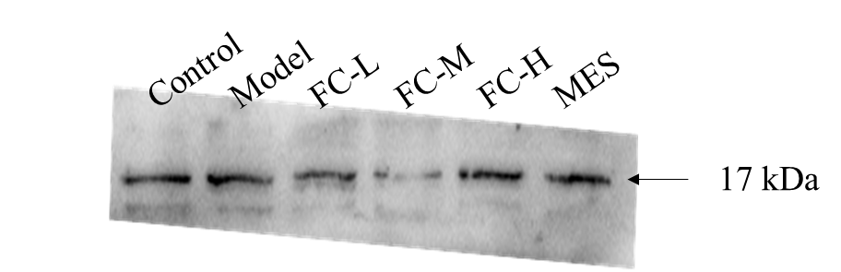
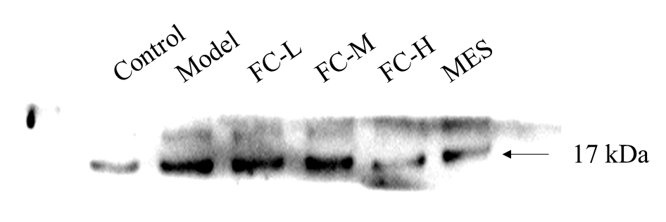

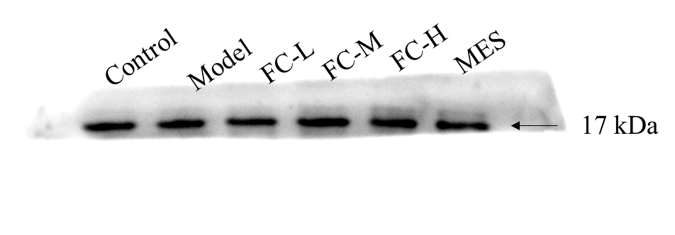

COX2 (69 kDa)
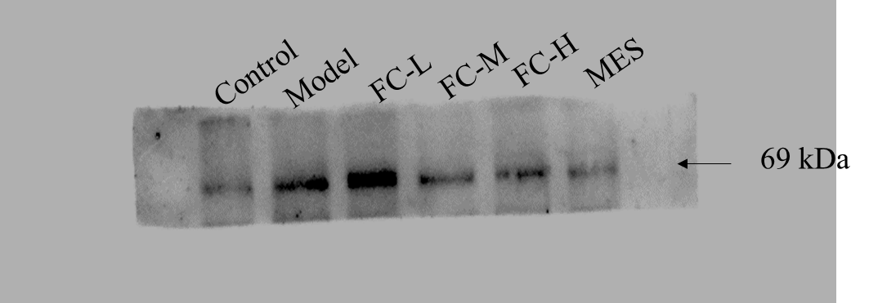

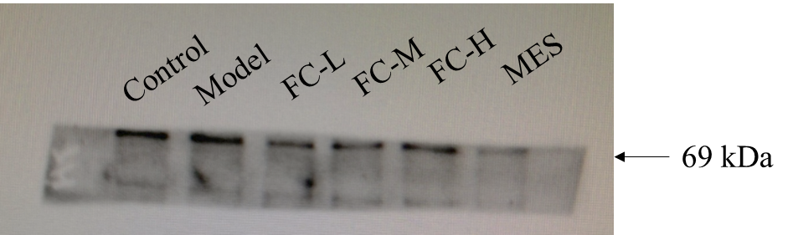

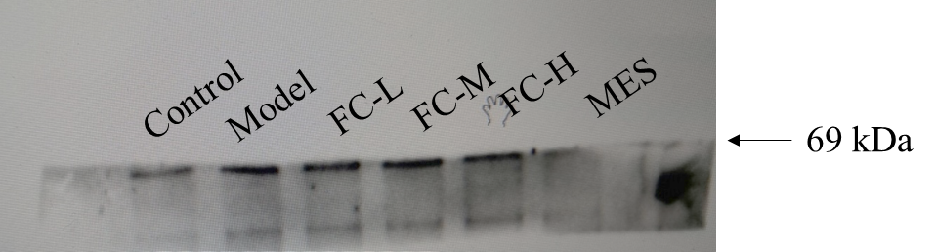

β-actin (42 kDa)
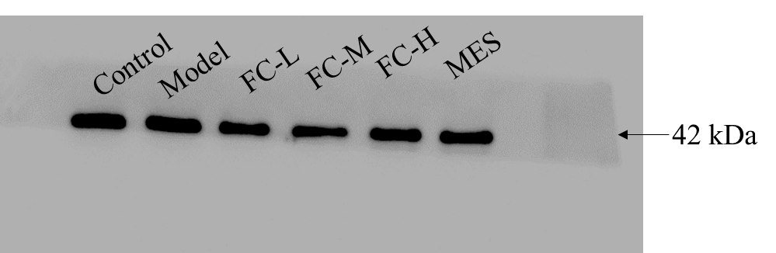

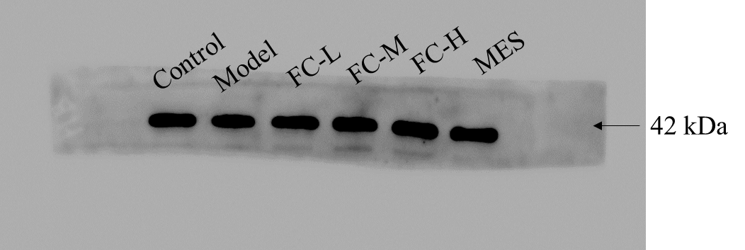

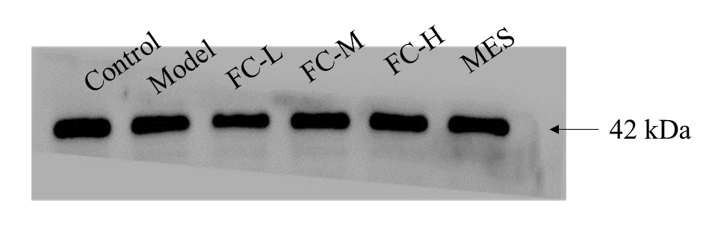

Figure 11C
1L-17 (18 kDa)
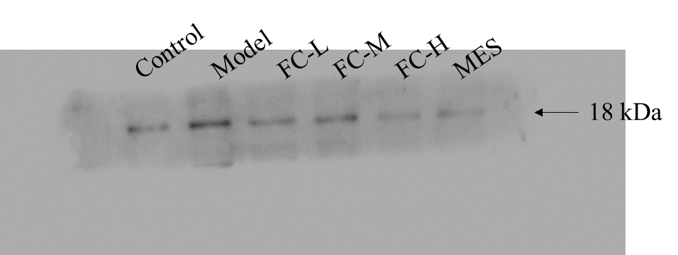

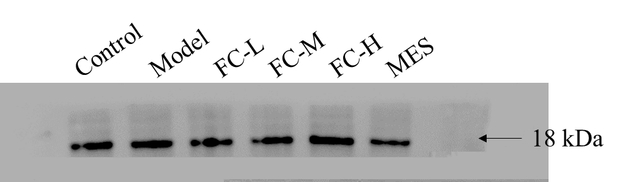

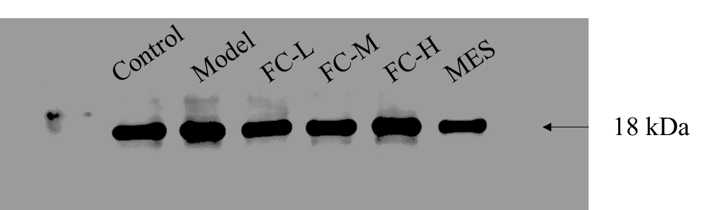

RORγt (58 kDa)

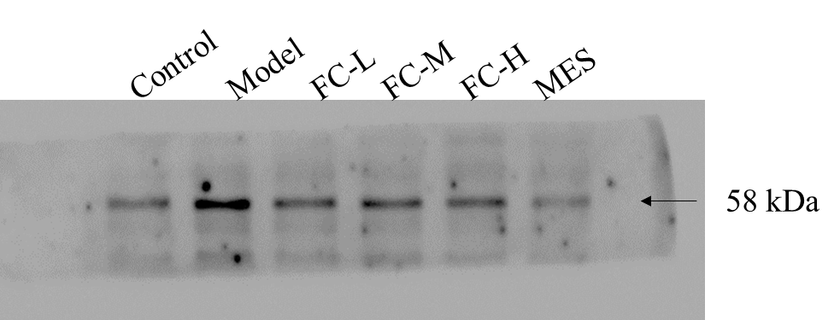

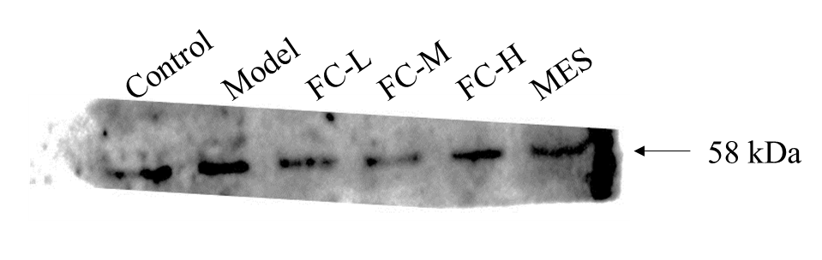

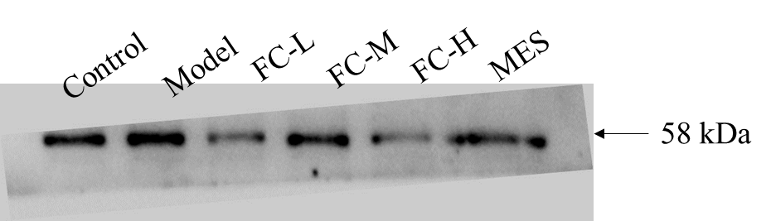

β-actin (42 kDa)
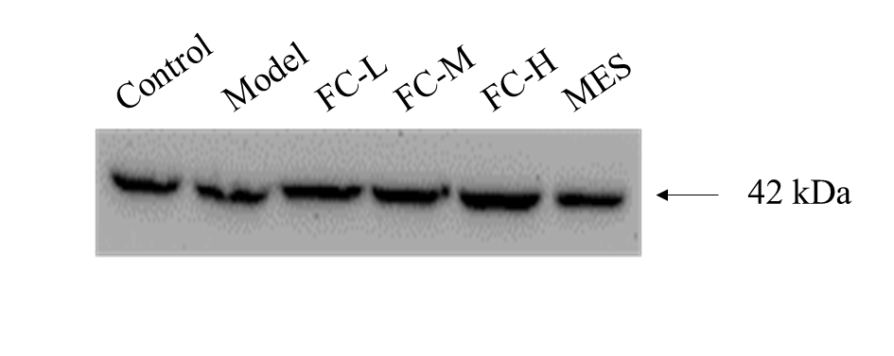
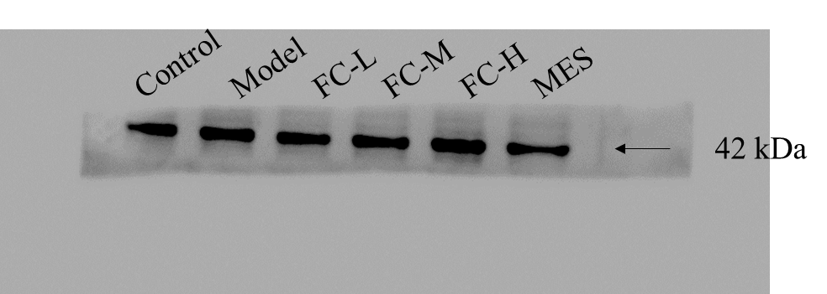

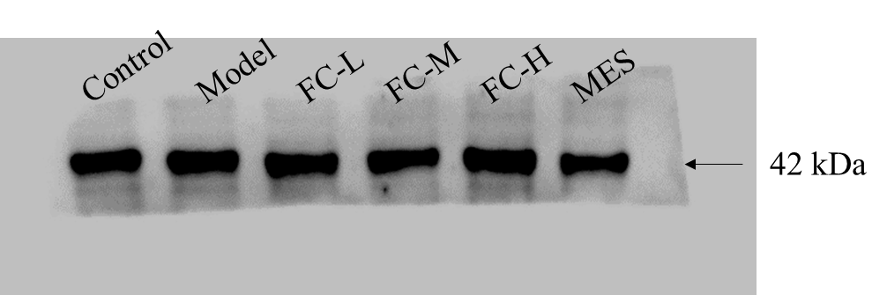

Figure 11C
MMP1 (54 kDa)
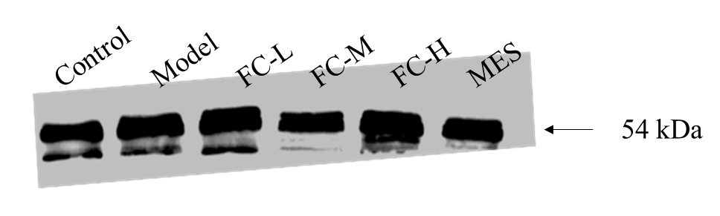
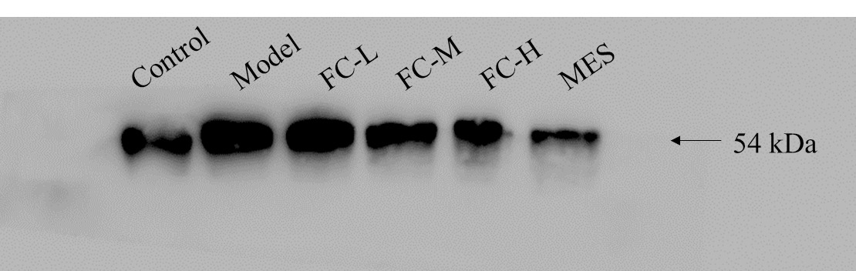
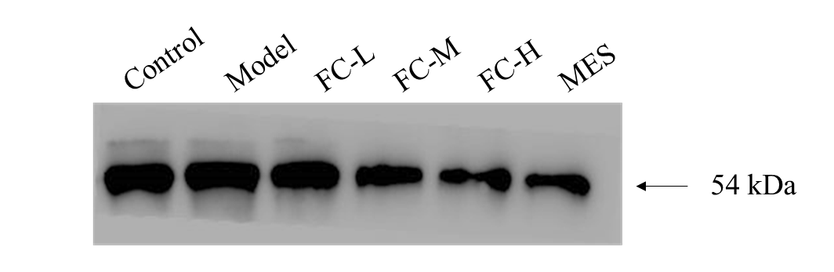

MMP3 (54 kDa)
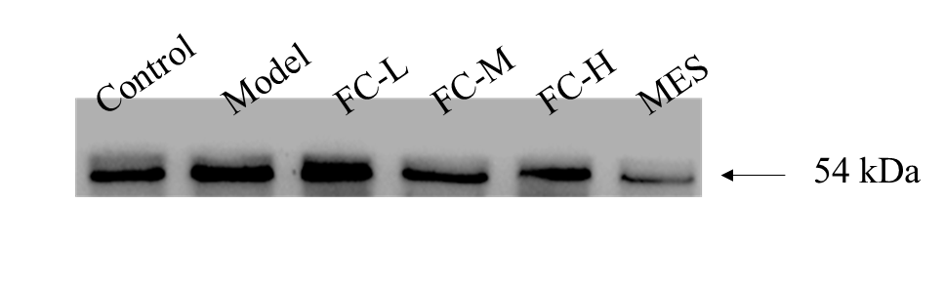
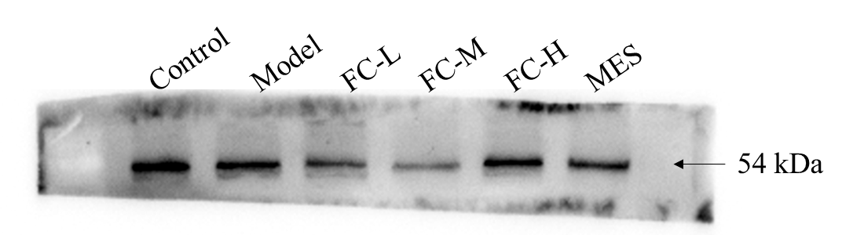

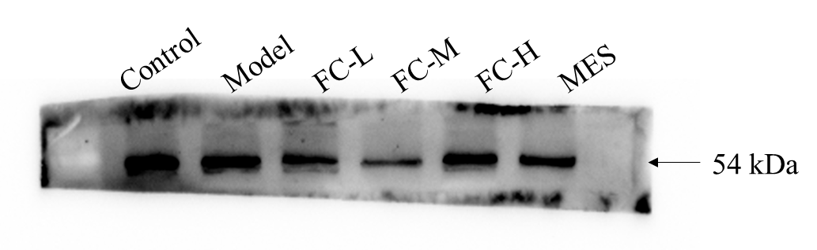

MMP9 (78 kDa)
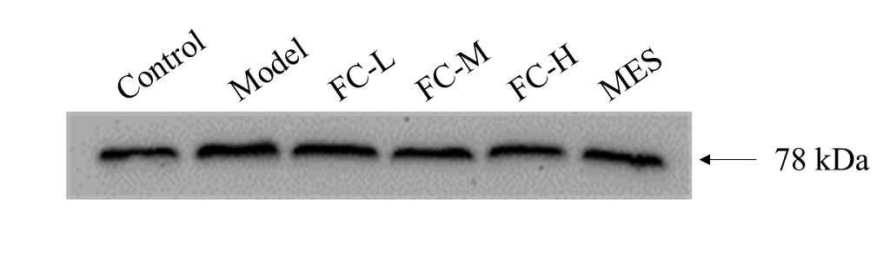
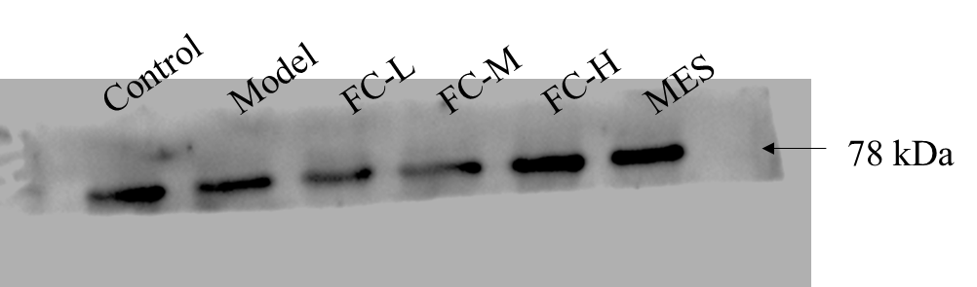

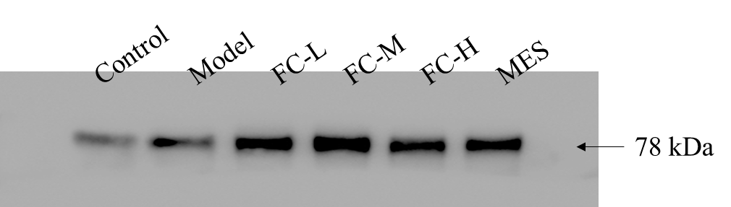

β-actin (42 kDa)
