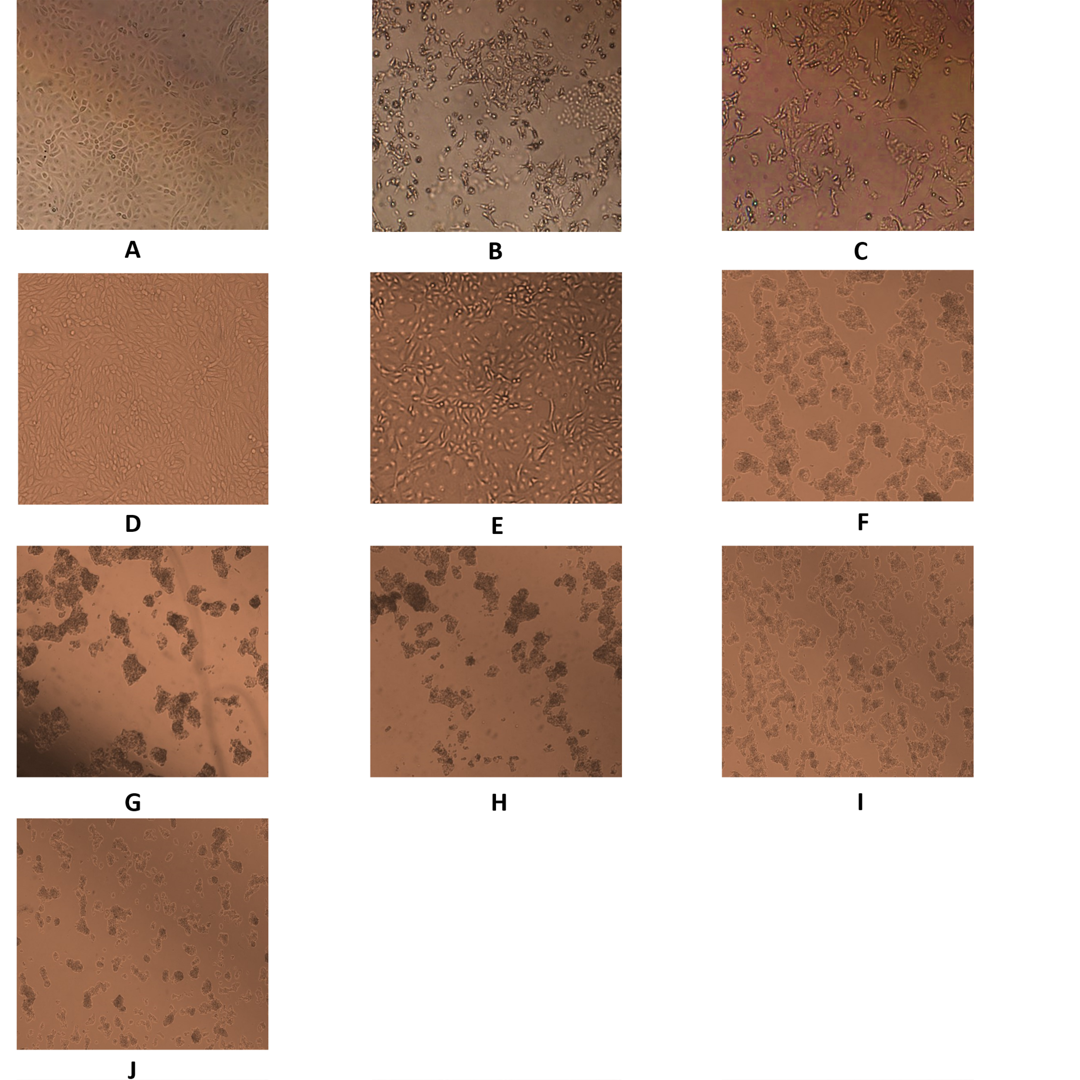

Supplementary Figure 1. Treatment of Huh-7 and HepG2 cells with different concentration of milk thistle loaded in nano carrier and milk thistle extract. A) Huh-7 control B) Huh-7 treatment with N-MT for 24h C) Huh-7 treatment with N-MT for 48h D) Huh-7 treatment with MT for 24h E) Huh-7 treatment with MT for 48h F) HepG2 control G) HepG2 treatment with N-MT for 24h H) HepG2 treatment with N-MT for 48h I) HepG2 treatment with MT for 24h J) HepG2 treatment with MT for 48h. N-MT gave rise to apoptosis of HepG2 and Huh-7 cell, while MT did not have significant effect on the apoptosis of these cells at the same concentrations.

