Supplementary Information
Apium Extract alleviates Indomethacin-Induced Gastric Ulcers in Rats via Modulating the VEGF and IK-κB/NF-κB p65 Signaling Pathway: Insights from In Silico and In Vivo Investigations
Dalia H. Abu-Baih^{a,†}, Alshymaa Abdel-Rahman Gomaa^{b,†}, Nada Mohamed Abdel-Wahab^{b,†}, Enas Reda Ab-delaleem^{b,†}, Azza M. Abdel Zaher^{c}, Noha F. Hassan^{d}, Gerhard Bringman^{e}, Usama Ramadan Abdelmohsen^{b, f, *}, Faisal H. Altemani^{g}, Naseh A. Algehainy^{g}, Fatma Alzahraa Mokhtar^{h}, Miada F. Abdelwahab^{b}
ªDepartment of Biochemistry, Faculty of Pharmacy, Deraya University, New Minia 61111, Egypt
^{b}Department of Pharmacognosy, Faculty of Pharmacy, Minia University, Minia 61519, Egypt
^{c}Department of Pathology, Faculty of Medicine, Minia University, Minia, Egypt
^{d}Department of Pharmacology and Toxicology, Faculty of Pharmacy, Modern University for Technology and Information, Cairo11571, Egypt,
^{e}Institute of Organic Chemistry, University of Würzburg, Am Hubland, 97074 Würzburg, Germany
^{f}Department of Pharmacognosy, Faculty of Pharmacy, Deraya University, Minia 61111, Egypt
^{g}Department of Medical Laboratory Technology, Faculty of Applied Medical Sciences, University of Tabuk, Tabuk 71491, Saudi Arabia.
^{h}Department of Pharmacognosy, Faculty of Pharmacy, Al Salam University, Kafr Alzayat 31611, Al Gharbia, Egypt.
*Correspondence: usama.ramadan@mu.edu.eg (U.R.A.)
†These authors contributed equally to this work
Abstract: Gastric ulcers represent a worldwide health problem, characterized by erosions that affect the mucous membrane of the stomach and may even reach the muscular layer, leading to serious complications. Numerous natural products have been assessed as anti-ulcerogenic and/or gastroprotective agents, and have been considered as new approaches to the complementary treatment and/or prevention of gastric ulcers. In the current study, we have explored the protective effects of the seed extract of Apium graveolens L. (Apiaceae), commonly known as celery, against indomethacin-induced gastric ulcers in rats. Metabolomic profiling, employing liquid chromatography coupled to high-resolution electrospray ionization mass spectrometry (LC-HR-ESI-MS), was implemented with the aim of investigating the chemical profile of the seeds. The in vivo evaluation was further confirmed by histopathological examination of the gastric tissues as well as assessment of various inflammatory cytokines, nitrosative stress and oxidative stress markers. Pre-treatment with A. graveolens seed extract improved gastric mucosal damage, as evidenced by the significant reduction in the ulcer index (0.28) compared to the indomethacin group (p < 0.05), with effects similar to those reported from the reference drug famotidine (0.3). Additionally, the gastric acidity was reduced with no significant difference between the famotidine and A. graveolens extract treated groups (p > 0.05). Moreover, the gastroprotective effect was demonstrated through examination of the level of malondialdehyde (MDA), which was significantly reduced (p < 0.05), as well as the level of gastric reduced glutathione (GSH) which was significantly increased (p < 0.05) upon pre-treatment with A. graveolens seed extract. Vascular endothelial growth factor (VEGF), a fundamental angiogenic factor that stimulates angiogenesis, was markedly inhibited by indomethacin. A. graveolens seed extract restored this diminished level of VEGF. The IKκB/NF-κB p65 signaling cascade, triggered by indomethacin, was markedly attenuated, as manifested by the remarkable decrements in IKκB and NF-κB protein levels compared to the injured mucosa. These activities were also correlated to the tentatively featured secondary metabolites including, phenolic acids, coumarins and flavonoids, previously evidenced to exert potent anti-inflammatory and antioxidant activities. According to our network pharmacology study, the identified metabolites annotated 379 unique genes, among which only 17 genes were related to gastric ulcer. The PTGS2, MMP2 and PTGS1 were the top annotated genes related to gastric ulcer. The top biological pathway was the VEGF signaling pathway. In conclusion, A. graveolens seed extract possesses significant anti-ulcer activity, similar to famotidine, against indomethacin-induced gastric lesions in rats. It is worth highlighting that the extract does not reduce gastric acidity, and thus it overcomes the side effects of the conventional chemical anti-secretory drugs.
Keywords: Apium graveolens L.; gastric ulcer; metabolomic profiling; network pharmacology; inflammatory cytokines.

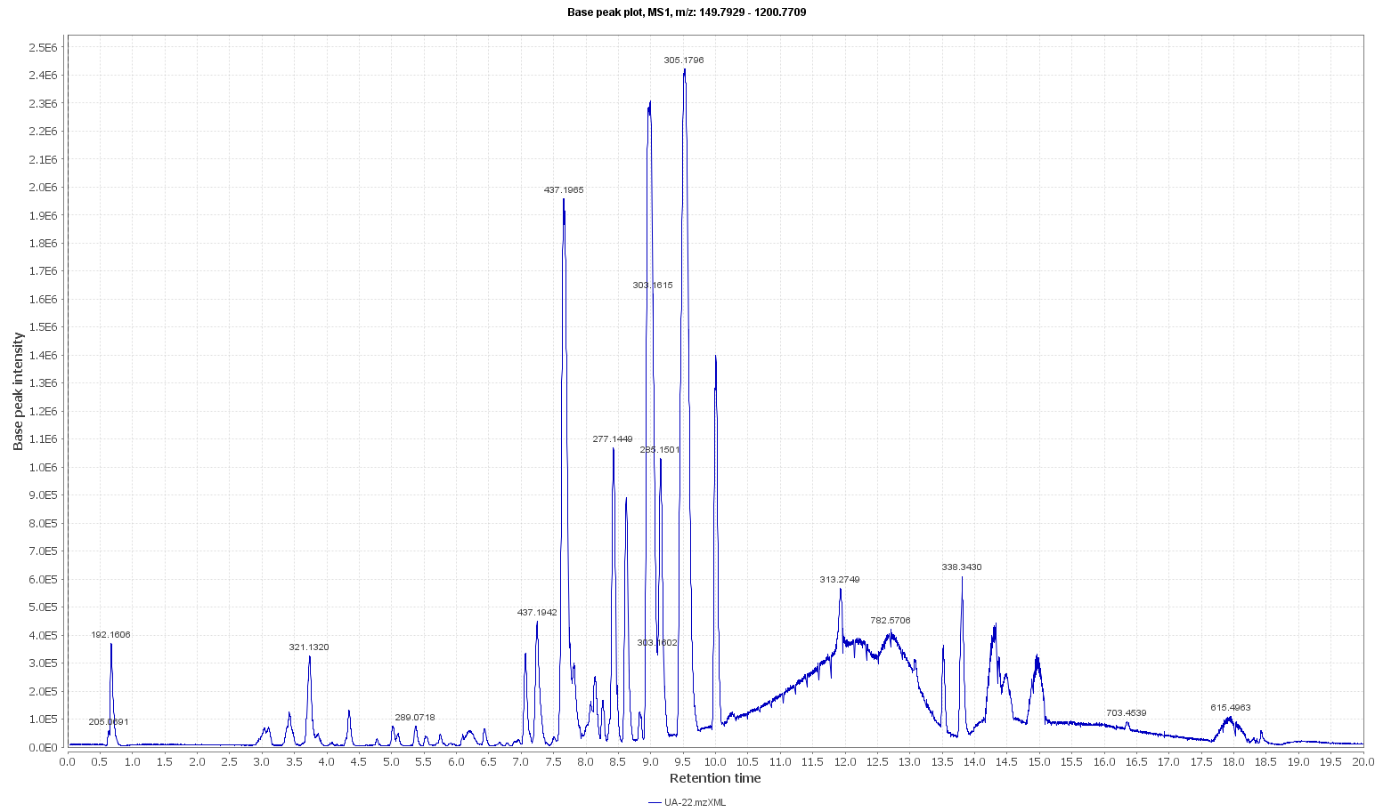
Figure S1. LC-ESI-HR-MS total ion chromatogram of A. graveolens L. seed extract, taken in positive ionization mode.
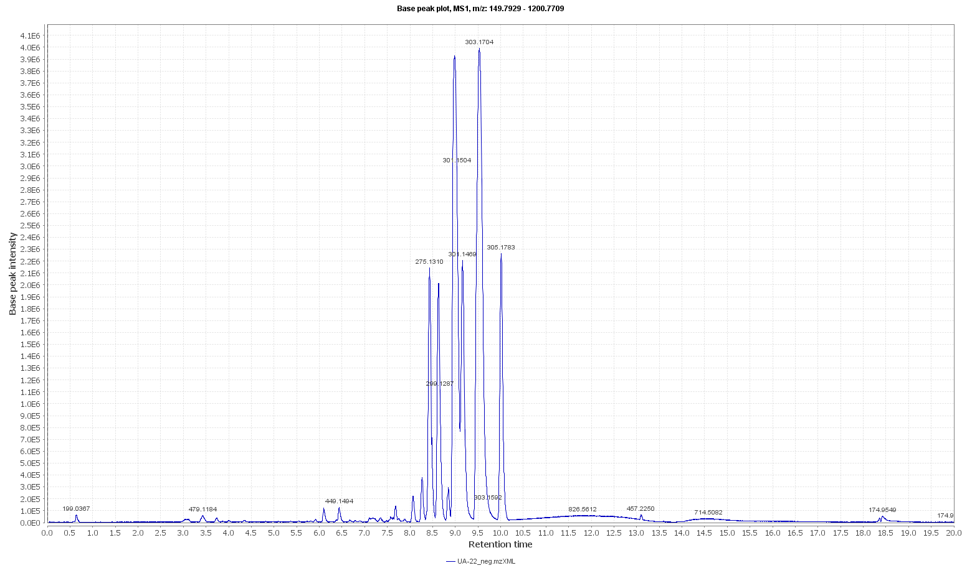
Figure S2. LC-ESI-HR-MS total ion chromatogram of A. graveolens L. seed extract, taken in negative ionization mode.

Table S1. List of tentatively identified metabolites and dereplicated from LC–HR– ESI–MS of Apium graveolens L. seeds.

No. | Compound | Retention  time (min) | m/z | Ionization mode | Accurate mass | Molecular formula | References
Phenolic acids

1 | 3-Methoxy-4,5-methylenedioxybenzoic acid  (Myristicic acid) | 2.28 | 197.044 | Positive | 196.0376 | C₉H₈O₅ | [56]
2 | Chlorogenic acid | 13.43 | 353.305 | Negative | 354.3125 | C₁₆H₁₈O₉ | [57]
3 | 2,3-Dihydro-6-hydroxy-2-methyl-5-benzofurancarboxylic  acid | 7.17 | 195.066 | Positive | 194.0587 | C₁₀H₁₀O₄ | [58]
Coumarins

4 | Celerin | 7.47 | 261.112 | Positive | 260.1055 | C₁₅H₁₆O₄ | [59]
5 | Osthenol | 9.13 | 231.101 | Positive | 230.0946 | C₁₄H₁₄O₃ | [32, 60]
6 | 6-Acetyl-7-hydroxy-2H-1-benzopyran-2-one | 6.16 | 203.033 | Negative | 204.040 | C₁₁H₈O₄ | [61]
7 | 7-(2-Hydroxy-3-methyl-3-butenyloxy)-6-methoxycoumarin  (Virgatenol) | 4.58 | 275.091 | Negative | 276.0985 | C₁₅H₁₆O₅ | [62]
8 | 10-O-Tigloylkhellactone | 8.39 | 343.114 | Negative | 344.1222 | C₁₉H₂₀O₆ | [63]
Furanocoumarins

9 | 2,3-dihydro-2(1-hydroxy-1-hydroxy-methylethyl)-7H-furo[3,2g][1]benzopyran-7-one  (Dorsteniol) | 9.48 | 263.128 | Positive | 262.1212 | C₁₄H₁₄O₅ | [32, 64]
10 | 5-Methoxy-8-O-β-D-glucosyloxypsoralen | 14.40 | 395.331 | Positive | 394.3240 | C₁₈H₁₈O₁₀ | [65]
11 | Oxypeucedanin | 7.37 | 287.092 | Positive | 286.0847 | C₁₆H₁₄O₅ | [66]

Phthalides

12 | 3'-β-D-Glucopyranosyloxy, 7,7a-didehydrobutylhexahydro-1(3H) isobenzofuranone  (Celephthalide C) | 8.28 | 373.194 | Positive | 372.1869 | C₁₈H₂₈O₈ | [67]
13 | 3-(3-Methylbutylidene)-1(3H)-isobenzofuranone  (3-Isovalidenephthalide) | 9.37 | 203.106 | Positive | 202.0997 | C₁₃H₁₄O₂ | [68]
14 | 3a,4-Dihydro-3-(3-methylbutylidene)-  1(3H) isobenzofuranone  (3-Isovalidene-3a,4-dihydrophthalide) | 9.39 | 205.123 | Positive | 204.1157 | C₁₃H₁₆O₂ | [32, 68]
Sesquiterpenes

15 | 4(15)-Eudesmene-1,2,11-  triol 11-O-glucoside  (Celerioside D) | 9.53 | 417.240 | positive | 416.2329 | C₂₁H₃₆O₈ | [32, 67]
Polyacetylenes

16 | 1,9-Heptadecadiene-4,6-diyne-3,8-diol  (Falcarindiol) | 9.57 | 261.185 | Positive | 260.1778 | C₁₇H₂₄O₂ | [69]
Flavonoids

17 | Luteolin | 11.85 | 287.237 | Positive | 286.2304 | C₁₅H₁₀O₆ | [70]
Fatty acids

18 | 6-Octadecenoic acid | 12.72 | 281.247 | Negative | 282.2548 | C₁₈H₃₄O₂ | [71]

Table S2. Top gene enrichment analysis of genes annotated by Apium graveolens L. metabolites and related to gastric ulcer in terms of biological process, cellular component and molecular function.

No. | Pathway | Fold enrichment | nGenes | Genes
Biological process
1 | Pos. reg. of endothelial cell chemotaxis | 268.188 | 3 | MET VEGFA KDR
2 | Cyclooxygenase pathway | 243.807 | 2 | PTGS2 PTGS1
3 | Cellular response to UV-A | 243.807 | 2 | MMP2 MMP9
4 | Response to UV-A | 191.563 | 2 | MMP2 MMP9
5 | Pos. reg. of cell migration involved in sprouting angiogenesis | 182.856 | 3 | PTGS2 VEGFA KDR
6 | Embryonic hemopoiesis | 174.905 | 3 | HIF1A VEGFA KDR
7 | Endothelial cell chemotaxis | 138.718 | 3 | MET VEGFA KDR
8 | Peptidyl-tyrosine autophosphorylation | 138.718 | 3 | VEGFA KDR ACE
9 | Mammary gland alveolus development | 134.094 | 2 | HIF1A VEGFA
10 | Pos. reg. of blood vessel endothelial cell migration | 124.161 | 5 | PTGS2 HIF1A VEGFA KDR ADAM17
11 | Vascular endothelial cell proliferation | 121.904 | 2 | PPARG ADAM17
12 | Reg. of vascular endothelial cell proliferation | 121.904 | 2 | PPARG ADAM17
13 | Serotonin secretion | 121.904 | 1 | HRH3
14 | Hydrogen peroxide mediated programmed cell death | 121.904 | 1 | MET
15 | Gas homeostasis | 121.904 | 1 | HIF1A
16 | Hormone catabolic proc. | 121.904 | 1 | ACE
17 | Hemoglobin biosynthetic proc. | 121.904 | 1 | HIF1A
18 | Bone trabecula formation | 121.904 | 1 | MMP2
19 | Macrophage proliferation | 121.904 | 1 | MAPK1
20 | Reg. of chemokine mediated signaling pathway | 121.904 | 1 | HIF1A
Cellular component
1 | Integral component of membrane | 273.161 | 1 | MET
2 | Intrinsic component of membrane | 273.161 | 1 | MET
3 | Membrane | 136.580 | 1 | MET
4 | Cellular anatomical entity | 57.507 | 1 | MET
Molecular function
1 | Nucleotide binding | 1 | 364.216 | MET
2 | ATP binding | 1 | 364.216 | MET
3 | Transferase activity | 1 | 364.216 | MET
4 | Purine nucleotide binding | 1 | 364.216 | MET
5 | Adenyl nucleotide binding | 1 | 364.216 | MET
6 | Ribonucleotide binding | 1 | 364.216 | MET
7 | Purine ribonucleotide binding | 1 | 364.216 | MET
8 | Adenyl ribonucleotide binding | 1 | 364.216 | MET
9 | Purine ribonucleoside triphosphate binding | 1 | 364.216 | MET
10 | Small molecule binding | 1 | 364.216 | MET
11 | Anion binding | 1 | 364.216 | MET
12 | Carbohydrate derivative binding | 1 | 364.216 | MET
13 | Nucleoside phosphate binding | 1 | 364.216 | MET
14 | Ion binding | 1 | 218.529 | MET
15 | Organic cyclic compound binding | 1 | 218.529 | MET
16 | Heterocyclic compound binding | 1 | 218.529 | MET
17 | Catalytic activity, acting on a protein | 1 | 182.108 | MET
18 | Catalytic activity | 1 | 121.405 | MET
19 | Binding | 1 | 109.265 | MET

Table S3. Top 20 KEGG biological pathways of genes annotated by Apium graveolens L. metabolites and related to gastric ulcer.
Pathway | Fold Enrichment | nGenes | Genes
Bladder cancer | 130.824 | 4 | MMP2 MAPK1 MMP9 VEGFA
VEGF signaling pathway | 90.911 | 4 | PTGS2 MAPK1 VEGFA KDR
Renal cell carcinoma | 78.879 | 4 | MAPK1 HIF1A MET VEGFA
Thyroid cancer | 72.483 | 2 | MAPK1 PPARG
EGFR tyrosine kinase inhibitor resistance | 67.896 | 4 | MAPK1 MET VEGFA KDR
Arachidonic acid metabolism | 65.948 | 3 | PTGS2 PTGS1 CYP2C19
Serotonergic synapse | 59.863 | 5 | PTGS2 PTGS1 MAPK1 CASP3 CYP2C19
Renin-angiotensin system | 58.302 | 1 | ACE
IL-17 signaling pathway | 57.675 | 4 | PTGS2 MAPK1 MMP9 CASP3
Epithelial cell signaling in Helicobacter pylori infection | 57.469 | 3 | MET ADAM17 CASP3
Central carbon metabolism in cancer | 57.469 | 3 | MAPK1 HIF1A MET
Platinum drug resistance | 55.107 | 3 | MAPK1 GSTM1 CASP3
AGE-RAGE signaling pathway in diabetic complications | 53.638 | 4 | MMP2 MAPK1 VEGFA CASP3
Proteoglycans in cancer | 53.107 | 8 | MMP2 MAPK1 HIF1A MMP9 MET VEGFA KDR CASP3
MicroRNAs in cancer | 49.973 | 6 | PTGS2 MAPK1 MMP9 MET VEGFA CASP3
Fluid shear stress and atherosclerosis | 48.585 | 5 | MMP2 MMP9 VEGFA KDR GSTM1
TNF signaling pathway | 47.891 | 4 | PTGS2 MAPK1 MMP9 CASP3
Reg. of lipolysis in adipocytes | 47.891 | 2 | PTGS2 PTGS1
Linoleic acid metabolism | 46.239 | 1 | CYP2C19
Endocrine resistance | 42.346 | 3 | MMP2 MAPK1 MMP9

