Supplementary data for antiproliferative potential of some selected Nigerian Medicinal plant by Olaleye et al 2023

Figure S1: Graph showing the selectivity indices of six active extracts against MCF-7 and HeLa cells

A
B

C
D

Figure.S2: Cell count assay of MCF-7 cells after 72 h extracts exposure. Data are expressed as mean±SD (n=3), ****p<0.0001, versus control (a two-way ANOVA followed by Tukey’s post hoc multiple comparison tests).

A
B

C
D

Figure S3: Cell count assay of HUH-7 cells after 72 h extracts exposure. Data are expressed as mean±SD (n=3), ****p<0.0001, versus control (a two-way ANOVA followed by Tukey’s post hoc multiple comparison tests).

B
A

D
C

Figure S4: Cell count assay of HeLa cells after 72 h exposure. Data are expressed as mean±SD (n=3), ****p<0.0001, versus control (a two-way ANOVA followed by Tukey’s post hoc multiple comparison tests).

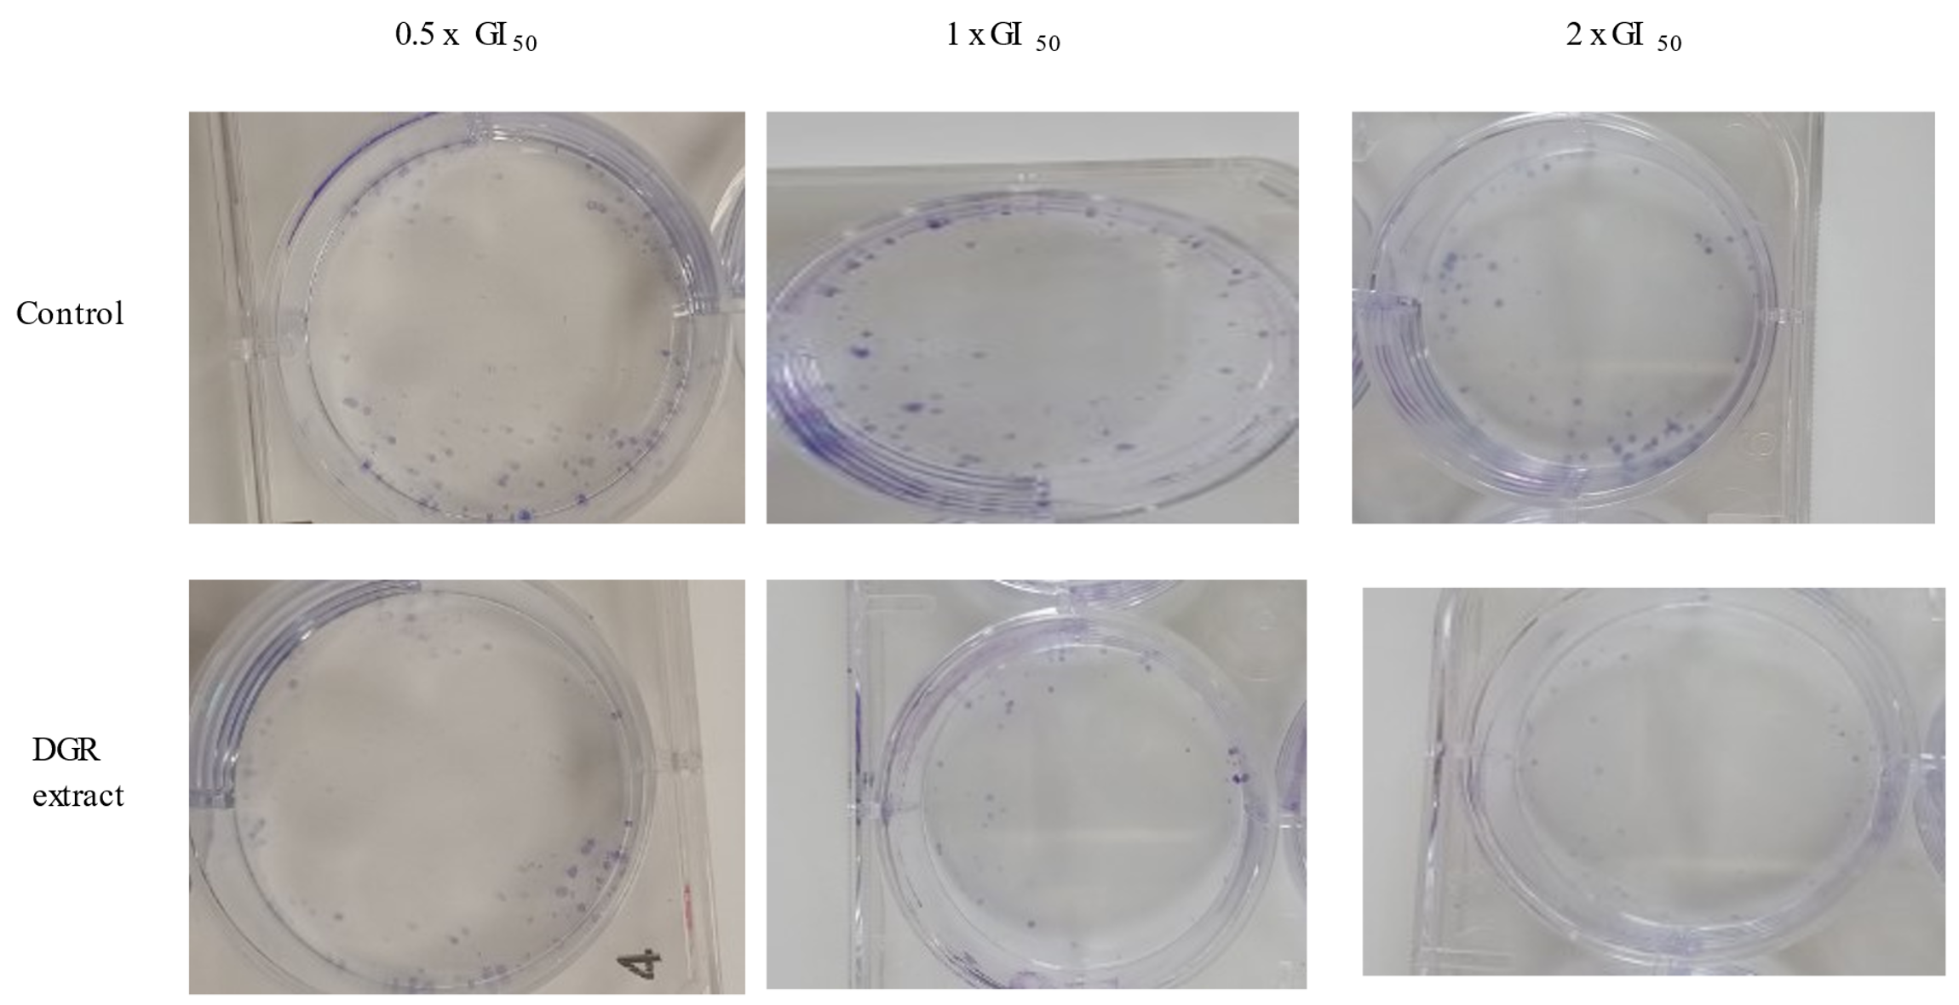
Figure S5: Representative images of plates where ethanol extracts of DGR suppresses colony formation in breast cancer cells at concentrations of 0.5 x GI₅₀, 1 x GI₅₀ and 2 x GI₅₀.

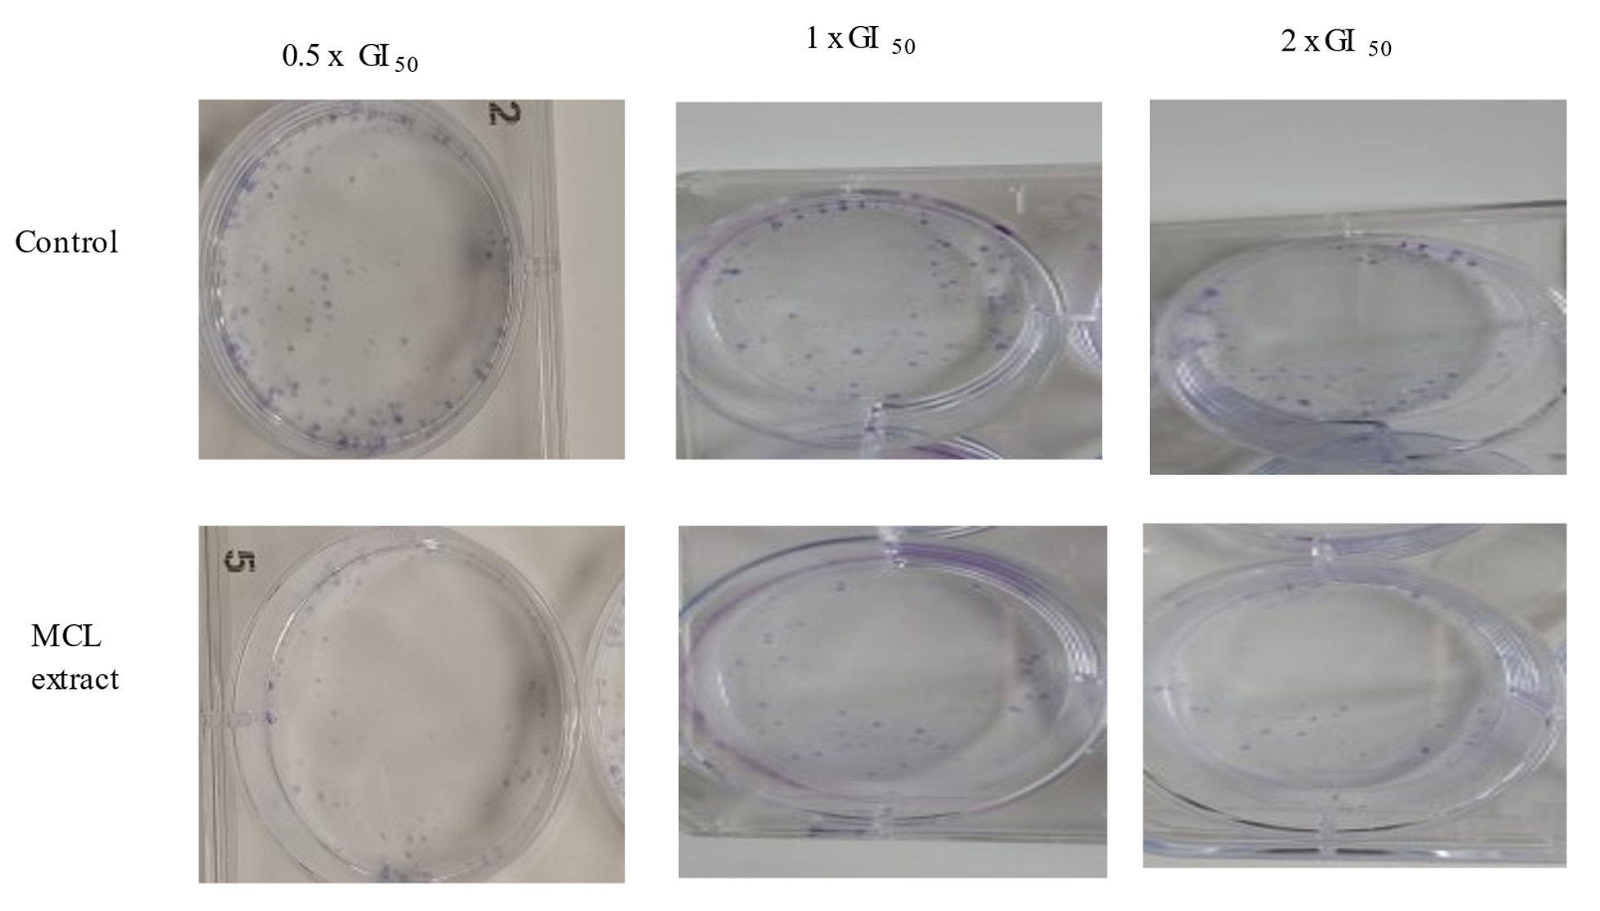
Figure S6: Representative images of plates where ethanol extracts of MCL suppresses colony formation in breast cancer cells at concentrations of 0.5 x GI₅₀, 1 x GI₅₀ and 2 x GI₅₀.

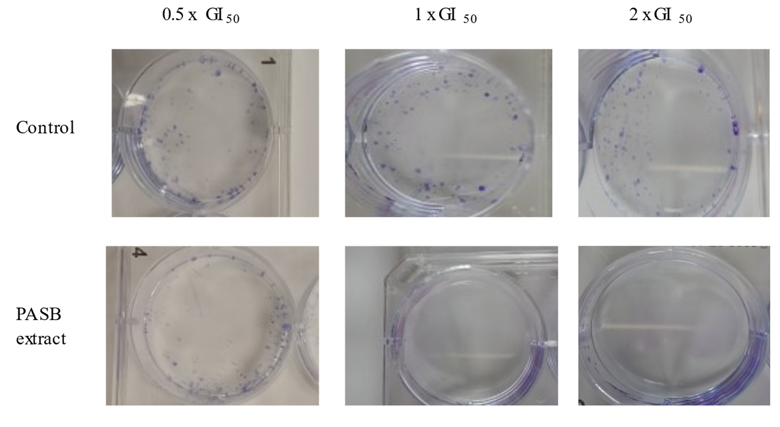
Figure S7: Representative images of plates where ethanol extracts of PASB suppresses colony formation in breast cancer cells at concentrations of 0.5 x GI₅₀, 1 x GI₅₀ and 2 x GI₅₀.

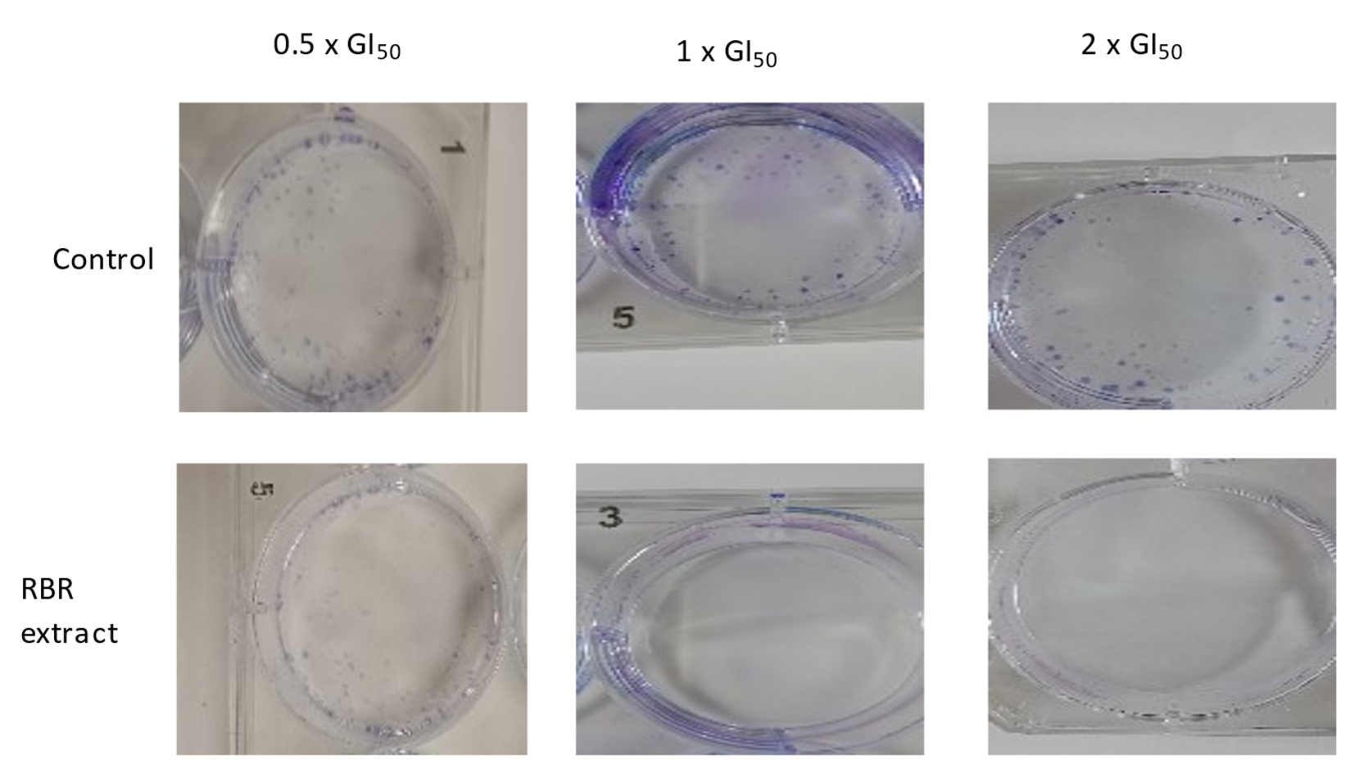
Figure S8: Representative images of plates where ethanol extracts of RBR suppresses colony formation in breast cancer cells at concentrations of 0.5 x GI₅₀, 1 x GI₅₀ and 2 x GI₅₀.

