Effects of Melissa officinalis (lemon balm) consumption on serum lipid profile: A systematic review and meta-analysis of randomized controlled trials

Kasra Shahsavari¹, Mohammad Reza Shams Ardekani², Mahnaz Khanavi², Tannaz Jamialahmadi^{3,4}, Mehrdad Iranshahi³, Maede Hasanpour^{2,3}∗
¹School of Medicine, Tehran University of Medical Sciences, Tehran, Iran
²Department of Pharmacognosy, Faculty of Pharmacy, and Persian Medicine and Pharmacy Research Center, Tehran University of Medical Sciences, Tehran, Iran.
³Biotechnology Research Center, Pharmaceutical Technology Institute, Mashhad University of Medical Sciences, Mashhad, Iran
⁴Department of Nutrition, Faculty of Medicine, Mashhad University of Medical Sciences, Mashhad, Iran

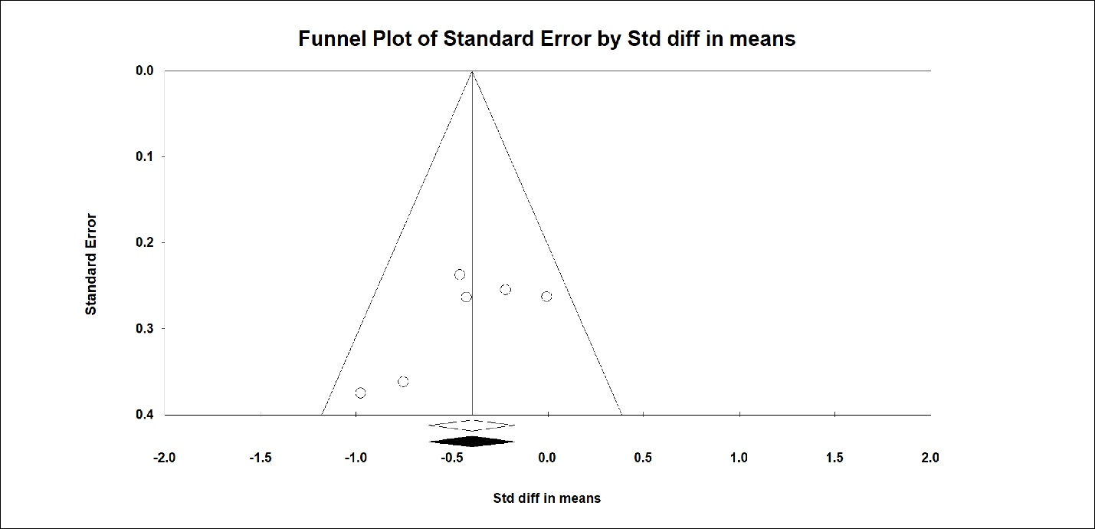
Figure S1: Publication bias funnel plots of studies that reported the effect of lemon balm treatment on TG level.
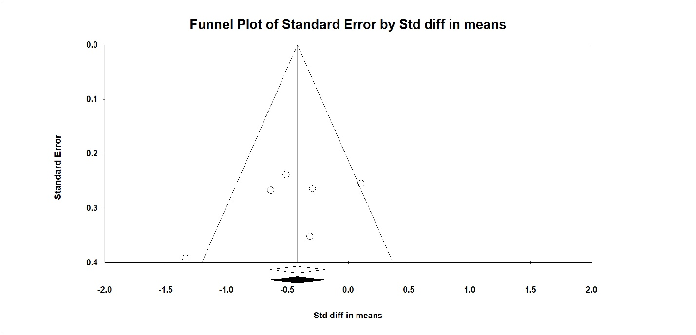
Figure S2: Publication bias funnel plots of studies that reported the effect of lemon balm treatment on TC level
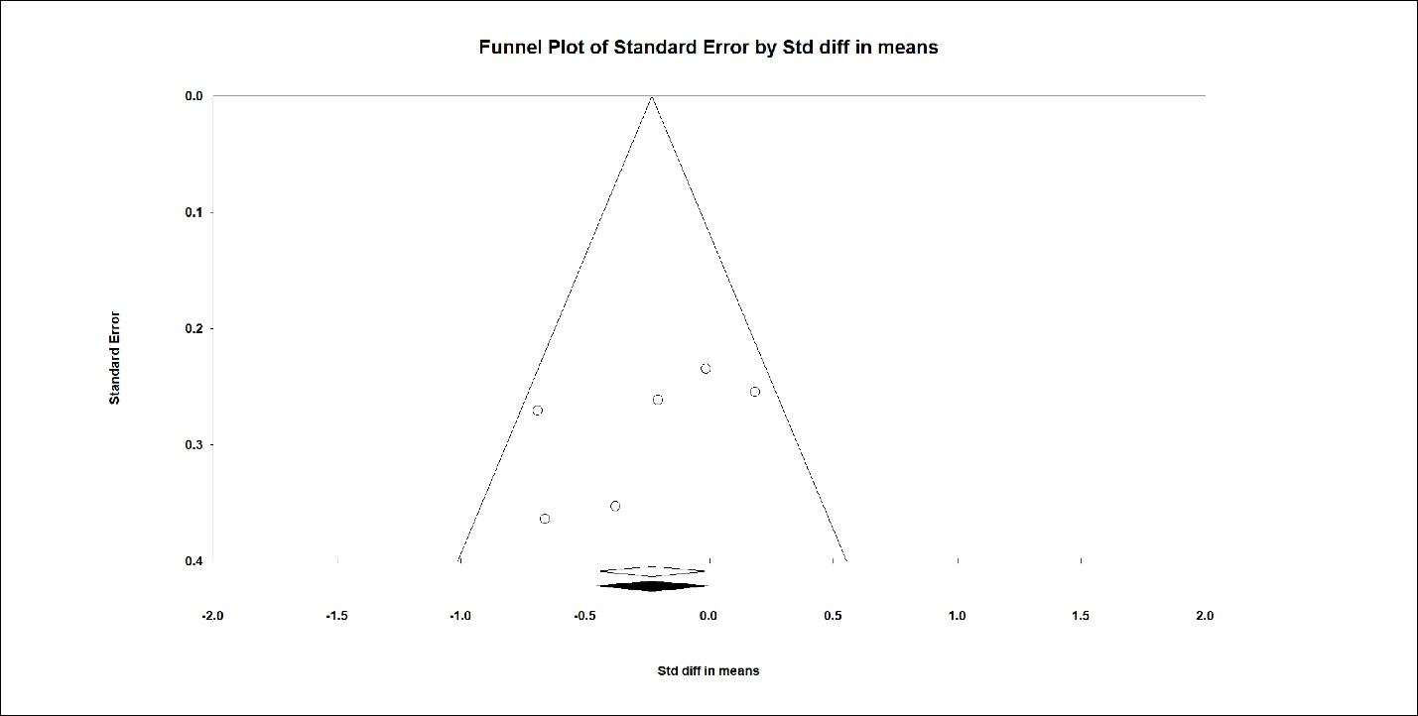
Figure S3: Publication bias funnel plots of studies that reported the effect of lemon balm treatment on LDL level
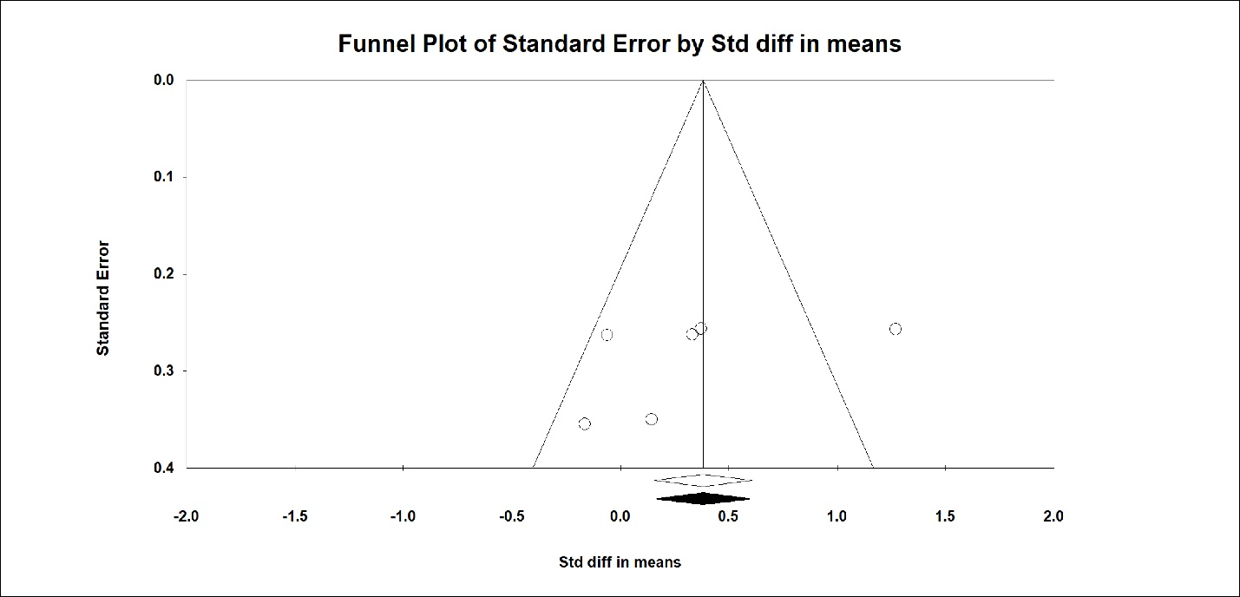
Figure S4: Publication bias funnel plots of studies that reported the effect of lemon balm treatment on HDL level

Table S1: The search terms of this study
Databases | Keywords | No
Scopus | ( TITLE-ABS-KEY ( melissa ) OR TITLE-ABS-KEY ( lemon AND balm ) AND TITLE-ABS-KEY ( hypercholesterolemia ) OR TITLE-ABS-KEY ( hypertriglyceridemia ) OR TITLE-ABS-KEY ( blood AND fat ) OR TITLE-ABS-KEY ( blood AND lipid ) OR TITLE-ABS-KEY ( lipid AND blood AND level ) OR TITLE-ABS-KEY ( TG ) OR TITLE-ABS-KEY ( triglyceride ) OR TITLE-ABS-KEY ( triglycerides ) OR TITLE-ABS-KEY ( glycerin AND trilaurate ) OR TITLE-ABS-KEY ( cholesterin ) OR TITLE-ABS-KEY ( cholesterol ) OR TITLE-ABS-KEY ( cholestenone ) OR TITLE-ABS-KEY ( hyperlipemia ) OR TITLE-ABS-KEY ( high AND density AND lipoprotein AND cholesterol ) OR TITLE-ABS-KEY ( HDL ) OR TITLE-ABS-KEY ( low AND density AND lipoprotein AND cholesterol ) OR TITLE-ABS-KEY ( LDL ) ) | 96
PubMed | ("Melissa"[Title/Abstract] OR "Lemon balm"[Title/Abstract]) AND ("hypercholesterolemia"[Title/Abstract] OR "hypertriglyceridemia"[Title/Abstract] OR "blood fat"[Title/Abstract] OR "blood lipid"[Title/Abstract] OR "lipid blood level" [Title/Abstract] OR "TG"[Title/Abstract] OR "triglyceride"[Title/Abstract] OR "triglycerides" [Title/Abstract] OR "cholesterin"[Title/Abstract] OR "cholesterol"[Title/Abstract] OR "cholestenone"[Title/Abstract] OR "hyperlipemia"[Title/Abstract] OR "high density lipoprotein cholesterol"[Title/Abstract] OR "HDL"[Title/Abstract] OR "low density lipoprotein cholesterol"[Title/Abstract] OR "LDL"[Title/Abstract]) | 25
Web of Sciences | TS=((("Melissa") OR ("Melon balm")) AND (("hypercholesterolemia") OR ("hypertriglyceridemia") OR ("blood fat") OR ("blood lipid") OR ("lipid blood level") OR ("TG") OR ("triglyceride") OR ("triglycerides") OR ("cholesterin") OR ("cholesterol") OR ("cholestenone") OR ("hyperlipemia") OR ("high density lipoprotein cholesterol") OR ("HDL") OR ("low density lipoprotein cholesterol") OR ("LDL"))) | 25

∗ Corresponding Author: Maede Hasanpour Department of Pharmacognosy, Faculty of Pharmacy, and Persian Medicine and Pharmacy Research Center, Tehran University of Medical Sciences, Tehran, Iran. Biotechnology Research Center, Pharmaceutical Technology Institute, Mashhad University of Medical Sciences, Mashhad, Iran Phone: +98-21-64122448, Fax: +98-21-64120000 E-mail: mhasanpour@farabi.tums.ac.ir and maede.hasanpour@yahoo.com

