Supplementary material for Western Blotting
Fig. 10
GAPDH
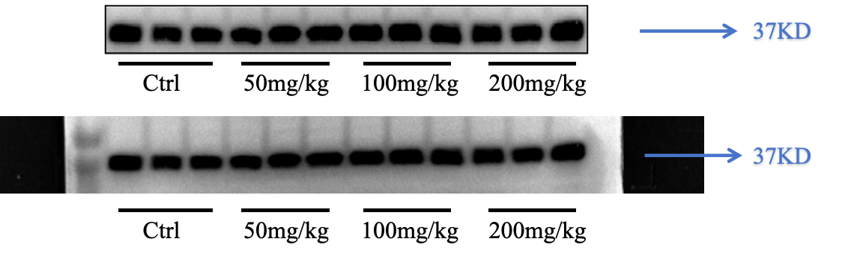
- PI3k
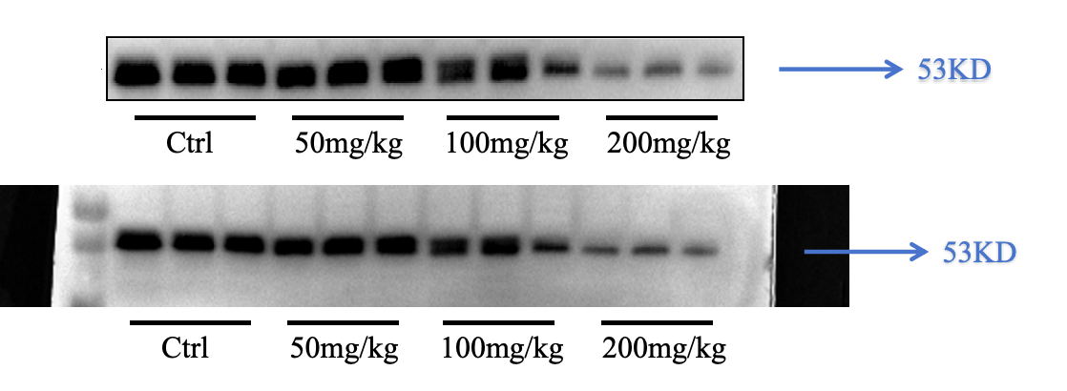
PI3K
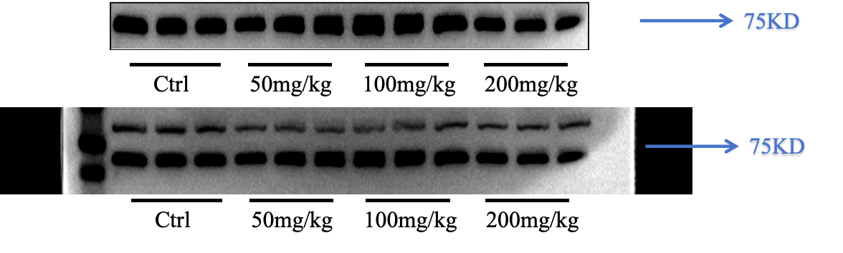
AKT
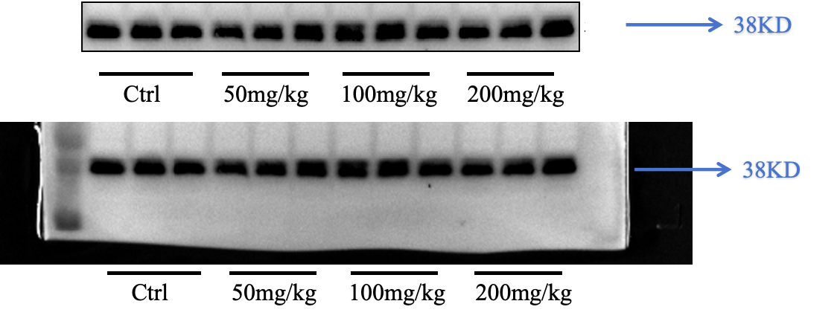
P-AKT
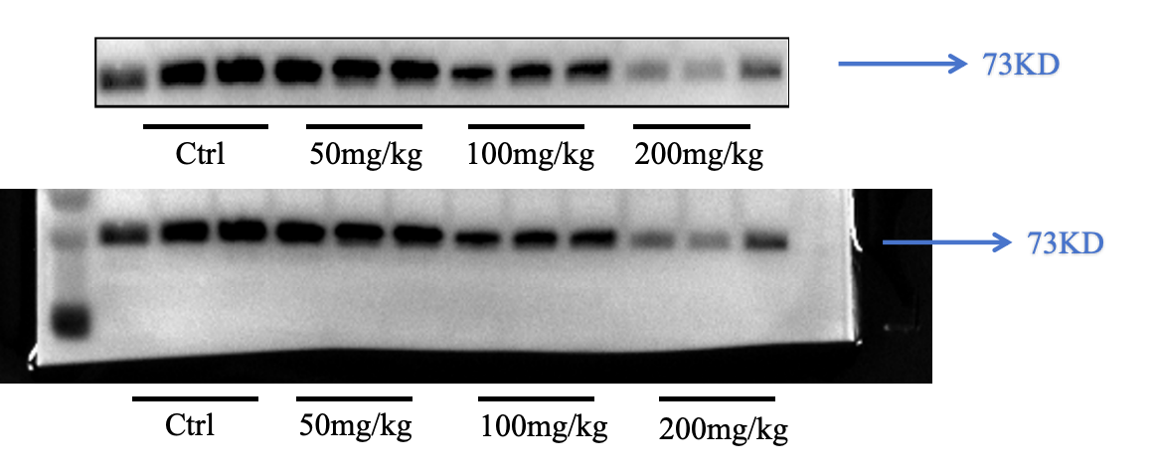
TP53
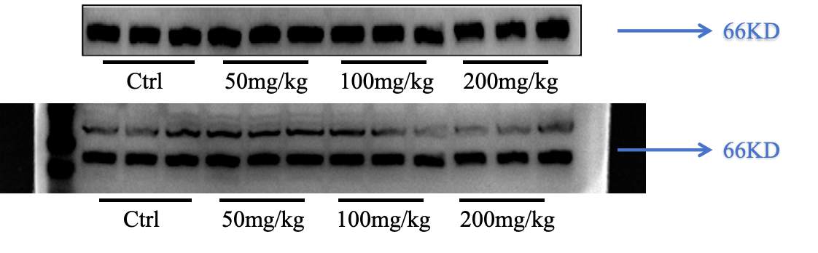
mTOR
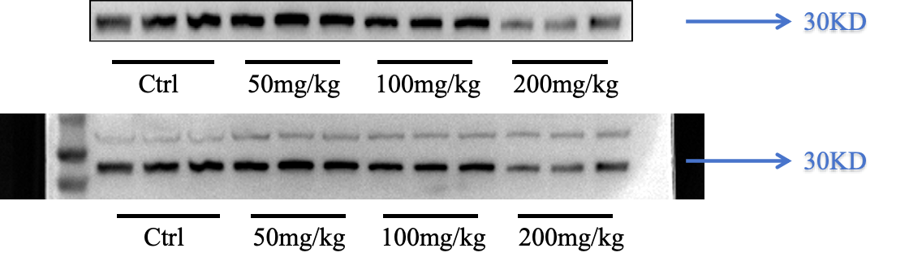
PTEN
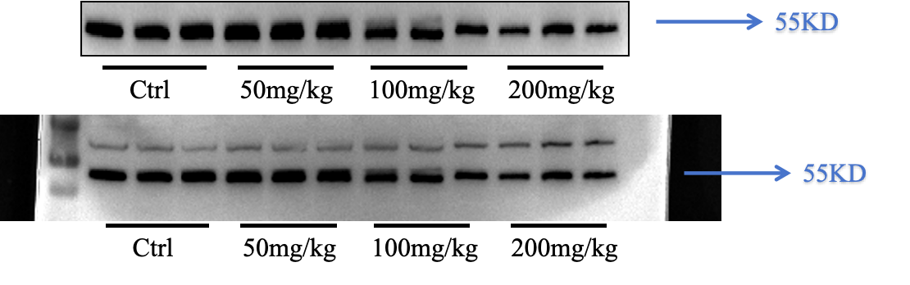
MAPK
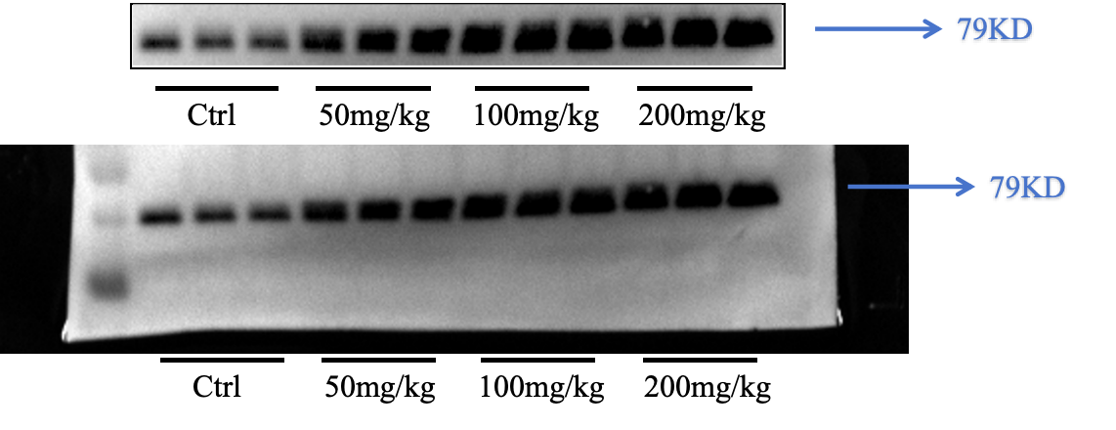
MYC
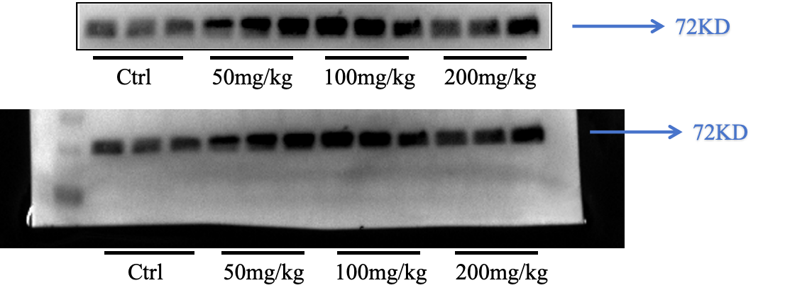

Bcl-2
