Supplementary Material

Table of Contents
Table 1. Formulated question of the study based on PICOS
Table 2. Detailed searching strategies
Table 3. The basic characteristics of included studies
Figure 1. Result of the risk of bias assessment
Table 4. Grade assessment
Table 5. Network meta-analysis results of subgroup analysis based on duration of interventions
Figure 2. Cumulative Probability Ranking of the subgroup analysis based on duration of interventions
Table 6. Network meta-analysis results of subgroup analysis based on baseline pulmonary function of COPD patients
Table 7. Cumulative Probability Ranking of the subgroup analysis based on baseline pulmonary function of COPD patients
Table 8. Network meta-analysis results of subgroup analysis based on frequency of interventions
Table 9. Cumulative Probability Ranking of the subgroup analysis based on frequency of interventions
Table 10. Sensitivity analysis based on sample size
Figure 3. Cumulative Probability Ranking of the sensitivity analysis based on sample size
Table 11. Sensitivity analysis based on methodological quality
Table 12. Cumulative Probability Ranking of the sensitivity analysis based on methodological quality
References
Table 1. Formulated question of the study based on PICOS

Components of PICOS | Defined as
Population/patients | patients with chronic obstructive pulmonary disease (COPD) diagnosed and in the stable phase, without psychiatric disorders and cognitive impairment, aged 18-90 years, with no restriction on gender
Intervention/exposure | The patients only participated in one of the four traditional Chinese exercises which included Taichi, Wuqinxi, Liuzijue, and Baduanjin.
Control/comparison | Received medication, health guidance and did not receive any additional training interventions
Outcome | Primary outcome measures in this study assessed the pulmonary function, including the forced expiratory volume in the first second (FEV1); the first second forced vital capacity percentage of expected value (FEV1%); the ratio of the forced expiratory volume in the first second to the forced vital capacity (FEV1/FVC), and adverse events
Study design | Randomized controlled trials (RCTs)

Table 2. Detailed searching strategies

Database | Search history | Results | Date
Pubmed | ((((((Tai Chi[Title/Abstract]) OR (Taiji[Title/Abstract])) OR (qigong[Title/Abstract])) OR (Baduanjin[Title/Abstract])) OR (Wuqinxi[Title/Abstract])) OR (Liuzijue[Title/Abstract])) AND (((COPD[Title/Abstract]) OR (Chronic Obstructive Pulmonary Disease[Title/Abstract])) OR (Chronic Obstructive Lung Disease[Title/Abstract])) | 101 | 2 Sep 2023
Embase | #3  #1 And #2  #2  'chronic obstructive pulmonary disease':ti,ab,kw OR 'chronic obstructive lung disease':ti,ab,kw OR copd:ti,ab,kw  #1  'tai chi':ti,ab,kw OR taiji:ti,ab,kw OR qigong:ti,ab,kw OR baduanjin:ti,ab,kw OR wuqinxi:ti,ab,kw OR liuzijue:ti,ab,kw | 160 | 2 Sep 2023
The Cochrane Library | #1 (Tai Chi):ti,ab,kw (Word variations have been searched)  #2 (Taiji):ti,ab,kw (Word variations have been searched)  #3 (qigong):ti,ab,kw (Word variations have been searched)  #4 (Baduanjin):ti,ab,kw (Word variations have been searched)  #5 (Wuqinxi):ti,ab,kw (Word variations have been searched)  #6 (Liuzijue):ti,ab,kw (Word variations have been searched)  #7 #1 OR #2 OR #3 OR #4 OR #5 OR #6  #8 (COPD):ti,ab,kw (Word variations have been searched)  #9 (Chronic Obstructive Pulmonary Disease):ti,ab,kw (Word variations have been searched)  #10 (Chronic Obstructive Lung Disease):ti,ab,kw (Word variations have been searched)  #11 #8 OR #9 OR #10  #12 #7 AND #11 | 120 | 2 Sep 2023
Opengrey | (Tai Chi OR Taiji OR qigong OR Baduanjin OR Wuqinxi OR Liuzijue) AND (COPD OR Chronic Obstructive Pulmonary Disease OR Chronic Obstructive Lung Disease) | 50 | 2 Sep 2023
Scopus | ( ( TITLE-ABS-KEY ( copd ) OR TITLE-ABS-KEY ( chronic AND obstructive AND pulmonary AND disease ) OR TITLE-ABS-KEY ( chronic AND obstructive AND lung AND disease ) ) ) AND ( ( TITLE-ABS-KEY ( tai AND chi ) OR TITLE-ABS-KEY ( taiji ) OR TITLE-ABS-KEY ( qigong ) OR TITLE-ABS-KEY ( baduanjin ) OR TITLE-ABS-KEY ( wuqinxi ) OR TITLE-ABS-KEY ( liuzijue ) ) ) | 178 | 2 Sep 2023
WOS | #3  #1 And #2  #2  COPD (TOPIC) or Chronic Obstructive Pulmonary Disease (TOPIC) or Chronic Obstructive Lung Disease (TOPIC)  #1  Tai Chi (TOPIC) or Taiji (TOPIC) or qigong (TOPIC) or Baduanjin (TOPIC) or Wuqinxi (TOPIC) or Liuzijue (TOPIC) | 174 | 2 Sep 2023
CNKI | (太极 OR 太极拳 OR 气功 OR 八段锦 OR 五禽戏 OR 六字诀) AND (COPD OR 慢性阻塞性肺疾病 OR 慢阻肺) | 306 | 2 Sep 2023
CSTJ | (太极 OR 太极拳 OR 气功 OR 八段锦 OR 五禽戏 OR 六字诀) AND (COPD OR 慢性阻塞性肺疾病 OR 慢阻肺) | 406 | 2 Sep 2023
Wanfang | (太极 OR 太极拳 OR 气功 OR 八段锦 OR 五禽戏 OR 六字诀) AND (COPD OR 慢性阻塞性肺疾病 OR 慢阻肺) | 228 | 2 Sep 2023

Table 3. The basic characteristics of included studies

Study  （author/year） | Country | Sample size  (EG/CG) | Age  (years old) | Interventions  (EG/CG) | Duration of intervention（months） | Main outcomes
Du Shuting (1) 2013^{[1]} | China | 74(36/38) | 60-70 | Taichi/CT | 3 | ①②③
Du Shuting (2) 2013^{[2]} | China | 74(36/38) | 60-70 | Taichi/CT | 3 | ②
Gu Gang 2012^{[3]} | China | 70(35/35) | 50-65 | Taichi/CT | 3 | ①②③
Xing Bing 2014^{[4]} | China | 74(36/38) | 60-80 | Taichi/CT | 3 | ②③
Yu Yajie 2019^{[5]} | China | 55(27/28) | 40-50 | Taichi/CT | 6 | ③
Li Qing 2012^{[6]} | China | 60(30/30) | 68-79 | Taichi/CT | 6 | ①③
Zhang Xingcai 2014^{[7]} | China | 36(18/18) | 60-72 | Taichi/CT | 12 | ①②③
Liu Dunhuang 2019^{[8]} | China | 100(50/50) | 53-67 | Taichi/CT | 12 | ②③
Yao Yanping 2004^{[9]} | China | 80(40/40) | 56-70 | Taichi/CT | 3 | ②③
Li Shaoxian 2016^{[10]} | China | 40(20/20) | 45-70 | Taichi/CT | 3 | ①②③
Zhang Lihua 2012^{[11]} | China | 60(30/30) | 60-70 | Taichi/CT | 12 | ①②③
Pan Yi 2018^{[12]} | China | 41(20/21) | 45-75 | Taichi/CT | 2 | ①②
Chan 2011^{[13]} | China | 139(70/69) | 55-88 | Taichi/CT | 3 | ①
Chan 2013^{[14]} | China | 139(70/69) | 55-88 | Taichi/CT | 6 | ①
Ng 2014^{[15]} | China | 192(94/98) | 65-80 | Taichi/CT | 6 | ①②
Niu 2014^{[16]} | China | 40(20/20) | 50-75 | Taichi/CT | 6 | ①②
Polkey 2018^{[17]} | UK | 110(55/55) | 40-80 | Taichi/CT | 3 | ①②③
Zhu 2018^{[18]} | China | 60(30/30) | 60-80 | Taichi/CT | 9 | ②
Yeh 2010^{[19]} | USA | 10(5/5) | 55-75 | Taichi/CT | 3 | ③
Gao Yanfang 2017^{[20]} | China | 72(36/36) | 55-80 | Wuqinxi/CT | 3 | ①②③
Zang Min 2017^{[21]} | China | 68(32/36) | 40-80 | Wuqinxi/CT | 6 | ②
Zhao Qiaoliang 2015^{[22]} | China | 60(30/30) | 45-70 | Wuqinxi/CT | 3 | ①②③
Wei Shanshan 2015^{[23]} | China | 100(50/50) | 45-70 | Wuqinxi/CT | 6 | ②③
Zhu Yi 2010^{[24]} | China | 53(26/27) | 40-70 | Wuqinxi/CT | 3 | ①②③
Chen Fengxiang 2019^{[25]} | China | 68(34/34) | 55-80 | Liuzijue/CT | 3 | ①②③
Chen Hongying 2016^{[26]} | China | 67(33/34) | 55-80 | Liuzijue/CT | 6 | ②③
Jiang Meina 2017^{[27]} | China | 65(32/33) | 50-70 | Liuzijue/CT | 3 | ①②③
Ji Siqin 2019^{[28]} | China | 60(30/30) | 55-70 | Liuzijue/CT | 3 | ②③
Shen Qian 2017^{[29]} | China | 100(50/50) | 65-75 | Liuzijue/CT | 6 | ②③
Sun Ning 2019^{[30]} | China | 112(56/56) | 56-74 | Liuzijue/CT | 6 | ①②
Zhang Mingming 2019^{[31]} | China | 138(67/71) | 60-80 | Liuzijue/CT | 12 | ②
Li Rong 2018^{[32]} | China | 30(15/15) | 60-75 | Liuzijue/CT | 3 | ①③
Chen Jinxiu 2009^{[33]} | China | 60(31/29) | 60-80 | Liuzijue/CT | 3 | ①②③
Zhu Zhen 2011^{[34]} | China | 42(20/22) | 50-70 | Liuzijue/CT | 3 | ①②③
Lan Yang 2016^{[35]} | China | 84(42/42) | 60-75 | Liuzijue/CT | 2 | ①③
Li 2018^{[36]} | China | 36(17/19) | 55-75 | Liuzijue/CT | 6 | ②③
Wu(1) 2018^{[37]} | China | 31(15/16) | 45-76 | Liuzijue/CT | 3 | ②③
Wu(2) 2018^{[38]} | China | 33(16/17) | 50-75 | Liuzijue/CT | 6 | ②③
Chen Yi 2017^{[39]} | China | 120(60/60) | 60-75 | Baduanjin/CT | 6 | ①
Deng Yanfang 2015^{[40]} | China | 61(31/30) | 60-75 | Baduanjin/CT | 3 | ①②③
Dong Liangjie 2018^{[41]} | China | 92(46/46) | 55-75 | Baduanjin/CT | 6 | ②
Guo Xiujun 2016^{[42]} | China | 101(55/56) | 60-80 | Baduanjin/CT | 9 | ①②③
Huang Baoju 2017^{[43]} | China | 62(31/31) | 60-75 | Baduanjin/CT | 6 | ①②③
Lei Congyun 2019^{[44]} | China | 99(49/50) | 60-75 | Baduanjin/CT | 12 | ②
Liu Surong 2012^{[45]} | China | 80(40/40) | 58-68 | Baduanjin/CT | 3 | ②③
Liu Surong 2013^{[46]} | China | 80(40/40) | 58-70 | Baduanjin/CT | 3 | ②③
Liu Surong 2014^{[47]} | China | 80(40/40) | 55-70 | Baduanjin/CT | 3 | ②③
Pan Meiying 2016^{[48]} | China | 84(42/42) | 50-70 | Baduanjin/CT | 6 | ①②③
Sun Yiping 2014^{[49]} | China | 80(40/40) | 60-75 | Baduanjin/CT | 12 | ②
Wang Li 2018^{[50]} | China | 76(38/38) | 60-75 | Baduanjin/CT | 3 | ①②③
Xue Guangwei 2015^{[51]} | China | 59(31/28) | 40-80 | Baduanjin/CT | 6 | ①②③
Zhang Lixiu 2017^{[52]} | China | 60(30/30) | 50-80 | Baduanjin/CT | 2 | ①②
Zhang Tingting 2019^{[53]} | China | 60(30/30) | 54-75 | Baduanjin/CT | 6 | ①
Zheng Yanchan 2019^{[54]} | China | 38(19//19) | 60-80 | Baduanjin/CT | 3 | ①②③
Yang Biying 2015^{[55]} | China | 116(58/58) | 46-78 | Baduanjin/CT | 3 | ①③
Yang Dongling 2017^{[56]} | China | 90(45/45) | 40-70 | Baduanjin/CT | 3 | ①
Zhu Zhenggang 2014^{[57]} | China | 123(63/60) | 55-80 | Baduanjin/CT | 6 | ①②③
Table 1 Note：EG=experimental group, CG=control group, CT= conventional treatment; ① FEV1= the forced expiratory volume in the first second; ② FEV1%= the first second forced vital capacity percentage of expected value; ③ FEV1/FVC= the ratio of the forced expiratory volume in the first second to the forced vital capacity.

Figure 1. Result of the risk of bias assessment

Table 4. Grade assessment
Quality assessment |  |  |  |  |  |  |  |  | No of patients |  | MD  (95% CI) | Quality | Importance
Arm1 | Arm2 | No of studies | Design | Risk of bias | Inconsistency | Indirectness | Imprecision | Other considerations | Arm1 | Arm2 | MD  (95% CI) | Quality | Importance
FEV1
Taichi | CT | 12 | randomised trials | serious¹ | no serious inconsistency | no serious indirectness | serious² | none | 498 | 503 | -0.07(-0.19, 0.04) | ⊕⊕⊕Ο  LOW | IMPORTANT
Baduanjin | CT | 13 | randomised trials | serious¹ | no serious inconsistency | no serious indirectness | no serious imprecision | none | 533 | 525 | -0.27(-0.40, -0.14) | ⊕⊕⊕Ο  MODERATE | IMPORTANT
Wuqinxi | CT | 3 | randomised trials | serious¹ | no serious inconsistency | no serious indirectness | no serious imprecision | none | 92 | 93 | -0.18(-0.40, 0.03) | ⊕⊕⊕Ο  MODERATE | IMPORTANT
Liuzijue | CT | 7 | randomised trials | serious¹ | no serious inconsistency | no serious indirectness | no serious imprecision | none | 261 | 264 | -0.24(-0.40, -0.08) | ⊕⊕⊕Ο  MODERATE | IMPORTANT
FEV1%
Taichi | CT | 13 | randomised trials | serious¹ | no serious inconsistency | no serious indirectness | no serious imprecision | none | 520 | 531 | -2.55(-5.08, 0.02) | ⊕⊕⊕Ο  MODERATE | IMPORTANT
Baduanjin | CT | 15 | randomised trials | serious¹ | no serious inconsistency | no serious indirectness | serious² | none | 595 | 560 | -5.08(-7.35, -2.74) | ⊕⊕ΟΟ  LOW | IMPORTANT
Wuqinxi | CT | 5 | randomised trials | serious¹ | no serious inconsistency | no serious indirectness | no serious imprecision | none | 174 | 179 | -2.89(-6.97, 1.13) | ⊕⊕⊕Ο  MODERATE | IMPORTANT
Liuzijue | CT | 12 | randomised trials | serious¹ | no serious inconsistency | no serious indirectness | no serious imprecision | none | 401 | 411 | -8.60(-11.16, -5.92) | ⊕⊕⊕Ο  MODERATE | IMPORTANT
FEV1/FVC
Taichi | CT | 13 | randomised trials | serious¹ | no serious inconsistency | no serious indirectness | serious² | none | 382 | 387 | -3.48(-6.08, -0.85) | ⊕⊕ΟΟ  LOW | IMPORTANT
Baduanjin | CT | 12 | randomised trials | serious¹ | no serious inconsistency | no serious indirectness | serious² | none | 488 | 482 | -3.94(-6.57, -1.27) | ⊕⊕ΟΟ  LOW | IMPORTANT
Wuqinxi | CT | 4 | randomised trials | serious¹ | no serious inconsistency | no serious indirectness | no serious imprecision | none | 142 | 143 | -6.44(-10.84, -2.26) | ⊕⊕⊕Ο  MODERATE | IMPORTANT
Liuzijue | CT | 12 | randomised trials | serious¹ | no serious inconsistency | no serious indirectness | very serious² | none | 335 | 341 | -7.35(-10.02, -4.51) | ⊕ΟΟΟ  VERY LOW | IMPORTANT
¹ There is a potential risk of bias in the inclusion of studies in terms of randomization, allocation concealment, and blinding methods
² The sample size included in the study is small, and the confidence interval is large

Table 5. Network meta-analysis results of subgroup analysis based on duration of interventions
FEV1
Duration of intervention（＜6months）
CT
-0.05 (-0.26, 0.15) | Taichi
-0.15 (-0.42, 0.13) | -0.09 (-0.44, 0.25) | Baduanjin
-0.19 (-0.46, 0.06) | -0.13 (-0.47, 0.18) | -0.04 (-0.43, 0.33) | Wuqinxi
-0.27 (-0.51, -0.04) | -0.22 (-0.53, 0.09) | -0.13 (-0.49, 0.24) | -0.09 (-0.43, 0.28) | Liuzijue
Duration of intervention（≥6months）
CT
-0.09 (-0.24, 0.07) | Taichi
-0.32 (-0.49, -0.16) | -0.23 (-0.46, -0.01) | Baduanjin
-0.00 (-0.37, 0.36) | 0.09 (-0.32, 0.48) | 0.32 (-0.09, 0.72) | Wuqinxi
-0.27 (-0.51, -0.04) | -0.22 (-0.53, 0.09) | -0.13 (-0.49, 0.24) | -0.09 (-0.43, 0.28) | Liuzijue

FEV1%
Duration of intervention（＜6months）
CT
-4.07 (-8.72, 0.88) | Taichi
-2.59 (-7.61, 2.40) | 1.41 (-5.77, 8.21) | Baduanjin
-5.55 (-13.55, 2.06) | -1.47 (-11.08, 7.36) | -2.88 (-12.32, 6.12) | Wuqinxi
-8.26 (-12.75, -3.69) | -4.27 (-10.91, 2.40) | -5.64 (-12.22, 1.20) | -2.74 (-11.51, 6.51) | Liuzijue
Duration of intervention（≥6months）
CT
-0.84 (-3.82, 2.07) | Taichi
-5.98 (-8.37, -3.74) | -5.16 (-8.85, -1.45) | Baduanjin
-0.31 (-4.92, 4.09) | 0.47 (-4.74, 5.85) | 5.65 (0.62, 10.68) | Wuqinxi
-9.02 (-11.95, -5.79) | -8.21 (-12.35, -3.76) | -3.05 (-6.72, 0.96) | -8.71 (-13.98, -3.00) | Liuzijue

FEV1/FVC
Duration of intervention（＜6months）
CT
-3.58 (-8.46, 1.61) | Taichi
-2.94 (-7.10, 1.25) | 0.59 (-6.07, 6.98) | Baduanjin
-7.39 (-13.88, -1.41) | -3.82 (-12.17, 3.77) | -4.46 (-12.24, 2.76) | Wuqinxi
-7.55 (-11.40, -3.45) | -4.02 (-10.16, 2.41) | -4.58 (-10.22, 1.33) | -0.14 (-7.35, 7.63) | Liuzijue
Duration of intervention（≥6months）
CT
-3.37 (-6.65, 0.18) | Taichi
-5.03 (-8.89, -1.11) | -1.66 (-6.84, 3.44) | Baduanjin
-4.67 (-12.99, 3.57) | -1.30 (-10.44, 7.58) | 0.30 (-8.78, 9.72) | Wuqinxi
-7.25 (-11.93, -1.86) | -3.90 (-9.70, 2.41) | -2.27 (-8.14, 4.58) | -2.62 (-11.92, 7.60) | Liuzijue

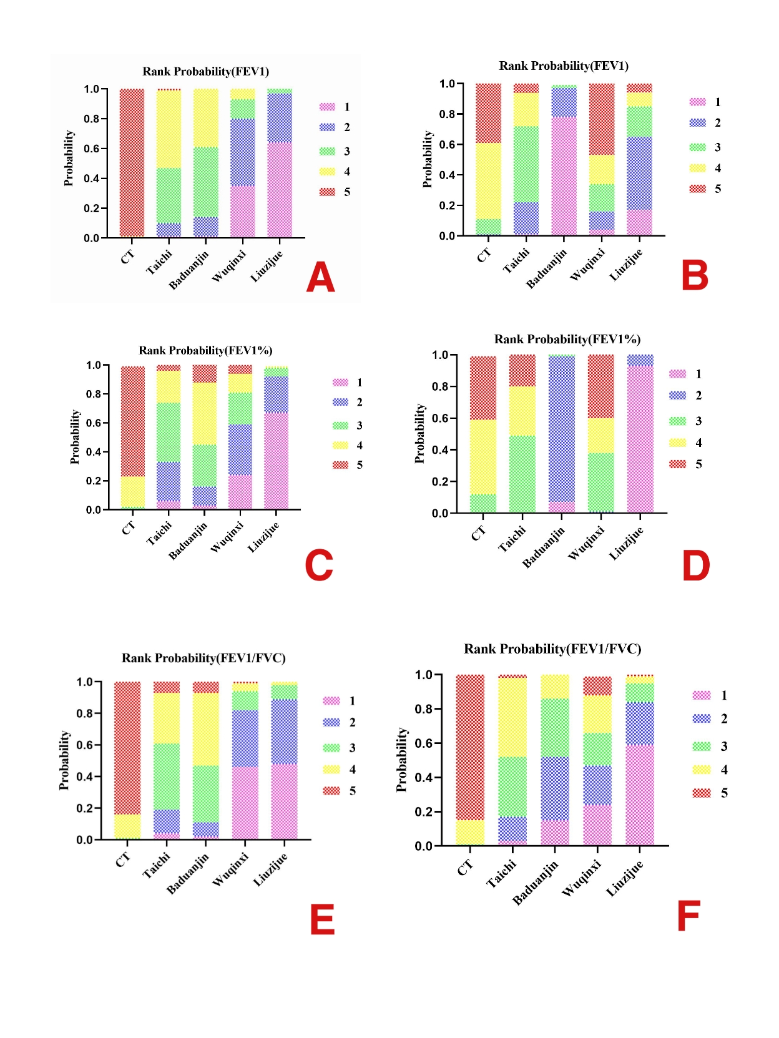
Figure 2. Cumulative Probability Ranking of the subgroup analysis based on duration of interventions. CT= conventional treatment; A= Results of FEV1 with Duration of intervention ＜ 6months; B= Results of FEV1 with Duration of intervention ≥ 6months; C= Results of FEV1% with Duration of intervention ＜ 6months; D= Results of FEV1% with Duration of intervention ≥ 6months; E= Results of FEV1/FVC with Duration of intervention ＜ 6months; F= Results of FEV1/FVC with Duration of intervention ＜ 6months.

Table 6. Network meta-analysis results of subgroup analysis based on baseline pulmonary function of COPD patients
FEV1%
Moderate
CT
2.51 (-0.25, 5.28) | Taichi
5.30 (3.00, 7.59) | 2.78 (-0.81, 6.38) | Baduanjin
2.08 (-1.41, 5.58) | -0.43 (-4.89, 4.03) | -3.21 (-7.39, 0.96) | Wuqinxi
9.81 (6.41, 13.22) | 7.30 (2.92, 11.68) | 4.52 (0.41, 8.62) | 7.73 (2.85, 12.61) | Liuzijue
Severe
CT
3.92 (-1.26, 9.09) | Taichi
4.35 (0.11, 8.59) | 0.43 (-6.23, 7.10) | Baduanjin
6.47 (-1.93, 14.87) | 2.55 (-7.31, 12.42) | 2.12 (-7.29, 11.53) | Wuqinxi
10.04 (4.84, 15.24) | 6.12 (-1.18 13.42) | 5.69 (-0.98, 12.35) | 3.57 (-6.31, 13.44) | Liuzijue
Table 7. Cumulative Probability Ranking of the subgroup analysis based on baseline pulmonary function of COPD patients
FEV1%
Moderate
Intervention  Rank | CT | Taichi | Baduanjin | Wuqinxi | Liuzijue
1st | 0.0 | 0.1 | 1.5 | 0.0 | 98.4
2nd | 0.0 | 5.6 | 87.1 | 5.8 | 1.5
3rd | 0.4 | 52.0 | 10.3 | 37.2 | 0.1
4th | 14.6 | 39.0 | 1.1 | 45.3 | 0.0
5th | 84.9 | 83.3 | 0.0 | 11.8 | 0.0
Severe
Intervention  Rank | CT | Taichi | Baduanjin | Wuqinxi | Liuzijue
1st | 0.0 | 2.9 | 2.2 | 22.7 | 72.2
2nd | 0.0 | 18.9 | 21.1 | 36.9 | 23.1
3rd | 0.7 | 33.9 | 42.9 | 18.6 | 3.9
4th | 14.2 | 37.9 | 31.7 | 15.4 | 0.8
5th | 85.1 | 6.4 | 2.1 | 6.4 | 0.0

Table 8. Network meta-analysis results of subgroup analysis based on frequency of interventions
FEV1
Frequency of intervention（More than three times a week）
CT
0.05 (-0.10, 0.20) | Taichi
0.38 (0.18, 0.59) | 0.33 (0.08, 0.58) | Baduanjin
0.31 (0.05, 0.57) | 0.26 (-0.04, 0.56) | -0.07 (-0.40, 0.25) | Wuqinxi
0.20 (0.04, 0.37) | 0.15 (-0.07, 0.37) | -0.18 (-0.44, 0.08) | -0.11 (-0.41, 0.20) | Liuzijue
FEV1%
Frequency of intervention（More than three times a week）
CT
5.46 (2.27, 8.65) | Taichi
5.01 (2.77, 7.25) | -0.44 (-4.34, 3.45) | Baduanjin
4.39 (0.83, 7.96) | -1.06 (-5.88, 3.75) | -0.62 (-4.84, 3.61) | Wuqinxi
8.71 (6.27, 11.14) | 3.25 (-0.74, 7.24) | 3.69 (0.39, 6.99) | 4.31 (-0.04, 8.66) | Liuzijue
FEV1/FVC
Frequency of intervention（More than three times a week）
CT
3.62 (0.83, 6.41) | Taichi
3.70 (0.82, 6.57) | 0.08 (-3.92, 4.07) | Baduanjin
8.02 (3.23, 12.82) | 4.40 (-1.15, 9.95) | 4.33 (-1.27, 9.92) | Wuqinxi
8.24 (5.16, 11.31) | 4.61 (0.49, 8.74) | 4.54 (0.36, 8.72) | 0.21 (-5.50, 5.93) | Liuzijue

Table 9. Cumulative Probability Ranking of the subgroup analysis based on frequency of interventions
FEV1
Frequency of intervention（More than three times a week）
Intervention  Rank | CT | Taichi | Baduanjin | Wuqinxi | Liuzijue
1st | 0.0 | 0.0 | 64.4 | 31.7 | 3.9
2nd | 0.0 | 1.4 | 29.7 | 44.7 | 24.2
3rd | 0.4 | 11.7 | 5.6 | 19.1 | 63.2
4th | 25.3 | 62.4 | 0.3 | 3.7 | 8.2
5th | 74.3 | 24.4 | 0.0 | 0.8 | 0.5
FEV1%
Intervention  Rank | CT | Taichi | Baduanjin | Wuqinxi | Liuzijue
1st | 0.0 | 5.2 | 0.9 | 2.1 | 91.8
2nd | 0.0 | 43.2 | 29.2 | 20.4 | 7.2
3rd | 0.0 | 30.4 | 42.6 | 26.1 | 0.9
4th | 0.8 | 21.2 | 27.2 | 50.6 | 0.1
5th | 99.2 | 0.0 | 0.0 | 0.8 | 0.0
FEV1/FVC
Intervention  Rank | CT | Taichi | Baduanjin | Wuqinxi | Liuzijue
1st | 0.0 | 0.4 | 0.4 | 46.2 | 53.0
2nd | 0.0 | 5.0 | 5.9 | 44.3 | 44.8
3rd | 0.0 | 45.1 | 46.4 | 6.5 | 2.0
4th | 1.4 | 48.9 | 46.6 | 2.9 | 0.2
5th | 98.6 | 0.6 | 0.7 | 0.0 | 0.0

Table 10. Sensitivity analysis based on sample size
FEV1/FVC
CT
-3.59 (-6.27, 0.81) | Taichi
-3.91 (-6.56, -1.25) | -0.35 (-4.15, 3.48) | Baduanjin
-6.40 (-10.95, -2.25) | -2.84 (-8.16, 2.12) | -2.50 (-7.70, 2.48) | Wuqinxi
-7.36 (-10.05, -4.56) | -3.79 (-7.55, 0.10) | -3.43 (-7.22, 0.41) | -0.95 (-5.94, 4.54) | Liuzijue

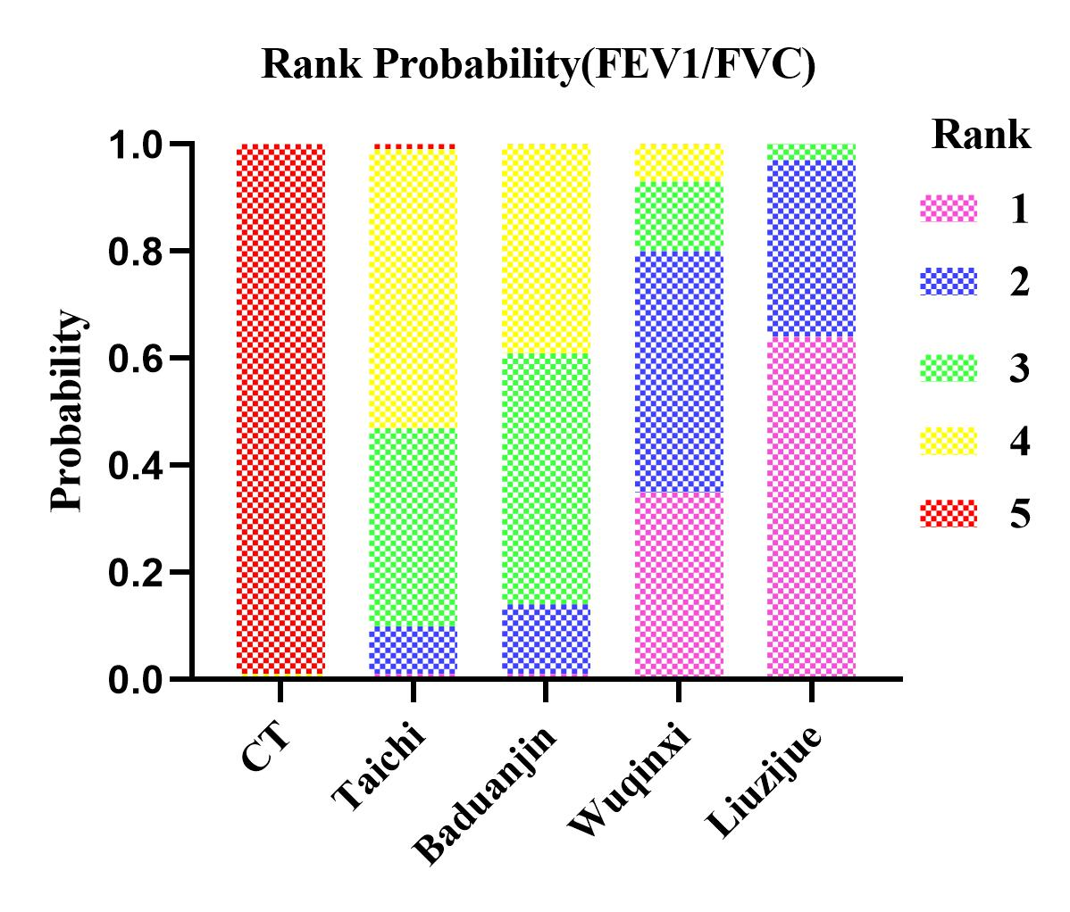
Figure 3. Cumulative Probability Ranking of the sensitivity analysis based on sample size. CT= conventional treatment.

Table 11. Sensitivity analysis based on methodological quality
FEV1
CT
0.08 (-0.03, 0.18) | Taichi
0.28 (0.15, 0.42) | 0.21 (0.04, 0.38) | Baduanjin
0.18 (-0.02, -0.38) | 0.11 (-0.12, 0.33) | -0.10 (-0.34, 0.14) | Wuqinxi
0.24 (0.09, 0.39) | 0.17 (-0.02, 0.35) | -0.04 (-0.24, 0.16) | 0.06 (-0.19, 0.31) | Liuzijue
FEV1%
CT
2.56 (0.15, 4.97) | Taichi
5.10 (2.82, 7.39) | 2.54 (-0.78, 5.86) | Baduanjin
3.85 (0.19, 7.51) | 1.29 (-3.09, 5.67) | -1.25 (-5.57, 3.07) | Wuqinxi
8.69 (5.92, 11.46) | 6.13 (2.46, 9.80) | 3.59 (0.00, 7.18) | 4.84 (0.25, 9.44) | Liuzijue
FEV1/FVC
CT
3.88 (1.32, 6.43) | Taichi
3.67 (1.10, 6.24) | -0.20 (-3.82, 3.41) | Baduanjin
6.41 (2.35, 10.46) | 2.53 (-2.28, 7.34) | 2.74 (-2.08, 7.55) | Wuqinxi
7.36 (4.72, 9.99) | 3.48 (-0.17, 7.13) | 3.68 (0.02, 7.35) | 0.95 (-3.93, 5.83) | Liuzijue

Table 12. Cumulative Probability Ranking of the sensitivity analysis based on methodological quality
FEV1
Intervention  Rank | CT | Taichi | Baduanjin | Wuqinxi | Liuzijue
1st | 0.0 | 0.1 | 57.5 | 14.2 | 28.2
2nd | 0.0 | 1.6 | 31.4 | 23.2 | 43.8
3rd | 0.3 | 18.7 | 10.7 | 45.0 | 25.3
4th | 11.6 | 71.7 | 0.4 | 13.7 | 2.6
5th | 88.1 | 8.0 | 0.0 | 3.8 | 0.1
FEV1%
Intervention  Rank | CT | Taichi | Baduanjin | Wuqinxi | Liuzijue
1st | 0.0 | 0.0 | 2.1 | 1.7 | 96.2
2nd | 0.0 | 3.7 | 66.8 | 26.0 | 3.5
3rd | 0.1 | 27.5 | 27.4 | 44.7 | 0.3
4th | 4.0 | 66.8 | 3.7 | 25.4 | 0.0
5th | 95.9 | 1.9 | 0.0 | 2.2 | 0.0
FEV1/FVC
Intervention  Rank | CT | Taichi | Baduanjin | Wuqinxi | Liuzijue
1st | 0.0 | 1.3 | 1.0 | 34.6 | 63.1
2nd | 0.0 | 11.8 | 9.6 | 45.1 | 33.5
3rd | 0.0 | 44.7 | 39.2 | 13.2 | 2.9
4th | 0.5 | 42.1 | 49.9 | 7.0 | 0.5
5th | 99.5 | 0.1 | 0.2 | 0.1 | 0.0

References

1. Du Shuting et al. The Effect of Taichi on Exercise Endurance and pulmonary Function in Patients with Chronic Obstructive Pulmonary Disease. Chinese Journal of Rehabilitation Medicine. 2013;28374-376.
2. Du Shuting et al. The Effects of Taijiquan Practice on the BODE and SGRQ of COPD Patients. Chinese Journal of Sports Medicine. 2013;32403-407+419.
3. Gang, G., Yumin, Z., Dali, W., Lian, C., Nanshan, Z. & Pixin, R. The Effect of Simple Taichi Exercise on Exercise Endurance and Quality of Life in Patients with Chronic Obstructive Pulmonary Disease. Chiese Medical Journal. 2012;92952-955.
4. Bin, X., Lianming, D., Chunxia, W., Fubing, Y., Zhenlan, L. & Lei, Z. The effect of Tai Chi on pulmonary function in patients with chronic obstructive pulmonary disease. Chinese Journal of Gerontology. 2014;344046-4047.
5. Yajie, Y. U. & Xinan, Z. Effect of TaiChi on Cognitive Potential P300 and Pulmonary ventilation Function of Patients with COPD-OSAHS overlay Syndrome. Journal of Shenyang Sport University. 2019;3891-97.
6. Qing, L. I., Weihua, F. & Cui, L. The effect of taijiquan combined with respiratory exercise training on rehabilitation of patients with sta ble chronic obstructive pulmonary disease. Chinese Journal of Rehabili tation Medicine. 2012;27825-828.
7. Xingcai, Z. et al. Effect of 24-style Tai Chi Combined with Respiratory Function Training and Western Medicine on Stable COPD. Journal of Traditional Chinese Medicine. 2014;551937-1941.
8. Yu, Z. & Dunhuang, L. The effect of 24 style Tai Chi combined with respiratory rehabilitation training on pulmonary function and quality of life in patients with chronic obstructive pulmonary disease. Journal of Practical Tradition Chinese Medicine. 2019;35350-351.
9. Yanping, Y. Effect of tai chi chuan on chronic obstructive pulmonary disease. Chin J Rehabil Theory Practice. 2004;59-60.
10. Shaoxianl, L. I., Aijun, L. I., Jing, S. & Haixia, W. Effects of Tai Chi Quan rehabilitation in patients with chronic obstructive pulmonary disease. BMU Journal. 2016;39275-277+284.
11. Lihua, Z., Jianjun, W. & Zhicheng, W. Effects of 24-form Tai Chi with Respiratory Rehabilitation Training on Pulmonary Function and Quality of Life of Patients with COPD. Journal of Shanghai University of Traditional Chinese Medicine. 2012;2653-56.
12. Yi, P. et al. The effect of 24 simplified Taichi on pulmonary rehabilitation in patients with stable chronic obstructive pulmonary disease. Chinese Journal of Rehabilitation Medicine. 2018;33681-686.
13. Chan, A. W., Lee, A., Suen, L. K. & Tam, W. W. Tai chi Qigong improves lung functions and activity tolerance in COPD clients: a single blind, randomized controlled trial. Complement Ther Med. 2011;193-11.
14. Chan, A. W. et al. The sustaining effects of Tai chi Qigong on physiological health for COPD patients: a randomized controlled trial. Complement Ther Med. 2013;21585-594.
15. Ng, L. et al. Effectiveness of incorporating Tai Chi in a pulmonary rehabilitation program for Chronic Obstructive Pulmonary Disease (COPD) in primary care—A pilot randomized controlled trial. European Journal of Integrative Medicine. 2014;6248-258.
16. Niu, R., He, R., Luo, B. L. & Hu, C. The effect of tai chi on chronic obstructive pulmonary disease: a pilot randomised study of lung function, exercise capacity and diaphragm strength. Heart Lung Circ. 2014;23347-352.
17. Polkey, M. I. et al. Tai Chi and Pulmonary Rehabilitation Compared for Treatment-Naive Patients With COPD: A Randomized Controlled Trial. Chest. 2018;1531116-1124.
18. Zhu, S. et al. A modified 6-form Tai Chi for patients with COPD. Complement Ther Med. 2018;3936-42.
19. Yeh, G. Y., Roberts, D. H., Wayne, P. M., Davis, R. B., Quilty, M. T. & Phillips, R. S. Tai chi exercise for patients with chronic obstructive pulmonary disease: a pilot study. Respir Care. 2010;551475-1482.
20. Yanfang, G., Yanyun, Q. & Miaoyuan, C. Effect of five-animal exercises on the lung function and exercis tolerance of chronic obstructive pulmonary disease patients during discharge transition period. J Clin Pathol Res. 2017;37975-980.
21. Min, Z., Gangli, C., Wenbo, L., Wei, Z., Ying, Z. & Guanyi, W. Influences of Wuqinxi Bird Exercises Combined with Simple Breath Exercises on Quality of Life and Immune Function of Patients with Chronic Obstructive Pulmonary Disease. Journal of Guangzhou University of Traditional Chinese Medicine. 2017;34819-823.
22. Qiaoliang, Z. Clinical Research on the Prevention and Cure Stable Phase Chronic Obstructive Pulmonary Disease in Community by Five-animal Exercises. China Journal of Chinese Medicine. 2015;30801-803.
23. Shanshan, W., Yufeng, C. & Rui, H. E. The traditional Hua Tuo Wuqinxi in stable patients with chronic obstructive pulmonary disease Effect of pulmonary function. Clinical Journal of Traditional Chinese Medicine. 2015;27793-795.
24. Yi, Z., Ning, L. I. & Hong-zhu, J. Effect on Chronic Obstructive Pulmonary Disease Patient in Stable Condition by Health Qigong Wuqinxi Exercise Early Treatment. Journal of Liaoning University of TCM. 2010;12107-110.
25. Fengxiang, C. Effect of Liuzijue on Inflammatory Factors in Patients with Stable Chronic Obstructive Pulmonary Disease. Fujian University of Traditional Chinese Medicine. 2019.
26. Hongying, C., Lei, P., Bihui, F. & Jianhao, L. Clinical Study on the Combination of Fitness "Liuzijue" and Yiqi Huoxue Method to Promote Pulmonary Rehabilitation in Stable COPD Patients. Henan Traditional Chinese Medicine. 2016;36835-837.
27. Meina, J. The effect of strengthening the Liuzijue on stable pulmonary function in patients with chronic obstructive pulmonary disease of lung spleen deficiency type. Hunan University of Chinese Medicine. 2017.
28. Siqin, J., Gongwen, L., Kejian, S., Peilan, Y. & Zhenwei, W. Clinical Study on Six-character Formula in the Intervention for COPD Patients at Stable Phase. Western Journal of Traditional Chinese Medicine. 2019;32111-114.
29. Qian, S. A Community Intervention Study on Treating COPD Stabilization (level I) in E lderly Patients by Six Strategics Health Exercises. Clinical Journal of Chinese Medicine. 2017;923-25.
30. Ning, S., Dongpan, L. & Yan, S. Liuzijue Combined with Lip and Abdomen Contraction Breathing Training for Pulmonary Function in Stable COPD Patients and the impact of quality of life. J Clin Res. 2019;361003-1004.
31. Mingming, Z., Qi, Z., Qinqin, S., Yan, W. & HuieRz. Evaluation of the Effect of Long Term Home Oxygen Therapy Assisted by Liuzijue Breathing Exercise in Patients with Chronic Obstructive Pulmonary Disease. Chinese Journal of Practical Nursing. 2019;352108-2113.
32. Rong, L. I. Qigong Six Tips Stability in the Elderly Chronic Obstuctive Pneumonia Intervention Study. Beijing Sports University. 2018.
33. Jinxiu, C. & Lijin, D. The Rehabilitation Effect of Traditional "Liuzijue Breathing Exercises" on Stable COPD Patients. Chinese Journal of Rehabilitation Medicine. 2009;24944-945.
34. Zhen, Z. Health Qigong's Effect on the 61 Stabilized Patients with Chronic Obstructive Pulmonary Disease. Journal of Nanjing TCM University. 2011;27235-237.
35. Yang, L., Xu, H., Yuanyuan, W., Wei, D., Shaobin, L. & Yichong, F. Impacts of the Combined Therapy of Tiotropium Bromide and Medical Exercise of the Six － Character Formula on the Living Quality and Pulmonary Function in the Patients of Chronic Obstructive Pulmonary Disease at the Stable Stage. World Journal of Integrated Traditional and Western Medicine. 2016;111369-1371+1395.
36. Li, P., Liu, J., Lu, Y., Liu, X., Wang, Z. & Wu, W. Effects of long-term home-based Liuzijue exercise combined with clinical guidance in elderly patients with chronic obstructive pulmonary disease. Clin Interv Aging. 2018;131391-1399.
37. Wu, W., Liu, X., Liu, J., Li, P. & Wang, Z. Effectiveness of water-based Liuzijue exercise on respiratory muscle strength and peripheral skeletal muscle function in patients with COPD. Int J Chron Obstruct Pulmon Dis. 2018;131713-1726.
38. Wu, W., Liu, X., Li, P., Li, N. & Wang, Z. Effect of Liuzijue Exercise Combined with Elastic Band Resistance Exercise on Patients with COPD: A Randomized Controlled Trial. Evid Based Complement Alternat Med. 2018;20182361962.
39. Yi, C. Effect of Eight-section Brocade Rehabilitation Nursing on Rehabilitation of Patients with Chronic Obstructive Pulmonary Disease. Journal of Liaoning University of TCM. 2017;19213-215.
40. Yanfang, D. & Jinxiu, C. The effects of Baduanjin's third part on rehabilitation in stable chronic obstructive pulmonary disease patients with lung and spleen deficiency syndrome. Chin J Nurs. 2015;501458-1463.
41. Liangjie, D. & Bao, L. Effect of Shaolin Baduanjin Qigong on BODE Index and Quality of Life in Patients with Stable Chronic Obstructive Pulmonary Disease. Clinical journal of traditional chinese medicine. 2018;301465-1467.
42. Xiujun, G., Cong, C., Ning, C., Xin, Y. & Huiling, Z. The Effect of Ba Duan Jin on Extraculmonary Manifestations of Stable Community Elderly Patients with Chronic Obstructive Pulmonary Disease. Chinese Journal of Practical Nursing. 2016;322291-2295.
43. Baoju, H., Qingping, Y. & Yimin, Z. Clinical Observation of Health Qigong Ba Duan Jin on Stable Chronic Obstructive Pulmonary Dis ease with Lung and Spleen Deficienc. Hubei Journal of TCM. 2017;394-6.
44. Congyun, L., Xiuchun, Y., Weijuan, J. & Jizhen, W. The effects of Ba DuanJin on clinical outcomes of patients with stable chronic ob structive pulmonary disease. Chin J Nurs Educ. 2019;16188-192.
45. Surong, L. & Yunfeng, C. Clinical Study on the Efficacy of Health Qigong Ba Duan Jin on Improving Lung Function of Patients with Chronic Obstructive Pulmonary Disease in Its Stable Period. West China Medical Journal. 2012;271248-1250.
46. Surong, L. & Yunfeng, C. Clinical study on Health-qi-gong-ba-duan-jin for the improvement of the 6min of patients with chronic obstructive pulmonary disease in stable period. Sichuan Medical Journal. 2013;341090-1092.
47. Surong, L. & Yunfeng, C. Clinical Study on the Effect of Fitness Qigong Baduanjin on Stable Stage Patients with Chronic Obstructive Pulmonary Disease. Sichuan Medical Journal. 2014;351481-1482.
48. Meiying, P., Jianhua, L. & Sanchun, Y. Observation on Rehabilitation Exercise Eight-section Brocade in Community Patients with Early Metaphase Chronic Obstructive Pulmonary Diseas. Journal of Chengdu University TCM. 2016;3949-52.
49. Yiping, S. Clinical Study on Effect of Health-Qigong Ba Duan Jin in Treating Chronic Obstructive Pulmonary Disease. Changchun University of Chinese Medicine. 2014.
50. Li, W. & Li, F. The Effect of Practicing Ba Duan Jin on Stable Pulmonary Function in Chronic Obstructive Pulmonary Disease. Guiding Journal of Traditional Chinese Medicine and Pharmacy. 2018;2486-87+91.
51. Guangwei, X., Cuiling, F., Xiaoqin, Y., Ying, Q., Yanning, W. & Jia, M. Efficacy of fitness qigong Ba Duan Jin in pulmonary rehabilitation of patients with chronic obstructive pulmonary disease at stable stage. Journal of Beijing University of Traditional Chinese Medicine. 2015;38139-144.
52. Lixiu, Z. et al. Effect of Eight-section brocade on therapeutics nutrition status and evaluation of cardiopulmonary function of chronic obstructive pulomonary disease rehabilitation by adjusting pectoral qi. Journal of Changchun University of Chinese Medicine. 2017;33954-956.
53. Tingting, Z., Xiuqin, M., Ruhua, C. & Yan, Y. Effects of the Baduanjin Exercise on The Pulmonary Function，Fatigue Status and Activ ity Tolerance in The Patients with Stable COPD. World Journal of Integrated Traditional and Western Medicine. 2019;14415-418.
54. Yanchan, Z. Clinial Study of Respiratory Baduanjin in Patients with Chronic Obstructive Pulmonary Disease. Guangzhou University of Chinese Medicine. 2019.
55. Biying, Y. The Application of Ba Duan Jin Tiao Bu Fei Spleen Kidney Method in the Adjuvant Treatment of COPD Patients. International Journal of Nursing. 2016;352357-2359.
56. Dongling, Y., Junhong, W. & Zhijuan, H. Evaluation of the therapeutic effect of fitness Qigong Baduanjin on stable pulmonary rehabilitation in chronic obstructive pulmonary disease. Chinese General Practice. 2017;20356-358.
57. Zhenggang, Z. & Yan, C. Impacts of Baduanjin Qigong of Sitting Style on Lung Function in COPD Patients. World Journal of Integrated Traditional and Western Medicine. 2014;9846-848.

