Supplementary material
Table S1. OFV, AIC, BIC, and BICc values
 | Group 1 (Day 1) | Group 2 (Day 14) | Group 2 (Day 28)
OFV | 566.47 | 837.42 | 741.81
AIC | 582.47 | 853.42 | 757.81
BIC | 586.35 | 859.09 | 762.53
BICc | 597.34 | 870.07 | 773.31

Figure S1. Comparison predicted versus observed of plasma-concentration time profiles of total bioactivity of Atractylodes Lancea Thunb (DC) in each patient in group 1 (day 1).
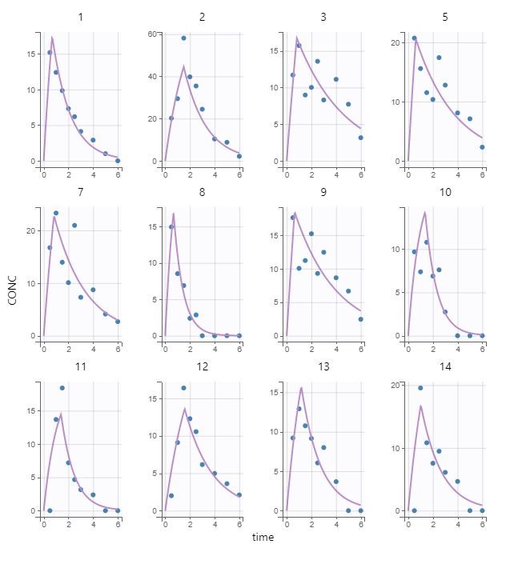

Figure S2. Predicted of plasma-concentration time profiles of total bioactivity of Atractylodes lancea (Thunb) DC versus observed data in group 1 (day 1)
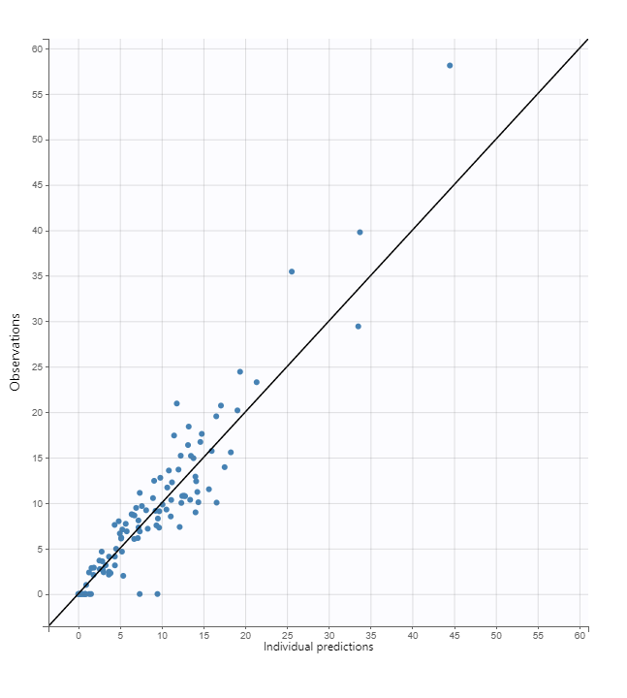
Figure S3 A virtual predictive check of plasma-concentration time profiles of total bioactivity of Atractylodes Lancea (Thunb) DC in group 1 (day 1).
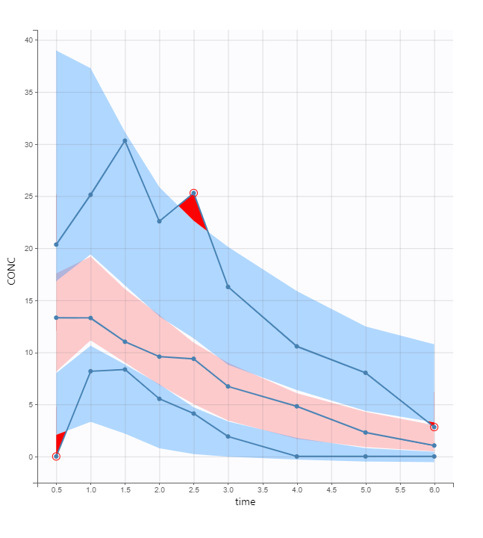
Figure S4. A scatter plot of residual errors of plasma-concentration time profiles of total bioactivity of Atractylodes Lancea (Thunb) DC in group 1 (day 1).
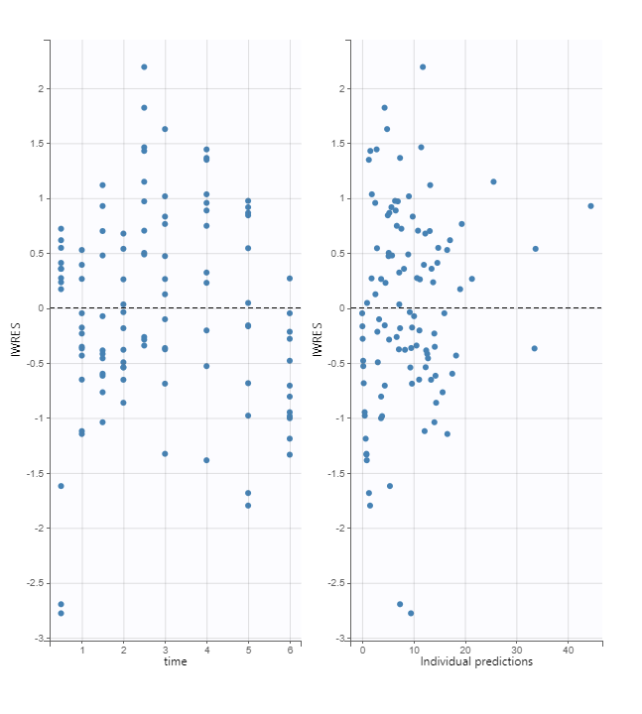
Figure S5. Comparison predicted versus observed of plasma-concentration time profiles of total bioactivity of Atractylodes Lancea Thunb (DC) in each patient in group 2 (day 14).
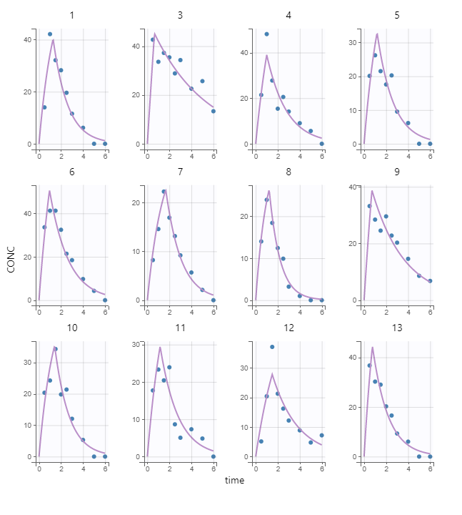
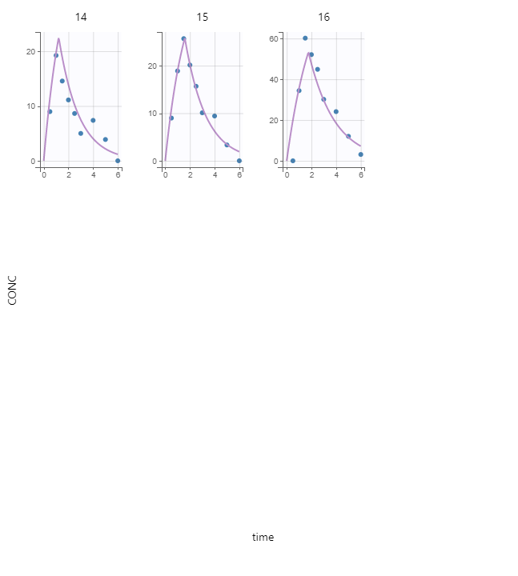
Figure S6. Predicted of plasma-concentration time profiles of total bioactivity of Atractylodes lancea (Thunb) DC versus observed data in group 2 (day 14).
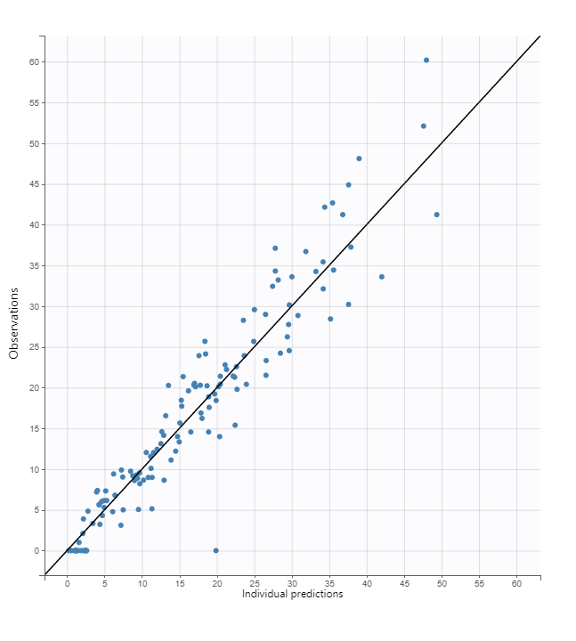
Figure S7 A virtual predictive check of plasma-concentration time profiles of total bioactivity of Atractylodes Lancea (Thunb) DC in group 2 (day 14).
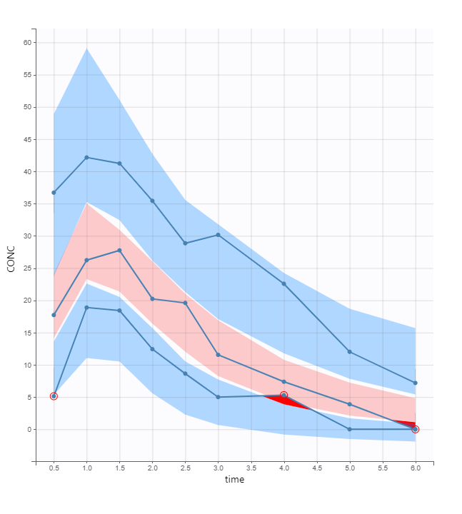
Figure S8. A scatter plot of residual errors of plasma-concentration time profiles of total bioactivity of Atractylodes Lancea (Thunb) DC in group 2 (day 14).
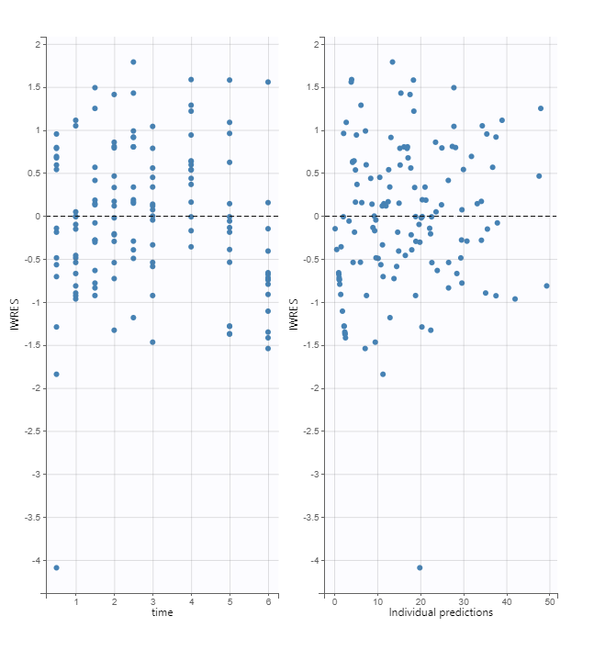
Figure S9. Comparison predicted versus observed of plasma-concentration time profiles of total bioactivity of Atractylodes Lancea Thunb (DC) in each patient in group 2 (day 28).
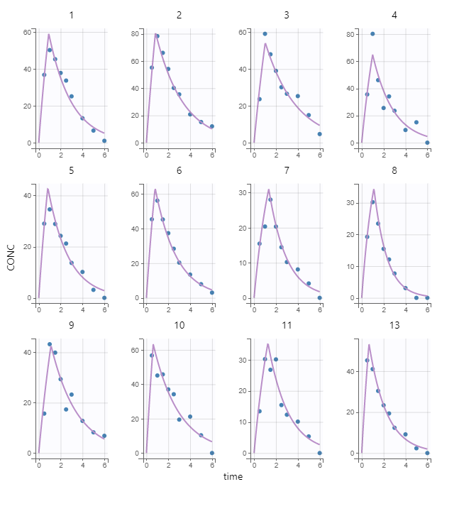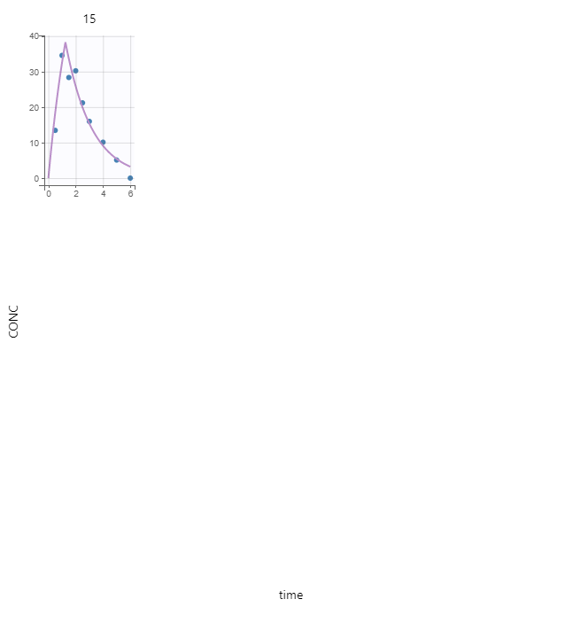
Figure S10. Predicted of plasma-concentration time profiles of total bioactivity of Atractylodes lancea (Thunb) DC versus observed data in group 2 (day 28).
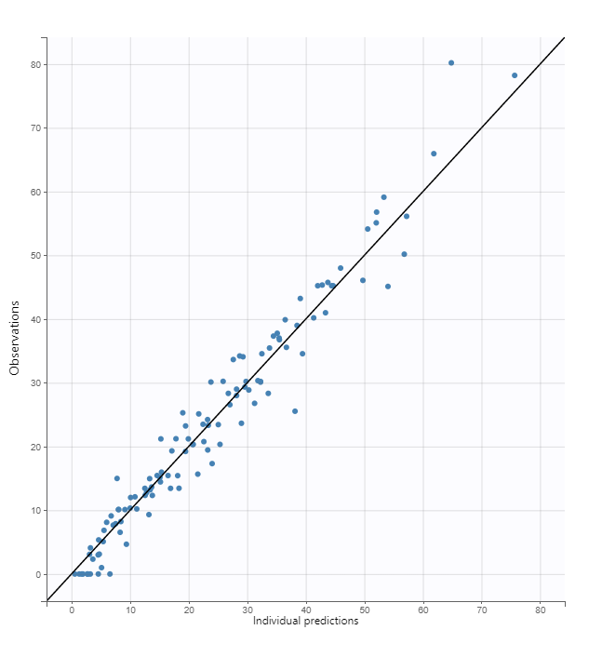
Figure S11 A virtual predictive check of plasma-concentration time profiles of total bioactivity of Atractylodes Lancea (Thunb) DC in group 2 (day 28).
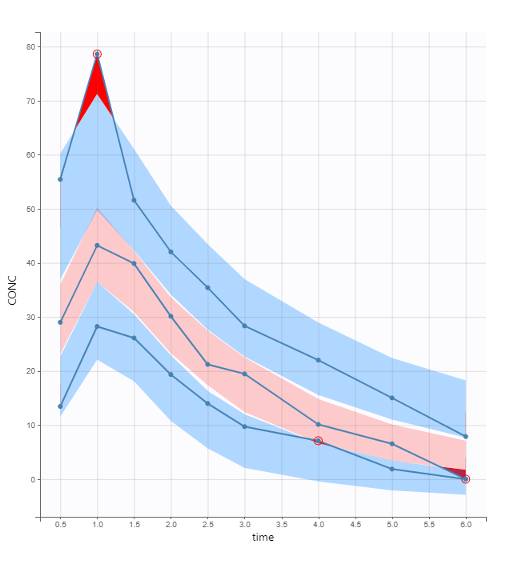
Figure S12. A scatter plot of residual errors of plasma-concentration time profiles of total bioactivity of Atractylodes Lancea (Thunb) DC in group 2 (day 28).
