Supplementary Materials
Bioassay-guided isolation and structure elucidation of anti-Mycobacterium tuberclusis compounds from Crinitaria grimmii (Regel & Schmalh.) Grierson
Abolfazl Shakeri^{1,a}, Mehrangiz Tajvar^{1,a}, Ghazaleh Tabriznia Tabrizi¹, Saman Soleimanpour^{2,3,4}, Javid Davoodi¹, Javad Asili¹, Mohammad Sadegh Amiri⁵, Seyed Ahmad Emami^{6,*}

¹Department of Pharmacognosy, School of Pharmacy, Mashhad University of Medical Sciences, Mashhad, Iran
² Tuberculosis Reference Laboratory, Shariati Hospital, Mashhad University of Medical Sciences, Mashhad, Iran
³ Antimicrobial Resistance Research Center, Bu-Ali Research Institute, Mashhad University of Medical Sciences, Mashhad, Iran
⁴ Department of Microbiology and Virology, School of Medicine, Mashhad University of Medical Sciences, Mashhad, Iran
⁵ Department of Biology, Payame Noor University, Tehran, Iran
⁶ Department of Traditional Pharmacy, School of Pharmacy Mashhad University of Medical Sciences, Mashhad, Iran.
ª These authors contributed equally to this work.
* Address correspondence to this author at the Department of Traditional Pharmacy, School of Pharmacy Mashhad University of Medical Sciences, Mashhad, Iran.; Tel: +98-51-31801267; Fax: +98-51-38823251; E-mail: emamia@mums.ac.ir.

List of Supporting Information
Figure S1. ¹H NMR Spectrum (300 MHz, MeOH-d4) of compound 1.
Figure S2. ¹³C NMR Spectrum (75 MHz, MeOH-d4) of compound 1.
Figure S3. HSQC Spectrum of compound 1.
Figure S4. HMBC Spectrum of compound 1.
Figure S5. HH-COSY Spectrum of compound 1.
Figure S6. ¹H NMR Spectrum (300 MHz, MeOH-d4) of compound 2.
Figure S7. ¹³C NMR Spectrum (75 MHz, MeOH-d4) of compound 2.
Figure S8. ¹H NMR Spectrum (300 MHz, MeOH-d4) of compound 3.
Figure S9. ¹³C NMR Spectrum (75 MHz, MeOH-d4) of compound 3.
Figure S10. ¹H NMR Spectrum (300 MHz, MeOH-d4) of compound 4.
Figure S11. ¹³C NMR Spectrum (75 MHz, MeOH-d4) of compound 4.
Figure S12. ¹H NMR Spectrum (300 MHz, MeOH-d4) of compound 5.

Figure S1. ¹H NMR Spectrum (300 MHz, MeOH-d4) of compound 1.

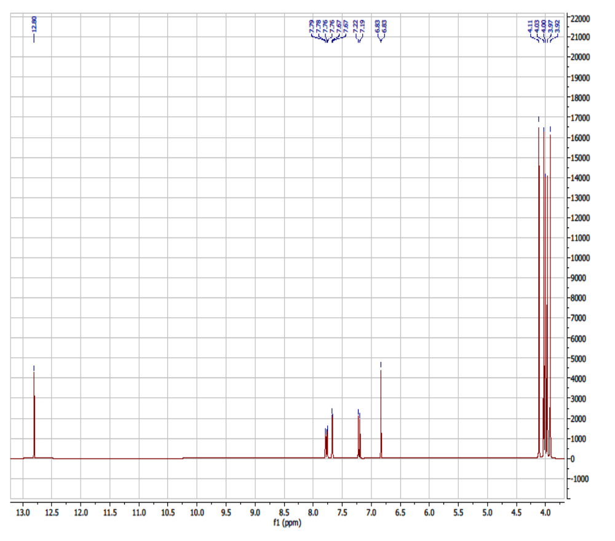

Figure S2. ¹³C NMR Spectrum (75 MHz, MeOH-d4) of compound 1.
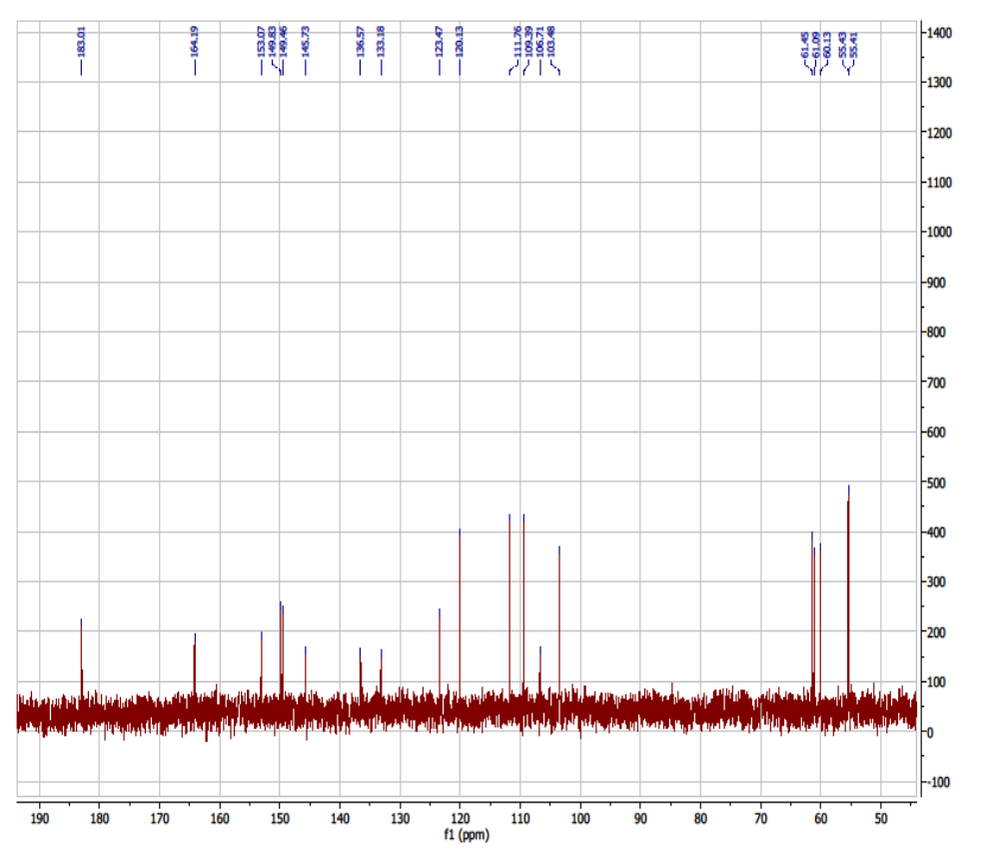

Figure S3. HSQC Spectrum of compound 1.
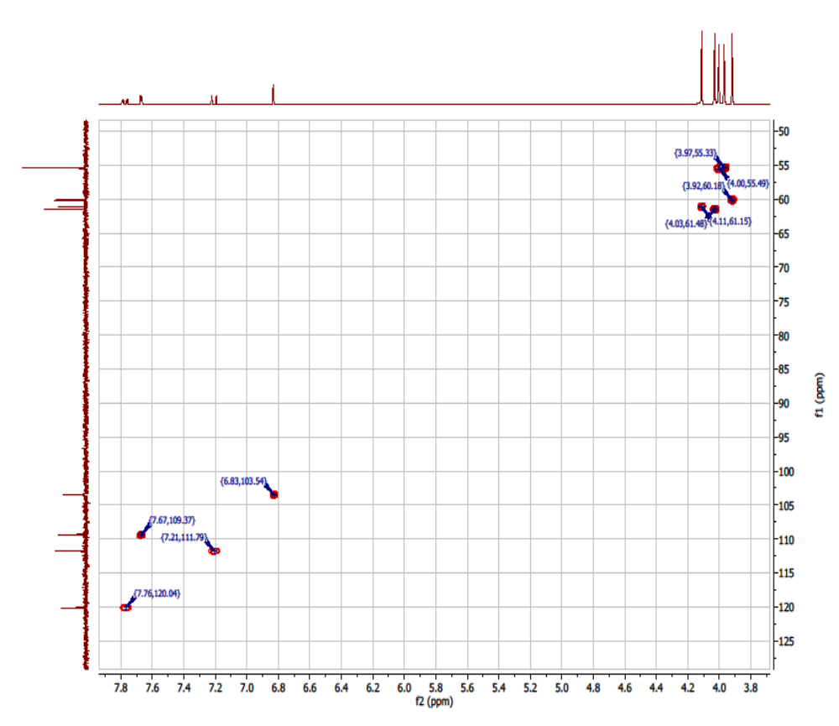

Figure S4. HMBC Spectrum of compound 1.
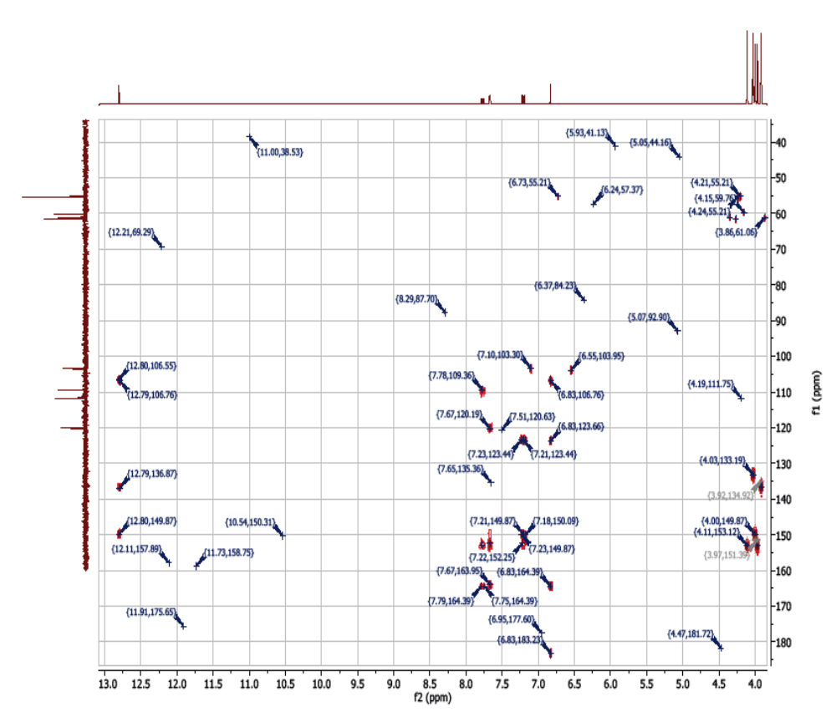

Figure S5. HH-COSY Spectrum of compound 1.
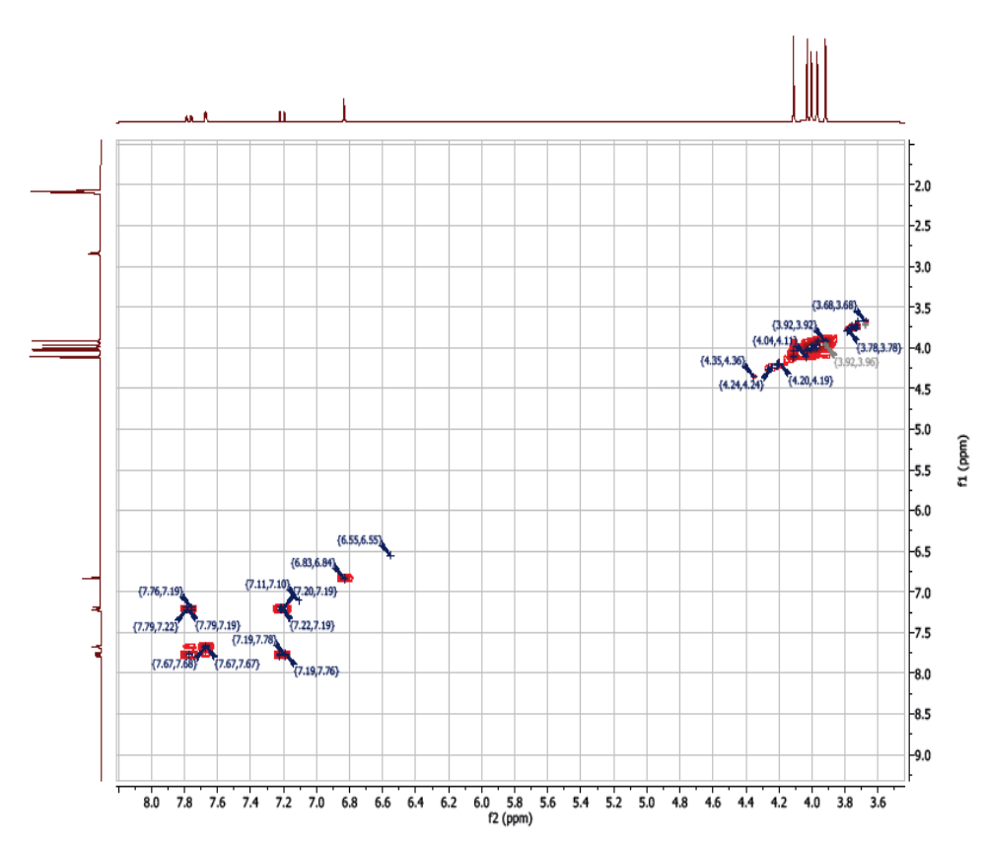

Figure S6. ¹H NMR Spectrum (300 MHz, MeOH-d4) of compound 2.
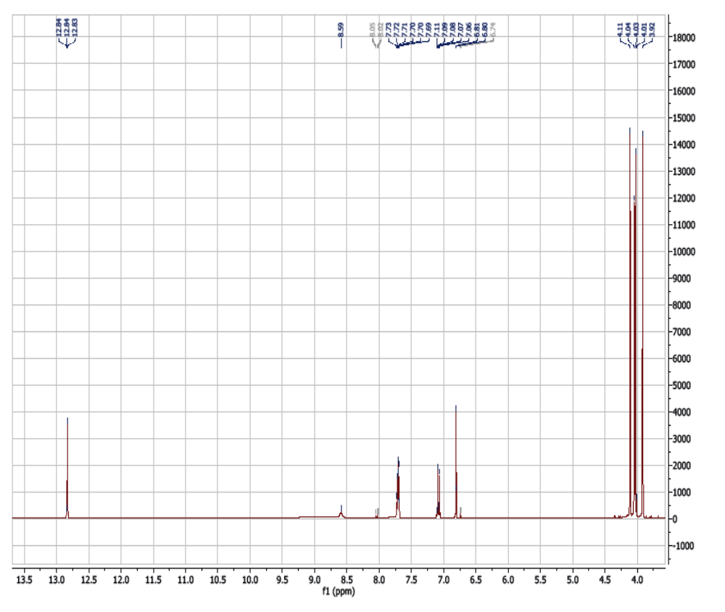

Figure S7. ¹³C NMR Spectrum (75 MHz, MeOH-d4) of compound 2.
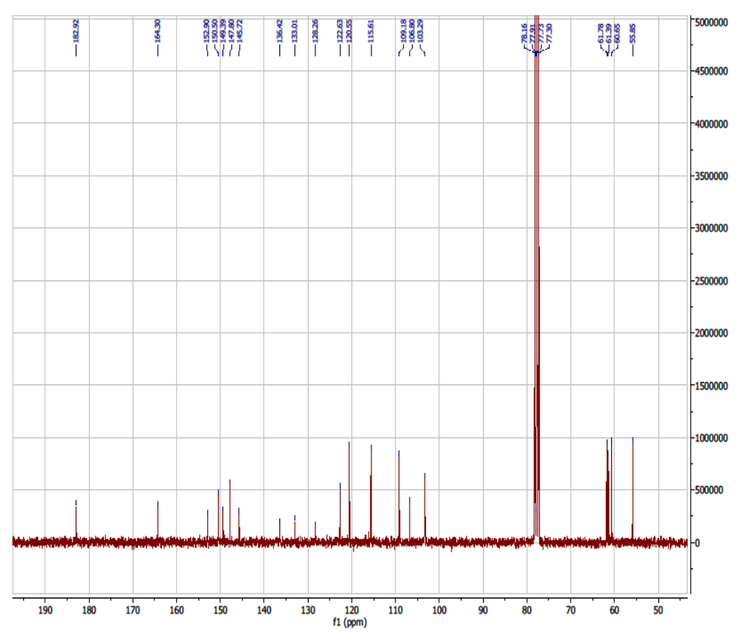

Figure S8. ¹H NMR Spectrum (300 MHz, MeOH-d4) of compound 3.
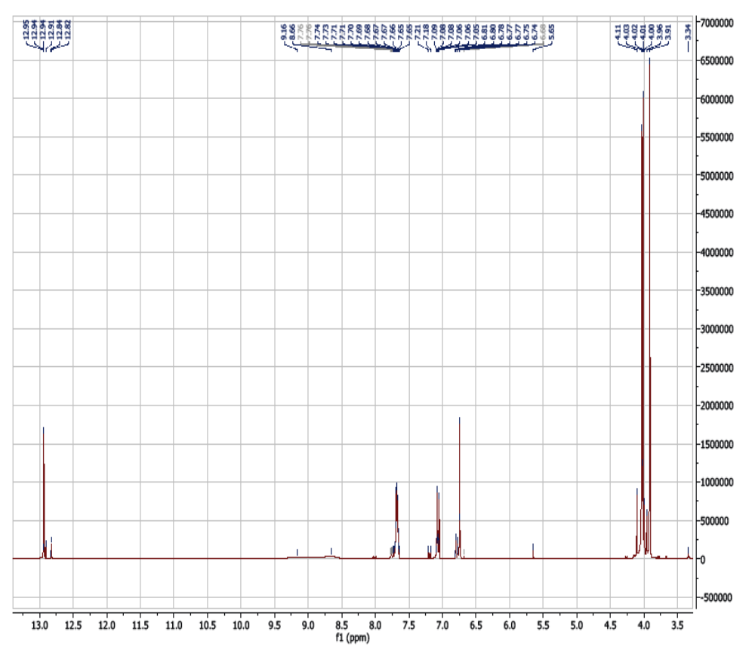

Figure S9. ¹³C NMR Spectrum (75 MHz, MeOH-d4) of compound 3.
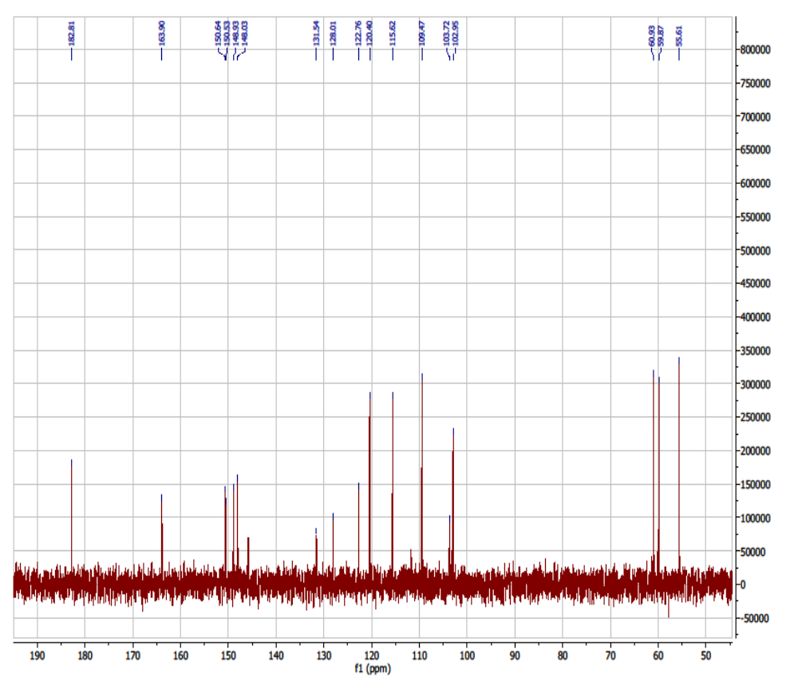

Figure S10. ¹H NMR Spectrum (300 MHz, MeOH-d4) of compound 4.
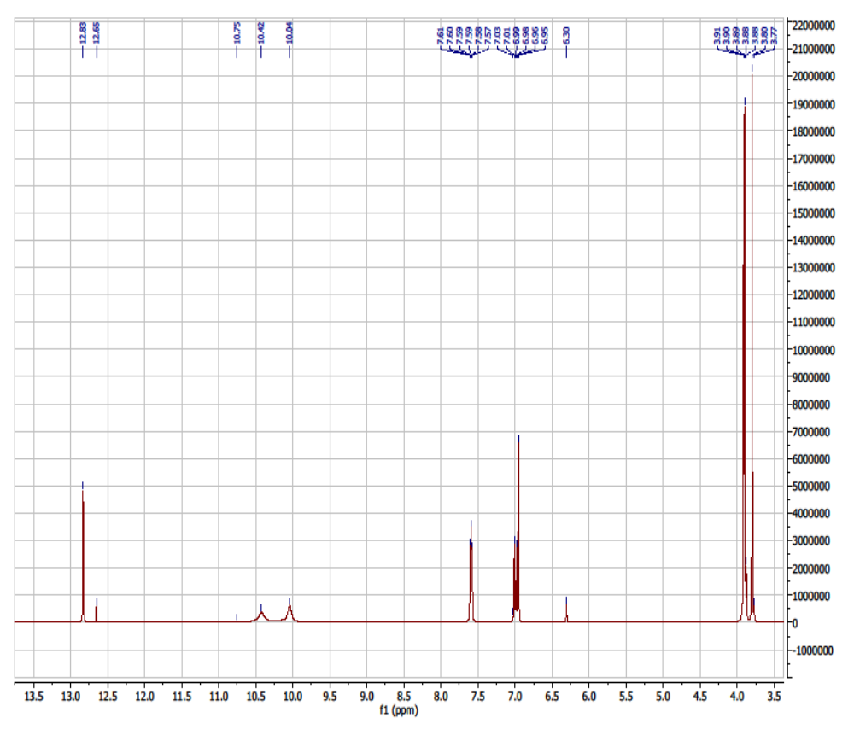

Figure S11. ¹³C NMR Spectrum (75 MHz, MeOH-d4) of compound 4.
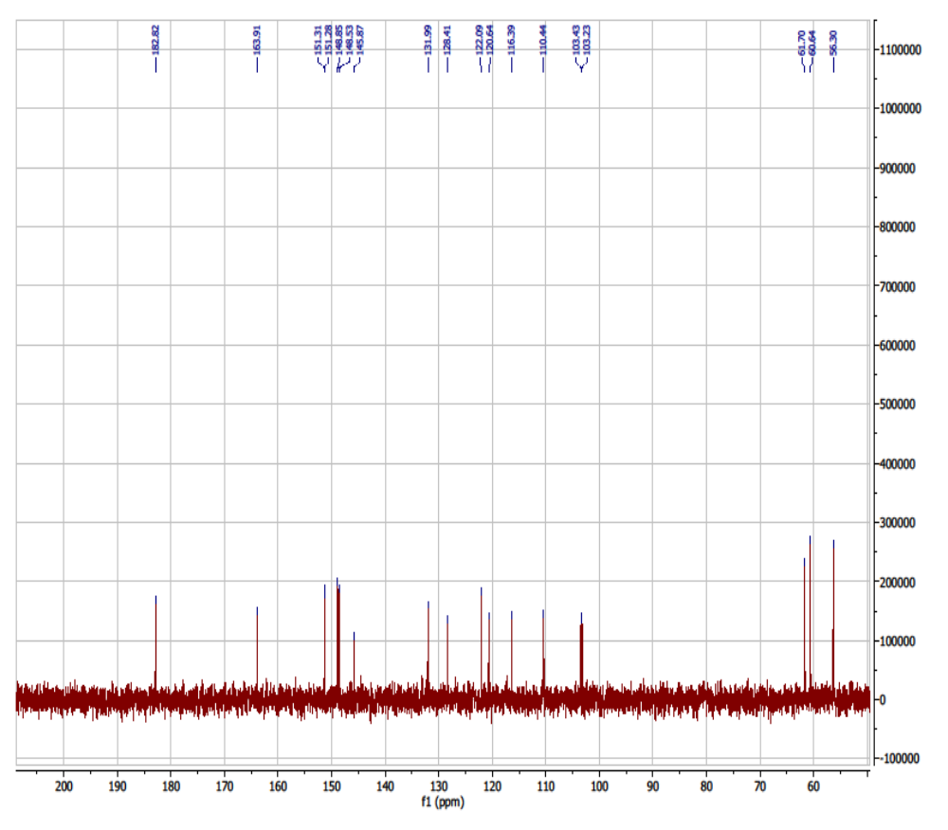

Figure S12. ¹H NMR Spectrum (300 MHz, MeOH-d4) of compound 5.
