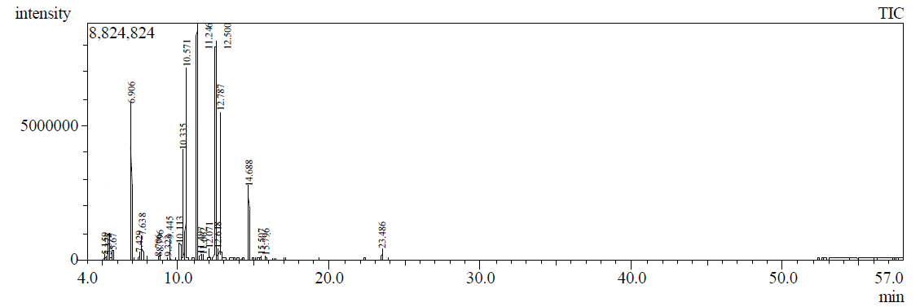
Fig. S1. GC- MS chromatogram of HS extracted oil

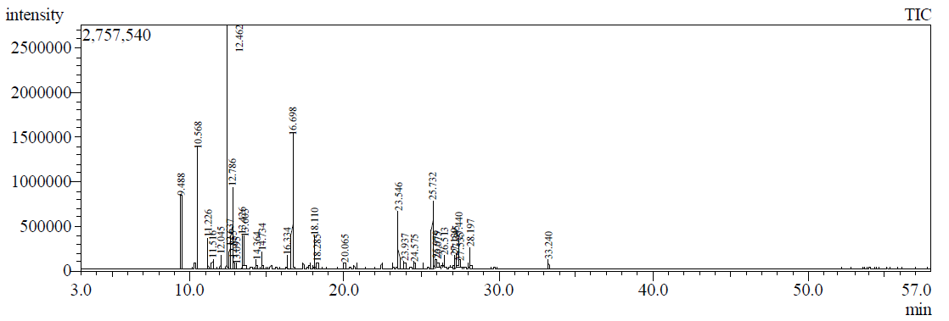
Fig. S2. GC- MS chromatogram of HD extracted oil

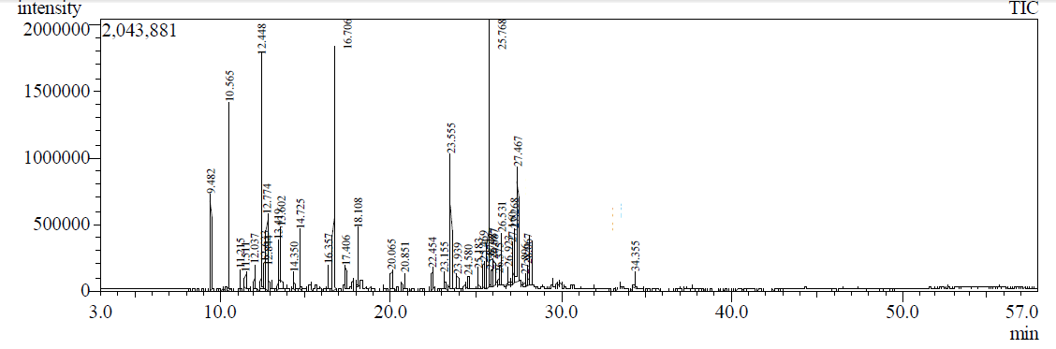
Fig. S3. GC- MS chromatogram of MAHD extracted oil

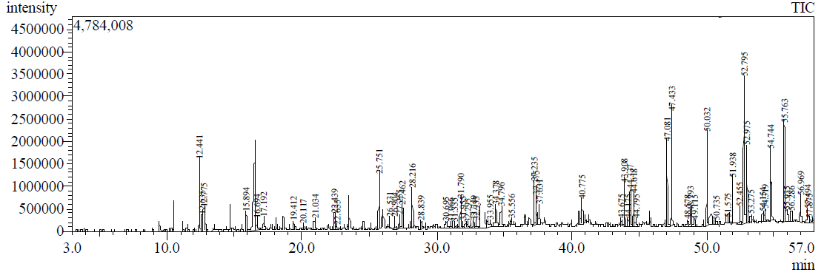
Fig. S4. GC- MS chromatogram of SF extracted oil

B-actin | i-NOS
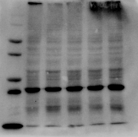 | 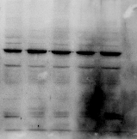

Un-cropped western blot images

