Supplementary Data
Exploring the Complex Immunomodulatory Effects and Gut Defense through Oral Administration of Astragali Radix to Normal Mice
Mi-Gi Lee^{1,§} , Youngju Song^{2, §} and Hee Kang^{3,*}
¹Bio-Center, Gyeonggido Business & Science Accelerator, Suwon, 16229, Republic of Korea
²Department of Biomedical Science and Technology, Graduate school, Kyung Hee University, Seoul, 02447, Republic of Korea.
³Humanitas College, Kyung Hee University, Yongin, 17104, Republic of Korea.
§ These authors contributed equally to this manuscript as co-first authors.
* Correspondence: Dr. Hee Kang
Humanitas College, Kyung Hee University, 1732 Deogyeong-daero, Yongin, 17104, Republic of Korea. Tel; +82-31-201-3493, Fax;+82-31-204-8106

This file includes Table S1, Figures S1

Table S1. Primer sequences
Gene | Forward | Reward
Muc2 | 5'-GTGTGGGACCTGACAATGTG- 3' | 5'-ACAACGAGGTAGGTGCCATC-3'
RegIIIγ | 5'- CATCAACTGGGAGACGAATCC -3' | 5'- CAGAAATCCTGAGGCTCTTGACA -3'
Pigr | 5'-TTTGCTCCTGGGCCTCCAAGTT-3' | 5'-AGCCCGTACTGCCACAAATCA-3'
GAPDH | 5'-GGTGGTCTCCTCTGACTTCAACA-3' | 5'-GTTGCTGTAGCCAAATTCGTTGT-3'

A
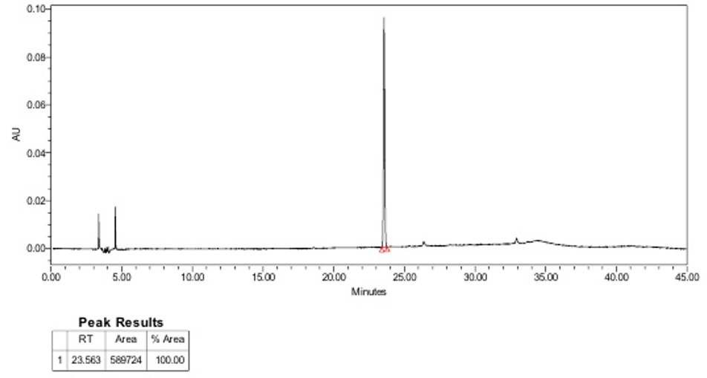
B
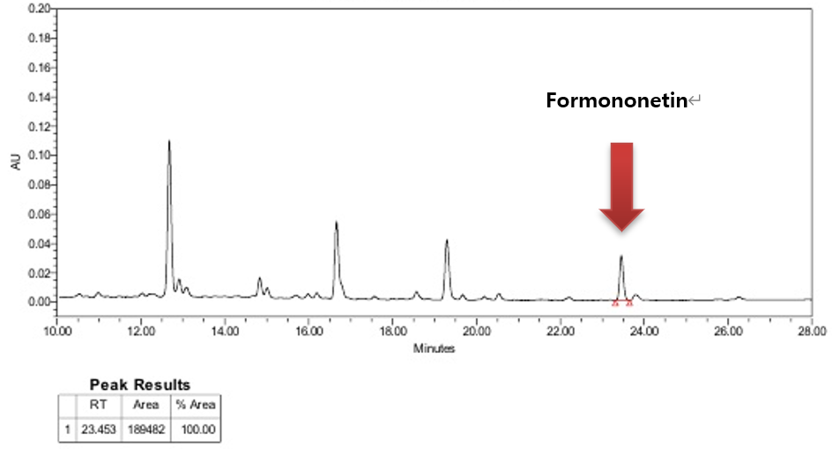
Figure S1. HPLC chromatogram of Astragli Radix extract. A) Formononetin B) AR extract

