Supplementary Materials

Description of Spleen and Stomach Disharmony
In the theory of Traditional Chinese Medicine (TCM), the syndrome of spleen and stomach disharmony encompasses a group of syndromes with abdominal distention, or stomach noise, or eating less and being dull, or abdominal distension, or belching after eating, or stool irregularities. These symptoms are analogous to gastrointestinal disorders described in modern medicine.

Reasons for Choosing the Chronic Insomnia with Spleen and Stomach Disharmony
Research suggests that disturbances in gut health can significantly impact sleep quality and that individuals with insomnia are at a higher risk for gastrointestinal diseases^{1,2}. Interestingly, there is an ancient saying in the classic book of Chinese medicine "“Huangdi Neijing”, that is, “stomach disharmony leading to restless sleep”. It means that gastrointestinal disorders could interfere with people's sleep. Both Western medicine and TCM recognize the close correlation between gastrointestinal symptoms and sleep disturbances. Hence, this interrelationship prompted us to focus on CID patients with this particular TCM diagnostic pattern.

References:
1. Wuestenberghs F, Melchior C, Desprez C, Leroi AM, Netchitailo M, Gourcerol G. Sleep Quality and Insomnia Are Associated With Quality of Life in Functional Dyspepsia. Frontiers in neuroscience. 2022;16:829916.
2. Zhao N, Chen QG, Chen X, et al. Intestinal dysbiosis mediates cognitive impairment via the intestine and brain NLRP3 inflammasome activation in chronic sleep deprivation. Brain, behavior, and immunity. 2023;108:98-117.

Supplementary figure legends
Fig S1. Location of the hypothalamus seeds. Abbreviations: LH, lateral hypothalamus; MH, medial hypothalamus.
Fig S2. The group difference between LH functional connectivity network between CID patients and HCs (Voxel level p = 0.05, not corrected for multiple comparisons). Abbreviations: LH, lateral hypothalamus; CID, chronic insomnia disorder; HCs, healthy controls.
Fig S3. The main effect of group and treatment on the MH functional connectivity network (Voxel level p = 0.05, not corrected for multiple comparisons). Abbreviations: MH, medial hypothalamus.

Fig S1. Location of the hypothalamus seeds.

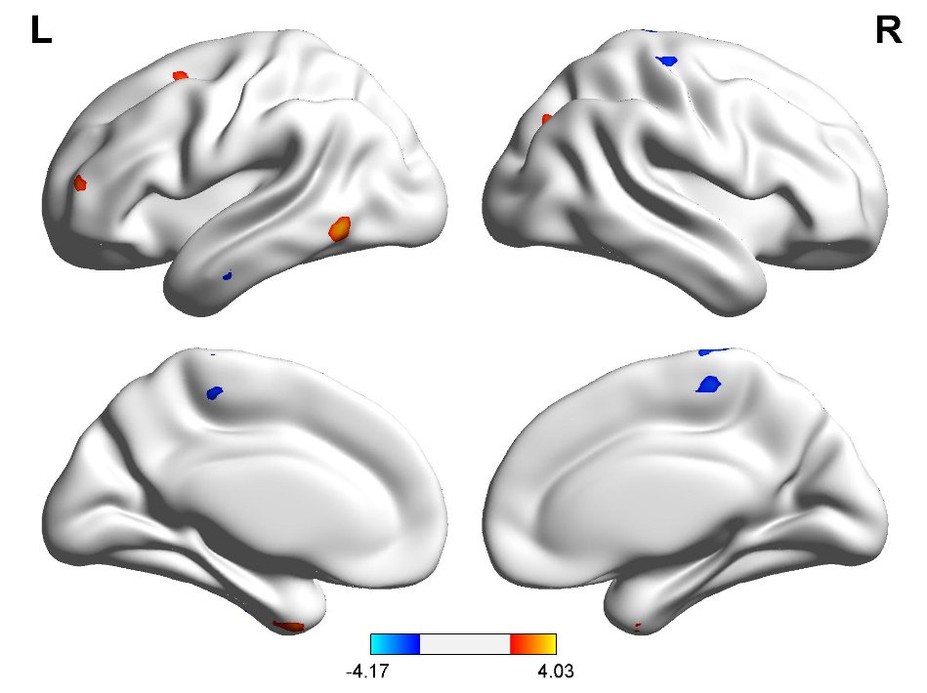
Fig S2. The group difference between LH functional connectivity network between CID patients and HCs.

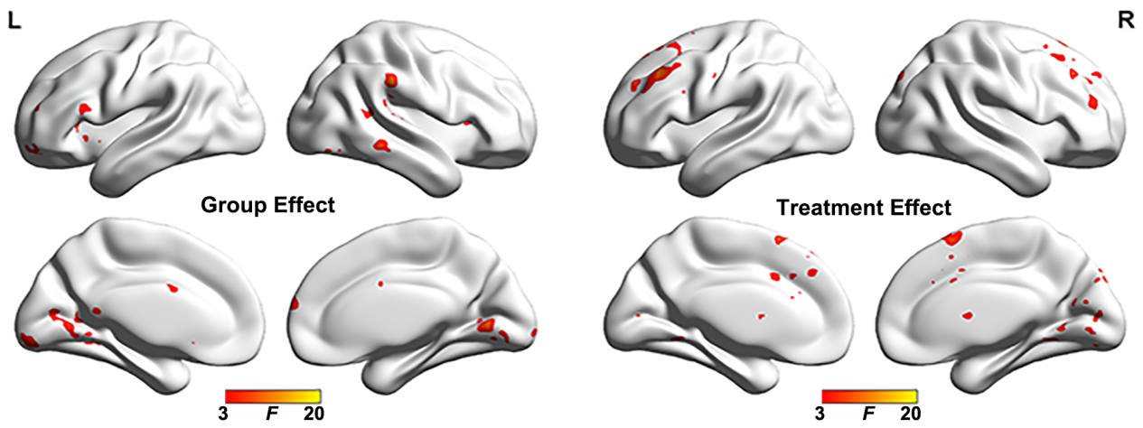

Fig S3. The main effects of group and treatment on the MH functional connectivity network.

