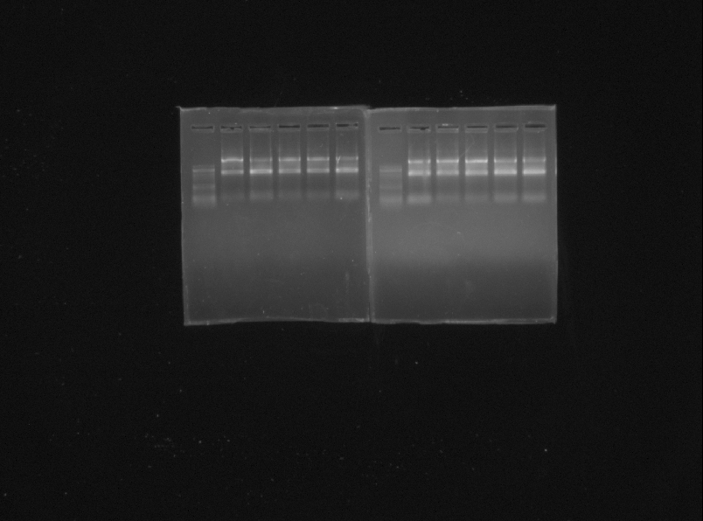
5S
18S
28S
RNA. 5S, 18S, and 28S Band

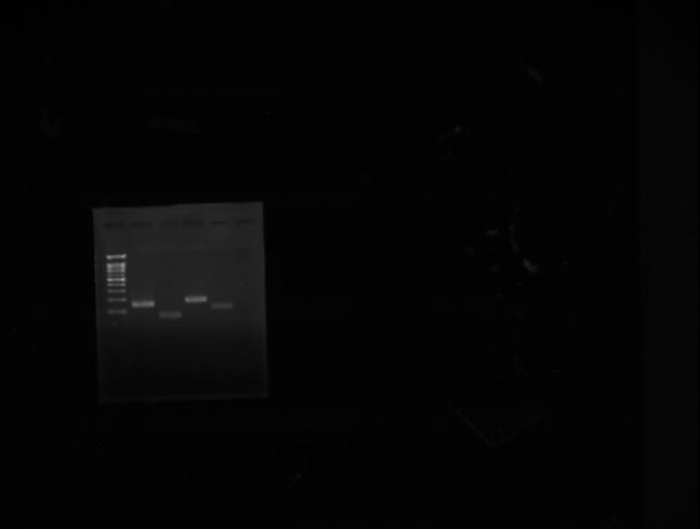
5
4
3
2

1
1. Caspase3 (146 bp), 2. NF-kB p65 (97 bp), 3. MDR1 (162 pb), 4. MRP1 (123 bp), and 5. Negative Control

