Exploring the Therapeutic Potential of Marjoram (Origanum majorana L.) in Polycystic Ovary Syndrome: Insights from Serum Pharmacochemistry, Network Pharmacology and Experimental Validation

Experimental
UHPLC TQD-MS analysis conditions:
The UPLC-TQD-MS/MS was performed using Waters Corporation, Milford, MA01757, U.S.A. the detailed chromatographic condition can be found under supplementary material. The chromatographic separation was performed using the Waters Acquity UPLC BEH C18 column, with dimensions of 50 mm × 2.1 mm ID × 1.7 μm particle size. The column was operated at a flow rate of 0.2 mL.min⁻¹ and a temperature of 30°C. The analysis was conducted using a gradient elution method, where the concentration of phase B was increased. A binary mobile phase consisting of 0.1% formic acid in ultrapure water (Phase A) and 0.1% formic acid in acetonitrile (Phase B) was utilized. The sample solution was prepared using UPLC analytical grade methanol at a concentration of 100 μg/mL. The filtration process involved the use of a membrane disc filter with a pore size of 0.2 μm. Prior to injection, the sample was subjected to sonication in order to remove any trapped gases. Subsequently, a volume of 10 μL was injected into the UPLC apparatus. The data acquisition in a mass range of 100-1000 m/z was performed using a Triple Quadrupole (TOD) mass analyzer, employing both negative and positive ionization modes. The working conditions of ESI were optimized by adjusting several parameters included the capillary voltage set at 3 kV, the temperature of the ion source maintained at 150 ◦C, the cone voltage set to 30 V, the pressure of the nitrogen gas nebulizer set at 35 psi, and the temperature of the drying and sheath gas set at 440 ◦C. The optimal flow rates for the sheath and drying gas were determined to be 50 L/h and 900 L/h, respectively. The duration of the analytical run was increased to 30 minutes. The CID energy was increased incrementally from 30 to 70 eV by introducing nitrogen gas as the collision gas in the second quadrupole collisional cell (Q2). In this study, we employed a third quadrupole mass analyzer (Q3) to assess the daughter ions produced during collision-induced dissociation (CID). Raw LC-MS data were imported into MZmine 2.0 (http://mzmine.sourceforge.net/) for data processing and analysis. The parameters used for processing included a mass range of 100–1000 Da, a retention time (RT) tolerance of 0.1 minutes, and a signal-to-noise threshold of 1.5. A data matrix was then generated, comprising retention time, mass-to-charge ratio (m/z), and peak intensity (Rummun et al., 2023).
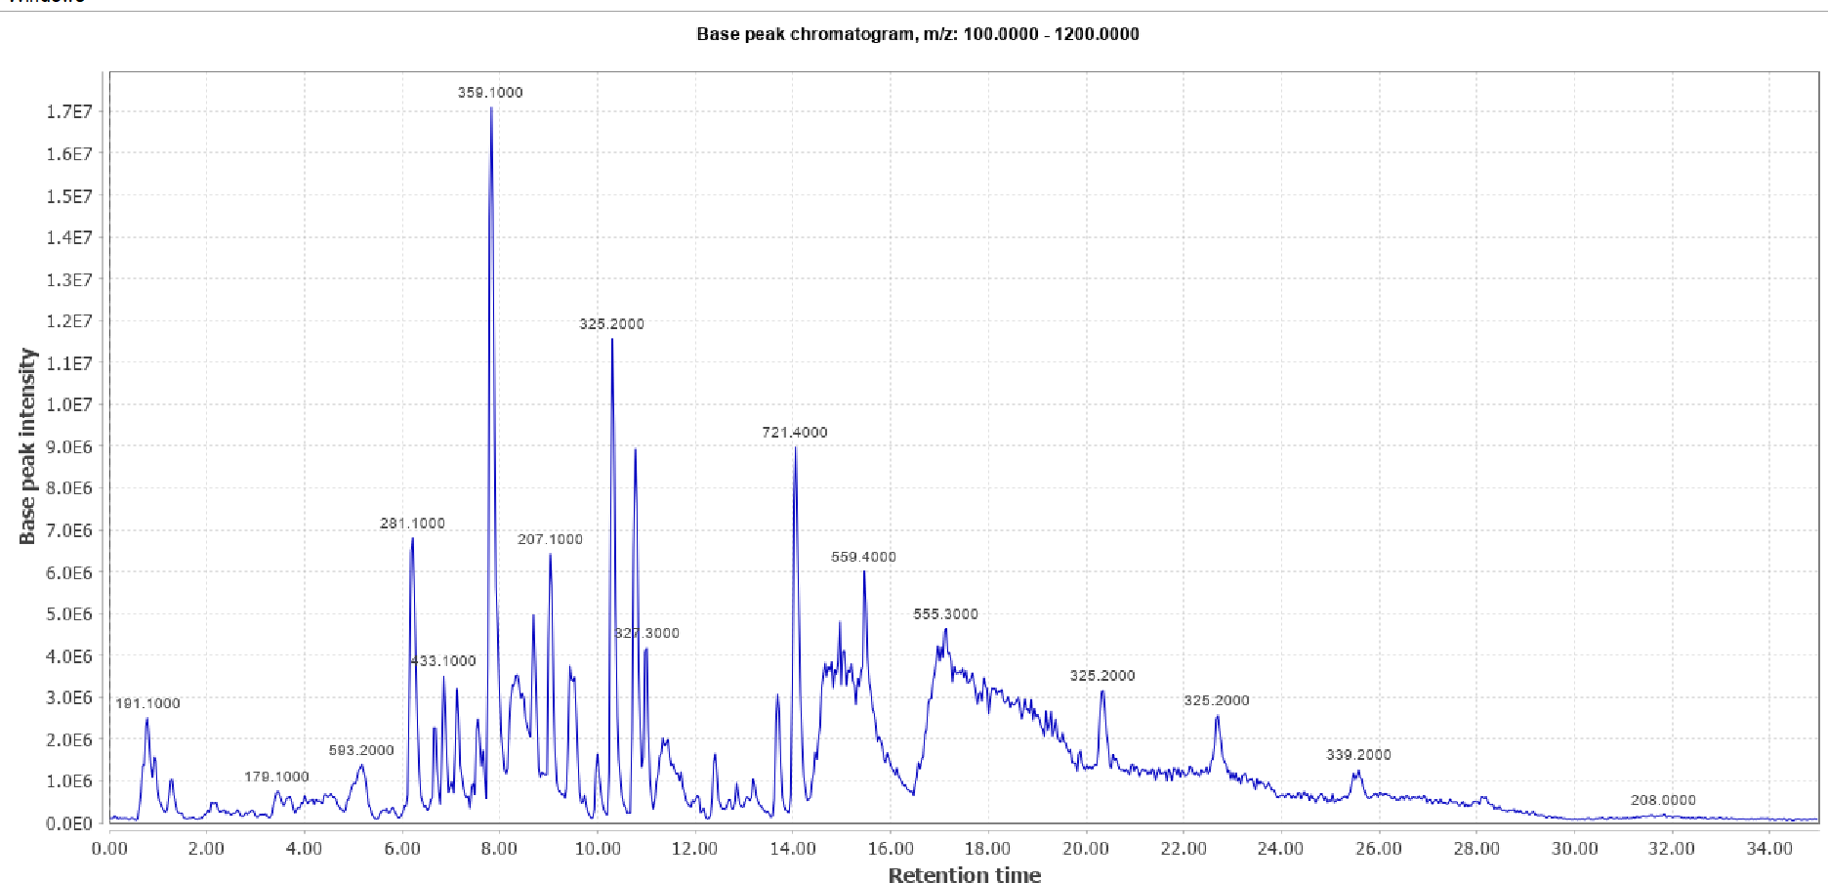
A
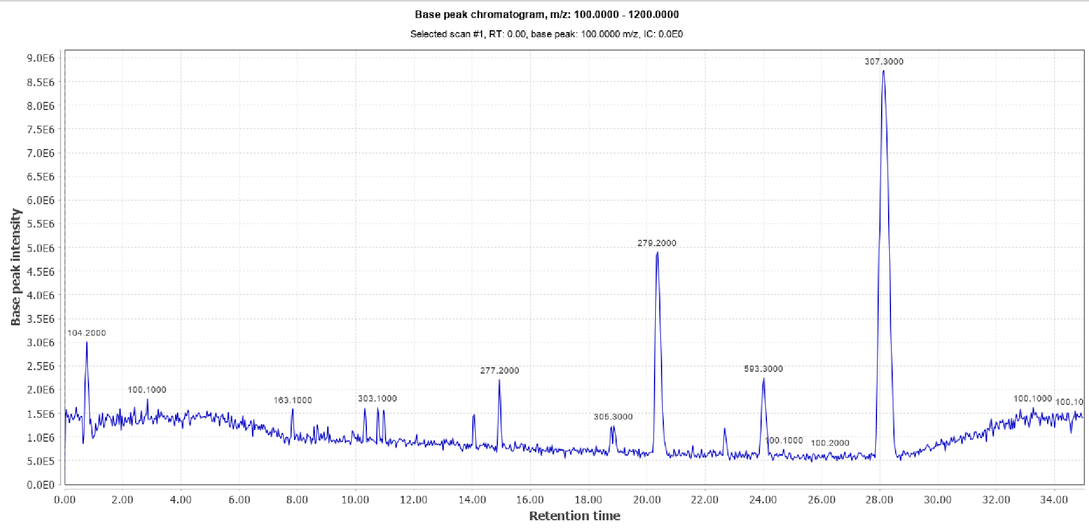
B
Figure S1. Base peak chromatogram of marjoram alcoholic extract on (A) negative ionization mode and (B) positive mode.

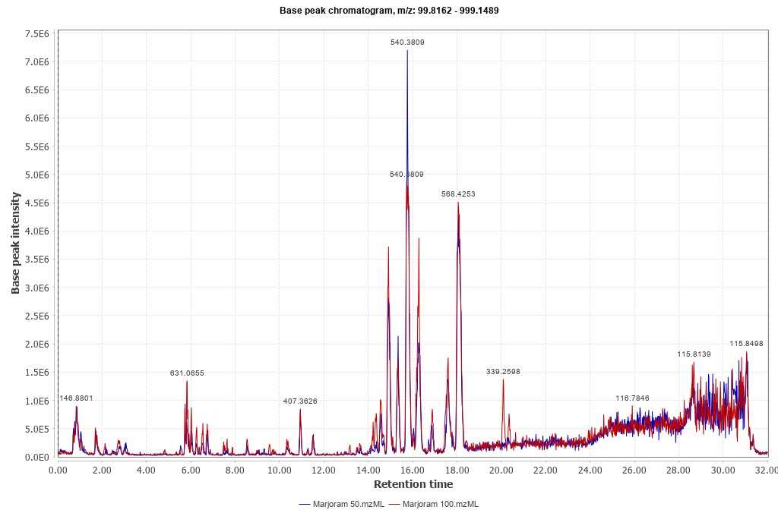
A
Mj100
Mj50

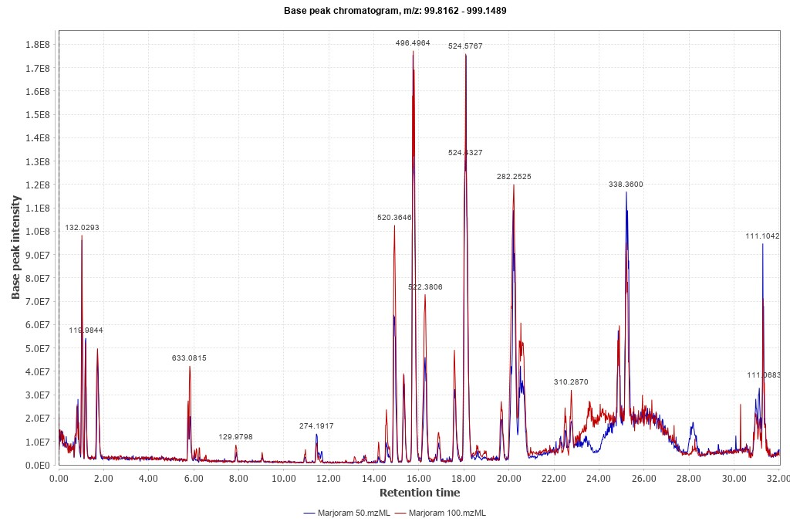Figure S2. Base peak chromatogram of dose-based marjoram-treated serum samples in A) negative mode and B) in positive mode.
B
Mj100
Mj50

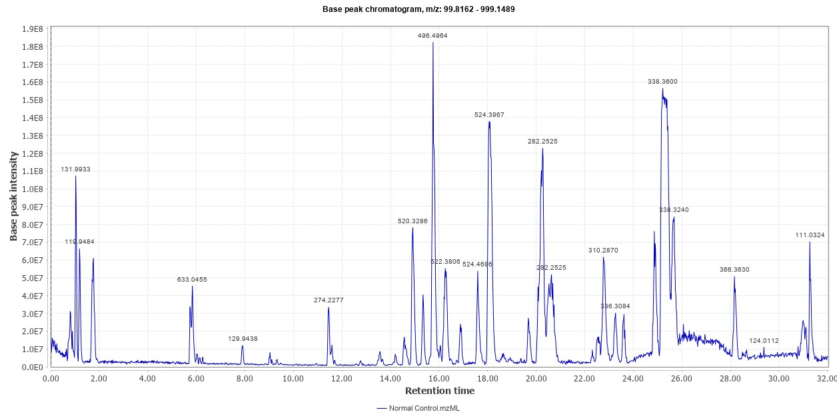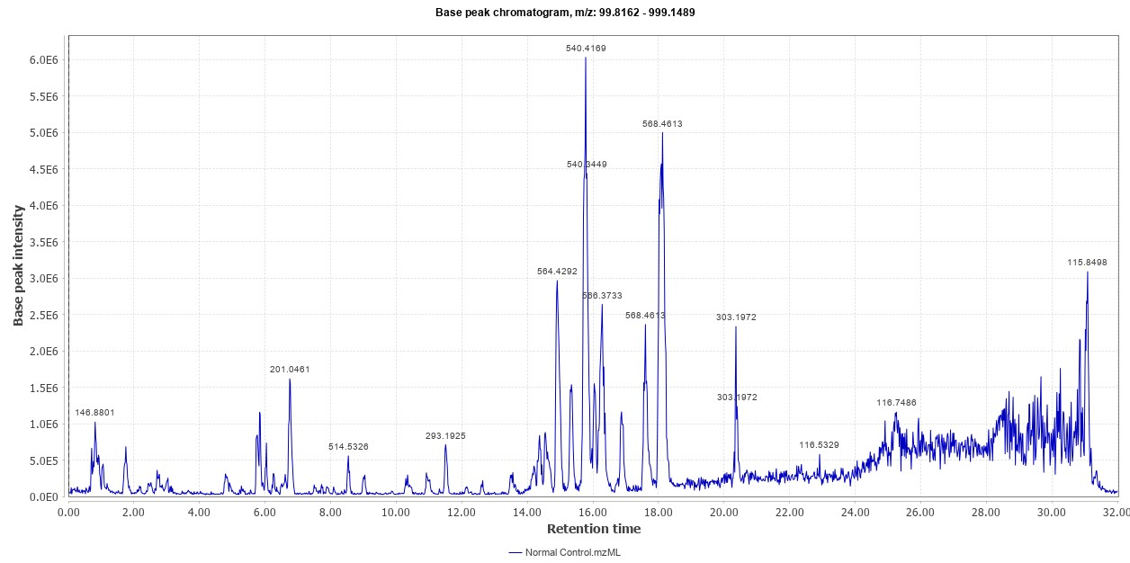
A
B
Figure S3. Base peak chromatogram of Control serum samples in A) positive mode and B) negative mode
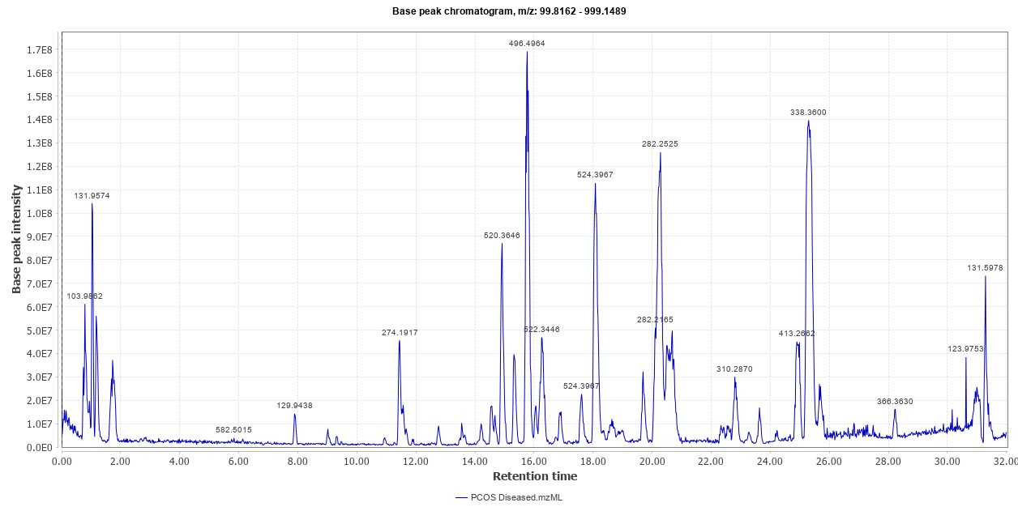
A
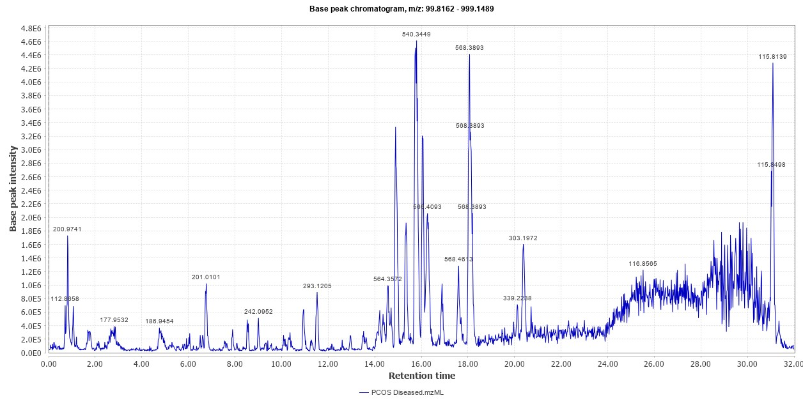 Figure S4. Base peak chromatogram of PCOS serum samples in A) positive mode and B) negative mode
B

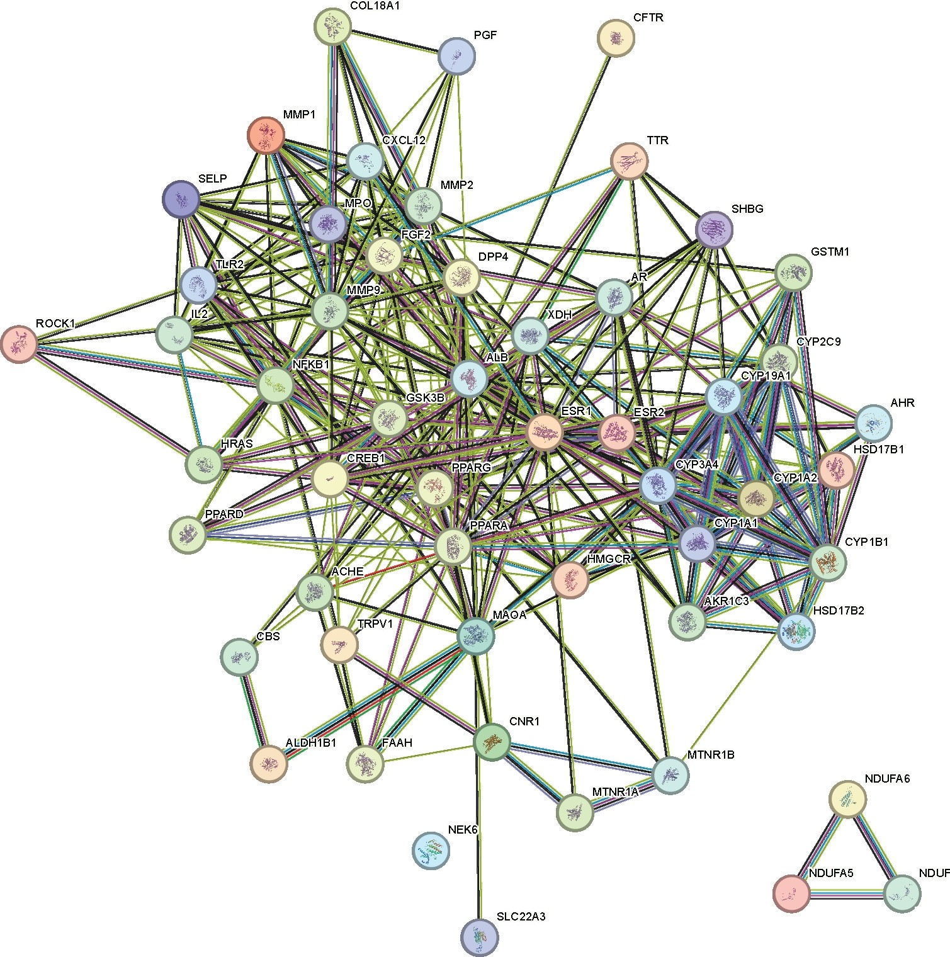

Figure S5. Protein-protein interaction diagram of associated with marjoram absorbed compounds.
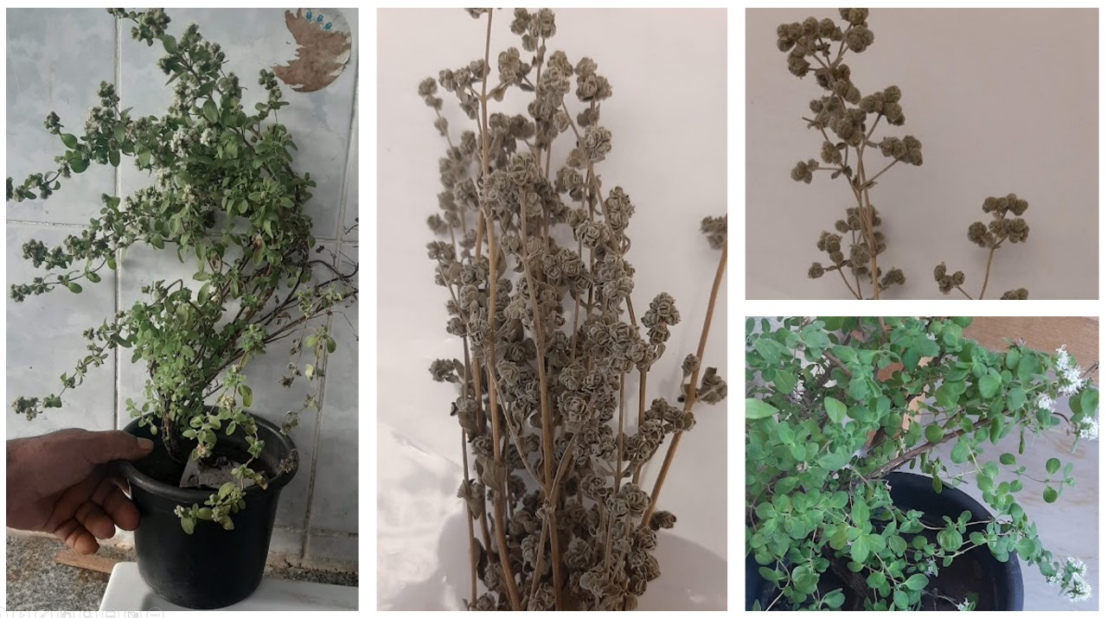
Figure S6: Origanum majorana L. collected plant specimen

 | Table S1. Characterization of marjoram extract constituents by UPLC ESI-MS/MS
No. |  | Retention time (min.) | Identified metabolites | Molecular Formula | Precursor  Ions | MS/MS  product ions | Reference
 |  | 0.75 | Malic acid | C₄H₆O₅ | [M-H]⁻  133.0827 | 115.00 | (Taamalli et al., 2015)
 |  | 0.79 | Citric acid | C₆H₈O₇ | [M-H]⁻  191.1 | 111.00 | (Taamalli et al., 2015)
 |  | 0.95 | Gluconic acid | C₆H₁₂O₇ | [M-H]⁻  195.1 | 129.01 | (Taamalli et al., 2015)
 |  | 1.42 | Fumaric acid | C₄H₄O₄ | [M-H]⁻  115.0627 | 115.00, 71.01 | (Taamalli et al., 2015)
 |  | 1.98 | Hydroquinone | C₆H₆O₂ | [M+H]⁺  111.1173 | 110, 11 | (Erenler et al., 2016)
 |  | 2.08 | Vanillic acid | C₈H₈O₄ | [M+H]⁺  169.1573 | 167, 152, 108 | (Taamalli et al., 2015)
 |  | 2.39 | Chlorogenic acid | C₁₆H₁₈O₉ | [M-H]⁻  353.1 | 173.47, 135.04, 191.05, 179.03 | (Taamalli et al., 2015)  (Vallverdú-Queralt et al., 2015)
 |  | 2.43 | Gentisic acid | C₇H₆O₄ | [M-H]⁻  153.1127 | 152.9, 108.88 | (Erenler et al., 2016)
 |  | 3.7 | Sacranoside A | C₂₀H₃₂O₁₀ | [M-H]⁻  431.2 | 153.09, 385.18, 223.13 | (Taamalli et al., 2015)
 |  | 3.97 | Caffeic acid glucoside | C₁₅H₁₈O₉ | [M-H]⁻  341.2927 | 179, 161, 135 | (Hossain et al., 2014)
 |  | 5.18 | Luteolin rutinoside | C₂₇H₃₀O₁₆ | [M-H]⁻  593.2 | 285.00 | (Taamalli et al., 2015)  (Hossain et al., 2014)
 |  | 5.68 | Caffeic acid | C₉H₈O₄ | [M-H]⁻  179.1527 | 135.00 | (Vallverdú-Queralt et al., 2015)
 |  | 5.81 | Ferulic acid | C₁₀H₁₀O₄ | [M-H]⁻  193.1727 | 193.00 , 178.00, 149.00, 134.00 | (Vallverdú-Queralt et al., 2015)
 |  | 6.08 | Thymohydroquinone | C₁₀H₁₄O₂ | [M-H]⁻  165.2127 | 151.00, 105.00, 39.00, 166.00, 95.00 | (Bouyahya & Jamal, 2016)
 |  | 6.25 | procumboside B | C₁₅H₂₂O₁₀ | [M-H]⁻  361.33 | 361.16 | (Wang et al., 2021)
 |  | 6.72 | Carvacrol 2-O-β-glucopyranosyl-(1-2)-β-glucopyranosid | C₂₂H₃₄O₁₁ | [M-H]⁻  473.3 | 473.30 | (Kamel et al., 2001)
 |  | 6.78 | Rutin | C₂₇H₃₀O₁₆ | [M-H]⁻  609.2 | 611.15 | (Taamalli et al., 2015)
 |  | 6.85 | Caffeoyl-arbutin | C₂₁H₂₂O₁₀ | [M-H]⁻  433.1 | 323.07, 161.02 | (Taamalli et al., 2015)
 |  | 6.95 | Kaempferol-O-sambubioside | C₂₆H₂₈O₁₅ | [M-H]⁻  579.2 | 285.04 | (Taamalli et al., 2015)
 |  | 7.15 | Luteolin glucuronide | C₂₁H₁₈O₁₂ | [M-H]⁻  461.1 | 285.00 | (Taamalli et al., 2015)
 |  | 7.25 | salvianolic acid C | C₂₆H₂₀O₁₀ | [M-H]⁻  537.4527 | 491.09, 311.05, 179.03 | (Lin et al., 2003)
 |  | 7.29 | diosmetin-7-glucuronide | C₂₂H₂₀O₁₂ | [M-H]⁻  475.3927 | 475.08, 299.05 | (Goel & Vasudeva, 2018)
 |  | 7.55 | 2-Isopropyl-5-methylphenol (Thymol) | C₁₀H₁₄O | [M-H]⁻  149.2127 | 149.09, 151.11, 97.05, 93.06, 81.06, 43.05 | (Raina & Negi, 2012)
 |  | 7.59 | Hesperidin | C₂₈H₃₄O₁₅ | [M-H]⁻  609.5927 | 301.07 | (Taamalli et al., 2015)
 |  | 7.65 | Apigenin-O-glucuronide | C₂₁H₁₈O₁₁ | [M-H]⁻  445.1 | 269.04, 175.02, 113.02 | (Taamalli et al., 2015)
 |  | 7.69 | Thymoquinone | C₁₀H₁₂O₂ | [M-H]⁻  163.1 | 163.05 | (Abdelaali et al., 2021)
 |  | 7.82 | Rosmarinic acid | C₁₈H₁₆O₈ | [M-H]⁻  359.1 | 179.00, 161.00, 135.00 | (Taamalli et al., 2015)  (Erenler et al., 2016)
 |  | 7.99 | Quercitrin | C₂₁H₂₀O₁₁ | [M-H]⁻  447.3927 | 445.07 | (Taamalli et al., 2015)  (Erenler et al., 2016)
 |  | 8.06 | Didymin | C₂₈H₃₄O₁₄ | [M-H]⁻  593.2 | 593.18, 285.07 | (Goel & Vasudeva, 2018)
 |  | 8.09 | Tilianin | C₂₂H₂₂O₁₀ | [M-H]⁻  445.3927 | 284.00 | (Goel & Vasudeva, 2018)
 |  | 8.69 | Gastrodin | C₁₃H₁₈O₇ | [M-H]⁻  285.1 | 123.04, 285.09, 105.03 | (H. Liu et al., 2012)
 |  | 9.53 | Kaempferol-3-O-glucoside (Astragaline) | C₂₁H₂₀O₁₁ | [M-H]⁻  447.3927 | 285.00 | (Vallverdú-Queralt et al., 2015)
 |  | 9.03 | Luteolin-7-O-glucoside (Cynaroside) | C₂₁H₁₉O₁₁ | [M-H]⁻  447.3927 | 285.00 | (Hossain et al., 2014)
 |  | 9.43 | (+)-lariciresinol | C₂₀H₂₄O₆ | [M-H]⁻  359.1 | 359.14 | (Wang et al., 2021)
 |  | 9.43 | Coumaric acid | C₉H₈O₃ | [M-H]⁻  163.1527 | 119.00 | (Vallverdú-Queralt et al., 2015)
 |  | 9.6 | Arbutin | C₁₂H₁₆O₇ | [M-H]⁻  271.05 | 253.00, 108.00 | (Taamalli et al., 2015)
 |  | 9.83 | Orientin | C₂₁H₂₀O₁₁ | [M-H]⁻  447.3927 | 357.05, 327.05 | (Taamalli et al., 2015)
 |  | 10.1 | Epigallocatechin | C₁₅H₁₄O₇ | [M-H]⁻  305.2627 | 289.00, 225.00 | (Hossain et al., 2014)
 |  | 10.3 | Quinic acid | C₇H₁₂O₆ | [M-H]⁻  191.1 | 127.03 | (Taamalli et al., 2015)
 |  | 10.47 | Origanine A | C₂₉H₃₀O₁₆ | [M-H]⁻  633.4927 | 589.15, 633.14 | (H. Liu et al., 2012)
 |  | 10.75 | Hesperetin | C₁₆H₁₄O₆ | [M+H]⁺  303.1 | 301.07, 287.05 | (Erenler et al., 2016)
 |  | 11 | Gallocatechin | C₁₅H₁₄O₇ | [M-H]⁻  305.2627 | 225.11 | (Taamalli et al., 2015)
 |  | 11.41 | Origanine B/C | C₃₈H₃₈O₂₀ | [M-H]⁻  813.6927 | 813.18, 571.14 | (Taamalli et al., 2015)
 |  | 11.64 | Lithospermic acid | C₂₇H₂₂O₁₂ | [M-H]⁻  537.2 | 159.00, 203.00, 223.00, 253.00, 267.00, 295.00, 313.00, 383.00, 537.00 | (G. V. Rao et al., 2011)
 |  | 12.4 | Carnosic acid | C₂₀H₂₈O₄ | [M+H]⁺  333.2 | 333.20, 315.19, 287.20 | (Bina & Rahimi, 2017)
 |  | 12.71 | Caftaric acid | C₁₃H₁₂O₉ | [M-H]⁻  311.2 | 149.00 | (Vallverdú-Queralt et al., 2015)
 |  | 13.7 | Quercetin arabinoside | C₂₀H₁₈O₁₁ | [M-H]⁻  433.2927 | 301.00 | (Hossain et al., 2014)
 |  | 14.07 | Carnosol | C₂₀H₂₆O₄ | [M+H]⁺  331.4073 | 331.19 | (Bina & Rahimi, 2017)
 |  | 14.92 | Narigenin-O-hexoside | C₂₁H₂₂O₁₀ | [M-H]⁻  433.3927 | 271.00 | (Vallverdú-Queralt et al., 2015)
 |  | 15.16 | Salvianolic acid I | C₂₇H₂₂O₁₂ | [M-H]⁻  537.4527 | 493.11, 339.05, 295.06, 197.04,135.04 | (Taamalli et al., 2015)
 |  | 15.49 | Globoidnan A | C₂₆H₂₀O₁₀ | [M-H]⁻  491.3927 | 311.05, 267.06, 197.85 | (Erenler et al., 2017)
 |  | 17.91 | Triacontanol | C₃₀H₆₂O | [M-H]⁻  437.7927 | 437.47 | (G. V. Rao et al., 2011)
 |  | 18.86 | Taxifolin | C₁₅H₁₂O₇ | [M+H]⁺  305.3 | 285.04, 125.02 | (Taamalli et al., 2015)
 |  | 20.35 | Quercetin | C₁₅H₁₀O₇ | [M-H]⁻  301.2227 | 285.00, 227.10, 151.10, 135.00 | (Hossain et al., 2014)
 |  | 20.55 | Kaempferol | C₁₅H₁₀O₆ | [M-H]⁻  285.2327 | 285.00, 151.00 | (Vallverdú-Queralt et al., 2015)
 |  | 20.79 | Naringenin | C₁₅H₁₂O₅ | [M-H]⁻  271.2 | 271.00, 151.00 | (Vallverdú-Queralt et al., 2015)
 |  | 20.88 | Ursolic acid | C₃₀H₄₈O₃ | [M-H]⁻  455.6927 | 456.35 | (G. V. Rao et al., 2011)
 |  | 21.16 | Morin | C₁₅H₁₀O₇ | [M-H]⁻  301.2227 | 300.02, 299.09, 317.03 | (Erenler et al., 2016)
 |  | 21.35 | oleanolic acid | C₃₀H₄₈O₃ | [M-H]⁻  455.4 | 455.34, 54.00 | (G. V. Rao et al., 2011)
 |  | 21.57 | Apigenin | C₁₅H₁₀O₅ | [M+H]⁺  271.3 | 271.24, 151.00, 225.05, 119.04 | (Hossain et al., 2014)
 |  | 21.69 | Luteolin | C₁₅H₁₀O₆ | [M-H]⁻  285.1 | 151.00, 133.03 | (Taamalli et al., 2015)
 |  | 21.75 | Linolenic | C₁₈H₃₀O₂ | [M-H]⁻  277.3927 | 279.00, 54.00 | (Goel & Vasudeva, 2018)
 |  | 21.78 | Dihydroquercetin | C₁₅H₁₂O₇ | [M+H]⁺  305.2573 | 301.00, 285.00, 241.00, 227.00, 151.00, 135.00 | (Hossain et al., 2014)
 |  | 22.39 | Amentoflavone | C₃₀H₁₈O₁₀ | [M-H]⁻  537.4927 | 537.08 | (Goel & Vasudeva, 2018)
 |  | 22.46 | Isorhamnetin (O-Methyl-quercetin) | C₁₆H₁₂O₇ | [M-H]⁻  315.2527 | 300.02 | (Taamalli et al., 2015)
 |  | 22.68 | Linoleic acid | C₁₈H₃₂O₂ | [M+H]⁺  281.2 | 280.00, 281.00, 202.00, 203.00, 124.00, 54.00 | (Goel & Vasudeva, 2018)
 |  | 22.73 | Hydroperoxy octadecadienoic acid | C₁₈H₃₂O₄ | [M-H]⁻  311.2 | 223.17, 54.00 | (Taamalli et al., 2015)
 |  | 23.72 | Sebacic acid | C₁₀H₁₈O₄ | [M+H]⁺  203.3 | 201.04, 183.10, 113.09 | (Taamalli et al., 2015)
 |  | 25.51 | 3-O-methyl-catechin (meciadanol) | C₁₆H₁₆O₆ | [M-H]⁻  303.2827 | 96.95 | (Taamalli et al., 2015)
 |  | 26.03 | Oleic acid | C₁₈H₃₄O₂ | [M+H]⁺  283.3 | 283.00, 263.00, 237.00, 54.00 | (Goel & Vasudeva, 2018)

Table S2. Potential protein targets of marjoram:
Short name of protein | Full name of protein | Uniport ID | Interacting compound (s) (combined interaction score)
SHBG | Sex Hormone Binding Globulin | P04278 | lariciresinol sulphate (0.53), 2-(4-hydroxy-3-methoxyphenyl)-4H-chromene-3,4,5,7-tetraol (0.33)
PPARG | Peroxisome Proliferator Activated Receptor Gamma | P37231 | Glycine linoleamide (0.73), Oleoylglycine (0.7) , 16-hydroxyoctadec-9-enoic acid (0.62) , oleic (1)
CYP19A1 | Cytochrome P450 Family 19 Subfamily A Member 1 | P11511 | Apigenin (1)
AR | Androgen Receptor | P10275 | Apigenin (1)
VEGFA | Vascular Endothelial Growth Factor A | P15692 | Sebacic acid glucuronide (0.3), Gastrodin (0.43) , catechin (0.56) , Apigenin (0.69)
ESR1 | Estrogen Receptor 1 | P03372 | Dihydroisorhamnetin (0.42), Apigenin (1)
CYP1A1 | Cytochrome P450 Family 1 Subfamily A Member 1 | P04798 | Apigenin (0.48)
ESR2 | Estrogen Receptor 2 | Q92731 | Dihydroisorhamnetin (0.42), Apigenin (1)
AKR1C3 | Aldo-Keto Reductase Family 1 Member C3 | P42330 | Caffeic acid 4-O-sulphate (0.41), Caftaric acid (0.52)
GSK3B | Glycogen Synthase Kinase 3 Beta | P49841 | Apigenin (1)
PPARD | Peroxisome Proliferator Activated Receptor Delta | Q03181 | Oleic (1)
MTNR1B | Melatonin Receptor 1B | P49286 | Vanilloylglycine (0.45)
CYP2C9 | Cytochrome P450 Family 2 Subfamily C Member 9 | P11712 | Vanilloylglycine (0.41)
MMP9 | Matrix Metallopeptidase 9 | P14780 | Caffeic cid L-carnitine (0.49), Caffeic acid 4-O-sulphate (0.6), Caftaric acid (0.58)
HSD17B2 | Hydroxysteroid 17-Beta Dehydrogenase 2 | P37059 | Vanilloylglycine (0.54), Apigenin (0.48)
MMP2 | Matrix Metallopeptidase 2 | P08253 | Caffeic acid 4-O-sulphate (0.6), Caftaric acid (0.58)
HMGCR | 3-Hydroxy-3-Methylglutaryl-CoA Reductase | P04035 | Glycine linoleamide (0.45), Oleoylglycine (0.49), Sebacic acid (0.52) , 16-hydroxyoctadec-9-enoic acid (0.44) , oleic (0.65)
PPARA | Peroxisome Proliferator Activated Receptor Alpha | Q07869 | Glycine linoleamide (0.73), oleic (1)
MTNR1A | Melatonin Receptor 1A | P48039 | Vanilloylglycine (0.45)
HSD17B1 | Hydroxysteroid 17-Beta Dehydrogenase 1 | P14061 | Apigenin (1)
GSTM1 | Glutathione S-Transferase Mu 1 | P09488 | Oleoylglycine (0.4)
DPP4 | Dipeptidyl Peptidase 4 | P27487 | Apigenin (1)
CNR1 | Cannabinoid Receptor 1 | P21554 | Linolenic acid L-carnitine (0.49), Glycine linoleamide (0.7) , Oleoylglycine (0.62) , 16-hydroxyoctadec-9-enoic acid (0.44), oleic (0.7)
MMP1 | Matrix Metallopeptidase 1 | P03956 | Caffeic cid L-carnitine (0.49) , Caffeic acid 4-O-sulphate (0.6), Caftaric acid (0.6)
FAAH | Fatty Acid Amide Hydrolase | O00519 | Linolenic acid L-carnitine (0.49), Glycine linoleamide (0.91) , Oleoylglycine (0.81) , 16-hydroxyoctadec-9-enoic acid (0.44), oleic (0.63)
XDH | Xanthine Dehydrogenase | P47989 | Quercitrin-4'-glucuronide (0.46), Apigenin (1)
TLR2 | Toll Like Receptor 2 | O60603 | Linolenic acid L-carnitine (0.45) , Glycine linoleamide (0.45) , Oleoylglycine (0.5) , Sebacic acid (0.71) , 16-hydroxyoctadec-9-enoic acid (0.44) , oleic (0.74)
IL2 | Interleukin 2 | P60568 | Origanine L-glycine (0.44) , Gastrodin (0.46) , Origanine B/C (0.42) , Apigenin (0.44)
CYP1B1 | Cytochrome P450 Family 1 Subfamily B Member 1 | Q16678 | Caffeic acid 4-O-sulphate (0.4), Quercitrin-4'-glucuronide (0.5), catechin (0.41) , 2-(4-hydroxy-3-methoxyphenyl)-4H-chromene-3,4,5,7-tetraol (0.41) , Dihydroisorhamnetin (0.62), Apigenin (1)
MPO | Myeloperoxidase | P05164 | Vanilloylglycine (0.4), Apigenin (1)
TTR | Transthyretin | P02766 | Vanilloylglycine (0.4), Caffeic cid L-carnitine (0.49), Caffeic acid 4-O-sulphate (0.41), Caftaric acid (0.6), Apigenin (1)
TRPV1 | Transient Receptor Potential Cation Channel Subfamily V Member 1 | Q8NER1 | Vanilloylglycine (0.45), Glycine linoleamide (0.63), Oleoylglycine (0.55)
AHR | Aryl Hydrocarbon Receptor | P35869 | Apigenin (0.47)
FGF2 | Fibroblast Growth Factor 2 | P09038 | Malic acid glucuronide (0.41), Thymol-3-glucouronide (0.38), Sebacic acid glucuronide (0.41), Gastrodin (0.43)
SELP | Selectin P | P16109 | Sebacic acid glucuronide (0.3), Glycine linoleamide (0.4), Oleoylglycine (0.43)
NDUFA6 | NADH:Ubiquinone Oxidoreductase Subunit A6 | P56556 | lariciresinol sulphate (0.7), 7-hydroxyLariciresinol (Tanegool) (0.49)
NDUFS4 | NADH:Ubiquinone Oxidoreductase Subunit S4 | O43181 | lariciresinol sulphate (0.7) , 7-hydroxyLariciresinol (Tanegool) (0.49)
SLC22A3 | Solute Carrier Family 22 Member 3 | O75751 | 7-hydroxyLariciresinol (Tanegool) (0.4)
GABRB1 | Gamma-Aminobutyric Acid Type A Receptor Subunit Beta1 | P18505 | Thymohydroquinone (0.39)
NDUFA5 | NADH:Ubiquinone Oxidoreductase Subunit A5 | Q16718 | lariciresinol sulphate (0.7), 7-hydroxyLariciresinol (Tanegool) (0.49)
NEK6 | NIMA Related Kinase 6 | Q9HC98 | Apigenin (0.48)
CYP3A4 | Cytochrome P450 Family 3 Subfamily A Member 4 | P08684 | Vanilloylglycine (0.41), Apigenin (1)
CXCL12 | C-X-C Motif Chemokine Ligand 12 | P48061 | Vanilloylglycine (0.44), Caftaric acid (0.46) , 2-(4-hydroxy-3-methoxyphenyl)-4H-chromene-3,4,5,7-tetraol (0.31)
CBS | Cystathionine Beta-Synthase | P35520 | Quercitrin-4'-glucuronide (0.53) , Dihydroisorhamnetin (0.57), Apigenin (0.55)
ALB | Albumin | P02768 | Thymol-3-glucouronide (0.31)
NFKB1 | Nuclear Factor Kappa B Subunit 1 | P19838 | Vanilloylglycine (0.49), Caffeic acid 4-O-sulphate (0.4)
GABBR2 | Gamma-Aminobutyric Acid Type B Receptor Subunit 2 | O75899 | Sebacic acid (0.59)
MAOA | Monoamine Oxidase A | P21397 | Apigenin (1)
ROCK1 | Rho Associated Coiled-Coil Containing Protein Kinase 1 | Q13464 | Vanilloylglycine (0.43)
CYP1A2 | Cytochrome P450 Family 1 Subfamily A Member 2 | P05177 | Vanilloylglycine (0.4), Apigenin (1)
ALDH1B1 | Aldehyde Dehydrogenase 1 Family Member B1 | P30837 | Origanine L-glycine (0.36), Gastrodin (0.46), Origanine B/C (0.35)
HRAS | HRas Proto-Oncogene, GTPase | P01112 | Origanine L-glycine (0.35), Origanine B/C (0.35)
CFTR | CF Transmembrane Conductance Regulator | P13569 | Apigenin (1)
CREB1 | CAMP Responsive Element Binding Protein 1 | P16220 | Apigenin (0.47)
ACHE | Acetylcholinesterase (Yt Blood Group) | P22303 | Dihydroisorhamnetin (0.48), Apigenin (0.45)
PGF | Placental Growth Factor | P49763 | Apigenin (0.69)

Table S3. Marjoram main active component network node topological parameters
Compound name | Betweenness Centrality | Closeness Centrality | Degree
Apigenin | 0.54674428 | 0.35159817 | 25
Vanilloylglycine | 0.37809931 | 0.31950207 | 12
Glycine linoleamide | 0.09687317 | 0.24758842 | 8
Oleic | 0.08849875 | 0.23404255 | 8
Oleoylglycine | 0.107482 | 0.24758842 | 8
Caffeic acid 4-O-sulphate | 0.07922142 | 0.28 | 8
Caftaric acid | 0.03608799 | 0.27017544 | 6
7-hydroxyLariciresinol | 0.02648667 | 0.14076782 | 4
16-hydroxyoctadec-9-enoic acid | 9.63E-04 | 0.17460317 | 4
Dihydroisorhamnetin | 0.00590907 | 0.23404255 | 4
Gastrodin | 0.0743655 | 0.24919094 | 4
lariciresinol sulphate | 0.12354751 | 0.19012346 | 4
Caffeic cid L-carnitine | 0.00761007 | 0.25081433 | 3
Origanine L-glycine | 0.01698102 | 0.22063037 | 3
2-(4-hydroxy-3-methoxyphenyl)-4H-chromene-3,4,5,7-tetraol | 0.17242967 | 0.28 | 3
Quercitrin-4'-glucuronide | 0.00377324 | 0.2326284 | 3
Sebacic acid glucuronide | 0.09952789 | 0.27017544 | 3
Sebacic acid | 0.02608035 | 0.1738149 | 3
Origanine B/C | 0.01698102 | 0.22063037 | 3
Linolenic acid L-carnitine | 1.44E-04 | 0.17303371 | 2
catechin | 0.01461381 | 0.26460481 | 2
Thymol-3-glucouronide | 0.02597403 | 0.18465228 | 2
Thymohydroquinone | 0 | 1 | 1
isovaleryl glucuronide | 0 | 0.18377088 | 1

Table S4. Marjoram main active ingredient target network node topological parameters
Gene name | Betweenness Centrality | Closeness Centrality | Degree | Gene name | Betweenness Centrality | Closeness Centrality | Degree
CYP1B1 | 0.15583391 | 0.2972973 | 6 | CYP1A2 | 0.03642594 | 0.30923695 | 2
TLR2 | 0.0455676 | 0.20754717 | 6 | SHBG | 0.14559125 | 0.22713864 | 2
TTR | 0.12641181 | 0.32765957 | 5 | MPO | 0.03642594 | 0.30923695 | 2
HMGCR | 0.03231478 | 0.20643432 | 5 | PPARA | 5.45E-04 | 0.20104439 | 2
FAAH | 0.01985939 | 0.20533333 | 5 | MMP2 | 4.13E-04 | 0.22190202 | 2
IL2 | 0.1080097 | 0.27797834 | 4 | GABRB1 | 0 | 1 | 1
FGF2 | 0.08592254 | 0.2244898 | 4 | ACHE | 0 | 0.26101695 | 1
TRPV1 | 0.25828585 | 0.28 | 4 | HSD17B1 | 0 | 0.26101695 | 1
PPARG | 0.00740401 | 0.20424403 | 4 | PGF | 0 | 0.26101695 | 1
VEGFA | 0.12154274 | 0.30677291 | 4 | CREB1 | 0 | 0.26101695 | 1
ALDH1B1 | 0.00632376 | 0.20316623 | 3 | CYP1A1 | 0 | 0.26101695 | 1
CNR1 | 0.00142315 | 0.20316623 | 3 | ROCK1 | 0 | 0.24290221 | 1
MMP9 | 0.00208794 | 0.22318841 | 3 | GSK3B | 0 | 0.26101695 | 1
SELP | 0.06768612 | 0.24444444 | 3 | CYP19A1 | 0 | 0.26101695 | 1
MMP1 | 0.00208794 | 0.22318841 | 3 | ALB | 0 | 0.15618661 | 1
ESR1 | 0.02007579 | 0.27402135 | 3 | CYP2C9 | 0 | 0.24290221 | 1
CXCL12 | 0.08982345 | 0.27208481 | 3 | CFTR | 0 | 0.26101695 | 1
CBS | 0.01011389 | 0.26460481 | 3 | MTNR1B | 0 | 0.24290221 | 1
ESR2 | 0.00414035 | 0.26279863 | 2 | AHR | 0 | 0.26101695 | 1
NDUFA5 | 0.01663249 | 0.16142558 | 2 | PPARD | 0 | 0.19012346 | 1
HSD17B2 | 0.03642594 | 0.30923695 | 2 | MAOA | 0 | 0.26101695 | 1
HRAS | 1.14E-04 | 0.1820331 | 2 | SLC22A3 | 0 | 0.12359551 | 1
NFKB1 | 0.01412789 | 0.25925926 | 2 | GSTM1 | 0 | 0.19896641 | 1
NDUFA6 | 0.01663249 | 0.16142558 | 2 | NEK6 | 0 | 0.26101695 | 1
AKR1C3 | 4.13E-04 | 0.22190202 | 2 | MTNR1A | 0 | 0.24290221 | 1
NDUFS4 | 0.01663249 | 0.16142558 | 2 | GABBR2 | 0 | 0.14836224 | 1
XDH | 0.00562038 | 0.26279863 | 2 | DPP4 | 0 | 0.26101695 | 1
CYP3A4 | 0.03642594 | 0.30923695 | 2 | AR | 0 | 0.26101695 | 1

Table S5. KEGG pathway analysis of potential target gene functions:
#term ID | term description | observed gene count | false discovery rate (p value) | matching proteins in your network (labels)
hsa00140 | Steroid hormone biosynthesis | 8 | 2.70E-09 | HSD17B2, HSD17B1, CYP1A2, AKR1C3, CYP1A1, CYP19A1, CYP1B1, CYP3A4
hsa04915 | Estrogen signaling pathway | 7 | 7.85E-06 | MMP2, GABBR2, ESR2, MMP9, CREB1, ESR1, HRAS
hsa04913 | Ovarian steroidogenesis | 6 | 1.28E-06 | HSD17B2, HSD17B1, AKR1C3, CYP1A1, CYP19A1, CYP1B1
hsa04723 | Retrograde endocannabinoid signaling | 6 | 9.14E-05 | FAAH, GABRB1, NDUFS4, CNR1, NDUFA5, NDUFA6
hsa04024 | cAMP signaling pathway | 6 | 0.00051 | CFTR,NFKB1,GABBR2,ROCK1,PPARA,CREB1
hsa00380 | Tryptophan metabolism | 5 | 9.18E-06 | MAOA, CYP1A2, ALDH1B1, CYP1A1, CYP1B1
hsa04917 | Prolactin signaling pathway | 5 | 5.49E-05 | NFKB1, GSK3B, ESR2, ESR1, HRAS
hsa01522 | Endocrine resistance | 5 | 0.00016 | MMP2, ESR2, MMP9, ESR1, HRAS
hsa05224 | Breast cancer | 5 | 0.00095 | FGF2, GSK3B, ESR2, ESR1, HRAS
hsa04062 | Chemokine signaling pathway | 5 | 0.0021 | NFKB1, GSK3B, CXCL12, ROCK1, HRAS
hsa03320 | PPAR signaling pathway | 4 | 0.00096 | PPARG, PPARD, MMP1, PPARA
hsa04211 | Longevity regulating pathway | 4 | 0.0014 | NFKB1, PPARG, CREB1, HRAS
hsa04657 | IL-17 signaling pathway | 4 | 0.0016 | NFKB1, MMP1, GSK3B, MMP9
hsa04660 | T cell receptor signaling pathway | 4 | 0.0021 | NFKB1, IL2, GSK3B, HRAS
hsa04931 | Insulin resistance | 4 | 0.0025 | NFKB1, GSK3B, PPARA, CREB1
hsa04152 | AMPK signaling pathway | 4 | 0.0035 | CFTR, PPARG, HMGCR, CREB1
hsa04015 | Rap1 signaling pathway | 4 | 0.0147 | FGF2, CNR1, HRAS, PGF
hsa04014 | Ras signaling pathway | 4 | 0.0191 | NFKB1, FGF2, HRAS, PGF
hsa04010 | MAPK signaling pathway | 4 | 0.0347 | NFKB1, FGF2, HRAS, PGF
hsa00591 | Linoleic acid metabolism | 3 | 0.0012 | CYP2C9, CYP1A2, CYP3A4
hsa04929 | GnRH secretion | 3 | 0.0062 | GABBR2, ESR2, HRAS
hsa04662 | B cell receptor signaling pathway | 3 | 0.01 | NFKB1, GSK3B, HRAS
hsa04933 | AGE-RAGE signaling pathway in diabetic complications | 3 | 0.0147 | MMP2, NFKB1, HRAS
hsa04625 | C-type lectin receptor signaling pathway | 3 | 0.0156 | NFKB1, IL2, HRAS
hsa04668 | TNF signaling pathway | 3 | 0.0194 | NFKB1, MMP9, CREB1
hsa04722 | Neurotrophin signaling pathway | 3 | 0.0196 | NFKB1, GSK3B, HRAS
hsa04071 | Sphingolipid signaling pathway | 3 | 0.0213 | NFKB1, ROCK1, HRAS
hsa00190 | Oxidative phosphorylation | 3 | 0.0251 | NDUFS4, NDUFA5, NDUFA6
hsa04550 | Signaling pathways regulating pluripotency of stem cells | 3 | 0.0317 | FGF2, GSK3B, HRAS
hsa00340 | Histidine metabolism | 2 | 0.0113 | MAOA, ALDH1B1
hsa00260 | Glycine, serine and threonine metabolism | 2 | 0.0241 | MAOA, CBS
hsa00330 | Arginine and proline metabolism | 2 | 0.0333 | MAOA, ALDH1B1
hsa05213 | Endometrial cancer | 2 | 0.0449 | GSK3B, HRAS
hsa00590 | Arachidonic acid metabolism | 2 | 0.0473 | CYP2C9, AKR1C3

