Are alterations needed in Silybum marianum (Silymarin) administration practices? A novel outlook and meta-analysis on randomized trials targeting liver injury
Kasra Shahsavari¹, Shireen Shams Ardekani², Mohammad Reza Shams Ardekani³, Majid Mokaber Esfahani⁴, Hossein Kazemizadeh⁵, Tannaz Jamialahmadi^{6,7}, Mehrdad Iranshahi⁶, Mahnaz Khanavi^{3*}, Maede Hasanpour^{3,6}∗
¹School of Medicine, Tehran University of Medical Sciences, Tehran, Iran
²Department of Pathology, University of Chicago, Chicago, IL60637, USA
³Department of Pharmacognosy, Faculty of Pharmacy, and Persian Medicine and Pharmacy Research Center, Tehran University of Medical Sciences, Tehran, Iran.
⁴Department of Chemistry, Faculty of Science, Gonbad Kavous University, Iran
⁵Thoracic Research Center, Imam Khomeini Hospital Complex, Tehran University of Medical Sciences, Tehran, Iran.
⁶Biotechnology Research Center, Pharmaceutical Technology Institute, Mashhad University of Medical Sciences, Mashhad, Iran
⁷Department of Nutrition, Faculty of Medicine, Mashhad University of Medical Sciences, Mashhad, Iran
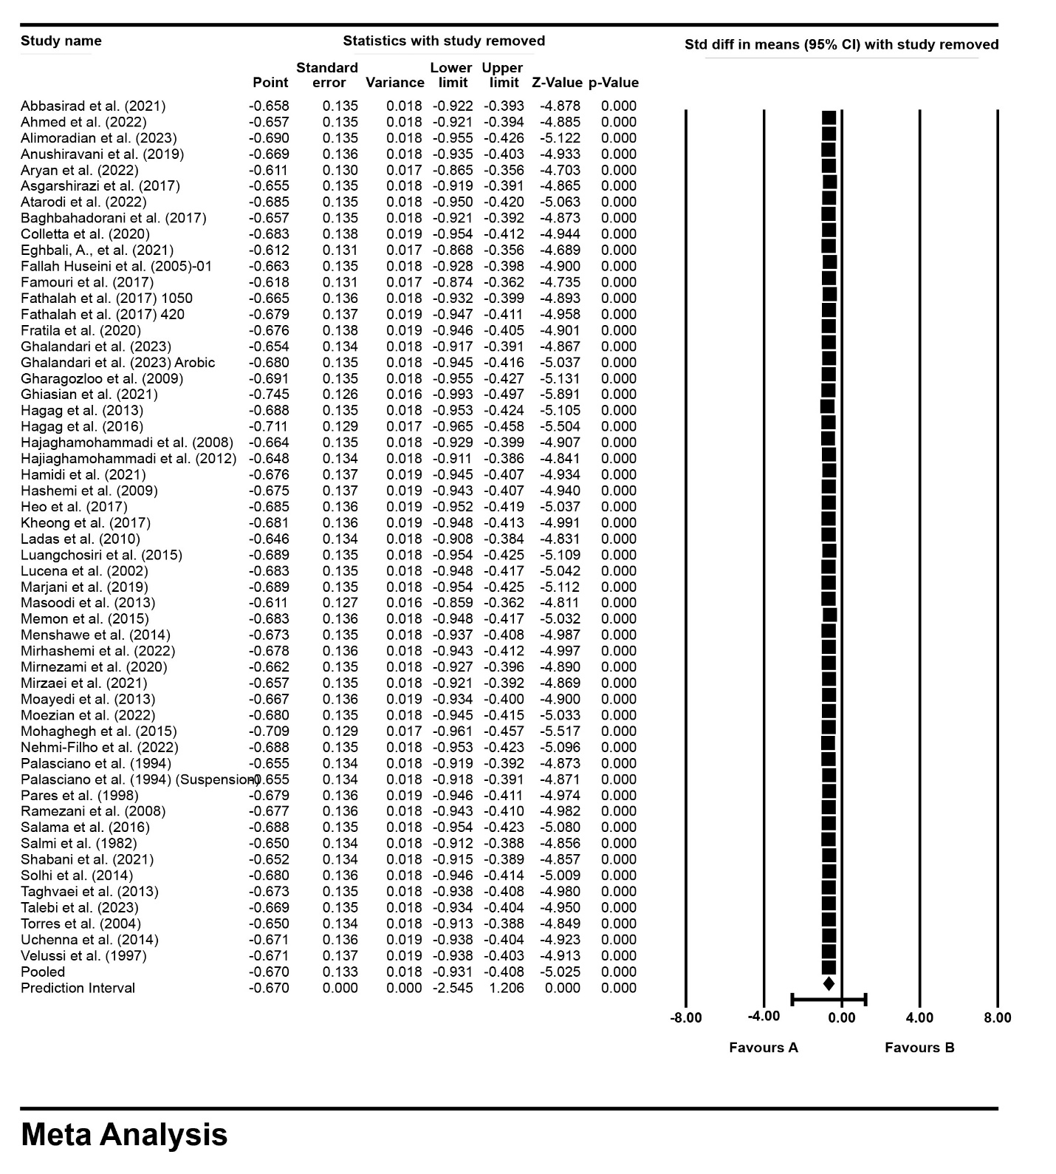
Figure S1. Sensitivity analysis by one-study remove method for the effect of silymarin treatment on serum AST level.
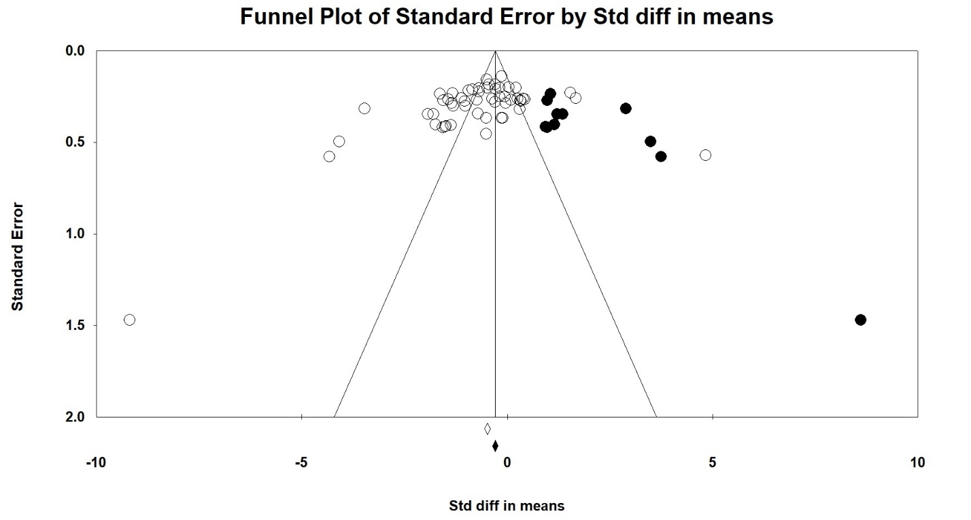
Figure S2. Publication bias funnel plots of studies that reported the effect of silymarin treatment on AST level.

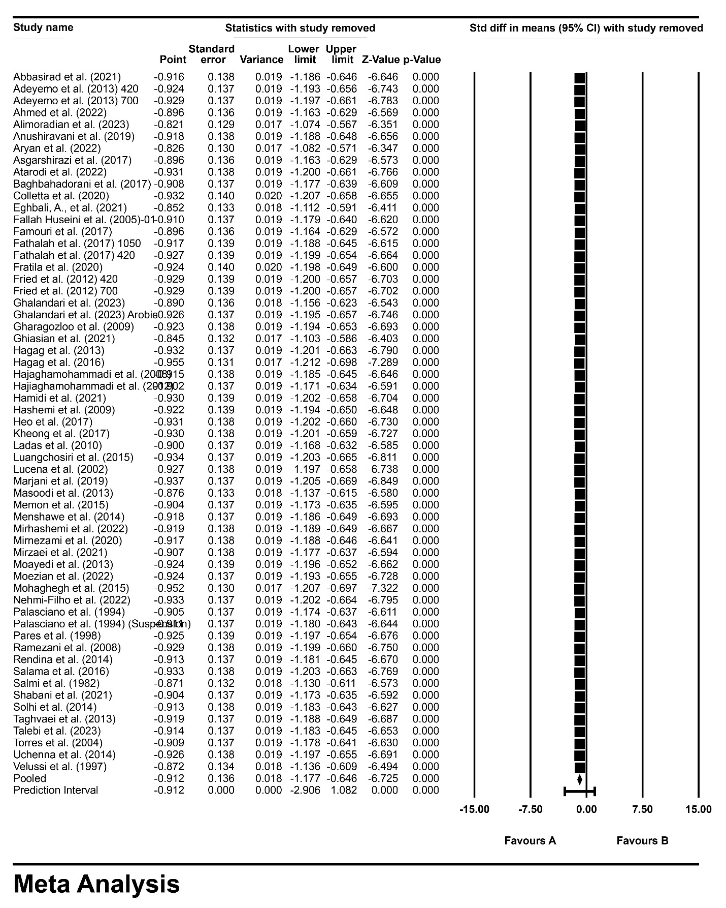
Figure S3. Sensitivity analysis by one-study remove method for the effect of silymarin treatment on serum ALT level.
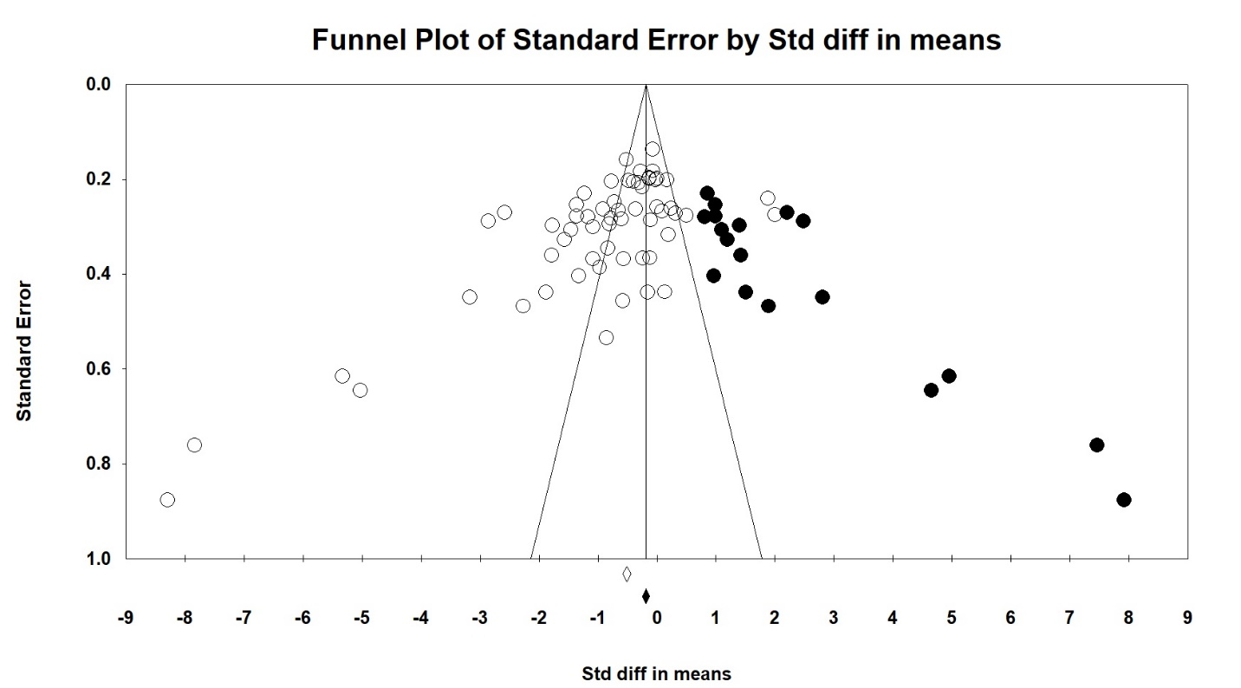
Figure S4. Publication bias funnel plots of studies that reported the effect of silymarin treatment on ALT level.

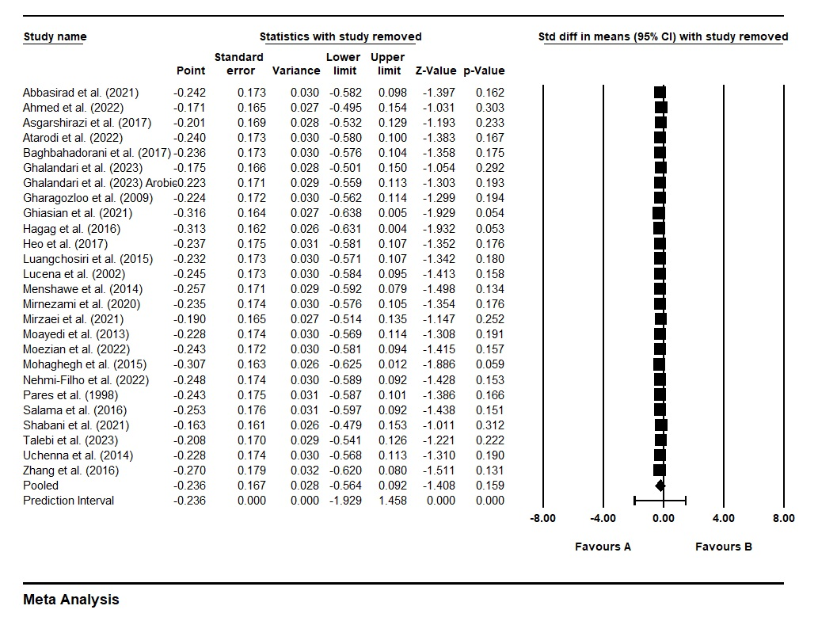
Figure S5. Sensitivity analysis by one-study remove method for the effect of silymarin treatment on serum ALP level.

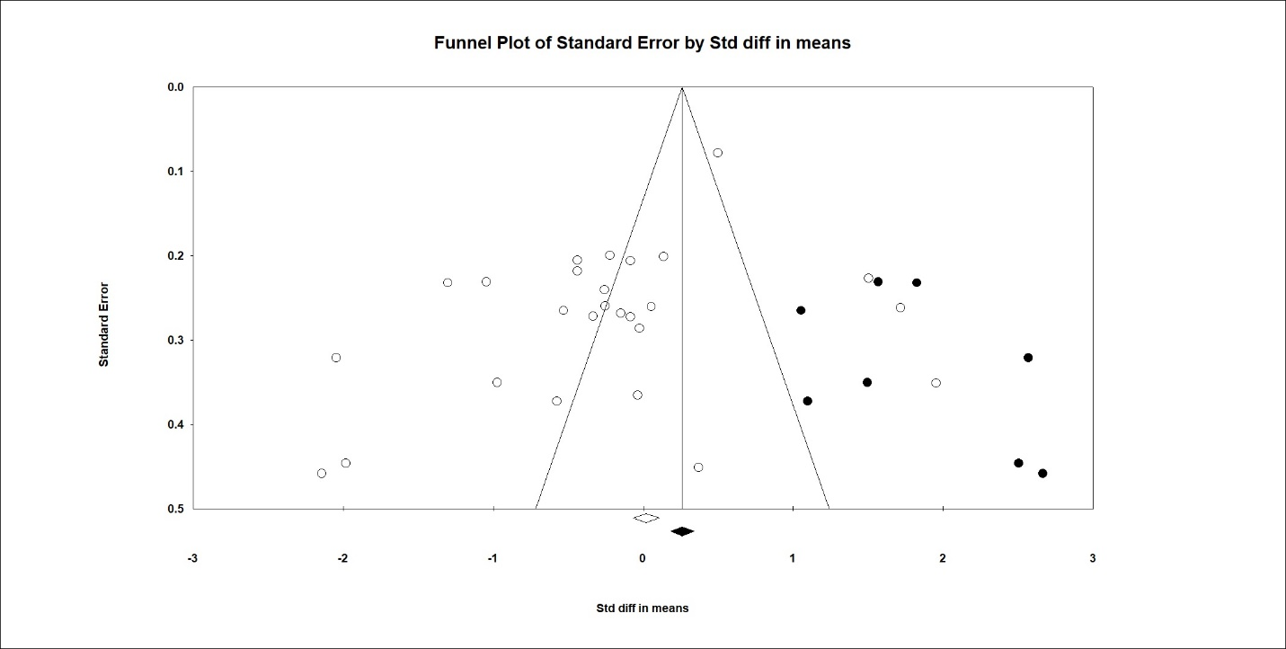
Figure S6. Publication bias funnel plots of studies that reported the effect of silymarin treatment on ALP level.

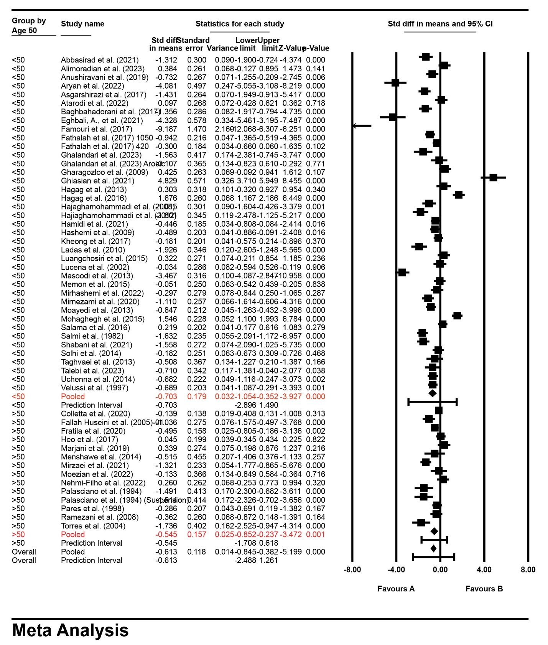
Figure S7. AST levels in the subgroup analysis stratified by patient age ≥50 or <50 years old

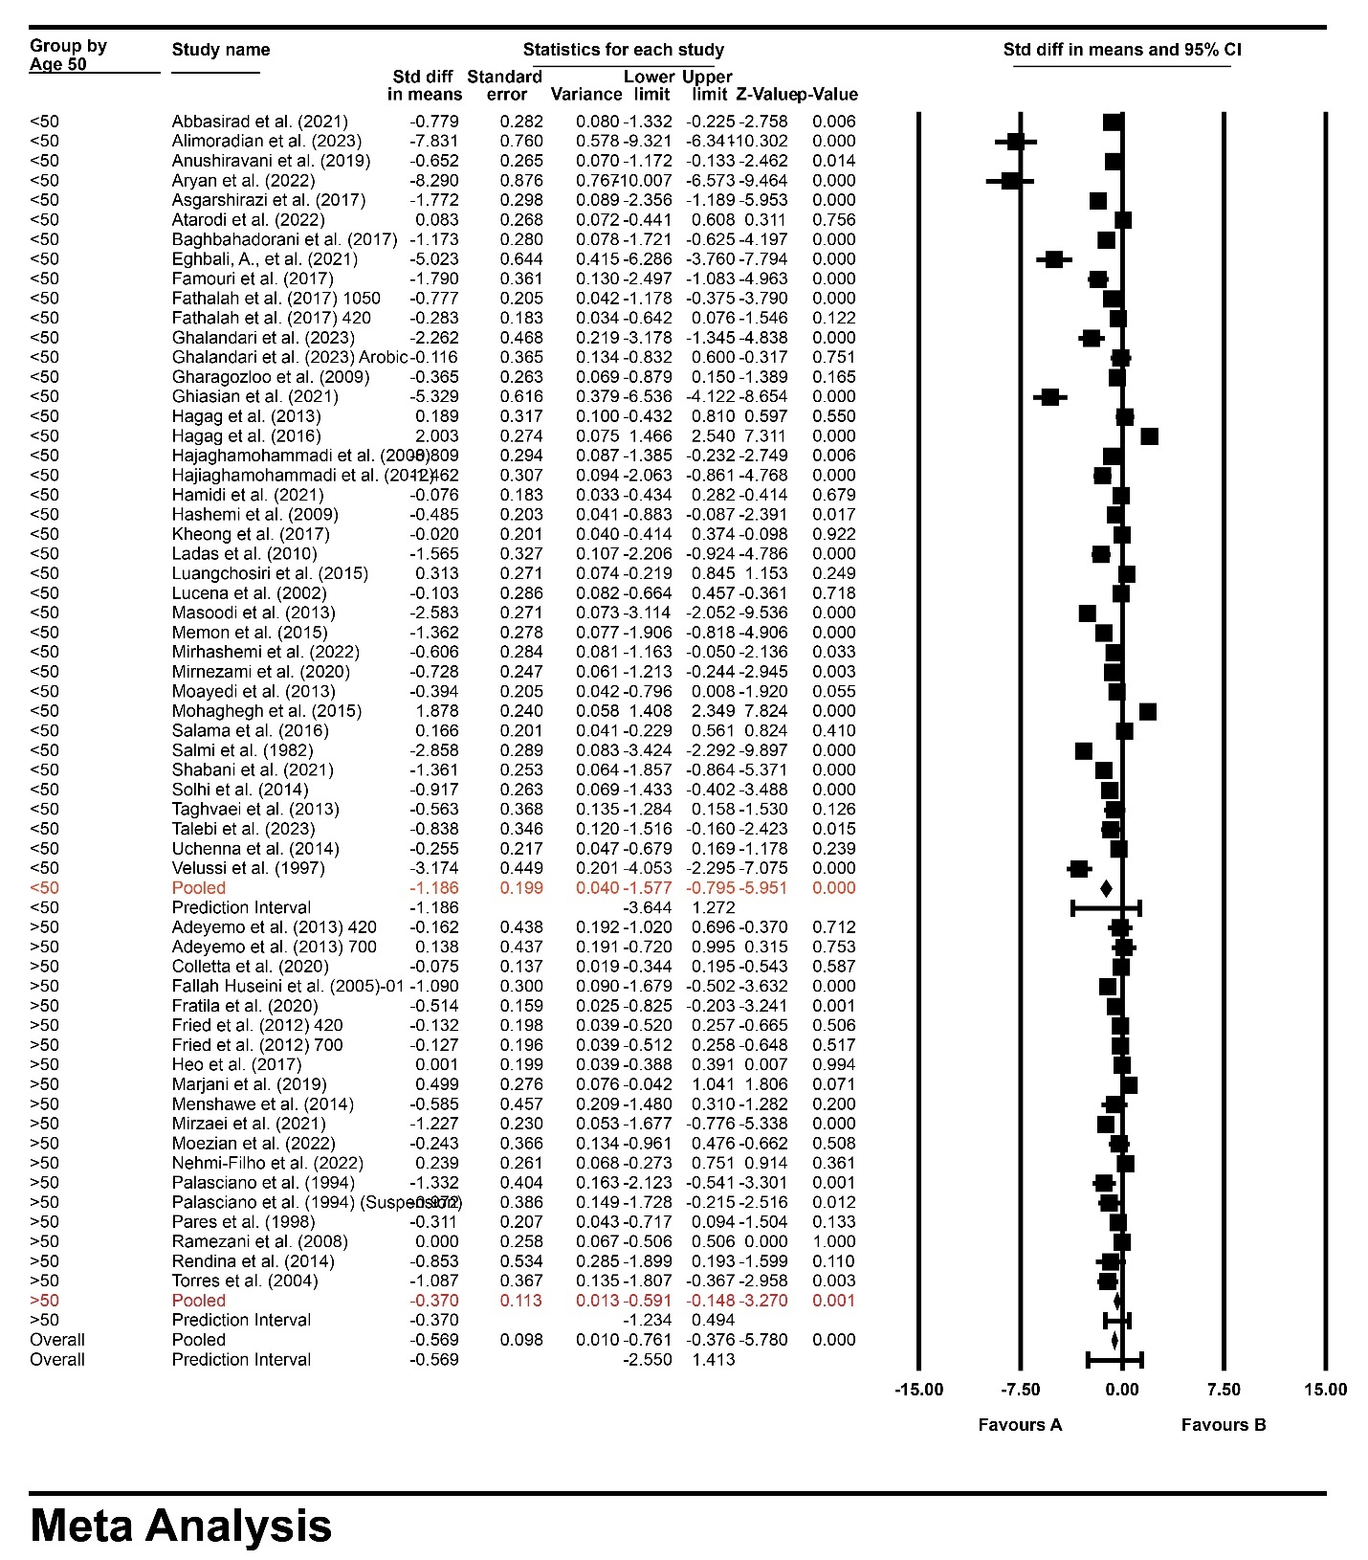
Figure S8. ALT levels in the subgroup analysis stratified by patient age ≥50 or <50 years old

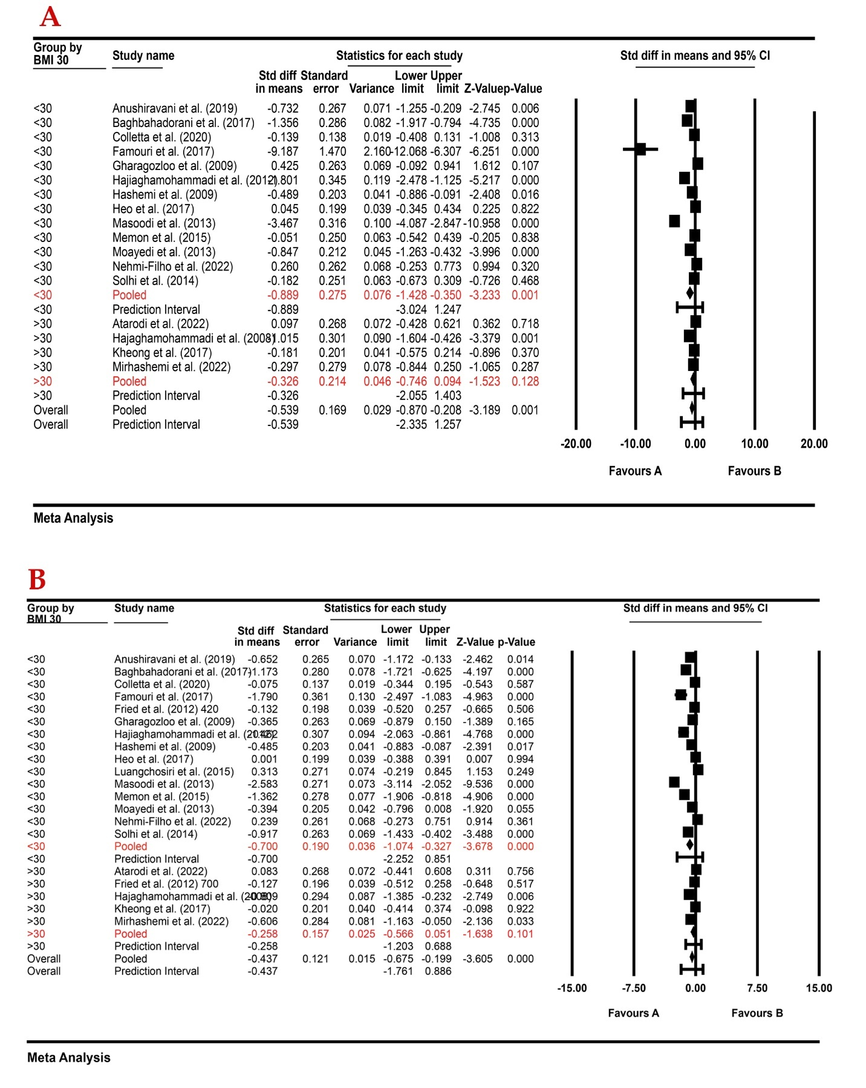
Figure S9. (A) AST and (B) ALT levels in the subgroup analysis stratified by BMI ≥30 or <30

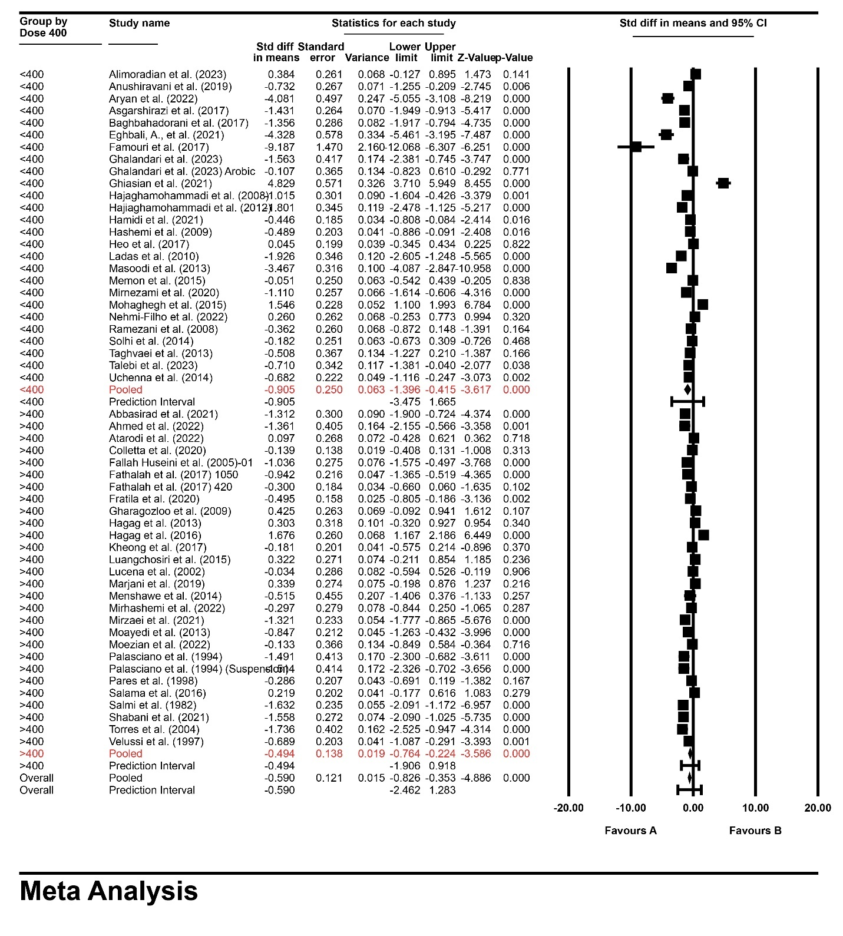
Figure S10. AST levels in the subgroup analysis stratified by dose of silymarin ≥400 or <400 mg/day

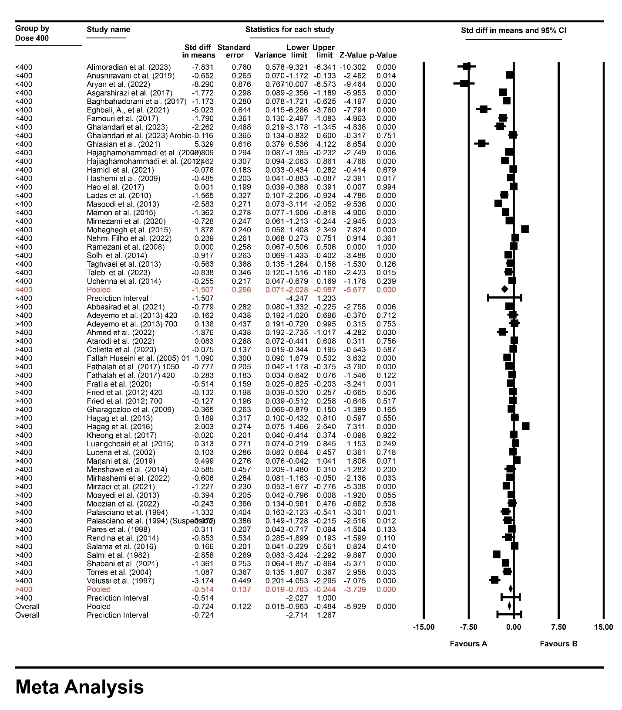
Figure S11. ALT levels in the subgroup analysis stratified by dose of silymarin ≥400 or <400 mg/day
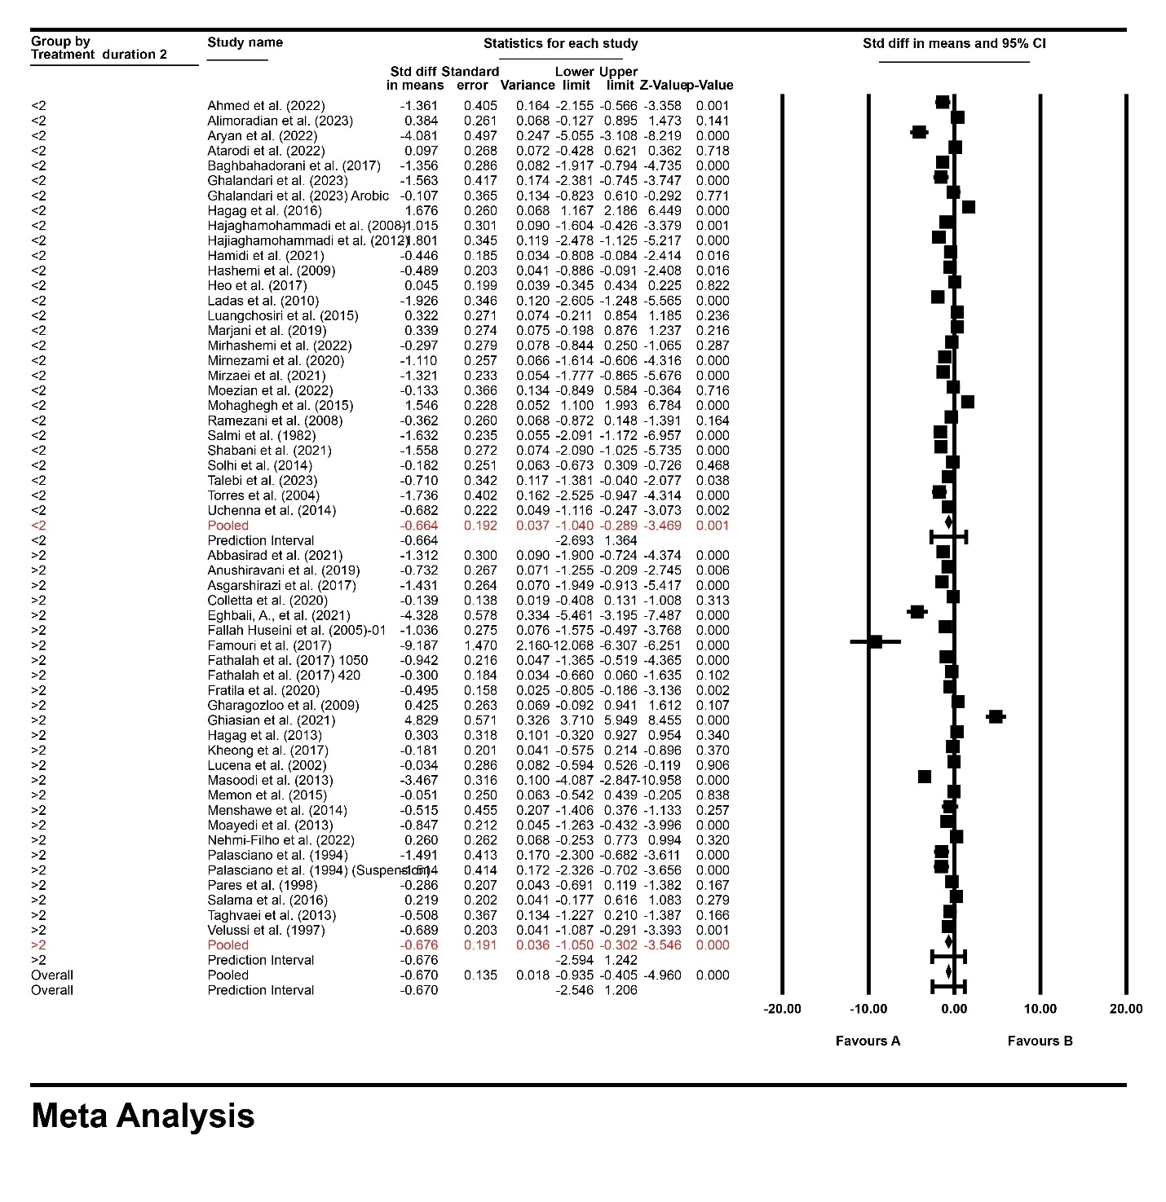
Figure S12. AST levels in the subgroup analysis stratified by treatment duration >2 or ≤2 months

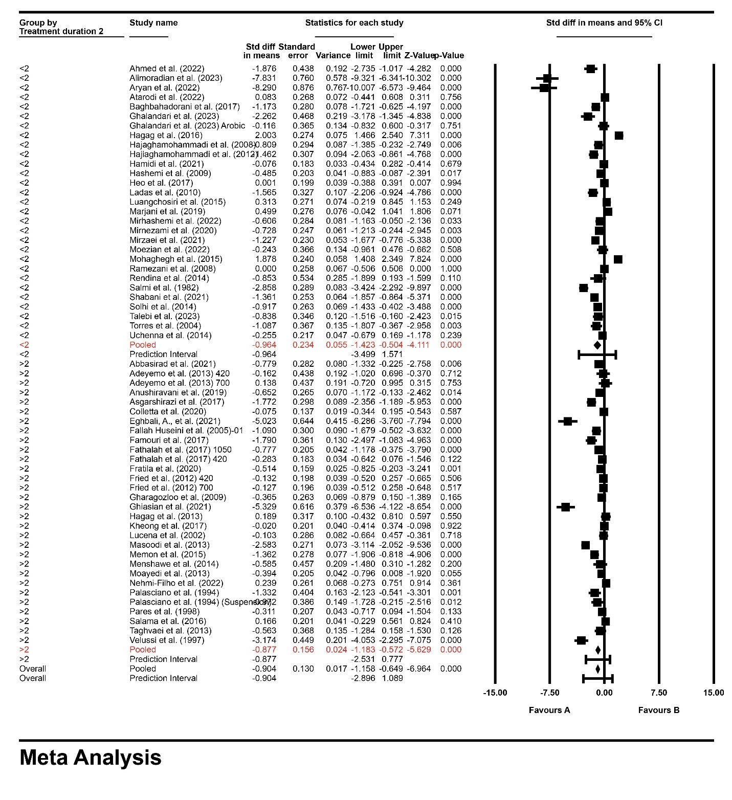
Figure S13. ALT levels in the subgroup analysis stratified by treatment duration >2 or ≤2 months

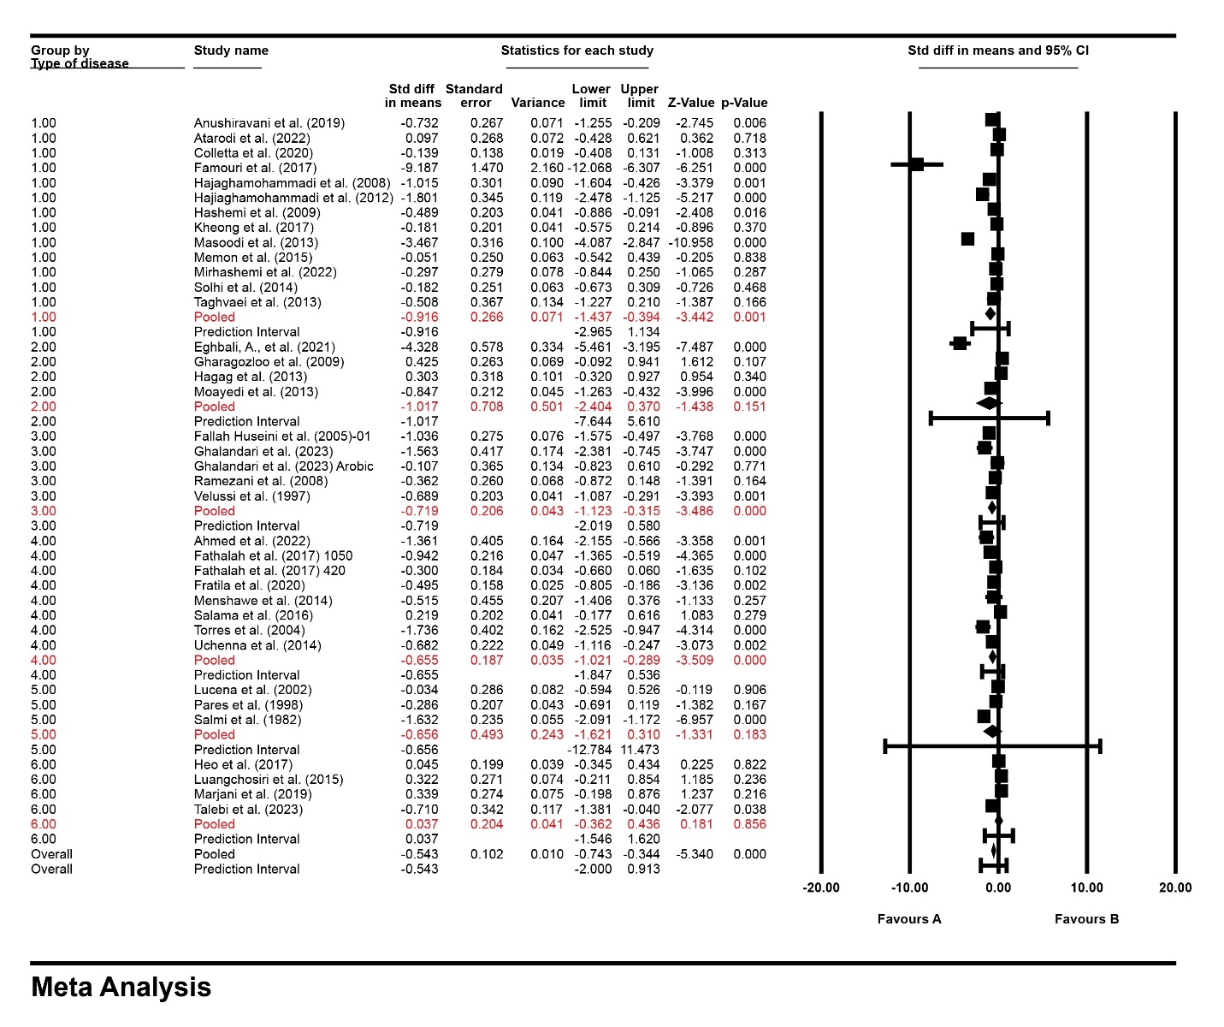
Figure S14. AST levels in the subgroup analysis stratified by type of diseases 1: non-alcoholic fatty liver diseases; 2: Thalassemia; 3: type 2 diabetes; 4: viral hepatitis; 5: alcoholic liver cirrhosis; 6: anti-tuberculosis drugs induced liver injury

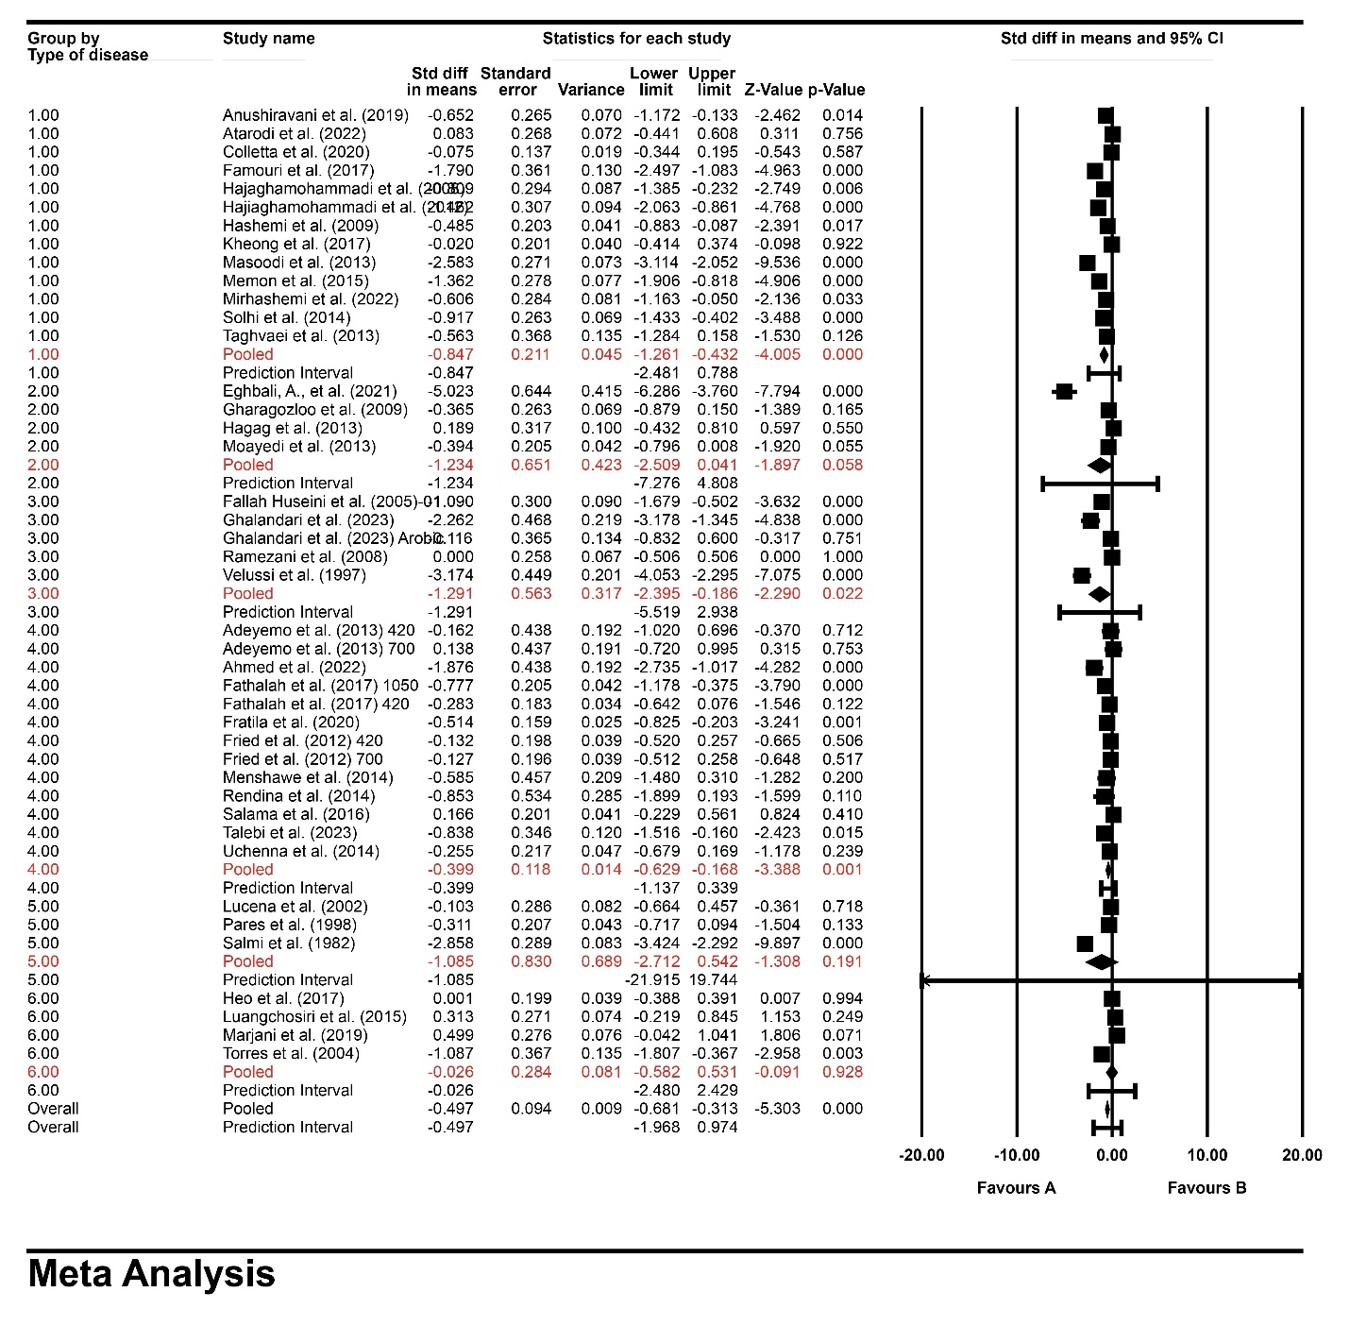
Figure S 15. ALT levels in the subgroup analysis stratified by type of diseases 1: non-alcoholic fatty liver diseases; 2: Thalassemia; 3: type 2 diabetes; 4: viral hepatitis; 5: alcoholic liver cirrhosis; 6: anti-tuberculosis drugs induced liver injury

Figure S16. Forest plot displaying standardized mean difference and 99% confidence intervals for the effect of silymarin treatment on serum AST level
Figure S17. Forest plot displaying standardized mean difference and 99% confidence intervals for the effect of silymarin treatment on serum ALT level
Figure S18. Forest plot displaying standardized mean difference and 95% confidence intervals for the effect of silymarin treatment on serum AST level after excluding studies with high risk of bias.

Figure S19. Forest plot displaying standardized mean difference and 95% confidence intervals for the effect of silymarin treatment on serum ALT level after excluding studies with high risk of bias.
Figure S20. Forest plot displaying standardized mean difference and 95% confidence intervals for the effect of silymarin treatment on serum ALP level after excluding studies with high risk of bias.

Table S 1. The search terms of this study
Databases | Scopus | No
Scopus | (TITLE-ABS-KEY (silymarin) OR TITLE-ABS-KEY (Silybum AND marianum) OR TITLE-ABS-KEY (milk AND thistle) AND TITLE-ABS-KEY (alanine AND aminotransferase) OR TITLE-ABS-KEY (transaminase) OR TITLE-ABS-KEY (aspartate AND aminotransferase) OR TITLE-ABS-KEY (aminotransferase) OR TITLE-ABS-KEY (alkaline AND phosphatase) OR TITLE-ABS-KEY (gamma-glutamyltransferase) OR TITLE-ABS-KEY (lactate AND dehydrogenase) OR TITLE-ABS-KEY (liver)) | 6432
PubMed | ("silymarin"[Title/Abstract] OR "Silybum marianum"[Title/Abstract]) OR "milk thistle"[Title/Abstract]) AND ("transaminase"[Title/Abstract] OR " aminotransferase"[Title/Abstract] OR " alanine transaminase"[Title/Abstract] OR " aspartate aminotransferases"[Title/Abstract] OR " alkaline phosphatase" [Title/Abstract] OR " gamma-glutamyltransferase"[Title/Abstract] OR " lactate dehydrogenase"[Title/Abstract] OR " liver" [Title/Abstract]) | 2027
Web of Sciences | TS=(((" silymarin") OR ("milk thistle ") OR ("Silybum marianum")) AND (("transaminase") OR ("aminotransferase") OR ("alanine transaminase") OR ("aspartate aminotransferases") OR ("alkaline phosphatase") OR ("gamma-glutamyltransferase") OR ("lactate dehydrogenase") OR ("liver"))) | 2796

∗ Corresponding Authors: Maede Hasanpour Department of Pharmacognosy, Faculty of Pharmacy, and Persian Medicine and Pharmacy Research Center, Tehran University of Medical Sciences, Tehran, Iran. https://orcid.org/0000-0002-8260-6123 Phone: +98-21-64122448, Fax: +98-21-64120000 E-mail: mhasanpour@farabi.tums.ac.ir and maede.hasanpour@yahoo.com Mahnaz Khanavi Professor of Pharmacognosy, Tehran University of Medical Sciences, Tehran, Iran. https://orcid.org/0000-0001-8392-9795 PO Box: 14155-6451, Tel/Fax: (98) 21-66461178 Email: khanavi@mail.ubc.ca and khanavim@tums.ac.ir

