S1. Isolation of phytochemicals from the ethanol extract of the leaves of Dolichos kilimandscharicus (DKL)
Compound 1: IR (cm⁻¹): 3380 (O – H), 2939 (C – H), 1638 (C=C) stretch of alkenes, 1461 (CH₂)_{n} cycloalkanes, 1373 (O – H), 1041 (C – H). ESI-MS [M⁺] peak at m/z 412. ¹³C NMR (126 MHz, CDCl₃) δ_{C} 140.77 (C-5), 138.34 (C-22), 129.28 (C-23), 121.73 (C-6), 71.83 (C-3), 56.78 (C-14), 56.06 (C-17), 51.25 (C-24), 50.14 (C-9), 42.24(C-13), 42.23 (C-4), 40.51 (C-20), 39.78 (C-12), 37.27 (C-1), 36.52 (C-10), 36.16 (C-25), 31.93 (C-7), 31.91 (C-8), 31.67 (C-2), 28.94 (C-16), 25.43 (C-28), 24.38 (C-15), 21.23 (C-21), 21.10 (C-11), 19.84 (C-26), 19.05 (C-19), 18.99 (C-27), 11.99 (C-29), 11.87 (C-18).

Supplementary Figure 1: ¹³C NMR spectrum (101 MHz, CDCl₃) of Compound 1.

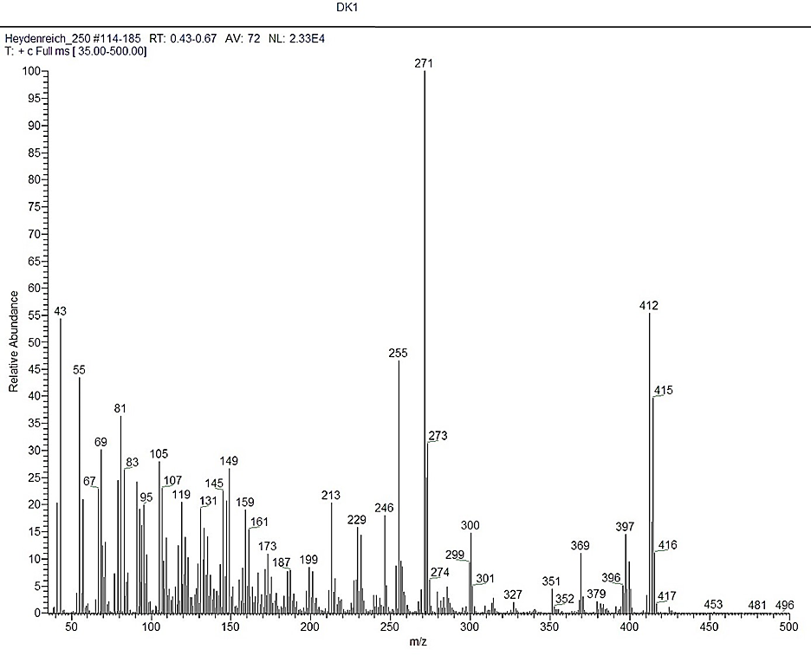
Supplementary Figure 2: Mass spectrum of Compound 1.

Compound 2: IR (cm⁻¹): 3415 (O – H), 3234 (cyclic olefinic –HC= CH-), 2930 (=CH), 2855 (C – H), 1688 (C=C), 1450 (-CH₂). ESI-MS [M⁺] peak at m/z 412. ¹³C NMR (126 MHz, CDCl₃) δ_{C} 139.57 (C-8), 138.19 (C-22), 129.44 (C-23), 117.47 (C-7), 71.08 (C-3), 55.90 (C-17), 55.14 (C-14), 51.27 (C-24), 49.45 (C-9), 43.29 (C-13), 40.86 (C-20), 40.27 (C-5), 39.47 (C-12), 37.98 (C-4), 37.15 (C-1), 34.23 (C-10), 31.89 (C-25), 31.47 (C-2), 29.65 (C-6), 28.53 (C-16), 25.42 (C-28), 23.03 (C-15), 21.56 (C-11), 21.40 (C-21), 21.12 (C-26), 19.01 (C-27), 13.06 (C-19), 12.27 (C-29), 12.07 (C-18).
Supplementary Figure 3: ¹H NMR spectrum (400 MHz, CDCl₃) of Compound 2.

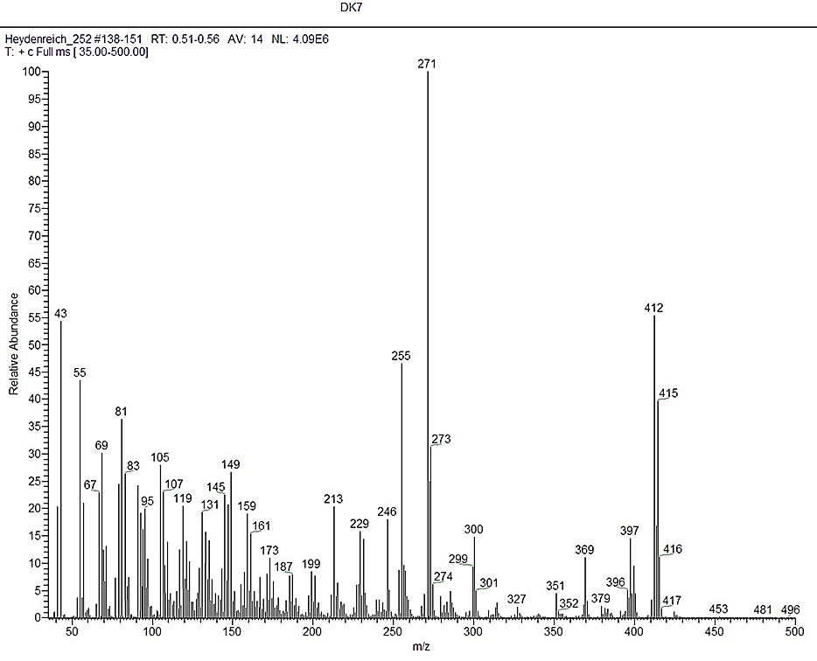
Supplementary Figure 4: Mass spectrum of Compound 2.

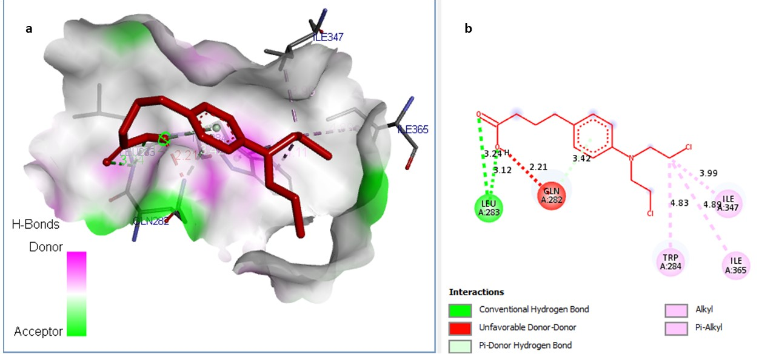
Supplementary Data Figure 5: Binding interactions of chlorambucil in the binding sites of 6VG8. (a) 2D-binding interaction diagram. (b) 3D-binding interaction diagram. Ligands are displayed as an orange color stick model. Protein residues in 3D diagrams are displayed as an atom-type color stick model.
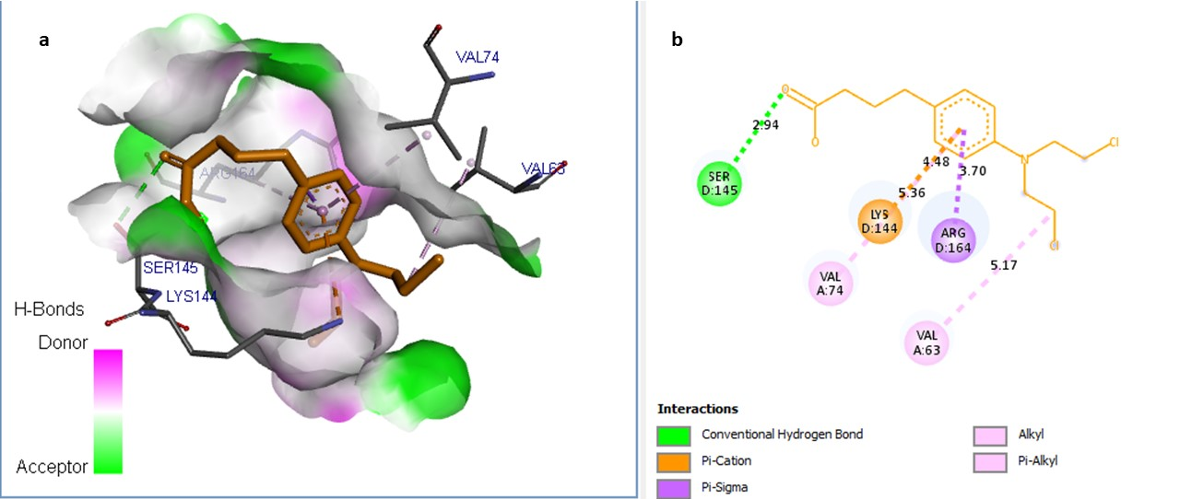
Supplementary Data Figure 6: Binding interactions of chlorambucil in the binding sites of 1HJC. (a) 2D-binding interaction diagram. (b) 3D-binding interaction diagram. Ligands are displayed as an orange color stick model. Protein residues in 3D diagrams are displayed as an atom-type color stick model.

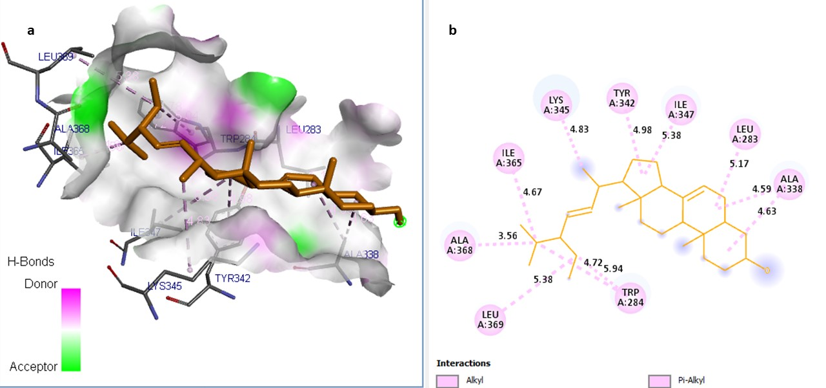

Supplementary Data Figure 7: Binding interactions of α-spinasterol in the binding sites of 6VG8. (a) 2D-binding interaction diagram. (b) 3D-binding interaction diagram. Ligands are displayed as an orange color stick model. Protein residues in 3D diagrams are displayed as an atom-type color stick model.

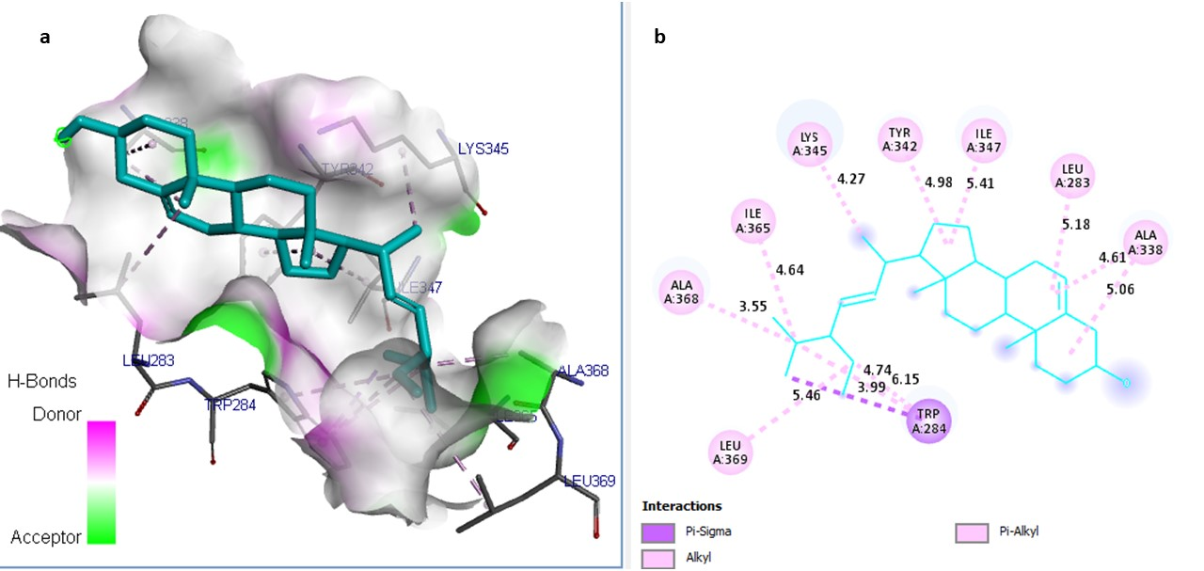

Supplementary Data Figure 8: Binding interactions of 3β-stigmasterol in the binding sites of 6VG8. (a) 2D-binding interaction diagram. (b) 3D-binding interaction diagram. Ligands are displayed as an orange color stick model. Protein residues in 3D diagrams are displayed as an atom-type color stick model.

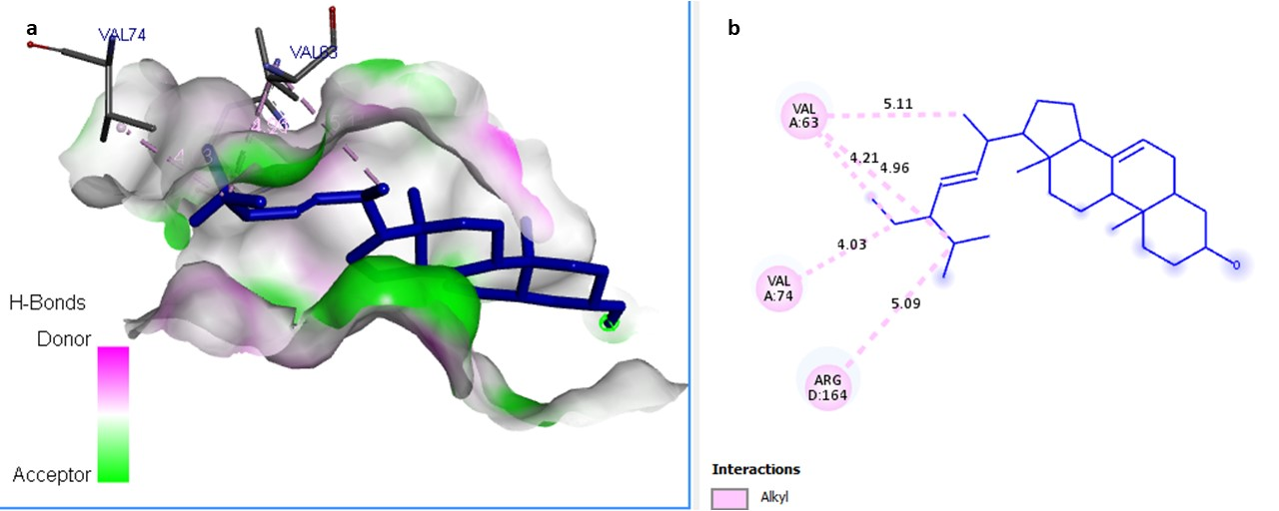

Supplementary Data Figure 9: Binding interactions of α-spinasterol in the binding sites of 1HJC. (a) 2D-binding interaction diagram. (b) 3D-binding interaction diagram. Ligands are displayed as an orange color stick model. Protein residues in 3D diagrams are displayed as an atom-type color stick model.

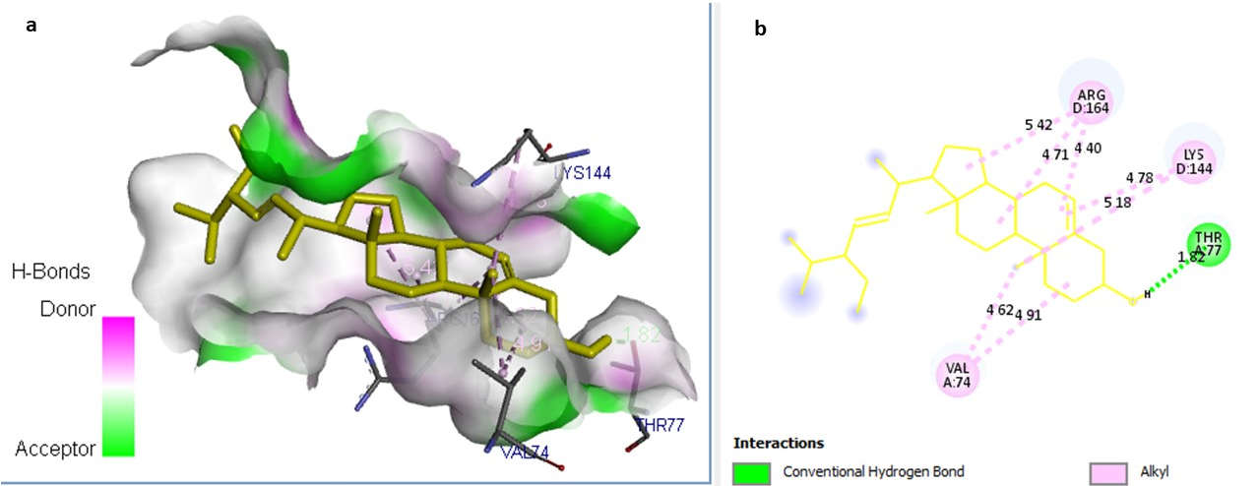
Supplementary Data Figure 10: Binding interactions of 3β-stigmasterol in the binding sites of 1HJC. (a) 2D-binding interaction diagram. (b) 3D-binding interaction diagram. Ligands are displayed as an orange color stick model. Protein residues in 3D diagrams are displayed as an atom-type color stick model.
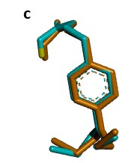
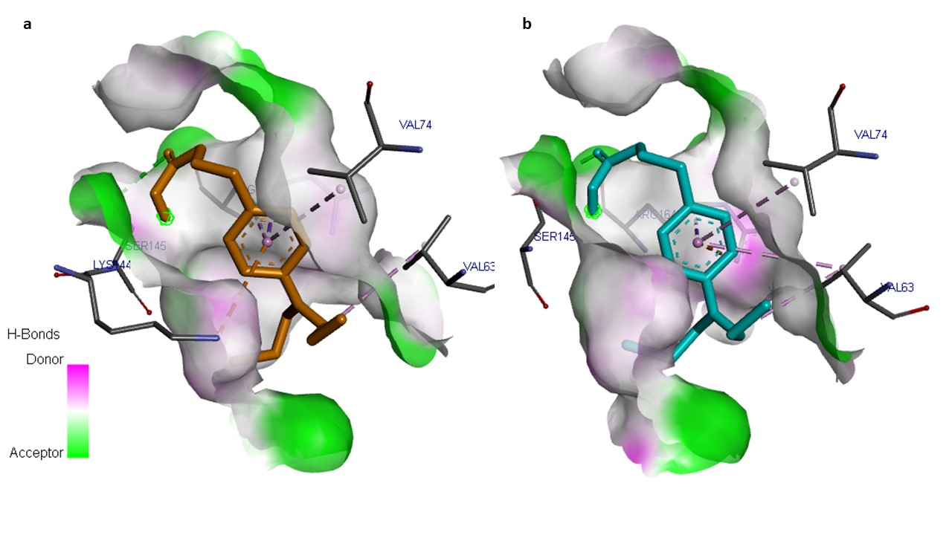

Supplementary Data Figure 11: Validation of the docking protocol. Comparative analysis of the binding interactions for the first docked chlorambucil (orange) (a) versus the redocked chlorambucil (pale blue) (b) in the binding sites of 1HJC. Superimposition of the two ligands, orange and pale blue (c) (RMSD= 0.3953 Å).

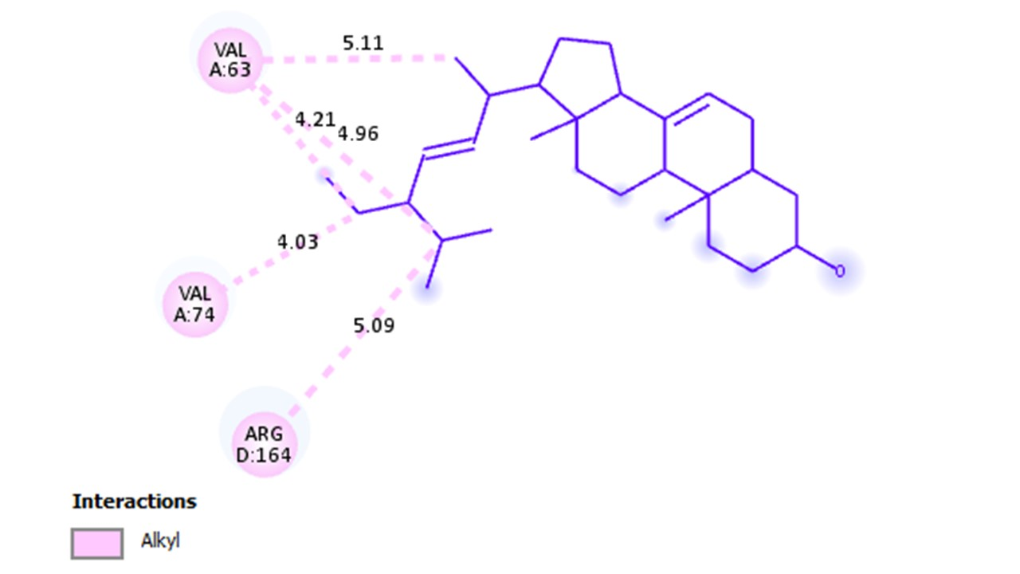
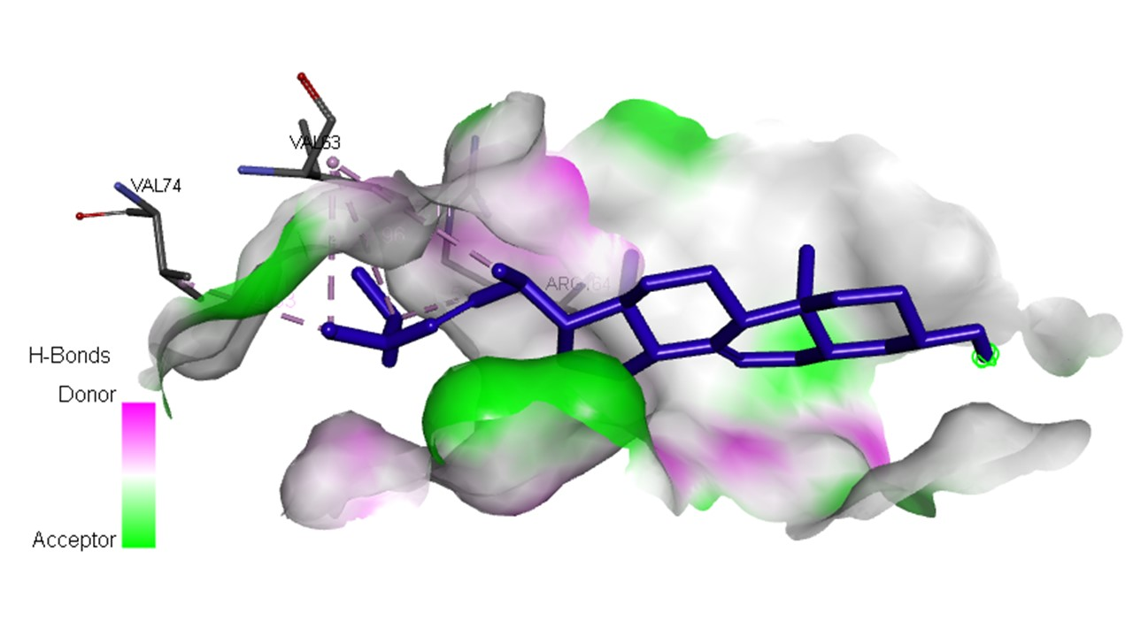
Supplementary Data Figure 12: Uncropped binding interactions of α-spinasterol in the binding sites of 1HJC.
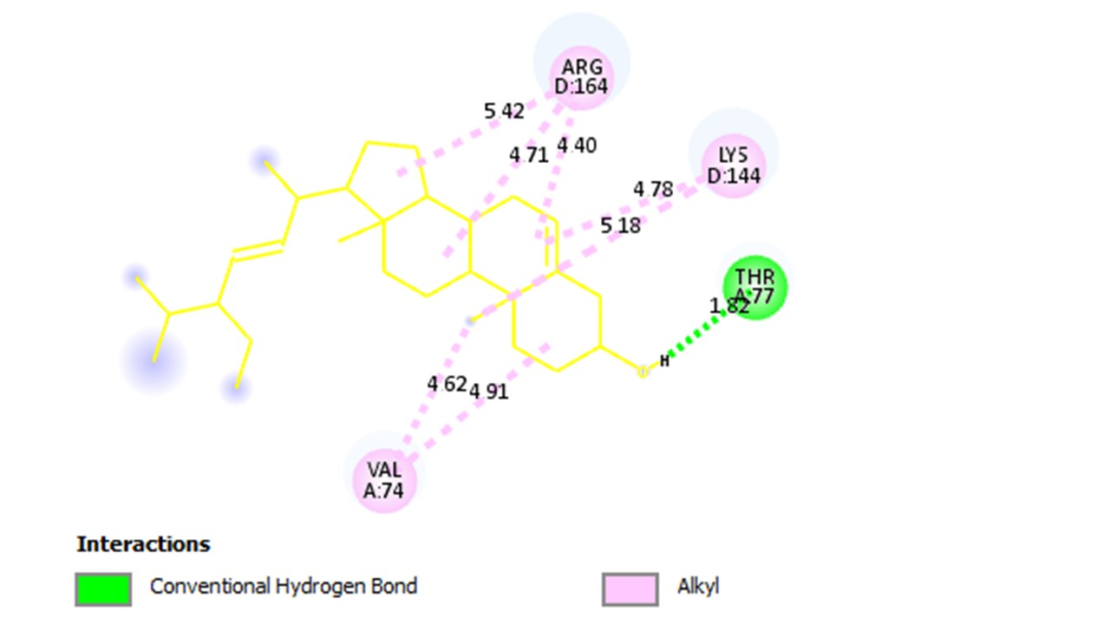
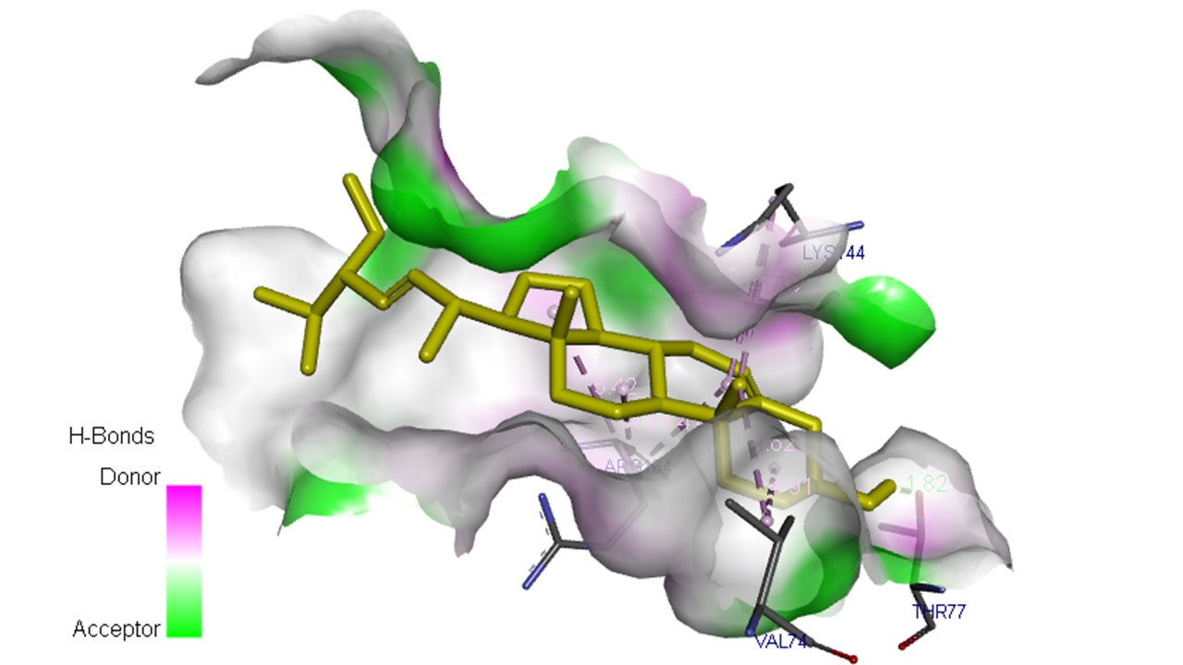
Supplementary Data Figure 13: Uncropped binding interactions of 3β-stigmasterol in the binding sites of 1HJC.
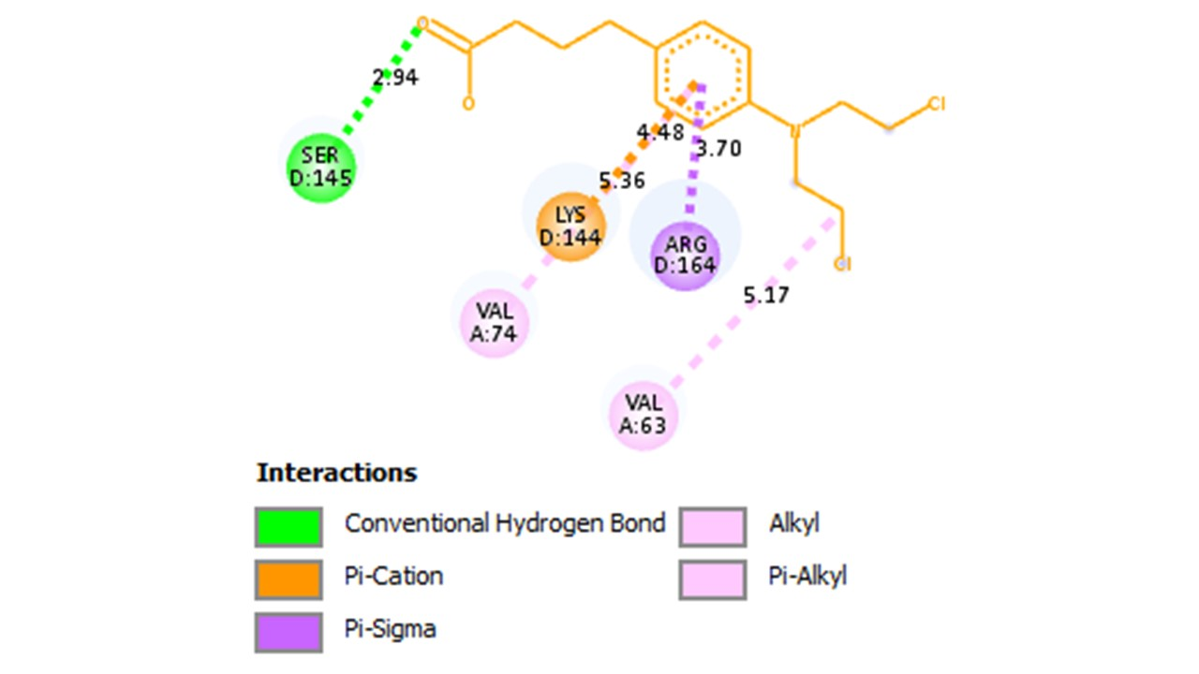
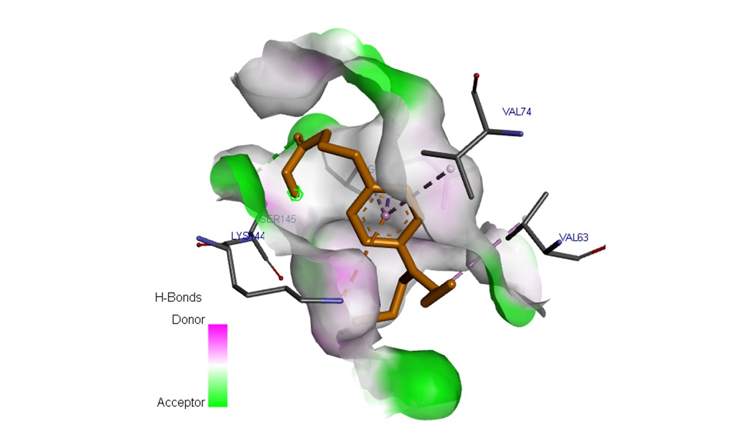
Supplementary Data Figure 14: Uncropped binding interactions of chlorambucil in the binding sites of 1HJC.
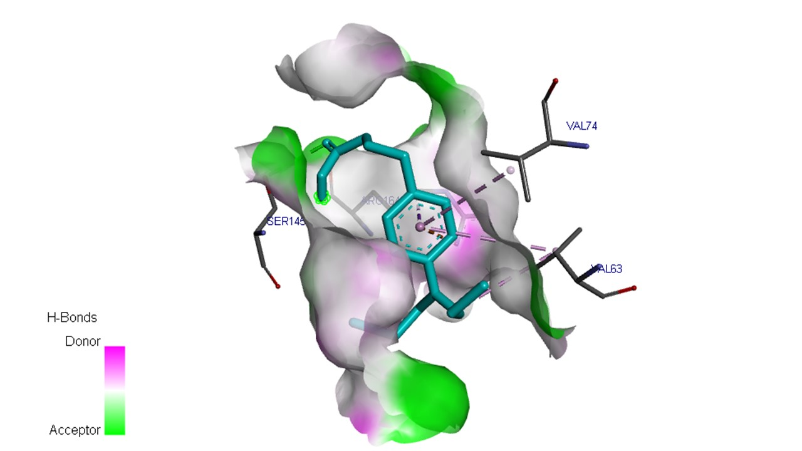
Supplementary Data Figure 15: Redocked binding interactions of chlorambucil in the binding sites of 1HJC.

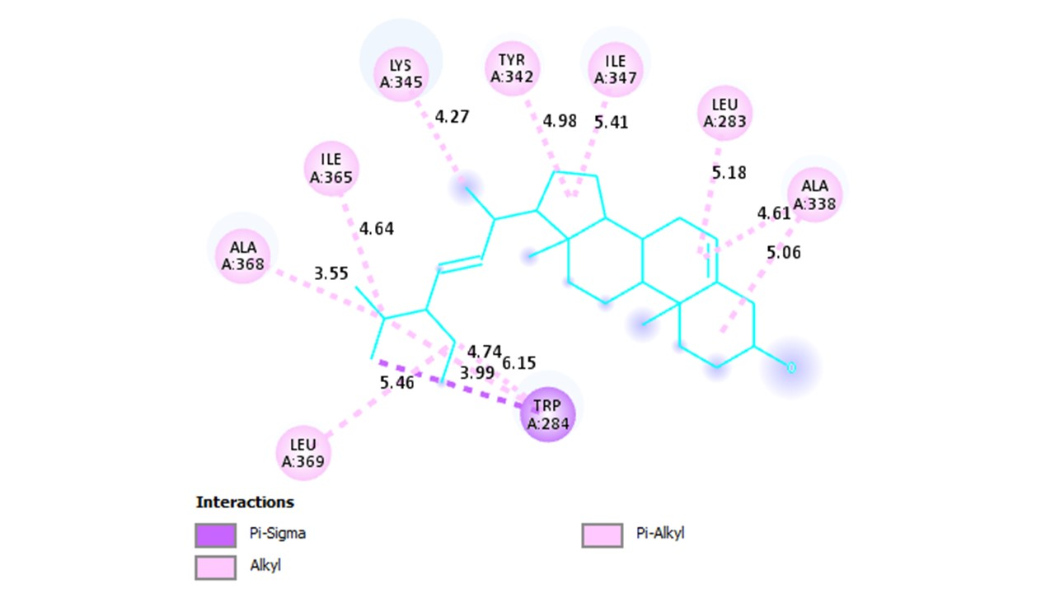
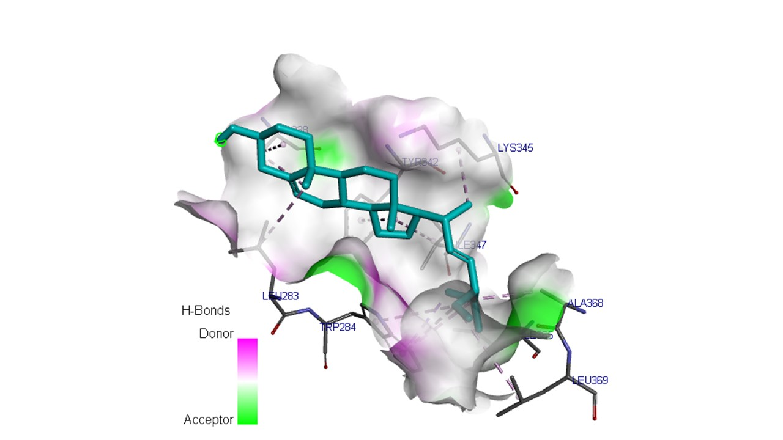
Supplementary Data Figure 16: Uncropped binding interactions of 3β-stigmasterol in the binding sites of 6VG8.
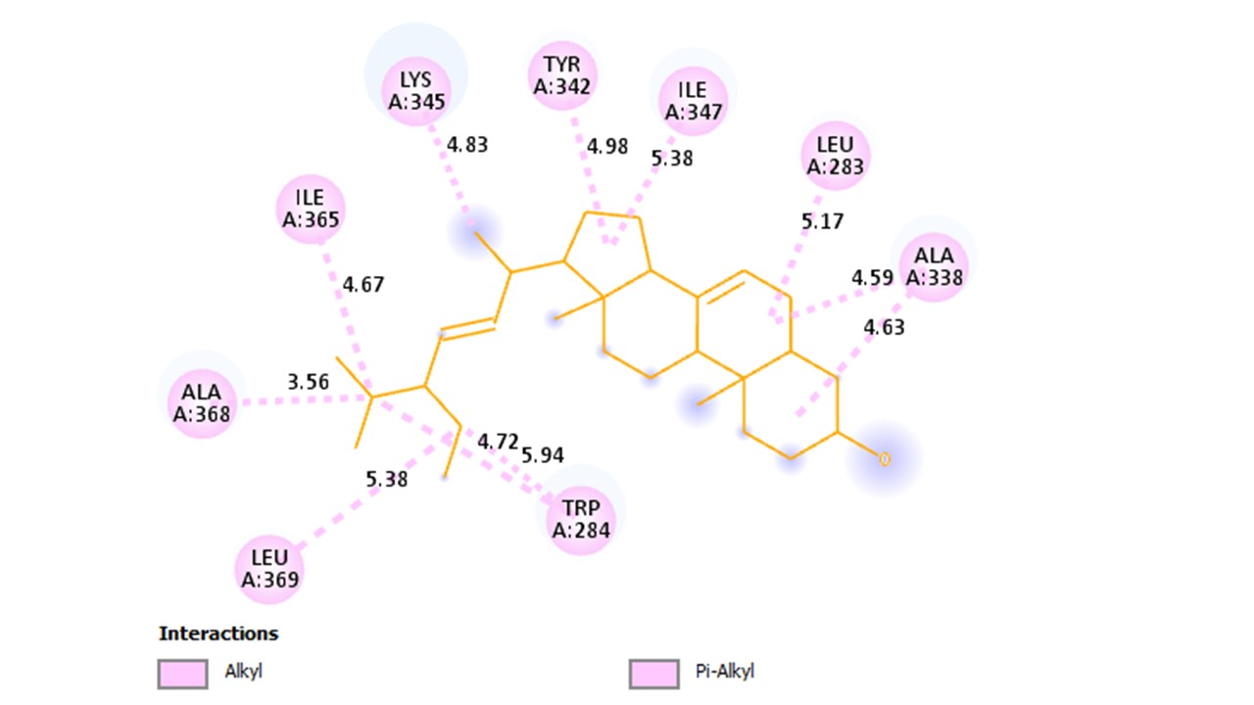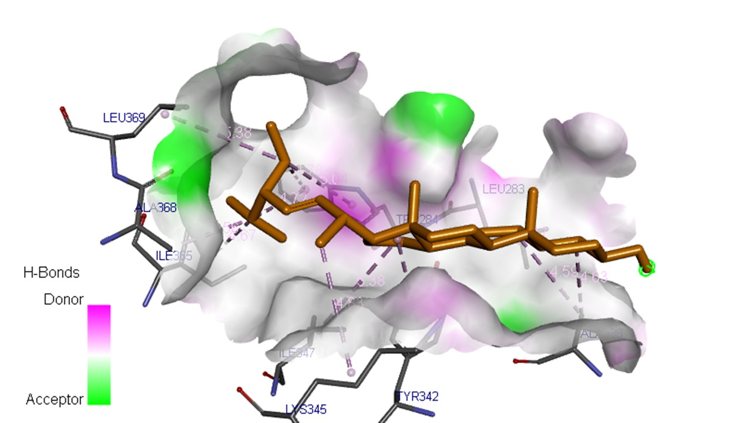
Supplementary Data Figure 17: Uncropped binding interactions of α-spinasterol in the binding sites of 6VG8.

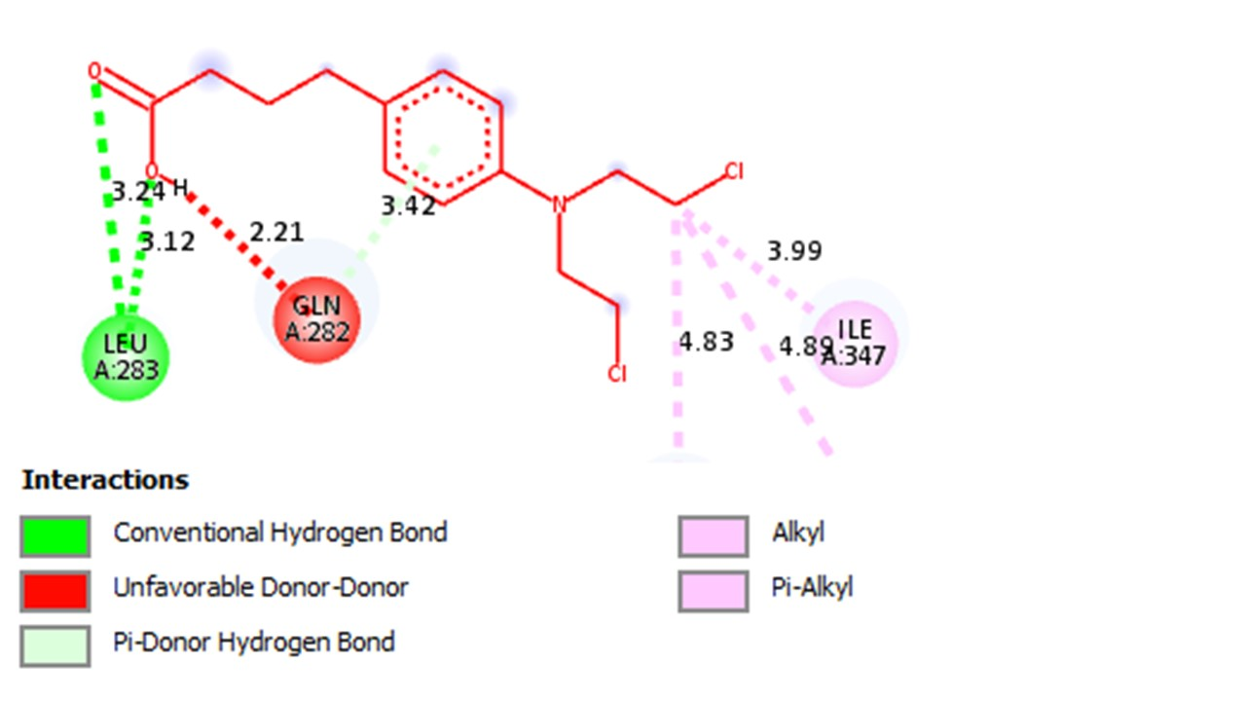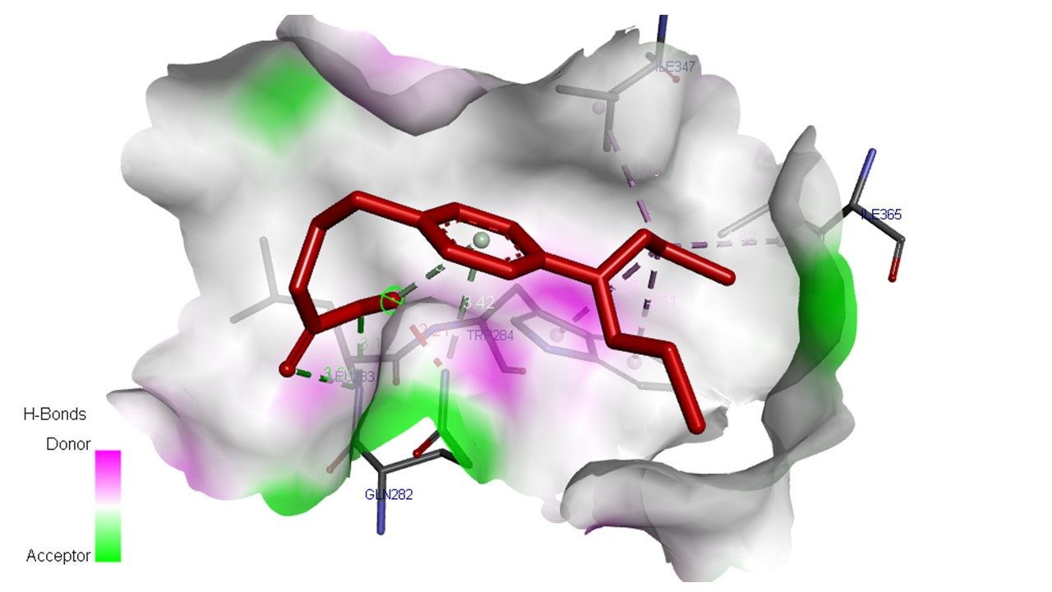
Supplementary Data Figure 18: Uncropped binding interactions of chlorambucil in the binding sites of 6VG8.

Supplementary Data Figure 19: Docking protocol docked vs redocked chlorambucil in the binding sites of 1HJC.
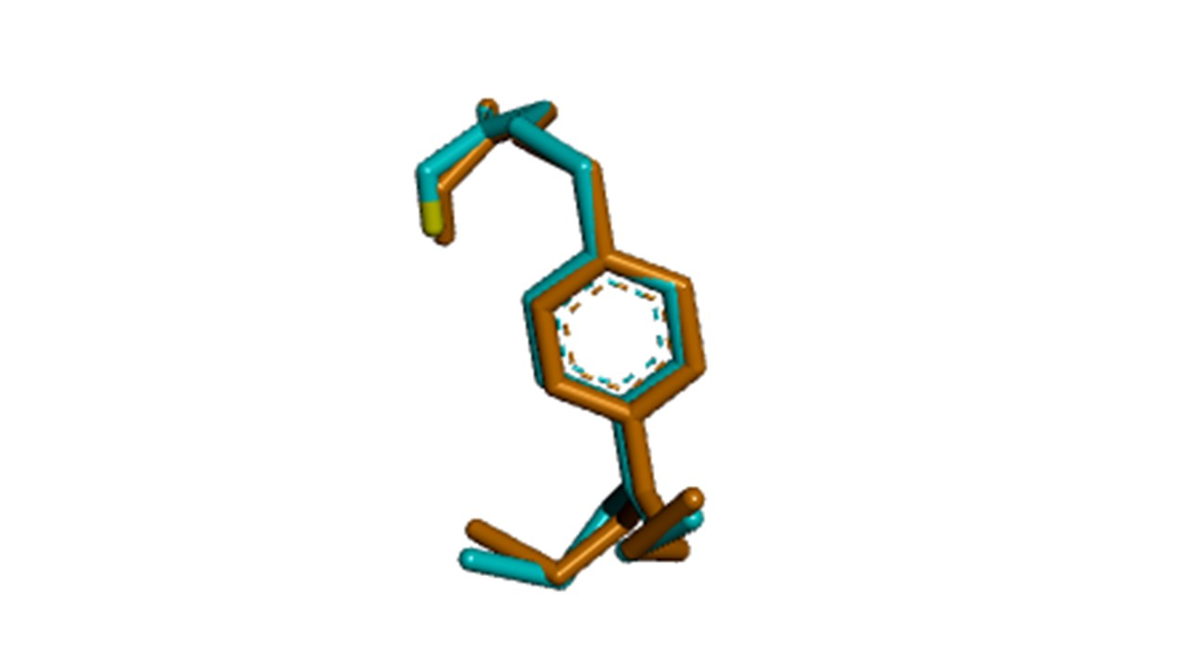
Supplementary Data Figure 20: Validated docking protocol docked vs redocked 1HJC-chlorambucil.

Docking protocol validation for chlorambucil
Heavy Atom RMSD to All

Name Reference RMSD (A)
1hjc_clean_chlorambucil_out_1.-5.3.complex 2 1hjc_clean_chlorambucil_out_1.-5.3.complex 2 0.0000
1hjc_clean_chlorambucil_out_1.-5.3.complex 2 1hjc_clean_redocked_chlorambucil_out_1.-5.4.complex 1 0.3953
1hjc_clean_redocked_chlorambucil_out_1.-5.4.complex 1 1hjc_clean_redocked_chlorambucil_out_1.-5.4.complex 1 0.0000

