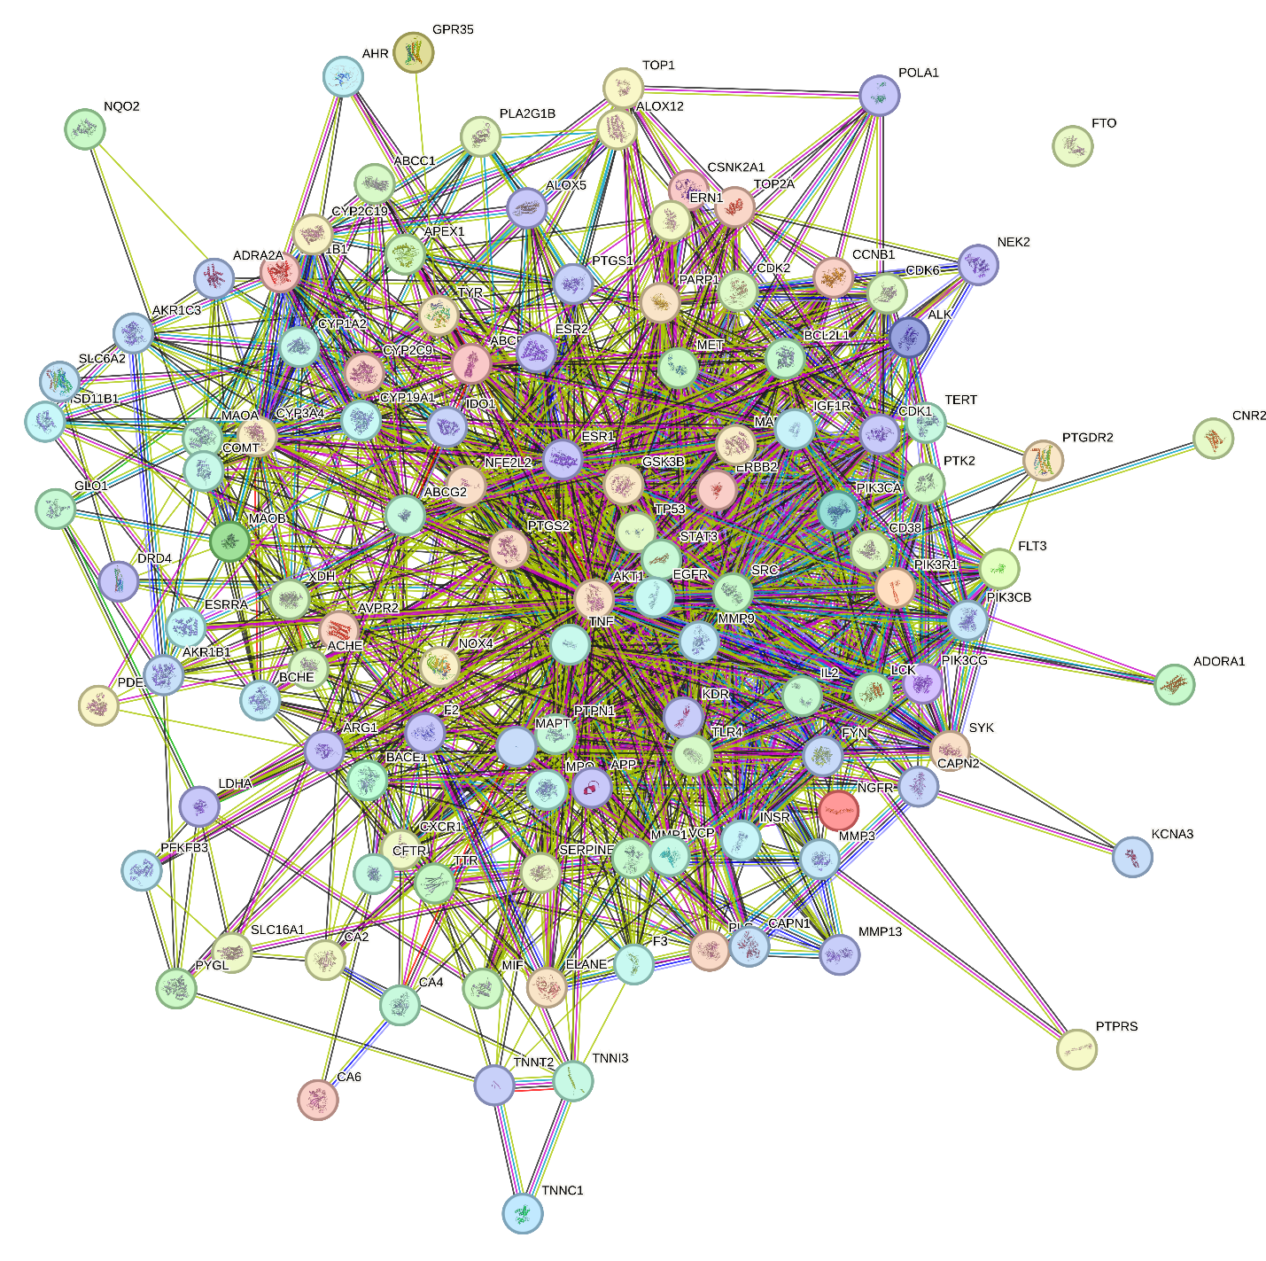
Figure S1: PPI network of bioactive compounds target and T2DM -related genes constructed using STRING database

Overlapping genes
XDH
CCNB1
MET
CYP2C19
ELANE
CD38
MAOA
CDK1
PTK2
BCHE
PIK3CB
ADRA2A
ESRRA
CAPN1
NQO2
AHR
NFE2L2
CYP19A1
TNF
NGFR
FYN
TNNT2
F2
PTGS2
CYP2C9
ESR1
APEX1
VCP
GSK3B
MMP1
IDO1
GLO1
ALOX12
MMP3
CXCR1
CA4
MAPK1
PLA2G1B
FTO
EGFR
CAPN2
ERBB2
KCNA3
PDE5A
GPR35
AKR1B1
DRD4
TERT
SRC
CDK2
PLG
TYR
TP53
PIK3R1
ABCC1
ESR2
CSNK2A1
SLC16A1
NEK2
CYP1B1
COMT
SLC6A2
MMP13
ALOX5
ALK
TNNI3
TNNC1
MAPT
ABCB1
POLA1
CDK6
LCK
MPO
LDHA
STAT3
ARG1
NOX4
PFKFB3
AVPR2
ACHE
PTGDR2
PARP1
KDR
ABCG2
PTPRS
PTPN1
CNR2
TTR
MAOB
CYP1A2
BACE1
PYGL
PIK3CG
PIK3CA
FLT3
ADORA1
IL2
SYK
TOP2A
IGF1R
BCL2L1
CA2
CFTR
TLR4
SERPINE1
INSR
AKT1
MIF
HSD11B1
AKR1C3
PTGS1
F3
ERN1
CA6
CYP3A4
APP
MMP9
TOP1

Table S1: Ratios of crude extracts high in flavonoids utilized during formulation
 | Ratio of crude flavonoid-rich extracts ($x:10)$
Plants | Form A | Form B
Beta vulgaris leaf | 2.5 | *
Persea americana seeds | * | 2.5
Beta vulgaris root | * | 2.5
Syzygium aromaticum | 2.5 | *

Table S2. Binding site coordinates of the target enzymes
Dimensions | 3TOP(Å) | 1B2Y (Å) | 6B1E (Å)
center_x | -30.82 | 17.45 | 39.12
center_y | 35.13 | 5.87 | 51.34
center_z | 27.06 | 47.38 | 37.24
Size x | 18.03 | 22.05 | 12.26
Size y | 19.97 | 17.25 | 8.77
Size z | 21.64 | 15.70 | 7.26

Table S3: Docking score of identified compounds across different targets
 | Docking scores
Compound | Akt1 | STAT-3 | P53 | TNF-alpha
Rutin | -9.3 | -7.2 | -7.6 | -7
Quercetrin | -8.4 | -6.9 | -6.9 | -6.7
Vildagliptin | -7.5 | -6.6 | -6.7 | -5.9
Quercetin | -7.4 | -7 | -7.1 | -6.6
kaempferol | -7.2 | -6.8 | -6.8 | -6.3
Myricetin | -7 | -6.8 | -6.5 | -6.5
Caffeic acid | -6 | -5.6 | -5.2 | -5.4
p-coumaric acid | -5.7 | -5.3 | -5.2 | -5
Gallic acid | -5.5 | -5.5 | -5 | -5
Methyl gallate | -5.5 | -5.3 | -5 | -4.8
Syringic acid | -5.5 | -5.8 | -4.9 | -4.7

Table S4: Raw data for alpha-amylase activity

 | Conc(ug/ml) | 1 | 2 | 3 |  | Percentage Inhibition
Form A | 1000 | 0.407 | 0.409 | 0.412 |  | 70.90592 | 71.25436 | 71.777
 | 500 | 0.364 | 0.369 | 0.368 |  | 63.41463 | 64.28571 | 64.1115
 | 250 | 0.324 | 0.327 | 0.325 |  | 56.44599 | 56.96864 | 56.62021
 | 125 | 0.282 | 0.285 | 0.288 |  | 49.12892 | 49.65157 | 50.17422
 | 62.5 | 0.243 | 0.248 | 0.257 |  | 42.33449 | 43.20557 | 44.77352
 | 31.25 | 0.201 | 0.203 | 0.208 |  | 35.01742 | 35.36585 | 36.23693
 | 15.625 | 0.164 | 0.168 | 0.171 |  | 28.57143 | 29.26829 | 29.79094
 | 7.8125 | 0.139 | 0.137 | 0.133 |  | 24.21603 | 23.8676 | 23.17073
Form B | 1000 | 0.383 | 0.386 | 0.387 |  | 66.72474 | 67.24739 | 67.4216
 | 500 | 0.337 | 0.339 | 0.334 |  | 58.7108 | 59.05923 | 58.18815
 | 250 | 0.307 | 0.308 | 0.307 |  | 53.48432 | 53.65854 | 53.48432
 | 125 | 0.256 | 0.252 | 0.258 |  | 44.5993 | 43.90244 | 44.94774
 | 62.5 | 0.218 | 0.213 | 0.215 |  | 37.97909 | 37.10801 | 37.45645
 | 31.25 | 0.179 | 0.181 | 0.181 |  | 31.18467 | 31.5331 | 31.5331
 | 15.625 | 0.136 | 0.138 | 0.137 |  | 23.69338 | 24.04181 | 23.8676
 | 7.8125 | 0.116 | 0.113 | 0.111 |  | 20.20906 | 19.68641 | 19.33798
Standard | 1000 | 0.505 | 0.502 | 0.504 |  | 87.97909 | 87.45645 | 87.80488
 | 500 | 0.473 | 0.478 | 0.473 |  | 82.40418 | 83.27526 | 82.40418
 | 250 | 0.423 | 0.424 | 0.427 |  | 73.69338 | 73.8676 | 74.39024
 | 125 | 0.389 | 0.381 | 0.387 |  | 67.77003 | 66.37631 | 67.4216
 | 62.5 | 0.344 | 0.342 | 0.347 |  | 59.93031 | 59.58188 | 60.45296
 | 31.25 | 0.307 | 0.306 | 0.307 |  | 53.48432 | 53.3101 | 53.48432
 | 15.625 | 0.271 | 0.276 | 0.276 |  | 47.21254 | 48.08362 | 48.08362
 | 7.8125 | 0.237 | 0.239 | 0.234 |  | 41.2892 | 41.63763 | 40.76655

Table S5: Raw data for alpha-glucosidase activity
Conc(ug/ml)
Form A | 4 | 5 | 6
1000 | 1.165 | 1.178 | 1.145 |  | 63.76574 | 64.47729 | 62.67105
500 | 1.009 | 1.004 | 1.011 |  | 55.22715 | 54.95348 | 55.33662
250 | 0.902 | 0.908 | 0.905 |  | 49.37055 | 49.69896 | 49.53476
125 | 0.783 | 0.789 | 0.787 |  | 42.85714 | 43.18555 | 43.07608
62.5 | 0.653 | 0.655 | 0.661 |  | 35.74165 | 35.85112 | 36.17953
31.25 | 0.577 | 0.572 | 0.573 |  | 31.58183 | 31.30816 | 31.36289
15.625 | 0.467 | 0.462 | 0.469 |  | 25.56103 | 25.28736 | 25.6705
7.8125 | 0.389 | 0.39 | 0.393 |  | 21.29174 | 21.34647 | 21.51067
Form B | 7 | 8 | 9
1000 | 0.891 | 0.82 | 0.82 |  | 48.76847 | 44.88232 | 44.88232
500 | 0.986 | 0.949 | 0.958 |  | 53.96825 | 51.94308 | 52.43569
250 | 1.019 | 0.984 | 0.985 |  | 55.77449 | 53.85878 | 53.91352
125 | 1.051 | 1.038 | 1.042 |  | 57.526 | 56.81445 | 57.03339
62.5 | 1.156 | 1.126 | 1.122 |  | 63.27313 | 61.63109 | 61.41215
31.25 | 1.153 | 1.121 | 1.105 |  | 63.10892 | 61.35742 | 60.48166
15.625 | 1.196 | 1.115 | 1.109 |  | 65.46251 | 61.02901 | 60.7006
7.8125 | 1.198 | 1.232 | 1.234 |  | 65.57198 | 67.43295 | 67.54242
ACARBOSE | 19 | 20 | 21
1000 | 1.611 | 1.615 | 1.613 |  | 88.17734 | 88.39628 | 88.28681
500 | 1.492 | 1.495 | 1.492 |  | 81.66393 | 81.82813 | 81.66393
250 | 1.402 | 1.409 | 1.404 |  | 76.73782 | 77.12096 | 76.84729
125 | 1.275 | 1.282 | 1.283 |  | 69.78654 | 70.16968 | 70.22441
62.5 | 1.168 | 1.168 | 1.167 |  | 63.92994 | 63.92994 | 63.87521
31.25 | 1.021 | 1.023 | 1.024 |  | 55.88396 | 55.99343 | 56.04817
15.625 | 0.924 | 0.921 | 0.927 |  | 50.57471 | 50.41051 | 50.73892
7.8125 | 0.801 | 0.808 | 0.811 |  | 43.84236 | 44.22551 | 44.38971

Table S6: Raw data for dipeptidyl peptidase IV activity
[C] µg/mL | Form A |  | Form B |  | Evogliptin
7.8125 | 7.67234 | 8.2621 | 7.52199 | 7.95201 | 10.3218 | 11.42502
15.625 | 15.6623 | 16.6834 | 13.4356 | 14.76541 | 20.3452 | 23.2256
31.25 | 23.3742 | 26.721 | 20.72231 | 23.55012 | 34.521 | 37.8231
62.5 | 35.44012 | 39.6522 | 33.01277 | 36.44231 | 40.5834 | 42.2199
125 | 43.6526 | 46.2345 | 40.14121 | 43.45106 | 55.6502 | 57.4848
250 | 51.4521 | 53.5266 | 48.26751 | 50.56021 | 64.72 | 67.3424
500 | 66.25011 | 68.8711 | 63.4562 | 65.5512 | 72.5633 | 73.221
1000 | 75.34201 | 78.01142 | 70.5621 | 73.2514 | 79.3422 | 80.2345

Table S7: Raw data for cytotoxicity study

μg/mL | FORM A |  |  |  |  |  | FORM B
1000 | 55.5 | 58 | 53.7 | 63.6 | 64.7 | 65.5 | 79.6 | 83 | 75.7 | 86.7 | 88 | 89.1
100 | 81.7 | 85.6 | 85.7 | 96.8 | 102 | 107 | 93 | 92.9 | 93.9 | 103 | 104 | 95.9
10 | 91.1 | 93.3 | 94.9 | 104 | 101 | 101 | 90.5 | 97 | 96.4 | 106 | 108 | 109
1 | 100 | 110 | 112 | 108 | 109 | 108 | 92.9 | 99 | 105 | 116 | 124 | 128

