Table 1 Sociodemographic characteristics of hypertensive patients aged 35-64 according to herbal medicine use.
Characteristics | Overall population  n = 139 (%) | HM users  n = 83 (%) | HM non-users  n = 56 (%) | X² | p-value
Age (years)  35–50  51–55  56–60  61–64 | 19 (13.7)  18 (12.9)  34 (24.5)  68 (48.9) | 10 (12)  10 (12)  18 (21.7)  45 (54.2) | 9 (16.1)  8 (14.3)  16 (28.6)  23 (41.1) | 2.354 | 0.502
Ethnicity  African  East-Indian  Mixed | 43 (31.4)  51 (37.2)  43 (31.4) | 25 (30.9)  28 (34.6)  28 (34.6) | 18 (32.1)  23 (41.1)  15 (26.8) | 1.032 | 0.597
Employment status  Employed  Unemployed  Retired | 49 (35.3)  25 (18)  65 (46.8) | 25 (30.1)  13 (15.7)  45 (54.2) | 24 (42.9)  12 (21.4)  20 (35.7) | 4.605 | 0.1
RHA  ERHA  NCRHA | 81 (58.3)  58 (41.7) | 51 (61.4)  32 (38.6) | 30 (53.6)  26 (46.4) | 0.853 | 0.356
Highest level of education  Primary  Secondary  Tertiary | 60 (45.1)  50 (37.6)  23 (17.3) | 39 (48.1)  25 (30.9)  17 (21) | 21 (40.4)  25 (48.1)  6 (11.5) | 4.554 | 0.103
Marital status  Single  Married  Divorced  Widowed | 34 (24.5)  72 (51.8)  14 (10.1)  19 (13.7) | 18 (21.7)  43 (51.8)  10 (12)  12 (14.5) | 16 (28.6)  29 (51.8)  4 (7.1)  7 (12.5) | 1.541 | 0.673
HM, herbal medicine; RHA, regional health authority; ERHA, Eastern Regional Health Authority; NCRHA, North Central Regional Health Authority

Table 2 Clinical characteristics of hypertensive patients according to herbal medicine use.
Characteristics | Overall population  n = 139 (%) | HM users  n = 83 (%) | HM non-users  n = 56 (%) | Test statisticª | p-value
Mean BMI (kg/m²) (SD) | 30.5 (7.4) | 30.2 (6.7) | 31 (8.5) | 2283 | 0.86
Mean initial systolic BP (mmHg) (SD) | 151.9 (20.9) | 153.2 (20.1) | 150.1 (22.1) | 2079 | 0.293
Mean initial diastolic BP (mmHg) (SD) | 85.1 (13.3) | 84.6 (14) | 85.9 (12.2) | 2125 | 0.393
Mean current systolic BP (mmHg) (SD) | 151.5 (17.2) | 153.5 (16.7) | 148.6 (17.7) | 1931.5 | 0.092
Mean current diastolic BP (mmHg) (SD) | 82.4 (10.8) | 83 (11.4) | 82 (9.9) | 2142.5 | 0.435
Stage of hypertension  Elevated  Stage 1  Stage 2 | 29 (20.9)  68 (48.9)  42 (30.2) | 12 (14.5)  45 (54.2)  26 (31.3) | 17 (30.4)  23 (41.1)  16 (28.6) | 5.312 | 0.07
Blood pressure control  Controlled  Uncontrolled | 30 (21.6)  109 (78.4) | 13 (15.7)  70 (84.3) | 17 (30.4)  39 (69.6) | 4.266 | 0.039*
Duration of hypertension (years) (SD) | 10.4 (8.9) | 11.3 (9.8) | 9.1 (7.2) | 2046 | 0.231
Adherence with prescribed antihypertensive medication  Compliant  Non-compliant | n = 134  86 (64.2)  48 (35.8) | n = 80  48 (60)  32 (40) | n = 54  38 (70.4)  16 (29.6) | 1.508 | 0.219
Prescribed antihypertensive therapy  Monotherapy  Combination therapy | n = 134  39 (29.1)  95 (70.9) | n = 79  25 (31.6)  54 (68.4) | n = 55  14 (25.5)  41 (74.5) | 0.602 | 0.438
ªTest statistics derived from Mann-Whitney U test comparing mean values, and X² test comparing proportions.
*Significant p-value <0.05
HM, herbal medicine; SD, standard deviation; BMI, body mass index; BP, blood pressure

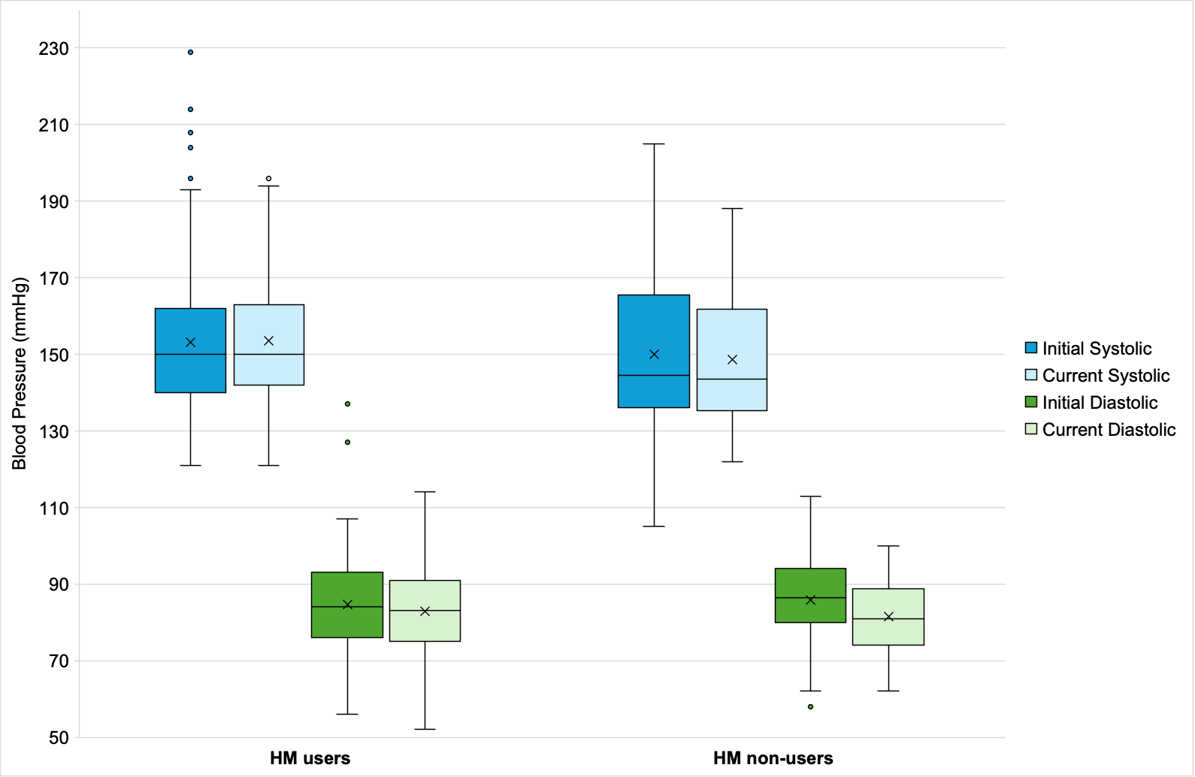
Figure 1 Box plot showing blood pressure readings of patients according to herbal medicine use.

Table 3 Commonly used herbal medicines among hypertensive patients, ranked by prevalence and blood pressure control status.
Common name | Scientific name | Family | n (%) | Blood pressure control
 |  |  |  | Controlled  n = 13 (%) | Uncontrolled  n = 66 (%)
Garlic | Allium sativum L. | Amaryllidaceae | 45 (57) | 6 (46.2) | 39 (59.1)
Ginger | Zingiber officinale Roscoe | Zingiberaceae | 33 (41.8) | 3 (23.1) | 30 (45.5)
Turmeric | Curcuma longa | Zingiberaceae | 24 (30.4) | 2 (15.4) | 22 (33.3)
Wonder-of-the-world | Bryophyllum pinnatum (Lam.) Oken | Crassulaceae | 10 (12.7) | 3 (23.1) | 7 (10.6)
Lemongrass | Cymbopogon citratus (D.C.) Stapfl | Poaceae | 9 (11.4) | 1 (7.7) | 8 (12.1)
Moringa | Moringa oleifera Lam. | Moringaceae | 7 (8.9) | 2 (15.4) | 5 (7.6)
Cinnamon | Cinnamomum verum | Lauraceae | 7 (8.9) | 0 (0) | 7 (10.6)
Vervine | Stachytarpheta jamaicensis (L.) Vahl | Verbenaceae | 6 (7.6) | 2 (15.4) | 4 (6.1)
Mango leaf | Mangifera indica L. | Anacardiaceae | 5 (6.3) | 1 (7.7) | 4 (6.1)
Saffron | Curcuma longa L. | Zingiberaceae | 4 (5.1) | 2 (15.4) | 2 (3)
Soursop leaf | Annona muricata L. | Annonaceae | 4 (5.1) | 0 (0) | 4 (6.1)
Bay leaf | Pimenta racemosa (Mill.) | Myrtaceae | 4 (5.1) | 1 (7.7) | 3 (4.5)
Berberine | Coptidis rhizoma | Berberidaceae | 4 (5.1) | 1 (7.7) | 3 (4.5)
Orange (rind) | Citrus sinensis (L.) Osbeck | Rutaceae | 3 (3.8) | 1 (7.7) | 2 (3)
Seed-under-leaf | Phyllanthus urinaria L. | Phyllanthaceae | 3 (3.8) | 1 (7.7) | 2 (3)
Ashwagandha | Withania somnifera (L.) Dunal | Solanaceae | 2 (2.5) | 1 (7.7) | 1 (1.5)
Pawpaw leaf | Carica papaya L. | Caricaceae | 2 (2.5) | 1 (7.7) | 1 (1.5)
Tambran | Tamarindus indica L. | Leguminosae | 2 (2.5) | 0 (0) | 2 (3)
Rosemary leaf | Rosemarinus officinalis | Lamiaceae | 2 (2.5) | 1 (7.7) | 1 (1.5)
Guava leaf | Psidium guajava L. | Myrtaceae | 2 (2.5) | 0 (0) | 2 (3)
Caraille | Momordica charantia L. | Cucurbitaceae | 2 (2.5) | 0 (0) | 2 (3)
Neem | Azadirachta indica A.Juss. | Meliaceae | 2 (2.5) | 0 (0) | 2 (3)
Unspecified “greens” / “bush” | N/A | N/A | 2 (2.5) | 0 (0) | 2 (3)
Shining bush | Peperomia pellucida (L.) Kunth | Piperaceae | 1 (1.3) | 0 (0) | 1 (1.5)
Avocado leaf | Persea americana Mill. | Lauraceae | 1 (1.3) | 0 (0) | 1 (1.5)
Olive bush | Bontia daphnoides L. | Myoporaceae | 1 (1.3) | 0 (0) | 1 (1.5)
Timarie | Mimosa pudica L. | Leguminosae | 1 (1.3) | 0 (0) | 1 (1.5)
Stinging nettle | Urtica dioica L. | Urticaceae | 1 (1.3) | 0 (0) | 1 (1.5)
Wild senna | Senna alata (L.) Roxb. | Leguminosae | 1 (1.3) | 0 (0) | 1 (1.5)
Black sage | Cordia curassavica (Jacq.) | Boraginaceae | 1 (1.3) | 0 (0) | 1 (1.5)

Table 4 Characteristics of herbal medicine use according to blood pressure control.
Characteristic | Overall n (%) | Controlled BP n (%) | Uncontrolled BP n (%)
Duration of time using HM  <1  1–5  6–10  11–15  >20 | n = 78  11 (14.1)  33 (42.3)  22 (28.2)  6 (7.7)  6 (7.7) | n = 13  2 (15.4)  6 (46.2)  5 (38.5)  0 (0)  0 (0) | n = 65  9 (13.8)  27 (41.5)  17 (26.2)  6 (9.2)  6 (9.2)
Mean duration of time using HM (SD) | 8.8 (13.5) | 5.1 (4.1) | 9.5 (14.6)
Preparation of HM  Homemade  Commercially made  Both | n = 81  62 (76.5)  2 (2.5)  17 (21) | n = 13  10 (76.9)  0 (0)  3 (23.1) | n = 68  52 (76.5)  2 (2.9)  14 (20.6)
Method of consumption  Tea  Combination tea and capsules | n = 73  65 (89)  8 (11) | n = 11  8 (72.7)  3 (27.3) | n = 62  57 (91.9)  5 (8.1)
Frequency of use  Daily  2-3 times per week  Once per week  Once per month | n = 60  32 (53.3)  13 (21.7)  8 (13.3)  7 (11.7) | n = 8  7 (87.5)  0 (0)  1 (12.5)  0 (0) | n = 52  25 (48.1)  13 (25)  7 (13.5)  7 (13.5)
Adherence with prescribed antihypertensive medication  Compliant  Non-compliant | n = 83  48 (57.8)  35 (42.2) | n = 13  9 (69.2)  4 (30.8) | n = 70  39 (55.7)  31 (44.3)
HM, herbal medicine; BP, blood pressure; SD, standard deviation

